**Assignment 09 – Drupal 9 CMS Website (Taxonomy, Custom Content Types)**

**Instructions for completing template:**Replace **[bracketed red text]** with the requested information or screen capture.  
Replace **bracketed red text with black text** and then remove the brackets.  
Do not include full screen shot images, or full screen shots that are reduced in size. Use a snippet tool to capture parts of the screen and insert those images into the template.  
Do not remove tags from this template. Please answer all questions.  
**Please do not alter the formatting or delete parts of this template.**  
Assignment questions are not as detailed as activity questions.   
The assignment is where you demonstrate understanding of the material.

**Part A: Student Information**

1. Student Name: [STUDENT NAME – Aamir Patel] [A01]
2. Student Email: [Aamir8567@gmail.com] [A02]
3. Student Cell: [(872) 985 - 4361] [A03] *optional
4. What day and date did you start this assignment: [Wednesday - 3/10/21] [A04]

**Go back to the instructions and begin work on part B.  
  
Part B: Create 1 Shared Web Host Drupal 9 CMS Website**

1. Platform Information

Platform name used for this assignment: [ NameCheap ] [B.1.1]  
Platform Admin Username: [aamir8567] [B.1.2]   
Platform Password: [ Kamboli90123! ] [B.1.3]

1. Drupal CMS Site Information:   
   Website Admin Username: [aapadcpate] [B.2.1]  
   Website Admin Password: [9aIwR@LZB%#uk9Fgh3] [B.2.2]  
   Database Name: [drup172] [B.2.3] *1  
   Table Prefix: [drlg_] [B.2.4] *2  
   Drupal CMS Website URL: [<https://aamirpatel.tech/assignment09>] [B.2.5]  
     
   *1 & *2 – Pantheon database info found using localhost tools MySQL Workbench or Sequel Pro

**Go back to the instructions and begin work on part C.**

**Part C: Review the Assets Adapter Record Structure**Review the Assets Adapter record structure and identify fields and Taxonomy-Vocabulary and Terms, create the Taxonomy-Vocabularies on your Drupal site, and add the terms, and then answer the following questions.

1. **How many Vocabularies did you identify?   
   [C.1]  
   [ 5 Total vocabularies in the AdapterRecord Data.]**
2. **List the names of all Taxonomy-Vocabularies you identified here. Note list only the Taxonomy-Vocabularies, not all the field names.  
   [C.2]**

**[**

**Manufacturer: - radio**

**Part No: - radio**

**Item No: - radio**

**Color: - radio**

**Battery Required: - Radio**

**]**

**For each vocabulary, identify the vocabulary by name and list its terms here.   
[C.3]  
[**

**Manufacturer: - radio**

**(MCM, Eaton, ARVANIA, Eaton)**

**Part No: - radio**

**(UK-PRO1-X23, 245-XA, 2601B-BU,** **28-12045)**

**Item No: - radio**

**(921594,** **89198, 1224, 784567)**

**Color: - Text**

**(Black, White, Brown)**

**Battery Required: - Radio**

**(Yes , No)**

**Go back to the instructions and begin work on part D.**

**Part D: Create new custom content type**

1. SCREEN CAPTURE of the **“My Adapter Record” content type structure**   
   Admin toolbar > Struct > Content types, select Edit for the “My Adapter Record” item  
     
   **[D1.1]   
   [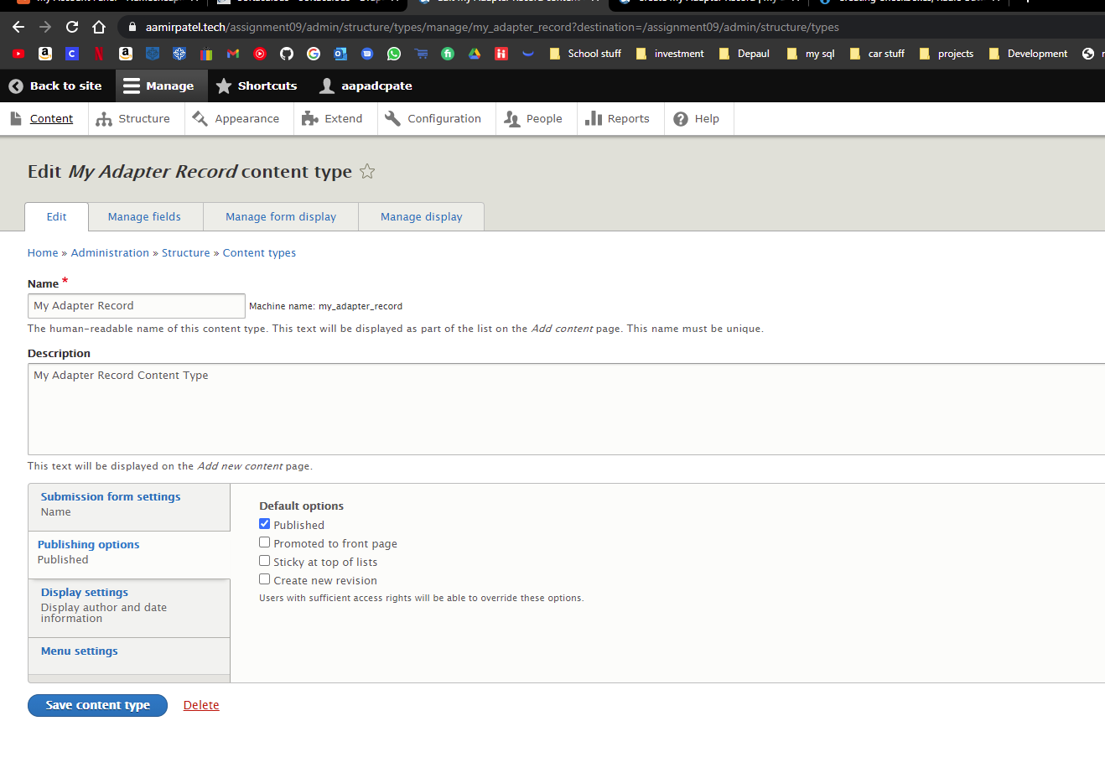]**

**[D1.2]   
[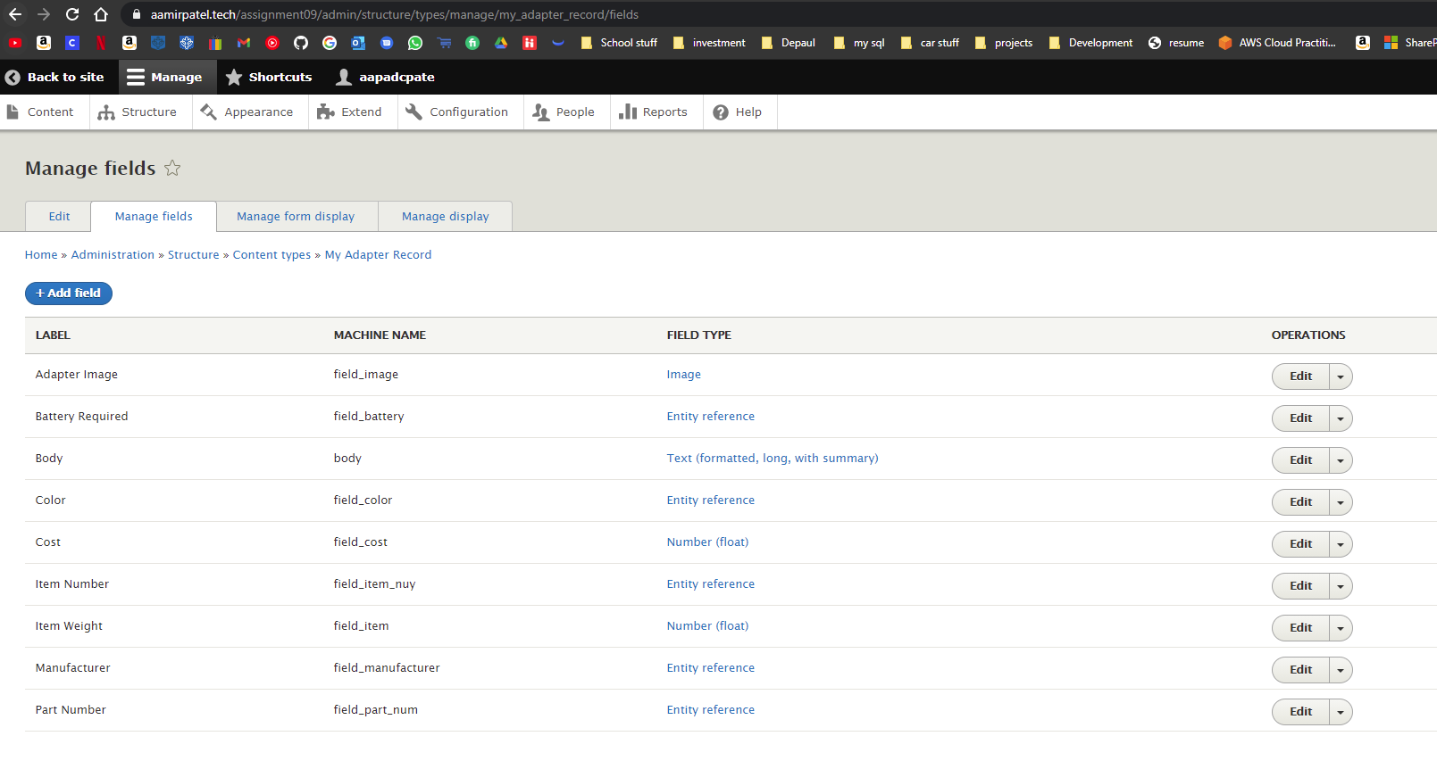]   
[D1.3]   
[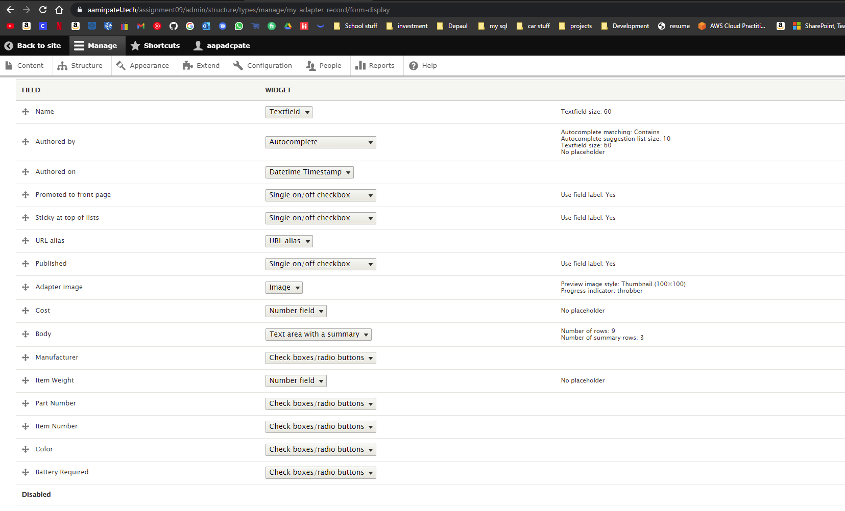]**

**[D1.4]   
[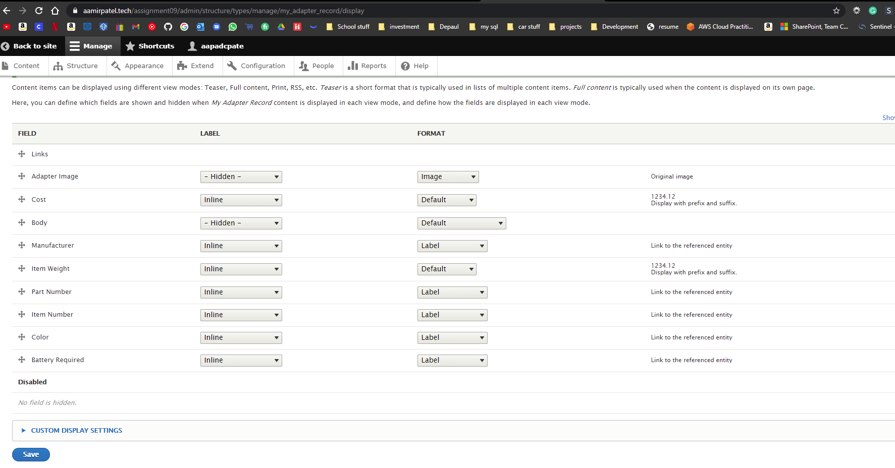]**

**Go back to the instructions and begin work on part E.**

**Part E: Add Website Content – Nodes**

1. **SCREEN CAPTURE of the list of “**My Adapter Record**” nodes (records)  
    [**Admin toolbar > Content, filter by “My Adapter Record”] **[E.1]   
   [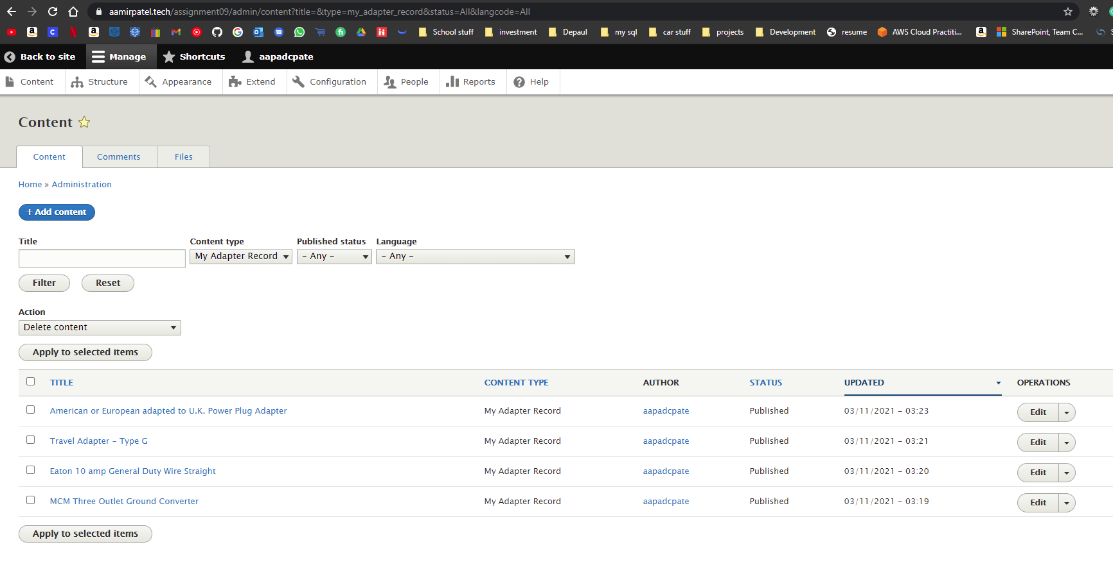]**
2. **SCREEN CAPTURE of first and last “My Adapter Records”**Please expand URL alias and Promotion options before taking the screen capture.  
   Use as many screen captures as it takes to display the whole page.E.2.1 and E.2.2 below are two record nodes in edit mode, first and last. You get this by selecting the record form the list, selected Edit tab and expand the URL alias and Promotion sections on the right side. **[E.2.1]   
   [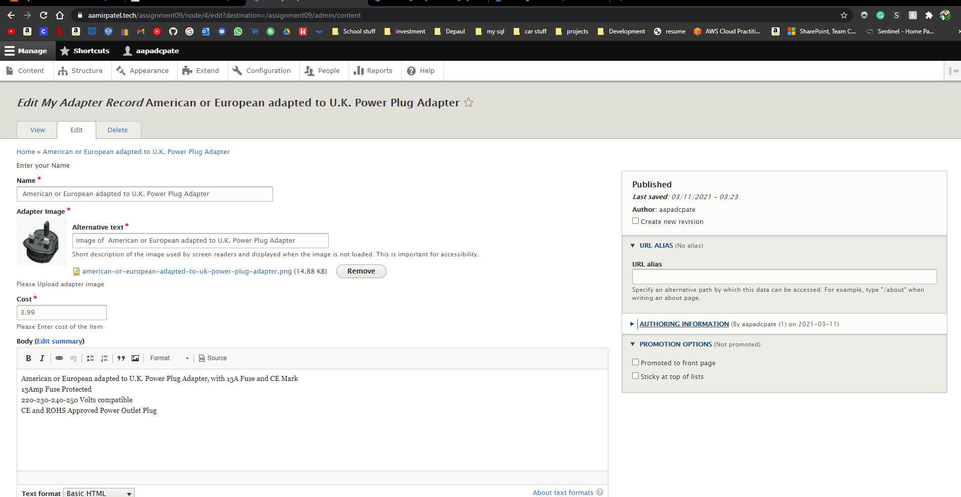]**

**[E.2.2]   
[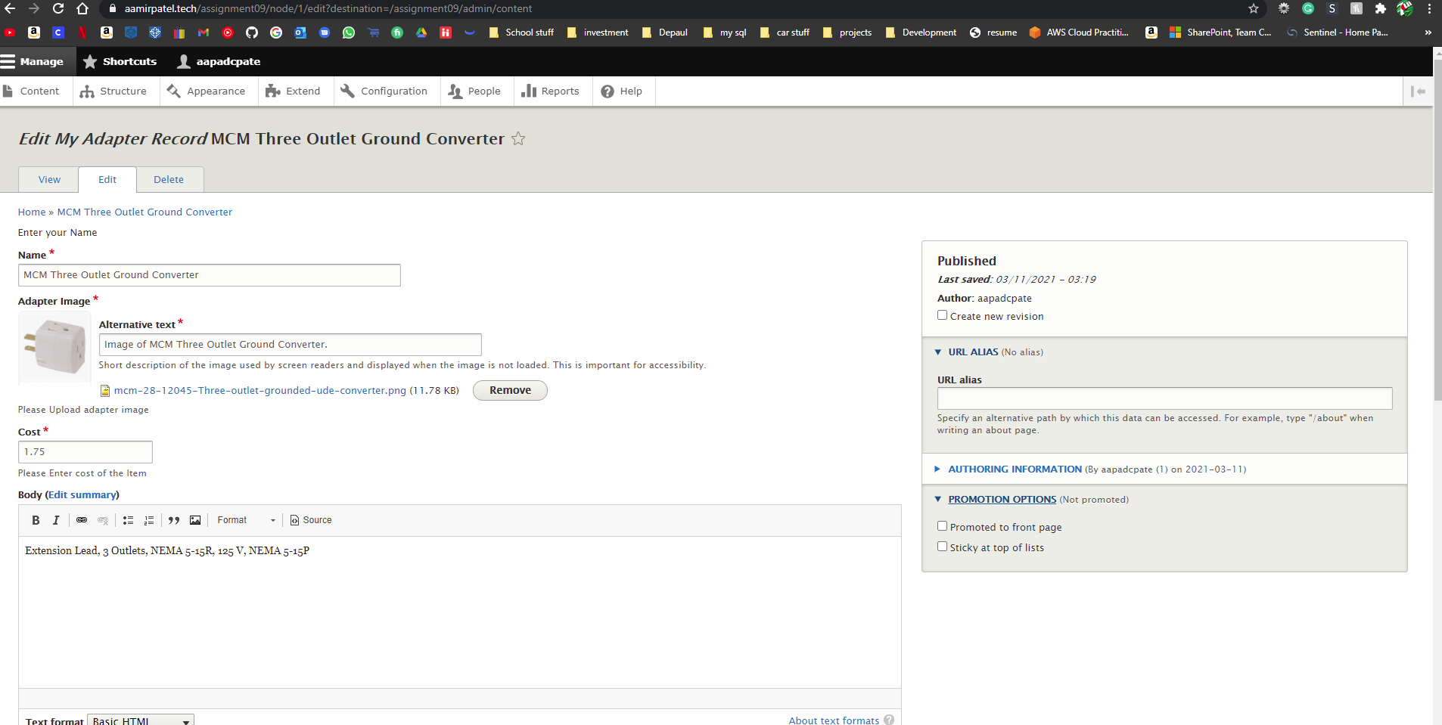]**

**Go back to the instructions and begin work on part F.**

**Part F: Create First View – Page View**

1. SCREEN CAPTURE of the backend **view list with “**My adapter record view 1” visible  **Admin toolbar > Structure > Views, with “**My adapter record view 1” visible

**[F.1]   
[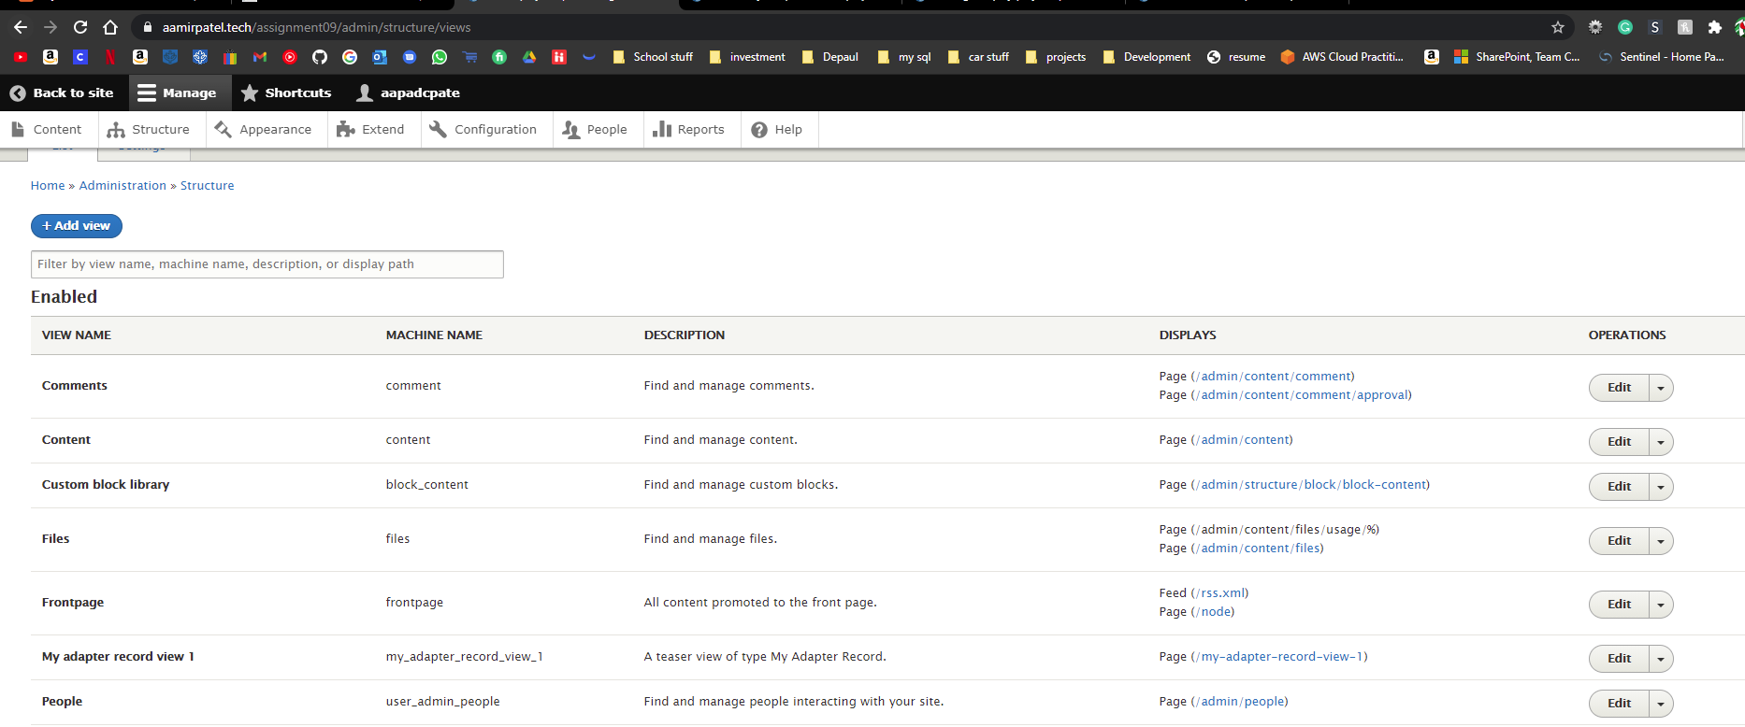]**

1. SCREEN CAPTURE of the backend **“**My adapter record view 1” summary page  **Admin toolbar > Structure > Views, Edit “**My adapter record view 1”  
   **[F.2.1]  
   [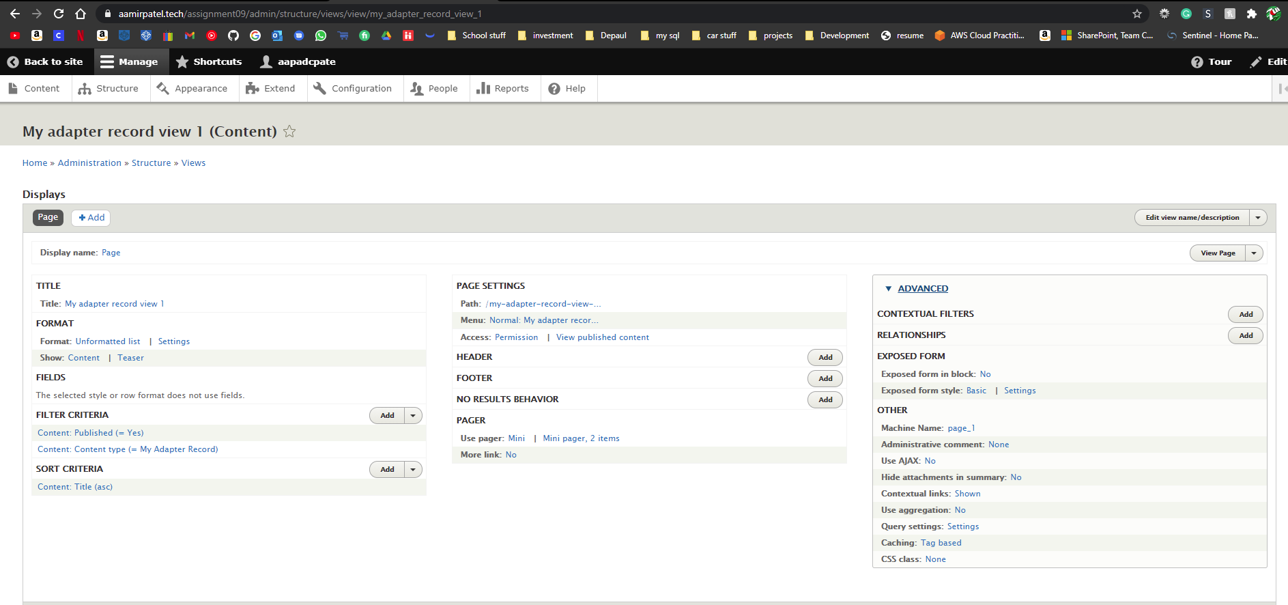]   
   [F.2.2]   
   [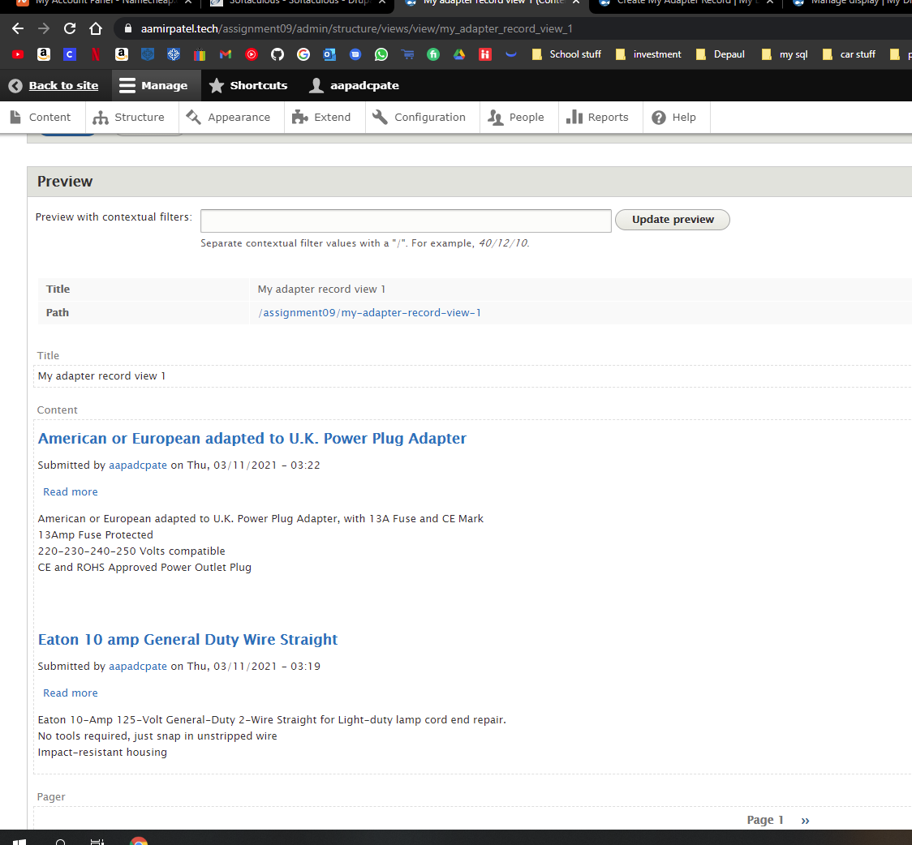]**
2. **SCREEN CAPTURE of the frontend** of the website showing the selected “My adapter record view 1” main navigation menu option. Take multiple screen captures to show output form page 1 and 2. Please make sure the web browser address bar is visible in the first image as well as the View Pager control at the bottom of the page. You can use multiple screen captures if necessary. **[F.3.1]   
   [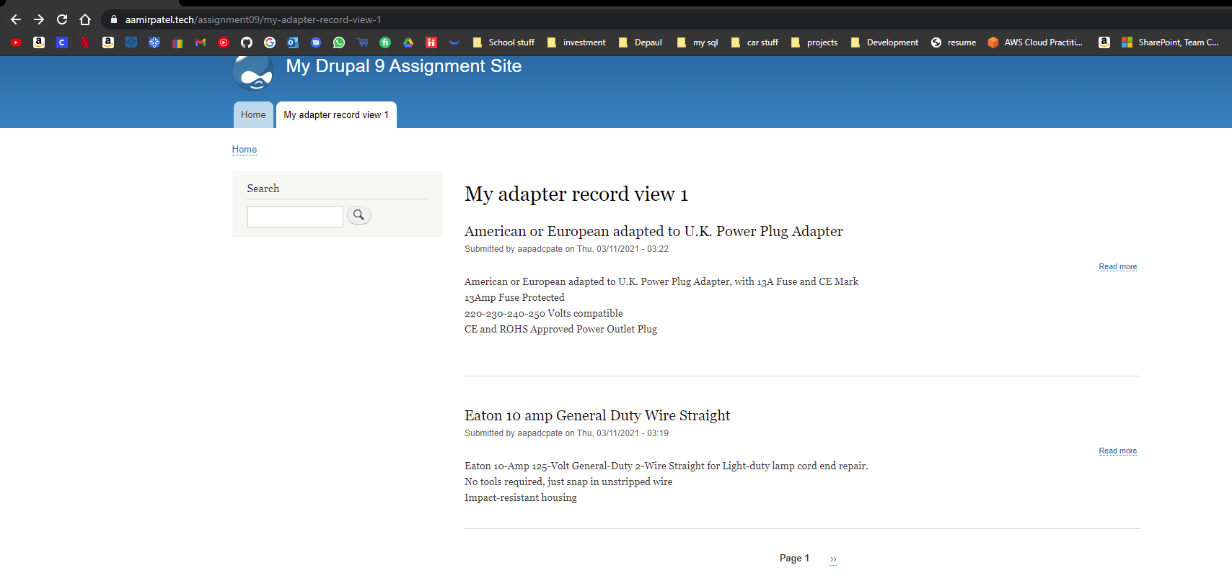]   
   [F.3.2]   
   [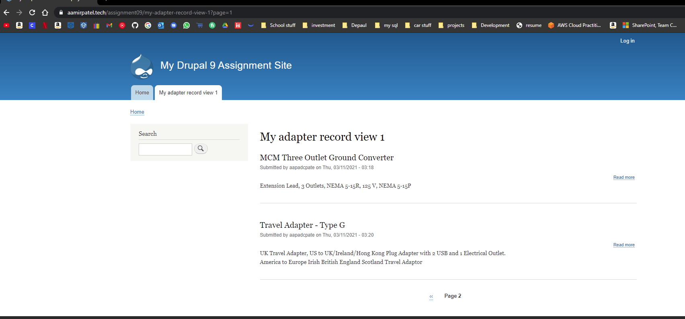 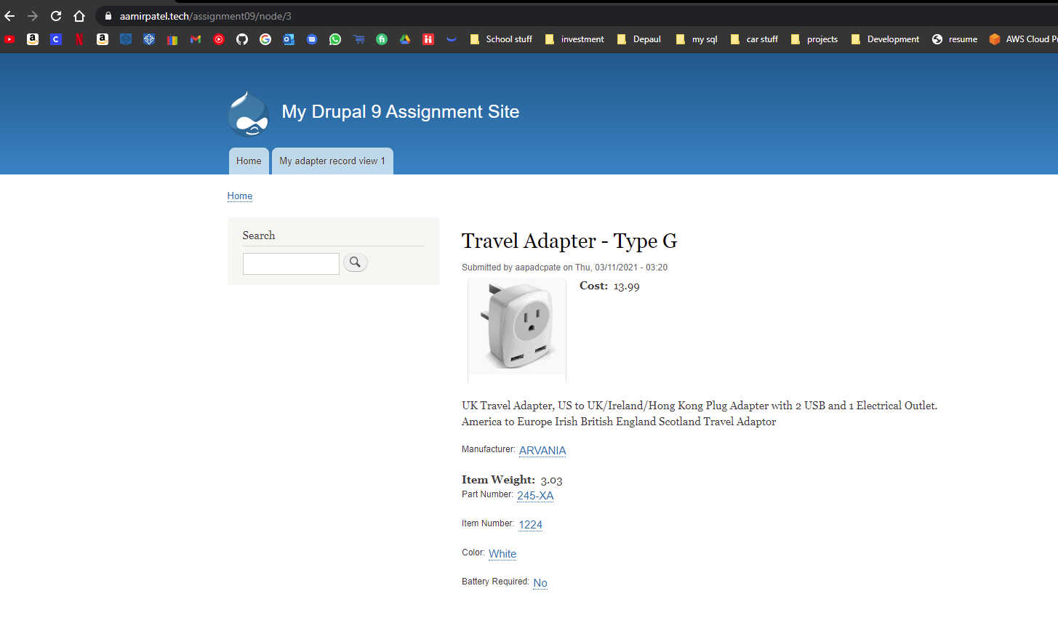]**

**Go back to the instructions and begin work on part G.**

**Part G – Create Second View – Block View**

1. SCREEN CAPTURE of the backend **view list with “**My adapter record view 2” visible  **Admin toolbar > Structure > Views, with “**My adapter record view 2” visible

**[G.1]   
[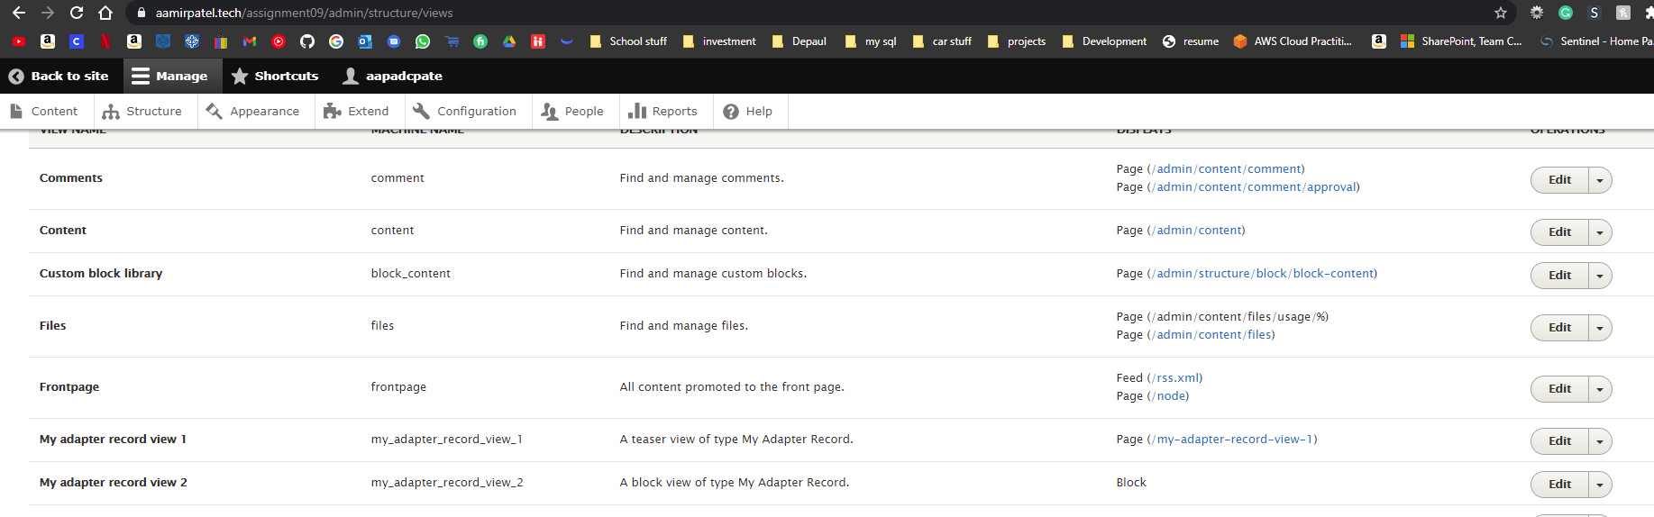]**

1. SCREEN CAPTURE of the backend **“**My adapter record view 2” summary page  **Admin toolbar > Structure > Views, Edit “**My adapter record view 2”  
   **[G.2.1]  
   [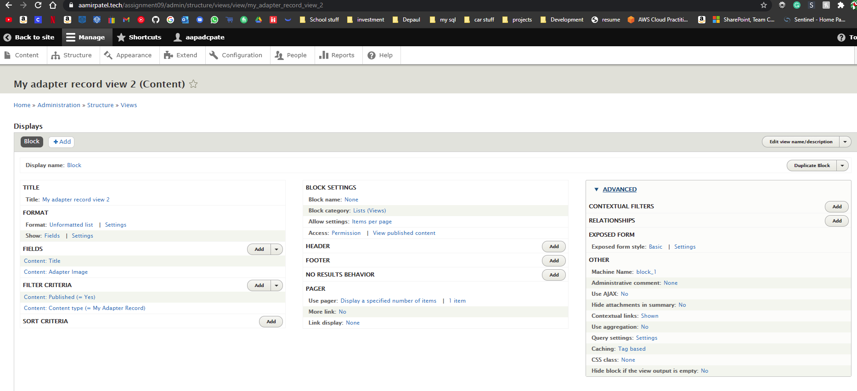]   
   [G.2.2]   
   [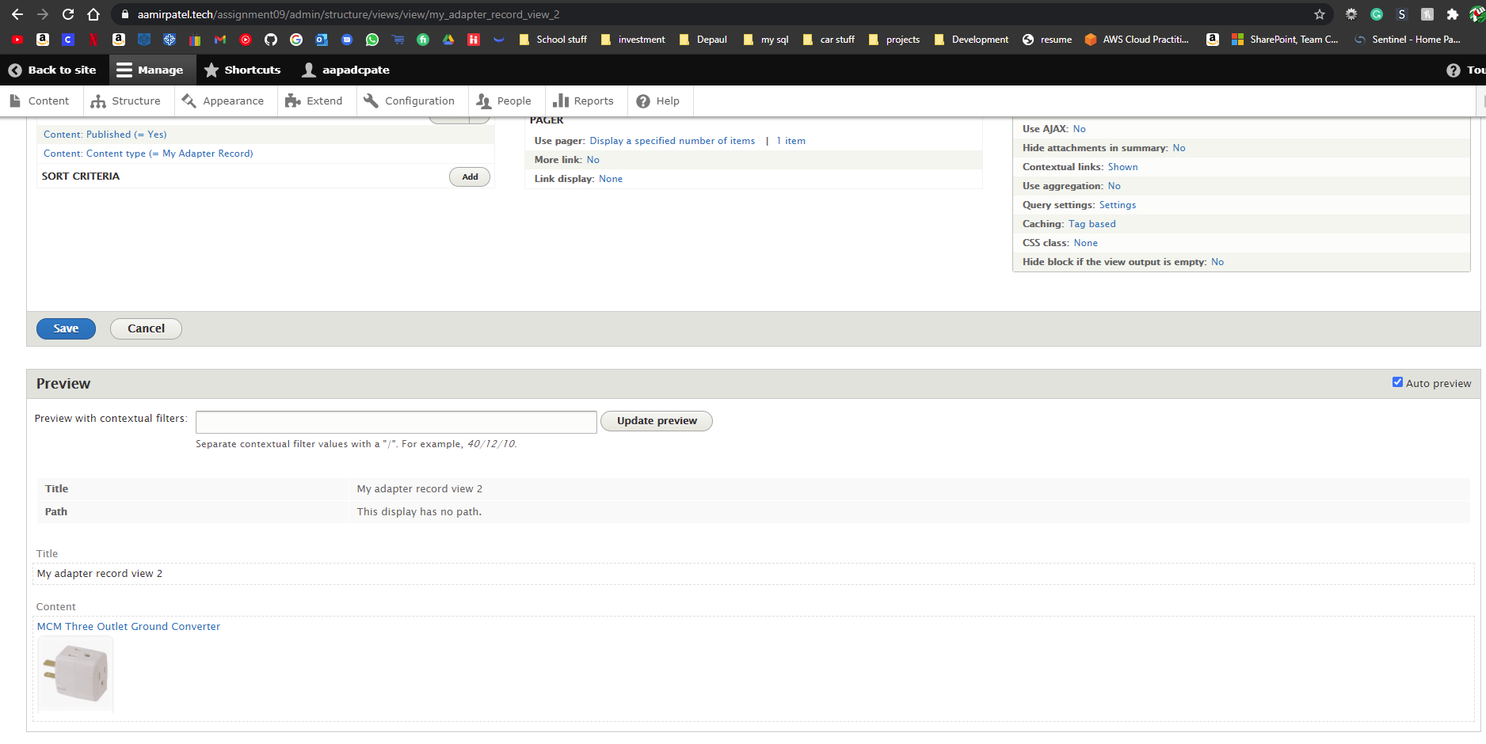]**
2. **SCREEN CAPTURE of the frontend** of the website showing the “My adapter record view 2” displayed on the sidebar. Please make sure the web browser address bar is visible on at least the screen capture. **[G.3]   
   [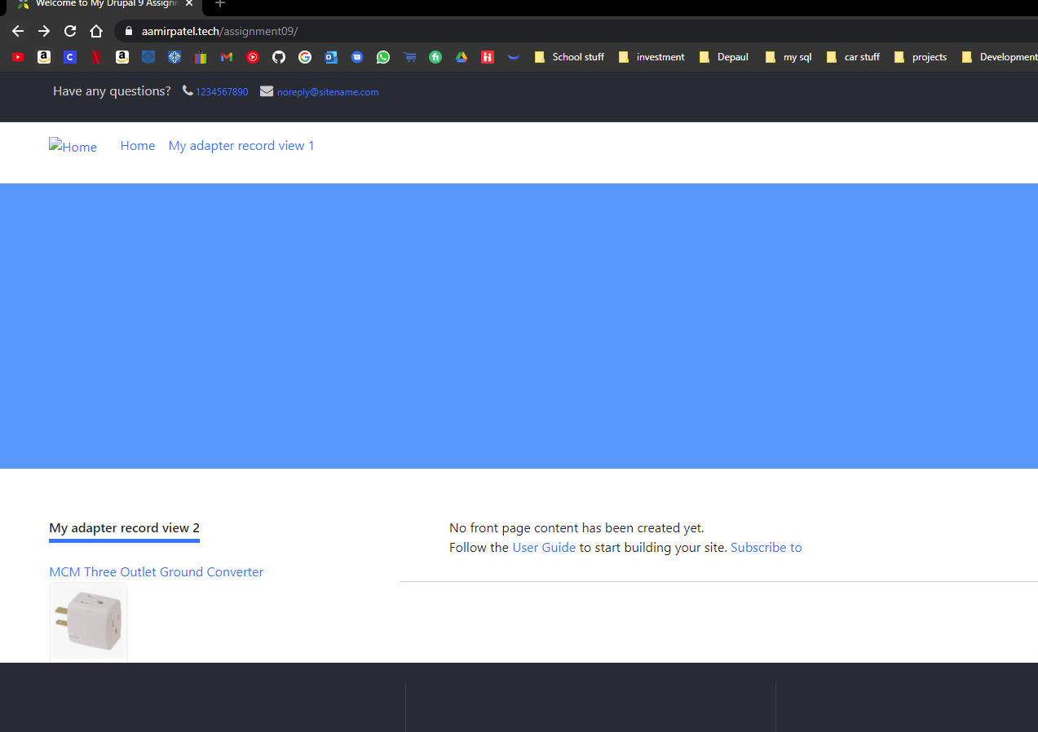]**

**Go back to the instructions and begin work on part H.**

**Part H – Java Script libraries**

1. Does the ‘libraries’ folder get created when you build a new Drupal 8-9 site?   
   **[H.1]**  
   **[No we have to create it]**
2. What is the procedure for creating a libraries folder for on a Drupal 8-9 site? **[H.2]**  
   **[Go to the root folder of webpage > create a folder named (libraries) ]**
3. What was the original name of the FlexSlider JS library folder that was extracted from the “FlexSlider-master.zip” file?  
    **[H.3]**  
   **[The original name was : - FlexSlider-master]**
4. Screen capture of the File system showing the libraries folder and an extracted and fully expanded “flexslider” folder.   
   **[H.4]**  
   **[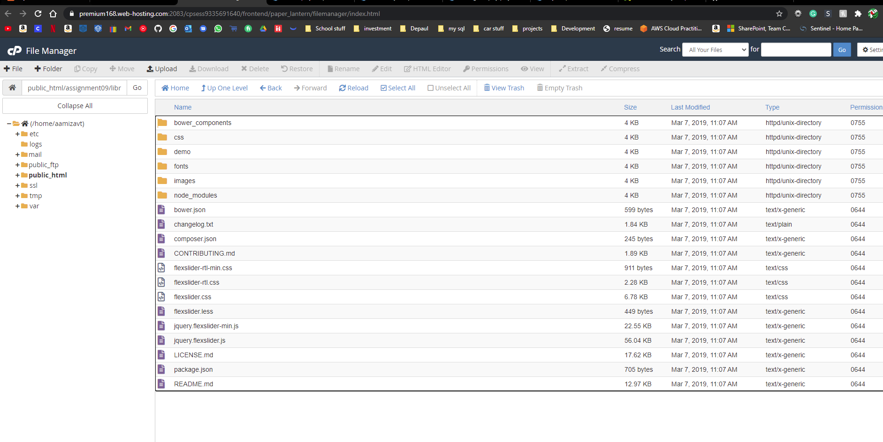]**

**Part I– Assignment Wrap up:**

1. Did you work with other classmates on this assignment?   
   [I.1]   
   [No]
2. Did you work with the instructor, tutor or volunteer on this assignment?  
   [I.2]   
   [No]
3. Did you have any problem or issues other than time management completing this assignment?   
   **This is not an optional question.**[I.3] **[No]**If you answered yes to this question, please elaborate and be specific.  
   If you had trouble with a specific question, please identify it by number and explain what you did not understand or had problems with.  
   I can only improve this assignment with your help. **[ N/A]**
4. Rate the complexity of this assignment from 1 to 10, 1 being easy and 10 being complex (difficult) [I.4] **[ 4]**
5. List the reasons for your rating on question 4. [I.5] **[ It was very much like the tutorial, the tutorial prepared us very well for this assignment.]**

Submit this completed template to the appropriate D2L assignment dropbox.If you prefer not to navigate by hand to the D2L dropbox, take advantage of the dropbox link in the D2L current Assignment section. This link will take you to the correct assignment dropbox location.