CCP
Cirrus Cloud Platform
Reference Architecture & Technical Guide
A comprehensive technical reference for an enterprise OpenStack and Kubernetes cloud orchestration platform — covering system design, architecture decisions, operational behaviour, and deployment patterns.
Version 1.0 | 2026

01 Introduction
Cirrus Cloud Platform (CCP) is a cloud self-service portal and orchestration layer that delivers hyperscaler-like consumption patterns over OpenStack and Kubernetes infrastructure. The platform unifies Infrastructure-as-a-Service and Container-as-a-Service into a single portal, REST API, and CLI surface — enabling seamless provisioning, monitoring, governance, and metering of compute, storage, networking, and Kubernetes resources for multi-tenant enterprise, sovereign, and service-provider clouds.
This document presents a reference architecture similar in structure to leading cloud providers, focusing on system design, architectural decisions, and operational behaviour. It is intended for cloud architects, platform engineers, and operators deploying or evaluating CCP as the orchestration layer of a regulated, sovereign, or commercial cloud.

KEY INSIGHT
CCP closes the gap between operator-grade open infrastructure and tenant-grade cloud experience — turning OpenStack and Kubernetes into a coherent, self-service cloud.

02 Problem Statement
Modern enterprise and sovereign clouds need to deliver:
- Hyperscaler-grade self-service UX over open infrastructure
- Unified IaaS and CaaS lifecycle from one portal and API
- Strong multi-tenant isolation across compute, network, storage, and identity
- Fine-grained quota, role, and audit governance per organisation and project
- Region- and AZ-aware deployment with predictable performance and resilience

Public clouds have set the bar for self-service speed, multi-tenant governance, and consumption-based metering. OpenStack and Kubernetes deliver the engine but expose operator-oriented surfaces that are fragmented across APIs and lack the consumer-grade UX, quota workflows, and policy guardrails expected by tenant teams.

KEY INSIGHT
CCP was purpose-built to address this gap — providing a unified orchestration layer that brings hyperscaler-style self-service, governance, and metering to OpenStack and Kubernetes deployments.

03 Design Principles

3.1 Hyperscaler-Like Self-Service
Every tenant interaction — virtual machine, volume, cluster, bucket, load balancer, role — is exposed as a single-page, wizard-driven workflow with Card and Table views, search, filters, view preferences, export, and bulk operations. Tenants never need to fall back to native OpenStack or Kubernetes CLIs for routine work.

3.2 Unified IaaS and CaaS
A single control plane manages OpenStack-based virtual infrastructure and Kubernetes clusters (both CCP-managed and externally imported), eliminating two-portal sprawl and giving tenants a coherent experience across VMs, volumes, networks, and clusters.

3.3 Multi-Tenant Isolation by Design
Isolation is enforced across every layer:
- Organisation (tenant) → Project → User identity hierarchy
- Region and Availability Zone scope on every long-lived resource
- VPC, Subnet, and Security Group network boundaries
- Per-tenant and per-project quotas with administrator-approved increases
- Per-bucket Access Keys with expiry for object storage

3.4 Declarative Resource Lifecycle
All resources — VMs, volumes, snapshots, networks, clusters, addons — are modelled declaratively and exposed via REST API for IaC and automation workflows. Kubernetes objects can be created and edited as YAML directly in the portal.

3.5 Governance and Metering as First-Class Services
Activity logs, metering, quotas, and quota-request approvals are built-in platform primitives — not afterthoughts — surfaced through dedicated Tenant Admin views.

04 Reference Architecture
The platform is composed of three primary layers — Access, Control, and Data — connected by authenticated, idempotent APIs.
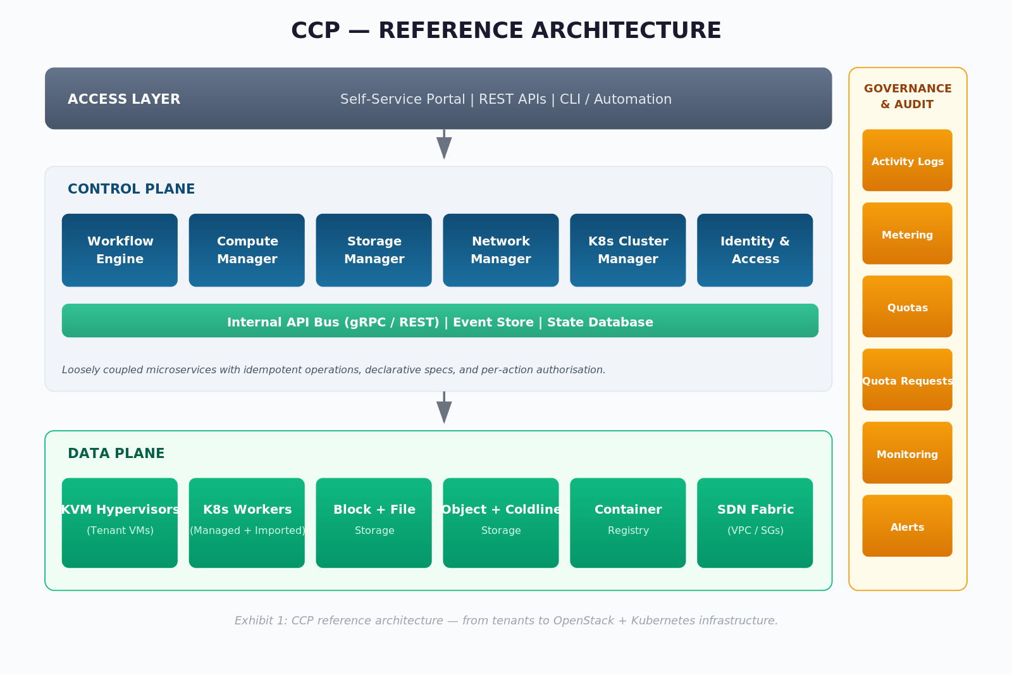
Exhibit 1: CCP reference architecture — from tenants to OpenStack + Kubernetes infrastructure.

4.1 Access Layer
- Self-service portal (Dashboard, Resources, Tenant Admin)
- REST APIs
- CLI and automation scripts (driven by the REST API)

4.2 Control Plane
- Workflow Orchestrator
- Compute Manager (virtual machine lifecycle)
- Storage Manager (block, file, object, archival, registry)
- Network Manager (VPC, subnets, security groups, NAT, EIP, load balancers)
- Kubernetes Cluster Manager (managed and imported clusters, addons)
- Identity and Access Service
- Metering and Quota Service
- Monitoring and Alerting Service
- Audit Service (Organization Activity Logs)

4.3 Data Plane
- OpenStack-managed compute hosts (KVM hypervisors) running tenant VMs
- Kubernetes worker fleet (managed CCP clusters and imported clusters)
- Block, file, object, and archival storage back-ends
- Container Registry for OCI images
- SDN fabric enforcing VPC, security group, NAT, and load-balancer policy

05 Control Plane Architecture
The control plane is responsible for orchestration, policy enforcement, and maintaining the desired state of the system. It operates as a set of loosely coupled microservices communicating over authenticated internal APIs (gRPC/REST), designed for idempotency and eventual consistency.
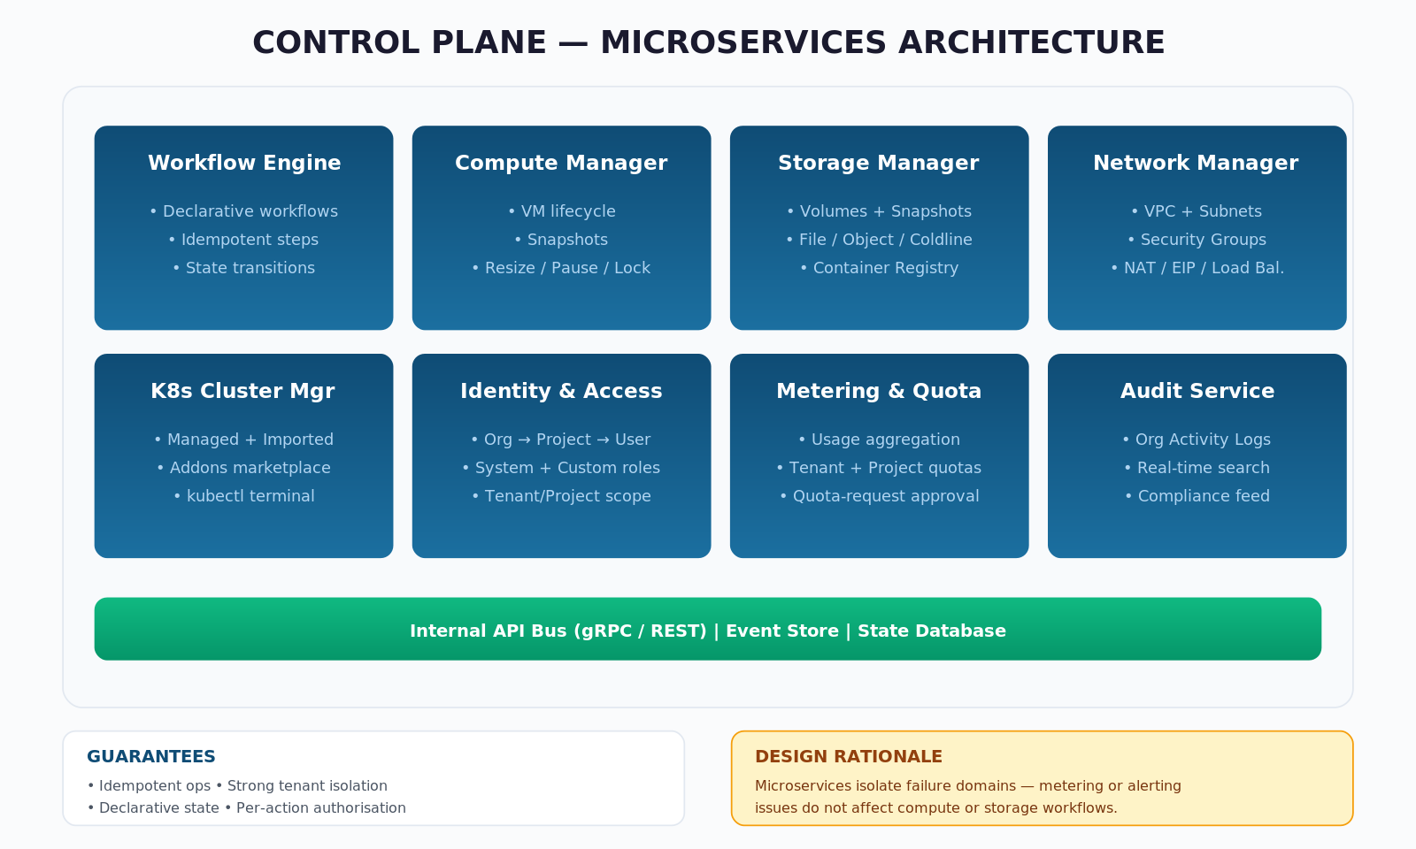
Exhibit 2: Control-plane microservices architecture with guarantees and design rationale.

Core Components

Workflow Engine
Executes declarative workflows for resource provisioning and lifecycle operations. It consumes high-level tenant intents — for example, “create VM”, “create cluster”, “raise quota request” — and decomposes them into ordered, retriable steps against OpenStack, Kubernetes, and supporting services. Each step is idempotent and emits state transitions to the orchestration store.

Compute Manager
Translates VM specifications (network, image, flavor, root volume, additional volumes, firewall rules, key pair, cloud-init) into Nova operations. Handles the full set of CCP lifecycle actions: resize, shutoff, pause, reboot, hard reboot, lock, suspend, snapshot, attach and detach volumes, attach and detach networks and security groups, and console access.

Storage Manager
Owns the lifecycle of volumes and their snapshots, file systems with Access Points, object-storage buckets (including versioning, object-lock, replication, and access-key issuance), the Coldline archival tier, and the Container Registry.

Network Manager
Programs VPCs, subnets, security groups, NAT gateways, Elastic IPs, and load balancers (Application HTTP/HTTPS and Network TCP/UDP) over the underlying SDN. It enforces L3 segmentation between tenant VPCs and projects and manages certificate lifecycle for application load balancers.

Kubernetes Cluster Manager
Provisions managed Kubernetes clusters (with auto-scaling node pools), onboards imported clusters via downloadable bootstrap manifests, installs addons from the Addons marketplace, and exposes a built-in terminal for Kubectl operations against managed and imported clusters.

Identity and Access Service
Integrates with enterprise identity providers. Models the Organisation → Project → User hierarchy with System Roles and Custom Roles, scoped at Tenant or Project level. Enforces RBAC at every API boundary.

Metering and Quota Service
Aggregates resource consumption signals into per-organisation and per-project meters; enforces quotas (block storage, object storage, load balancers, VMs, file systems and more) with health indicators that move from green at low utilisation to action-required near 100 per cent; routes quota-increase requests — with priority and justification — to administrators for approval or rejection.

Audit Service (Organization Activity Logs)
Centralises events — user actions, system tasks, resource creations and modifications — into a searchable, filterable, real-time audit feed at organisation scope.

Guarantees
- Idempotent operations (safe retries)
- Strong tenant isolation at API layer
- Declarative resource specification produces deterministic resource state
- Per-action authorisation against IAM scope

DESIGN RATIONALE
Microservices enable independent scaling and failure isolation — control plane disruptions do not impact running tenant workloads.

06 Data Plane Architecture
The data plane executes tenant workloads and handles all compute and data movement. It is optimised for stability, cost-efficiency, and operational predictability.

Components
- OpenStack-managed KVM hypervisors hosting tenant VMs
- Kubernetes worker nodes (managed CCP clusters and imported clusters)
- Block-storage back-ends serving tiered Cinder-style volumes
- File-storage back-ends exposing managed Access Points
- Object-storage back-ends (S3-API compatible) with versioning, object-lock, and replication
- Coldline archival storage back-end
- Container Registry for OCI images
- SDN fabric for VPC, security-group, load-balancer, and NAT/EIP enforcement

Execution Model
VMs are scheduled by the underlying Nova scheduler across hypervisor hosts within the selected Availability Zone. Kubernetes workloads (Pods, Jobs, Cronjobs, Daemonsets, Statefulsets, Replicasets) are scheduled by the cluster’s own Kube-scheduler. CCP brokers intent and policy; the data plane runs continuously, decoupled from control-plane availability events.

KEY INSIGHT
Separating execution from orchestration ensures that control-plane disruptions do not impact running workloads — a baseline expectation for production cloud services.

Guarantee | Mechanism | Benefit
Workload stability | Decoupled control and data planes | Control-plane events do not disrupt running VMs and clusters
Tenant isolation | Per-VPC SDN segmentation; per-tenant Kubernetes namespaces | Secure multi-tenancy
Predictable storage SLA | Tier-aware volume placement | Right-sized cost and performance per workload

07 Network Architecture
CCP exposes an AWS/Azure-style virtual network model over the underlying SDN fabric.
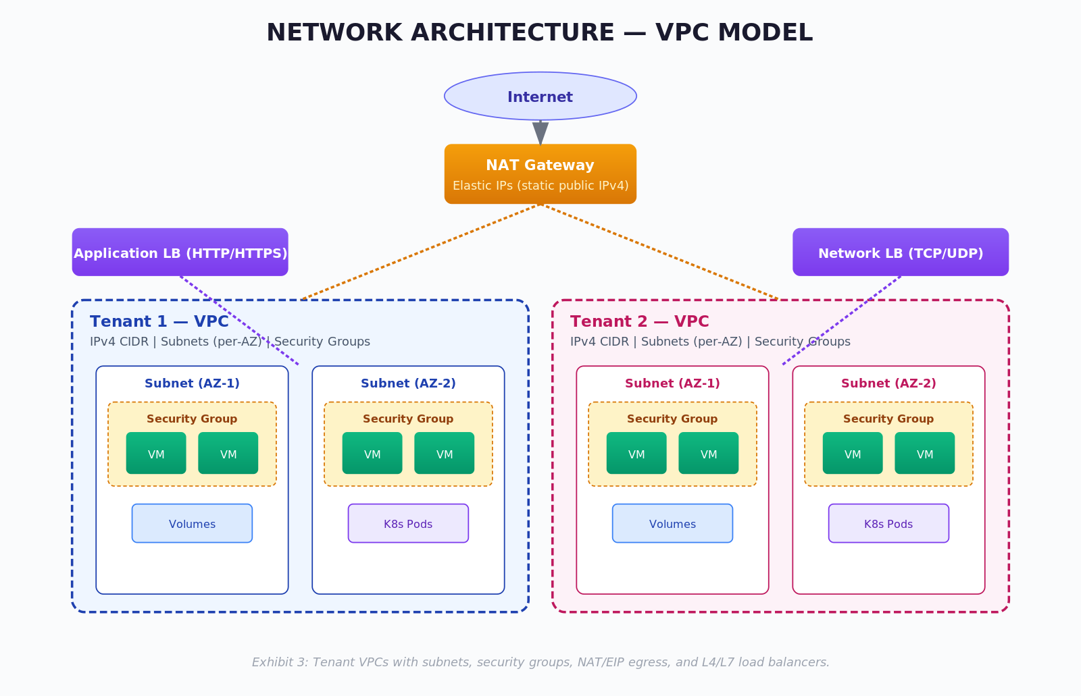
Exhibit 3: Tenant VPCs with subnets, security groups, NAT/EIP egress, and L4/L7 load balancers.

7.1 VPC Model
Tenants create one or more Virtual Private Clouds per project. Each VPC defines an IPv4 CIDR block and contains one or more subnets with sub-role classification. Subnets are AZ-scoped, enabling resilient multi-AZ deployments. VPCs and subnets are taggable (up to five labels) and have dedicated Overview and Subnets detail tabs.

7.2 Security Groups
Stateful network-level firewalls attached to VMs. Each rule specifies protocol, IP version, direction, network address, and ports (predefined or custom). Security groups are the first line of east-west and north-south filtering inside a VPC.

7.3 NAT Gateway and Elastic IP
The NAT Gateway provides outbound-only internet access for workloads in private subnets while preventing inbound connections. Elastic IPs are reserved, static, public IPv4 addresses that remain allocated to the tenant until explicitly released — used for fixed ingress endpoints.

7.4 Load Balancers
Two L4/L7 modes are supported:
- Application Load Balancer (HTTP/HTTPS) — for web and API tiers with health checks, SSL certificate management, and certificate-expiry monitoring
- Network Load Balancer (TCP/UDP) — for non-HTTP workloads
Each load balancer is attached to a VPC and VIP subnet. One or more VIPs and Virtual Servers (with backend server groups) are configured per load balancer. The real-time Monitoring panel surfaces system throughput, total virtual servers, server status and availability, certificate expiry, and client/server SSL issues.

Guarantee | Description
Tenant isolation | Per-tenant VPC and per-VM Security Group programming
Controlled egress | NAT Gateway with per-tenant Elastic IPs
Layer-aware load balancing | Application LB (HTTP/HTTPS) and Network LB (TCP/UDP)
Certificate visibility | SSL certificate-expiry surfaced on LB monitoring

KEY INSIGHT
VPC, Security Groups, NAT, and Load Balancers together deliver a familiar AWS/Azure-style network model on open infrastructure.

08 Storage Architecture
CCP exposes four primary storage modalities plus a container registry. Each is modelled as a first-class resource with snapshots, tagging, and quota tracking where applicable.
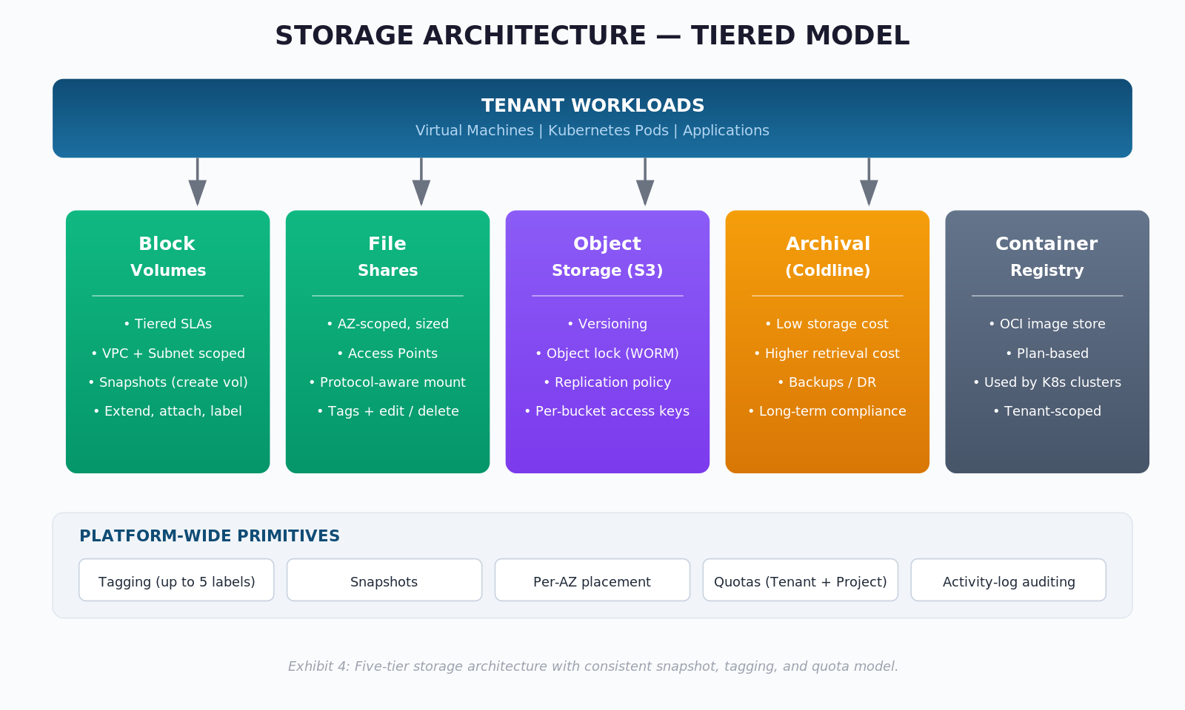
Exhibit 4: Five-tier storage architecture with consistent snapshot, tagging, and quota model.

8.1 Block Storage (Volumes)
Tiered, attachable block volumes scoped to a VPC and subnet. Operations include create, extend size, snapshot, attach to VM, manage labels (up to five), and delete. The detail view exposes total size, space used, percentage used, and current state across Overview, Attached Resources, Snapshots, and Monitoring tabs.

8.2 Volume Snapshots
Point-in-time copies of volumes. Snapshots can be used to materialise new volumes, enabling clone-and-restore workflows for application portability and disaster recovery rehearsals.

8.3 Shared File Storage
Managed file shares with configurable size, Availability Zone, description, and tagging. Access Points define how clients connect — protocol, access type, starting path, and permission profile — and are the unit of mount management. Access Points are editable and deletable independent of the share itself.

8.4 Object Storage
S3-API-compatible buckets with:
- Replication policy and Availability Zone selection
- Object versioning
- Object locking with lock-validity (days) for WORM/compliance retention
- Per-bucket Access Keys with expiration and one-time-display secret presentation
- Bucket-level monitoring (growth, request statistics)

8.5 Object Storage Archival
Cost-optimised cold storage for backups, disaster-recovery archives, and long-term compliance records. Coldline balances low storage costs with higher retrieval costs, making it suitable for data accessed infrequently but retained for long periods.

8.6 Container Registry
Plan-based OCI image registry for storing and distributing container images used by Kubernetes clusters managed or imported through CCP.

KEY INSIGHT
A consistent snapshot, tagging, and quota model across block, file, and object storage reduces tenant cognitive load and operational risk.

09 Identity, Access and Multi-Tenancy

9.1 Identity Hierarchy
- Organisation (Tenant) — top-level container with its own quotas, activity log, and project set
- Project — sub-container with its own users, quotas, and resource scope
- User — principal that can hold roles at Tenant and/or Project scope

9.2 Roles
- System Roles — pre-defined roles shipped with the platform
- Custom Roles — user-defined roles with granular per-resource and per-action permissions
Roles are assignable at Tenant or Project scope, enabling least-privilege separation between platform operators, project owners, and project members.

9.3 Role Lifecycle
The Manage Role flow surfaces a user’s current role assignments (with explicit Remove actions), supports assigning new roles via search across System and Custom roles, and clearly indicates the assignment scope. Newly assigned roles may require re-authentication to take effect.

DESIGN RATIONALE
A two-level Tenant/Project scope with separate System and Custom roles maps cleanly onto enterprise role hierarchies without forcing a deep group/policy graph.

10 Monitoring, Metering and Governance

10.1 Monitoring
Per-resource graphical monitoring for VMs, buckets, file systems, and load balancers, alongside aggregated dashboards across CPU, memory, network throughput, storage utilisation, bucket growth and request rates, and load-balancer health. Time-range, metric-type, and resource filters are supported throughout.

10.2 Alerts
Configurable alerts modelled as Basic Details, Resource Details, Metrics & Thresholds, and Resource Mapping, with edit and delete actions and a detail overview that exposes the full configuration and resource binding.

10.3 Metering
Visual representation of cloud-resource consumption at organisation level, used by tenant administrators to identify usage patterns and optimise allocation and budget.

10.4 Quotas
- Tenant Quota — service-level usage and utilisation with colour-coded health (green at low utilisation, action-required near 100 per cent)
- Project Quota — a subset of tenant quota carved out per project across File Storage, Object Storage, Load Balancers, and other services
- Quota Requests — tenant-initiated increase requests with description, priority (High/Medium/Low), requested resources, and tags; routed for administrator approval or rejection

10.5 Audit (Organization Activity Logs)
Centralised, real-time audit feed of resource creations, modifications, and system-initiated tasks. Searchable and filterable, this feed is the canonical source of truth for compliance reviews and incident investigations.

11 Kubernetes Platform Architecture
CCP’s Kubernetes plane treats clusters as first-class managed resources alongside VMs and storage.

11.1 Managed Cluster Lifecycle
The cluster creation wizard configures name, version, region, networking version, and one or more Node Pools — each with subnet, flavor, desired node count, and auto-scaling maximum. Cluster state is tracked as Connected, Not Connected, or Not Registered.

11.2 Imported Cluster Onboarding
External Kubernetes clusters can be onboarded by downloading the install configuration and bootstrap manifest, enabling the proxy, and applying the configuration on the target cluster. Imported clusters expose KubeConfig download, edit, delete, and a built-in Kubectl terminal — identical to the surface offered for managed clusters.

11.3 Cluster Surface
Each cluster’s detail view exposes Overview, Addons, Logs, Nodes, Namespace, Events, Workloads, Access Control, Service Discovery, and Storage tabs.

11.4 Addons Marketplace
Category-based marketplace (for example GPU and GitOps categories) for one-click enablement of cluster addons with namespace targeting and deployment-progress tracking through an Instance State indicator.

11.5 Kubernetes Object Coverage
- Workloads — Pods, Jobs, CronJobs, DaemonSets, StatefulSets, ReplicaSets, Resource Quotas (form or YAML; clone, edit, download YAML, delete; replica scaling and resource-metric edits)
- Access Control — Roles, RoleBindings, ClusterRoles, ClusterRoleBindings, ServiceAccounts
- Service Discovery — Services, Ingress, NetworkPolicies, Horizontal Pod Autoscalers, LoadBalancers
- Storage — StorageClasses, Secrets, ConfigMaps, PersistentVolumes, PersistentVolumeClaims
- Namespace — namespace lifecycle with labels and annotations
- Logs and Events — live and audit logs per cluster; event feeds scoped per namespace

KEY INSIGHT
Providing the full native Kubernetes object surface alongside managed cluster lifecycle gives tenants a complete cluster-admin experience without leaving CCP.

12 Security Architecture
CCP enforces defence-in-depth across the platform’s layers.

12.1 Identity and Access
- Org/Project/User hierarchy with scoped System and Custom roles
- Per-API authorisation
- Per-bucket access keys with expiry and one-time secret display

12.2 Network Security
- VPC and Subnet segmentation
- Stateful Security Groups attached per VM
- NAT Gateway with egress-only semantics
- Elastic IPs as managed static ingress endpoints
- TLS/SSL certificate-expiry monitoring on Application Load Balancers

12.3 Workload Security
- VM Lock action to prevent conflicting concurrent operations
- Per-VM Key Pair or credential authentication
- Snapshot-based recovery for VMs and volumes

12.4 Data Security
- Object Storage versioning
- Object Locking with retention period (WORM) for compliance
- Coldline archival tier for long-term compliance retention
- Per-bucket access-key issuance and expiry

12.5 Audit and Governance
- Organization Activity Logs (real-time, searchable, filterable)
- Kubernetes audit and live logs per cluster
- Quota and quota-request approval workflows as blast-radius controls

Layer | Mechanism
Identity | RBAC with Tenant/Project scope; System and Custom roles
Network | VPC + Security Group + NAT/EIP; LB certificate monitoring
Workload | VM Lock, key-pair authentication, snapshot recovery
Data | Object lock, versioning, access-key expiry, Coldline retention
Governance | Activity logs, quotas, quota-request approvals

13 Multi-Tenancy and Isolation Model
Isolation is enforced at every layer of the stack:
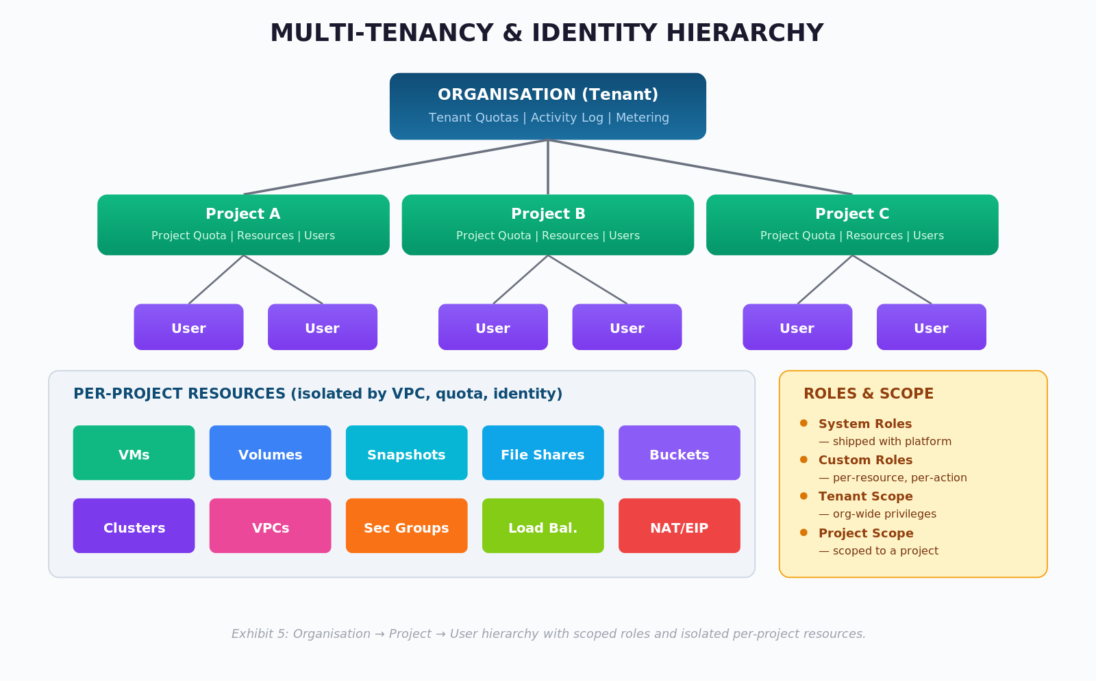
Exhibit 5: Organisation → Project → User hierarchy with scoped roles and isolated per-project resources.
Dimension | Isolation Boundary
Identity | Organisation → Project → User with scoped roles
Network | Per-tenant VPC, per-VM Security Group, per-tenant NAT/EIP
Storage | Per-bucket access keys, per-project volumes and shares
Compute | Per-AZ scheduling, per-tenant VM and volume quotas
Kubernetes | Per-tenant clusters; per-cluster RBAC and NetworkPolicies
Consumption | Per-tenant and per-project quotas with admin-approved increases
Audit | Per-organisation activity-log scope

KEY INSIGHT
Isolation is not a single control but a coordinated set of boundaries — identity, network, storage, compute, and governance must all enforce the tenancy line.

14 Deployment Model
CCP is region- and AZ-aware. Every long-lived resource — virtual machine, volume, file system, security group, bucket — is created within a chosen Region and Availability Zone. Multi-AZ deployment patterns are achieved through subnet placement and per-AZ resource selection. The portal exposes a Region Selector at the top of the dashboard, and AZ pickers throughout the resource-creation wizards.
Operational primitives — quotas, activity logs, metering, monitoring — are scoped at organisation and project level and remain consistent across regions, giving administrators a single governance pane regardless of geographic footprint.

15 Differentiators
- Unified IaaS and CaaS portal over OpenStack and Kubernetes
- Hyperscaler-style self-service UX with bulk operations, Card/Table views, export, search, and filters
- Built-in tenant governance: quotas, quota requests, activity logs, metering
- Full Kubernetes object surface plus a category-based Addons marketplace
- S3-compatible object storage with versioning, WORM object lock, replication, and archival
- Consistent labelling/tagging (up to five labels) and snapshot models across resource families
- Built-in terminal and KubeConfig download for in-portal and off-portal cluster operations

KEY INSIGHT
CCP transforms operator-grade open infrastructure into a tenant-grade cloud — without forcing tenants into the operational complexity of OpenStack and Kubernetes APIs.

