Product Design
Team 48  Members  1.  2.  3. | Web Application for Text Mining and Storage of Clinical Data.  Aamir Farhan (20161078)  Aniket Shrimal (20161136)  Lakshmee Sravya (20161084)

Design Model

Users | Class state  - This class is responsible for maintainingthe information about the different activities a user can do and the attributes it can have.  Class behavior : Methods  - login()  - addData()  - deleteData()  - download()  - view()
Dashboard | Class state  - This class is responsible for showing the user attributes and methods a user can perform.  Class behavior  - store()  - display()  - profile()
Drug | Class state  This class maintains the information about a drug and its functions.  Class behavior  - NCTsearch()  - query()  - scrape()
Database | Class state  This class maintains the information scraped off from the government website  Class behaviour  - store()  - extract()
Clinical Trials Data | Class state  The data about a trial. This class maintains the fields including NCT number, status etc.  Class behavior  - Data gets scraped from the government website  - Data gets tabulised  - Data gets downloaded  - Data gets added/deleted
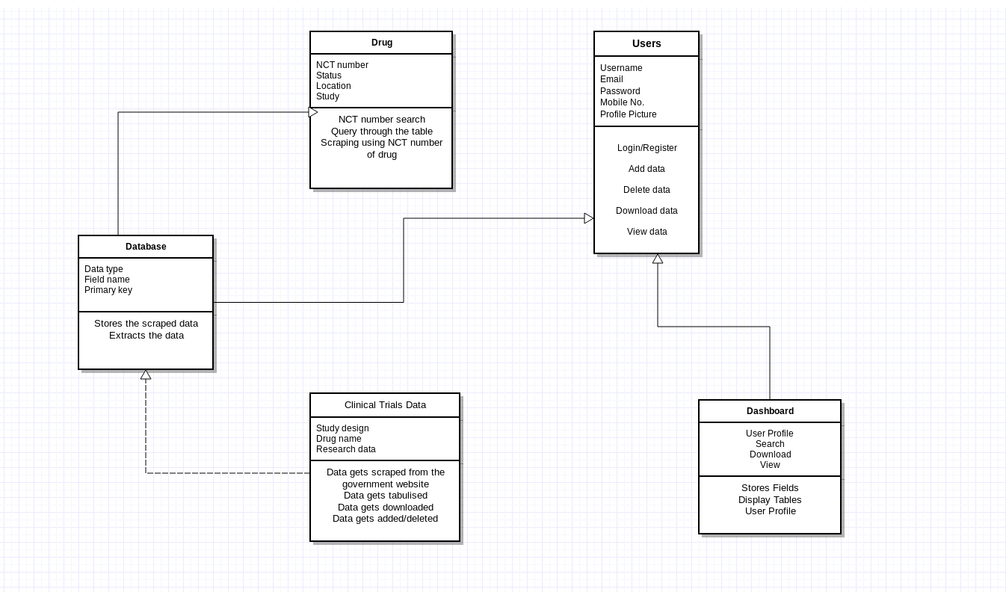

Sequence Diagram(s)

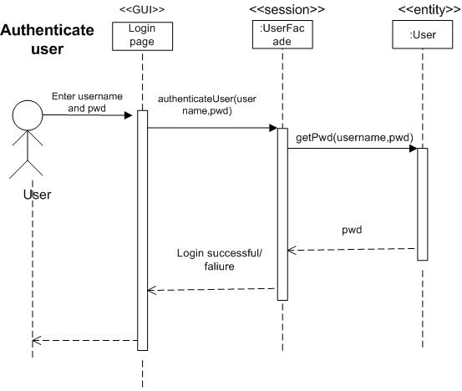

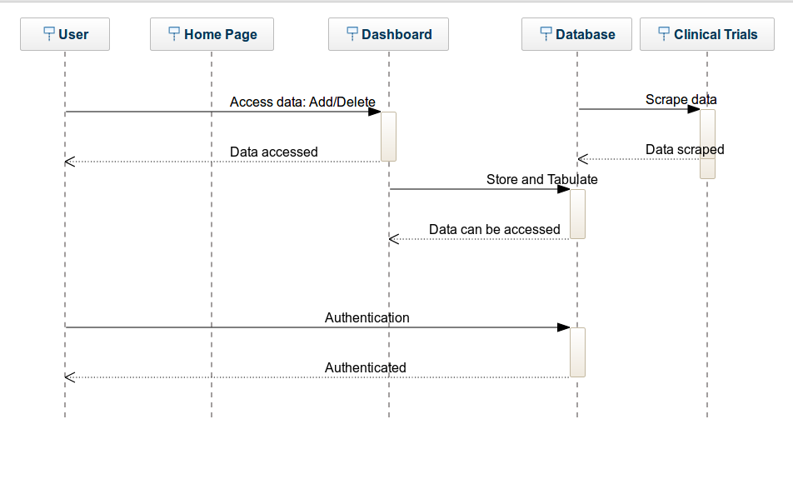

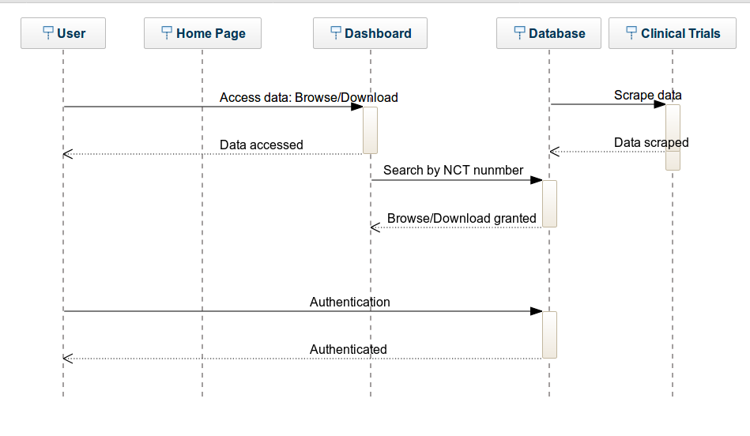

Design Rationale we

- Our first design choice for the home page was to add two buttons viz., Browse and Download. This design did not take into account the user authentication so we decided to have our home page as user registration and login functionalities.
- To query through documents we first decided to use Solr but then we found out that just for the purpose of basic search, we can use HTML parsing instead.
- For the Dashboard class we decided to have just one search box for all the methods but because of modularity and different functions taken care of separately, we decided to have a different search box for each functionality.
- To view the data in table, the search function was just taking NCT number but once the database becomes rich, we required more filters so we added more filters to our search feature.
- We decided to have different authentication for user and admin but then we realised that this application would only be used by the company employees and not to be hosted. So, we decided to just have one authentication for all the users.

