Software Requirements Specification (SRS) Document
Web Application for Text Mining and Storage of Clinical Data
SSAD48
Aamir Farhan (20161078)
Aniket Shrimal (20161136)
Lakshmi Sravya (20161084)

Brief problem statement
The objective of this web application is to develop a platform that captures information specific to clinical trials. The webapp uses text mining techniques to extract data from known sources like research papers and other databases. This data is stored in a database and can be searched through different queries.

System requirements

Clinical Trials Data, List of NCT number for search, other data sources.
HTML, CSS, Javascript, Python, SQL, Web Scraping and NLP tools, Beautiful Soup package, Bootstrap, Kazam.

Users profile
Pharmacists – Usage in identifying and tracking the best drug for a case.
Physician – Diagnosis and treatment.
Bio-Researchers – Helps in Pharmacogenetics

Feature requirements (described using use cases)

No. | User Case Name | Description | Release
1. | Login | Users and Owners can login into the web application using this. | R1
2. | Add Data | The owner can add the raw data into the database for extraction. | R1
3. | Delete Data | The owner can delete data from the database | R1
4. | Text Mining | A function will extract the required data. | R1
5. | Search | Users and Owner can search for a key in the database. | R1
6. | Browse | Users can browse/view the extracted data in the browser itself. | R2
7. | Download | Users can download the extracted data. | R2
8 | View all Users | A feature on dashboard which lets you view all users using the application | R2
9 | User Profile | Lets the user update his profile including a picture | R2
10 | View tables | Shows the added data till date in tabular form | R2

Use case diagram

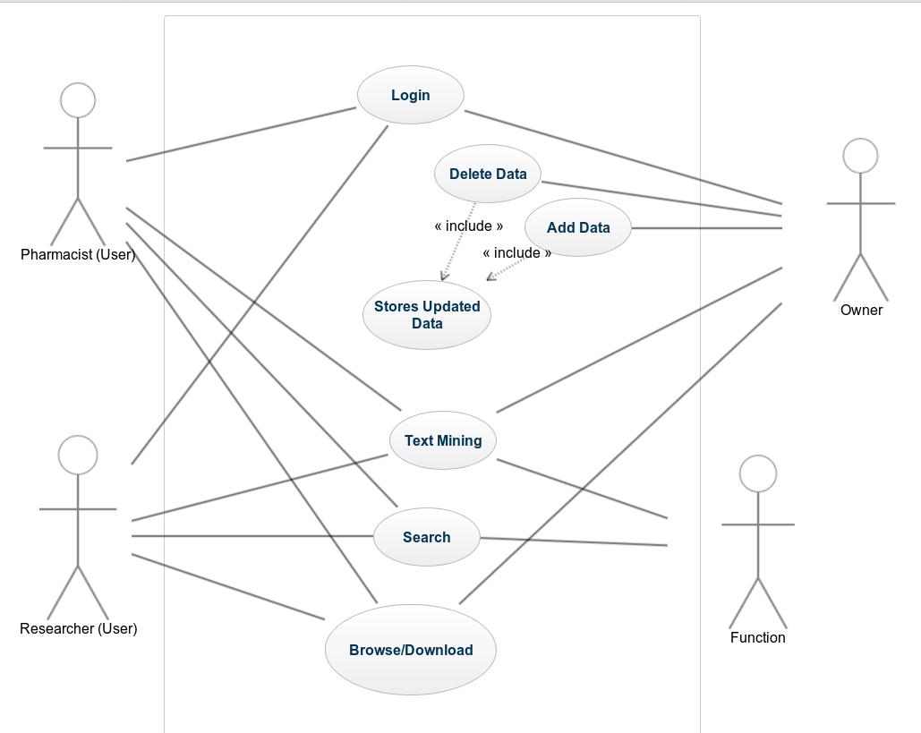

Use case description

Use Case Number: | UC-01
Use Case Name: | Login
Overview: | Users and Owners can login into the web application using this.
Actors: | User and Owner
Pre condition:
Flow: | Main (success) Flow: User enters the username, password and clicks on login button. The user is logged in to the application now.
 | Alternate Flows: If the username or password are incorrect then give a prompt.
Post Condition: | If the username and password are correct then the user is logged in.

Use Case Number: | UC-02
Use Case Name: | Add data
Overview: | The owner can add the raw data into the database for extraction.
Actors: | Owner
Pre condition: | Data is available and Owner is logged in.
Flow: | Main (success) Flow: 1. Owner selects the raw data to be added.  2. Owner uses the function to add the data.
 | Alternate Flows: If the data cannot be added then give a prompt.
Post Condition: | The database is updated with the new data.

Use Case Number: | UC-03
Use Case Name: | Delete data
Overview: | The owner can delete the data from database.
Actors: | Owner
Pre condition: | Data is available in the database and Owner is logged in.
Flow: | Main (success) Flow: 1. Owner selects the data to be deleted  2. Owner executes the function to delete data.
 | Alternate Flows: If the data cannot be deleted then give a prompt.
Post Condition: | The database is updated with the new data.

Use Case Number: | UC-04
Use Case Name: | Text Mining
Overview: | A function will extract the required data.
Actors: | Owner and User
Pre condition: | User and Owner should be logged in to the application.
Flow: | Main (success) Flow: 1. The data to be extracted is selected.  2. The data is fed to the function.
 | Alternate Flows: If the data cannot be extracted then give a prompt.
Post Condition: | The data is extracted according to the need of the users.

Use Case Number: | UC-05
Use Case Name: | Search
Overview: | Users and Owner can search for a key in the database.
Actors: | Owner and User
Pre condition: | User and Owner should be logged in to the application.
Flow: | Main (success) Flow: 1. User enters the key to be searched.  2. The function performs the search.  3. The searched data is diaplayed
 | Alternate Flows: If the required key is not found then display a message.
Post Condition: | The searched data is displayed.

Use Case Number: | UC-06
Use Case Name: | Browse
Overview: | Users can browse/view the extracted data in the browser itself.
Actors: | Owner and User
Pre condition: | User and Owner should be logged in to the application.
Flow: | Main (success) Flow: 1. User selects the browse option.  2. User searches for the desired information.  3. The searched data is displayed.
 | Alternate Flows: If the required key is not found then display a message.
Post Condition: | The searched data is displayed to the user.

Use Case Number: | UC-07
Use Case Name: | Download
Overview: | Users can download the extracted data.
Actors: | Owner and User
Pre condition: | User and Owner should be logged in to the application.
Flow: | Main (success) Flow: 1. User selects the download option.  2. User searches for the desired information.  3. The searched data can be downloaded.
 | Alternate Flows: If the required key is not found then display a message.
Post Condition: | The searched data is downloaded to the user.

