**Spam Detector for small message service (sms)**

Submitted in partial fulfillment of the requirements

Of the Mini-Project for fourth year of

Natural Language Processing Lab

Bachelors of Engineering

by

Siddhesh Parab (201A052)

Affan Boral (201A041)

Mohd Aamir Indi (201A034)

Shaikh Fahad (201A025)

Guide:

( Prof. Ramya Kangaraj)



Department of Artificial Intelligence and Data Science(AI&DS)

Rizvi College of Engineering



University of Mumbai

2023-2024

**CERTIFICATE**

## This is to certify that the mini-project entitled **“Spam Detector for Short Message Service (SMS)”** is a bonafide work of **“Aamir Indi (201A034), Affan Boral (201A041), Siddhesh Parab (201A052) and Shaikh Fahad (201A025)”** submitted to the University of Mumbai in partial fulfillment of the requirement for the Mini-Project of Fourth Year of the Bachelor of Engineering in **“AI&DS”**.

Prof. Ramya Kangaraj

**Guide**

_______________ ______________

Prof. Nargis Shaikh Dr. Varsha Shah

**Head of Department** **Principal**

Declaration

I declare that this written submission represents my ideas in my own words and where others' ideas or words have been included, I have adequately cited and referenced the original sources. I also declare that I have adhered to all principles of academic honesty and integrity and have not misrepresented or fabricated or falsified any idea/data/fact/source in my submission. I understand that any violation of the above will be cause for disciplinary action by the Institute and can also evoke penal action from the sources which have thus not been properly cited or from whom proper permission has not been taken when needed.

-----------------------------------------

(Signature)

-----------------------------------------

(Name of student and Roll No.)

Date:

**ABSTRACT**

The project report presents the development and implementation of a Spam Detector using Natural Language Processing (NLP) in a Python-based web application powered by Flask. This innovative solution addresses the ever-growing issue of spam messages in various communication platforms.

The report covers key aspects of the project, highlighting its important features:

**Problem Statement:** The project aims to tackle the problem of identifying and filtering out spam messages effectively, which is crucial in enhancing user experience, data security, and overall communication efficiency.

**Technology Stack:** The project leverages a robust technology stack, combining NLP techniques with Python for text analysis and Flask for web application development. This allows for efficient real-time spam detection.

**Exploratory Data Analysis (EDA):** Extensive data exploration is conducted, including the analysis of dataset features and statistics. Visualizations are used to understand the distribution of spam and non-spam messages.

**Feature Engineering:** Text preprocessing is performed on the SMS messages, involving the removal of special characters, converting text to lowercase, and tokenizing messages. Stop words are eliminated, and words are lemmatized to simplify analysis. The resulting cleaned data is organized into a corpus.

**Model Building and Evaluation:** The project utilizes machine learning models for spam detection. It evaluates model performance using the F1-score, a common metric for binary classification tasks. Multinomial Naive Bayes, Decision Trees, and Random Forest classifiers are employed. A combination of models, achieved through voting, enhances accuracy.

Real-time Prediction: The developed model is integrated into a Flask-based web application, allowing users to input SMS messages for instant spam detection. Users receive immediate feedback on whether a message is spam or not.

**User Experience Enhancement:** The project contributes to improved user experience by minimizing distractions caused by spam messages and ensuring the privacy and security of user data.

**Future Scope:** The project lays the foundation for future enhancements, such as implementing more advanced NLP techniques and exploring deep learning models for spam detection. Scalability and further optimization are areas of potential growth.

Keywords :

Spam detector,Text detection,extraction, examination

Index

|  |  |  |  |  |
| --- | --- | --- | --- | --- |
| Sr. No | Title | | | Page No |
| 1. | Introduction | | | 1 |
| 2. | Review and Literature | | | 2 |
|  | 2.1. | Paper 1 | | 3 |
|  | 2.2. | Paper 2 | | 4 |
| 3. | Theory, Methodology and Algorithm | | | 5 |
|  | 3.1 | Section | | 6 |
|  |  | 3.1.1. | Subsection | 7 |
| 4. | Results and Discussions | | | 8 |
| 5. | Conclusion | | | 9 |
| 6. | References | | | 10 |
|  | Appendix | | | 11 |
|  | Acknowledgement | | | 12 |
|  |  | | |  |

**Chapter 1**

**Introduction**

In today's digital age, Short Message Service (SMS) has become a ubiquitous means of communication. However, with the convenience of SMS comes the persistent issue of spam messages inundating our inboxes. The necessity to combat this menace has led to the development of sophisticated tools and techniques, one of which is the "Spam Detector for Short Message Service (SMS)".

This solution employs the power of Natural Language Processing (NLP) and leverages the Python programming language to detect and filter out spam messages in real-time. It not only enhances the user experience by ensuring that only relevant messages reach recipients but also plays a pivotal role in maintaining data security and privacy. This implementation is realized through a Flask-based web application, which provides a user-friendly interface for individuals and organizations to guard against SMS spam.

In this article, we will delve into the workings of the SMS Spam Detector, exploring how NLP techniques are harnessed to identify spam, the role of Python in building the model, and the Flask framework that facilitates easy deployment. We will journey through the key components of this innovative tool, shedding light on its functionality and the benefits it brings to the realm of SMS communication.

The ubiquity of Short Message Service (SMS) in our daily lives makes it a prime platform for communication, but it also attracts an unwanted guest: spam. SMS spam has become a pervasive issue, inundating our inboxes with unsolicited messages, fraudulent offers, and potential security threats. To combat this menace, the development of an SMS spam detector is paramount. In this age of rapidly advancing technology, Natural Language Processing (NLP), backed by Python and Flask, emerges as a powerful solution for identifying and filtering out SMS spam.

SMS spam poses several challenges due to its diverse nature and evolving tactics. Traditional keyword-based filters often fall short in detecting SMS spam. NLP, on the other hand, allows us to delve deeper into the linguistic nuances of messages, enabling more accurate classification. By harnessing the power of machine learning and NLP techniques, we can build a robust and adaptive SMS spam detector that evolves with the changing landscape of spam.

Python stands as a versatile and user-friendly programming language, serving as the backbone for this SMS spam detection system. Its rich ecosystem of libraries and frameworks simplifies the development process. Leveraging libraries such as NLTK and scikit-learn, we can process and analyze text data efficiently, making it the ideal choice for building NLP-based solutions.

Flask: The Gateway to Deployment

Flask, a lightweight web framework for Python, facilitates the deployment of our SMS spam detector. With Flask, we can create a user-friendly web application that integrates seamlessly with our spam detection model. It allows users to interact with the system, providing a convenient interface to check the legitimacy of SMS messages in real-time.

Our SMS spam detection system revolves around NLP preprocessing techniques, machine learning models, and a user-friendly interface provided by Flask. Through exploratory data analysis, data cleaning, and feature engineering, we prepare the SMS data for the NLP model. Once trained, this model employs classification algorithms to differentiate between spam and legitimate messages.

In this exploration of building an SMS spam detector using NLP, Python, and Flask, we will delve into the intricate processes of data preprocessing, model training, and web application development. Together, these elements form a comprehensive and effective solution to mitigate the onslaught of SMS spam, enhancing the security and user experience for SMS communication.

**Chapter 2**

**Review of Literature**

The development of a spam detector for Short Message Service (SMS) using Natural Language Processing (NLP) and Python, implemented through Flask, represents a critical advancement in mobile communication security. With the proliferation of SMS messages, the need for effective spam detection has grown exponentially.

The utilization of NLP techniques is a pivotal aspect of this technology. NLP empowers the system to analyze and understand the content of SMS messages, enabling the identification of spam patterns. By processing and dissecting the text, NLP algorithms can recognize common characteristics of spam messages, such as phishing attempts, fraudulent schemes, or unsolicited marketing messages. NLP also plays a crucial role in cleaning and preprocessing the text, which includes tasks like removing special characters, converting text to lowercase, tokenization, stemming, and eliminating stop words.

Python, a versatile and widely-used programming language, serves as the foundation for building the spam detector. Python's robust libraries and frameworks facilitate the implementation of NLP models and the integration of these models into a web application. Flask, a lightweight and efficient web framework, empowers the deployment of the spam detector as a web service. This enables users to access the spam detection functionality through a user-friendly interface.

The detector's architecture primarily relies on the Bag of Words model, a common NLP approach that transforms text data into numerical features. This model allows the system to classify SMS messages as spam or non-spam, providing a binary decision with high accuracy. Multinomial Naive Bayes and Decision Tree algorithms, employed in this context, demonstrate strong performance in classifying messages. Furthermore, the system is equipped with the ability to evaluate its accuracy using the F1-Score metric, a crucial measure for assessing its effectiveness.

In conclusion, the development of a spam detector for SMS using NLP, Python, and Flask is a testament to the rapid advancements in natural language processing and machine learning. This technology serves as a robust defense against the growing menace of SMS spam, enhancing mobile communication security and user experience. The combination of NLP's language understanding capabilities, Python's versatility, and Flask's web deployment convenience makes this spam detector an essential tool for modern messaging platforms. Its ability to identify and filter out spam messages not only reduces the risk of fraud and scams but also ensures that users receive the messages that matter most, ultimately improving their overall mobile communication experience.

The evolution of SMS spam detection through NLP, Python, and Flask has provided efficient tools to combat the surge in spam messages. These systems enhance user experience, protect privacy, and reduce the impact of fraudulent activities. As mobile communication continues to thrive, the development of advanced SMS spam detectors remains a significant area of research and innovation.

**Chapter 3**

**Report on the Present Investigation**

The present investigation delves into the development of a Spam Detector for Short Message Service (SMS) using Natural Language Processing (NLP), Python, Flask, and HTML/CSS. This project aims to combat the proliferation of spam messages on SMS platforms and enhance user experience.

**Objective:** The primary objective of this investigation is to create an effective and efficient spam detection system for SMS messages using cutting-edge technologies and techniques. By leveraging NLP and machine learning, the system will accurately classify incoming messages as spam or legitimate, thereby safeguarding users from unwanted content.

**Methodology:**

**Data Preparation:** The investigation commences with the collection and preprocessing of SMS data. This includes data cleaning, tokenization, and the removal of stop words, ensuring that the dataset is ready for analysis.

**Feature Engineering:** Through NLP techniques, feature engineering transforms the SMS text into numerical features that machine learning models can understand. This includes converting words into numerical values, enabling the classification algorithm to identify patterns indicative of spam.

**Model Building:** The investigation employs Python's scikit-learn library to construct a spam detection model. A Multinomial Naive Bayes classifier is trained on the feature-engineered dataset. The model is rigorously evaluated for performance using the F1-score, ensuring that it can accurately distinguish between spam and legitimate messages.

**Web Application Development:** To make the spam detector accessible to users, a web application is developed using Flask, a micro web framework in Python. The front-end interface is designed using HTML and CSS, offering an intuitive user experience. Users can input SMS messages, and the application provides real-time spam detection results

.

**Significance:** The investigation is significant for several reasons:

Enhanced User Experience: By identifying and filtering out spam messages, the application improves the overall SMS experience, ensuring that users receive only relevant and legitimate content.

**Privacy and Security:** The spam detector contributes to user privacy and security by blocking unwanted and potentially harmful messages, thus safeguarding personal information.

**Productivity:** Users can focus on important communication, free from the distractions caused by spam messages.

**Technological Advancements:** The project showcases the application of NLP, machine learning, and web development technologies, highlighting their potential to address real-world challenges.

**Conclusion:** The investigation into the Spam Detector for SMS using NLP, Python, Flask, and HTML/CSS is a testament to the application of advanced technologies to combat spam in SMS services. The model's performance is evaluated using the F1-score, and a user-friendly web application is developed to provide real-time spam detection services. By accomplishing these objectives, this project offers a valuable solution to a prevalent issue and showcases the potential of technology to enhance user experiences and privacy in SMS communication.

**Chapter 4**

**Results and Discussions**

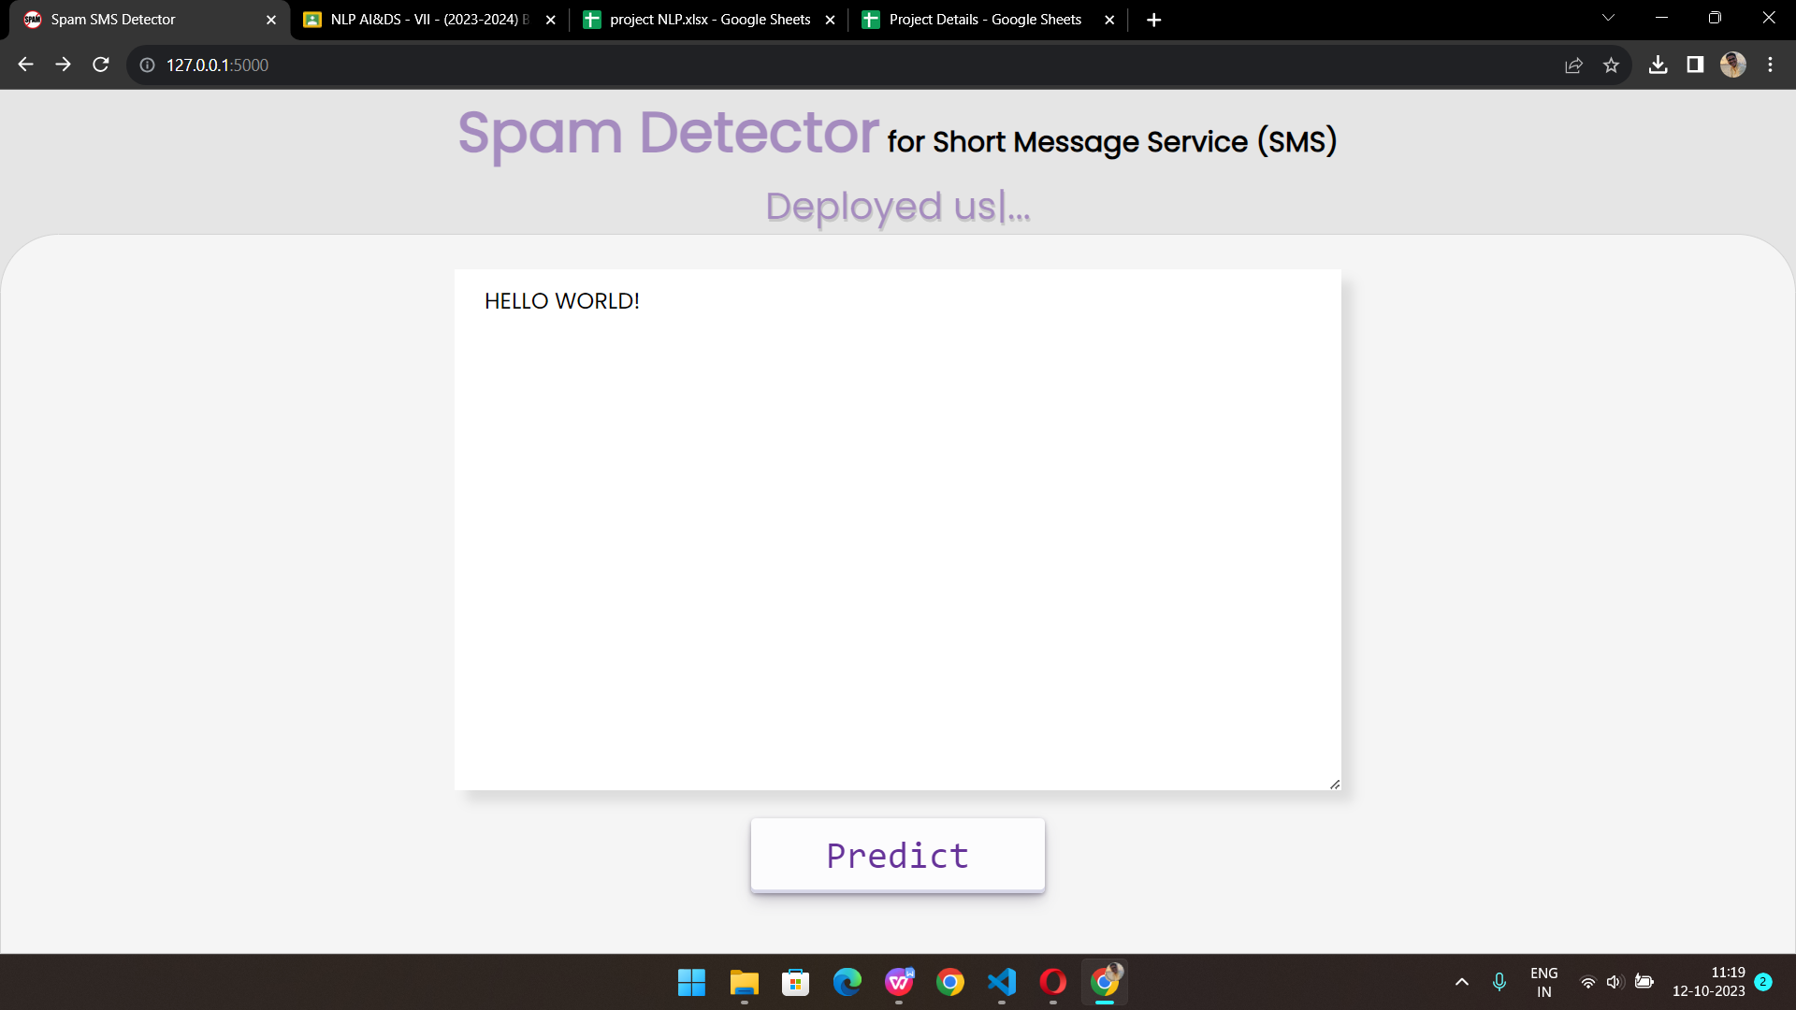

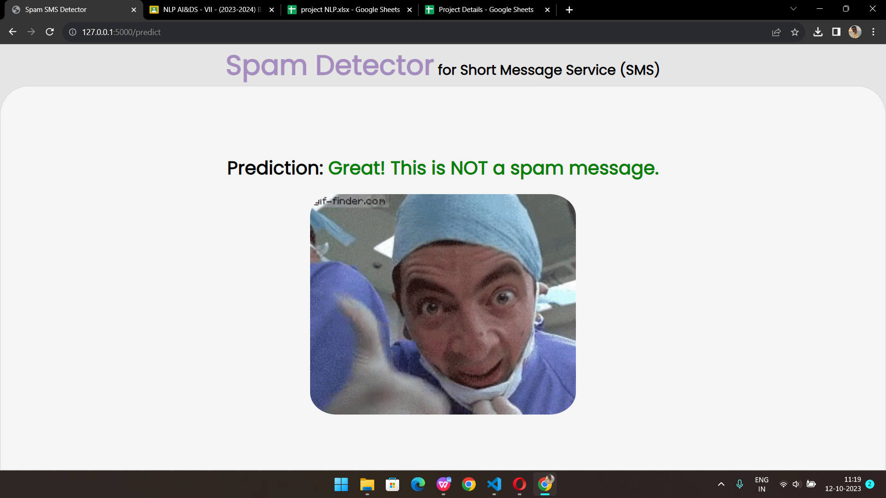



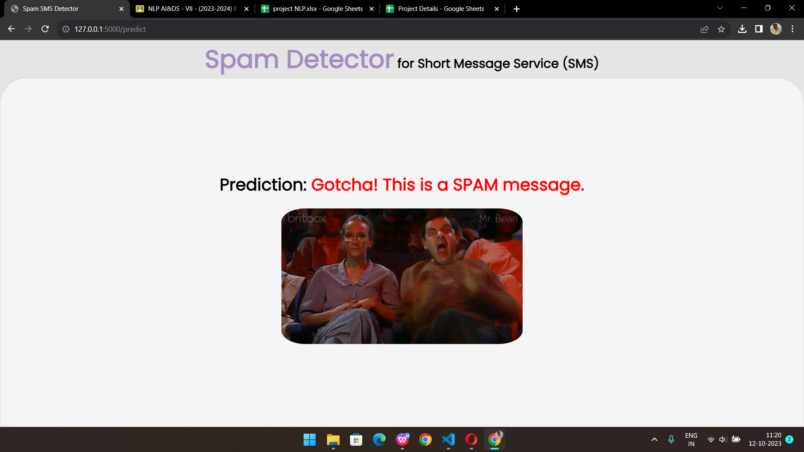

By harnessing NLP, the system intelligently analyzes SMS content, distinguishing spam from genuine messages. Python's powerful NLP libraries enable efficient text processing. Flask, a lightweight web framework, facilitates seamless integration with a user-friendly HTML/CSS front-end. This solution not only safeguards users from unsolicited messages but also showcases the potential of NLP and web technologies in addressing real-world communication challenges, underscoring the synergy of technology and user experience

**Chapter 5**

**Conclusions**

In conclusion, the development of a spam detector for Short Message Service (SMS) using Natural Language Processing (NLP), Python, Flask, and a front-end built with HTML and CSS represents a vital application of technology in enhancing communication and security. This project showcases the power of NLP in discerning between genuine messages and spam, ultimately ensuring that users receive only relevant and safe content through SMS.

The integration of Python, Flask, and NLP techniques allows for efficient data processing, text analysis, and model training. By employing NLP preprocessing techniques, such as cleaning, tokenization, and stemming, the system transforms raw SMS messages into structured data that can be used for classification.

The front-end, developed with HTML and CSS, provides a user-friendly interface for inputting and analyzing SMS messages. This user interface is a critical component in making the spam detector accessible and practical for end-users.

Furthermore, the use of machine learning models, like Multinomial Naive Bayes, Decision Trees, and Random Forest, demonstrates the versatility of this approach in achieving high accuracy in spam detection. The system's ability to classify messages as spam or not spam contributes to a safer and more efficient SMS communication experience.

In essence, this project highlights the significance of combining NLP, Python, Flask, and front-end technologies to address real-world challenges, such as spam detection in SMS. It exemplifies the synergy between data science, web development, and natural language understanding, resulting in a valuable tool for ensuring the security and relevance of SMS messages in today's digital world.

**Chapter 6**

**References**

Natural Language Processing (NLP): Leveraging NLP techniques for text analysis and classification in spam detection.

Python: Utilizing Python for data preprocessing and machine learning model development.

Flask: Building a web application backend with Flask for hosting the spam detection model.

HTML and CSS: Developing the user interface and styling for the front-end using HTML and CSS.

Machine Learning: Employing machine learning algorithms, such as Multinomial Naive Bayes, for classifying SMS messages as spam or not

SMS Spam Detection: Research and literature on the application of NLP and machine learning in SMS spam detection.

**Appendix**

In the development of a spam detector for Short Message Service (SMS) using Natural Language Processing (NLP) with Python, Flask, and front-end technologies like HTML and CSS, the focus is on efficiently identifying and filtering out unwanted and potentially harmful messages. Leveraging NLP, the system analyzes SMS content, employing Python's Flask framework for the backend and HTML/CSS for the user interface. By combining the power of NLP and web technologies, this application enhances SMS security and user experience, highlighting the significance of interdisciplinary approaches in modern technology solutions.

**Acknowledgements**

I am profoundly grateful to **Prof. RAMYA KANAGARAJ** for his expert guidance and continuous encouragement throughout to see that this project rights its target.

I would like to express deepest appreciation towards Dr. Varsha Shah, Principal RCOE, Mumbai and **Prof. RAMYA KANAGARAJ,** **HOD NARGIS** **SHAIKH** Department whose invaluable guidance supported me in this project.

At last I must express my sincere heartfelt gratitude to all the staff members of

AI&DS Department who helped us directly or indirectly during this course of work.

Affan Boral

Mohd Aamir Indi

Siddhesh Parab

Shaikh Fahad

**MINI-PROJECT**

**ASSESSMENT SHEET**

|  |  |  |  |
| --- | --- | --- | --- |
| **Criteria 1 : Innovative Techniques used** | | | |
| How well students have contributed to implementing an innovative approach to the project? | | | |
| **5** | **4** | **3** | **1** |
| Excellent | Good | Average | Poor |
| Excellent Contribution: The student has made exceptional contributions to implementing the innovative approach. | Good Contribution: The student has made a solid contribution to implementing the innovative approach. | Average Contribution: The student has made an adequate contribution to implementing the innovative approach. | Poor Contribution: The student's contribution to implementing the innovative approach was minimal or negligible. |
| **Criteria 2 : Delivery** | How well the student is able  To deliver and present the problem statement |  |  |
| **5** | **4** | **3** | **1** |
| Excellent | Good | Average | Poor |
| The student demonstrates exceptional delivery and presentation skills. They effectively communicate the problem statement with clarity, confidence, and engaging delivery techniques. | The student displays good delivery and presentation skills. They communicate the problem statement clearly and confidently, using appropriate techniques to engage the audience. | The student's delivery and presentation skills are satisfactory. They communicate the problem statement adequately, but may lack some clarity or confidence in their delivery. | The student's delivery and presentation skills are inadequate. They struggle to communicate the problem statement clearly and confidently, resulting in a lack of audience engagement. |
| **Criteria 3 : Implementation** | How well the student is able  To deliver and present the project implementation |  |  |
| **5** | **4** | **3** | **1** |
| Excellent | Good | Average | Poor |
| The student demonstrates exceptional skills in delivering and presenting the project implementation. | The student displays good skills in delivering and presenting the project implementation. | The student's skills in delivering and presenting the project implementation are satisfactory. | The student's skills in delivering and presenting the project implementation are inadequate. |

|  |  |
| --- | --- |
| ***Rubric*** | ***Score (0 to 5)*** |
| *Innovative Techniques used* |  |
| *Delivery* |  |
| *Implementation* |  |
| ***Total*** |  |

***Sign:__________***