MID TERM SYLLABUS CURRICULUM
Class 1
Subject : Computer
Unit 1: Introduction to Computer
Unit 2: Why Do We Prefer Computer
Unit 3: Helpful Computer
Unit 4: Parts of the Computer
Week 1
Unit 1: Introduction to Computer
Topic:- Reading and Explanation
Objectives:- Enable kids to understand and learn about the basic function and uses of computer.
Starter Activity:- Teacher will start the lesson by explaining about different parts of computer and its uses.
Brain storming:-Students will be asked about computer by cross questioning.
Methodology:-Teacher will explain about different machines and their importance in our life. All the difficult words will be explained.
Wrap up:
- Student will be able to recognize different uses of computer.

Resources:- flash cards, worksheet and book

Class-work:-
Day/Date | Topics | Homework
Day 1:
Day 2:
Day 3: | Cutting and pasting + reading of Page # 5 | Reading of Page#5
Day 4:
Day 5: | Reading and explanation of page # 6 and 7.  Do activity on Page# 5 on Book.

Evaluation:
Teacher will evaluate the students by asking different questions about Computer and its functions.

Week 2
Unit 1: Introduction to Computer
Topic: - Book Exercise + Title Page
Objectives: - Enable students to describe computer as a machine as its importance in our daily life.
Starter Activity: - Teacher will start the lesson with brain storming session.
Methodology: - The Teacher will analyze the students by making mind map. All the difficult words will be explained.
Wrap up:
- Student will be able to recognize computer and its functions.
- Identify the new terminology related to computer
Class-work: -
Day/Date | Topics | Homework
Day 1:
Day 2:
Day 3: | Book page #9 Ex A,B,C will be done on book. | Do page #8 on book.
Day 4:
Day 5: | Title page will be done on notebook.

Week 3
Unit 1: Introduction to Computer
Topic: - Vocabulary Words + Questions / Answers
Objectives: - Enable students to describe computer as a machine as its importance in our daily life.
Starter Activity: - Teacher will start the lesson with brain storming session.
Methodology: - The Teacher will analyze the students by making mind map. All the difficult words will be explained.
Wrap up:
- Student will be able to recognize computer and its functions.
- Identify the new terminology related to computer.
Class-work: -
Day/Date | Topics | Homework
Day 1:
Day 2:
Day 3: | V/W will be done on notebook | Learn Page no 9 Part (B, C) from book
Day 4:
Day 5: | Q1 & 2 will be done on notebook + worksheet
Vocabulary words
internet
email
accurate
storage
command

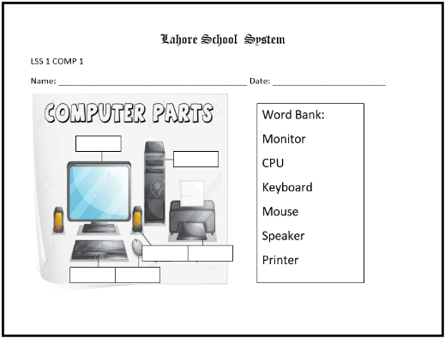
Questions /Answers
Q.1 What is a computer?
Ans. Computer is an electronic machine.
Q.2 What does computer follow?
Ans. Computer follows our command.

Week 4
Unit 2: Why do we prefer computer?
Topic: - Reading and Explanation
Objectives: - To enable kids to understand the main features of computers, which are the reason, why these machines are so dependable.
Starter Activity: - Teacher will start the lesson by explaining about features of computer.
Brain storming: -Students will be asked about Why do we prefer Computer by cross questioning.
Methodology: - Prior knowledge will be elicited to establish why we prefer to work with help of computers while doing certain tasks.

Wrap up:
- Student will be able to recognize distinct features of computer.
- Identify the importance of adopting a computer life style.

Resources: -flash cards and book

Class-work: -
Day/Date | Topics | Homework
Day 1:
Day 2:
Day 3: | Reading and explanation of Page 10 , 11 | Question/Answer of Unit #1 for test on Friday
Day 4:
Day 5: | Test + Reading and explanation of Page# 10,11

Week 5
Unit 2: Why we do prefer computer?
Topic: - Vocabulary words + Book Exercises
Objectives: - Students will be able to answer different questions related to the Unit.
Starter Activity: - Teacher will start the lesson by explaining about features of computer.
Brain storming: - Students will be asked about Why do we prefer Computer by asking questions
Methodology: - Prior knowledge will be elicited to establish why we prefer to work with help of computers while doing certain tasks.
Wrap up:
- Student will be able to recognize distinct features of computer.
- Identify the importance of adopting a computer life style.

Resources: -flash cards and book

Class-work: -
Day/Date | Topics | Homework
Day 1:
Day 2:
Day 3: | Book Page# 12 Ex: B, C,D will be done on book. | Book exercise of Unit#1 for test on Friday
Day 4:
Day 5: | Test +Vocabulary words and title page will be done

Vocabulary Words
- fast
- store
- cheap
- data
- connect
Week 6
Unit 2: Why we do prefer computer?
Topic: - Question / Answers
Objectives: - Students will be able to answer different questions related to the Unit.
Starter Activity: - Teacher will start the lesson by explaining about features of computer.
Brain storming: - Students will be asked about Why do we prefer Computer by asking questions
Methodology: - Prior knowledge will be elicited to establish why we prefer to work with help of computers while doing certain tasks.
Wrap up:
- Student will be able to recognize distinct features of computer.
- Identify the importance of adopting a computer life style.
Resources: -flash cards and book

Class-work: -
Day/Date | Topics | Homework
Day 1:
Day 2:
Day 3: | Questions / Answers will be done on notebook | Question/Answers of Unit#2 for test on Friday
Day 4:
Day 5: | Test will be conducted+worksheet

Questions / Answers
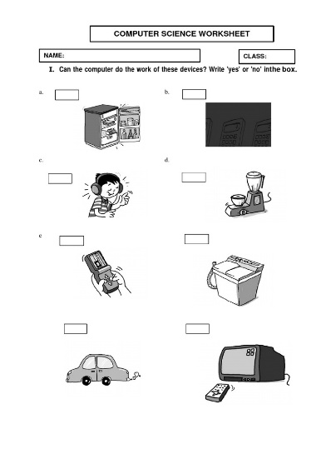
Q.1 Why do we prefer computer?
Ans: We prefer computer because it is:
- fast
- never tires
- accurate
- can store data
- can connect us to other people
Q.2 How can you say that computer is fast?
Ans: Computer works fast and can do a number of task at the same time.
Week 7
Unit 3: Helpful computer
Objectives: To make them understand the qualities of computer and in what manner the computer can help them.Kids will be asked to point out at least 3 places around them where computer is being used eg. School, home, market, post office, mall, hospital etc
Brain Storming:
The lesson will begin with a brain storming session. Children will be asked that how they use computer and for what purpose they use it for.
Wrap up:
- Student will be able to recognize different uses of computer.

Resources:- flash cards, worksheet and book
Class-work:-
Day/Date | Topics | Homework
Day 1:
Day 2:
Day 3: | Reading+ Explanation + Book Exercise Pg.# 15 , 16 B+C+D | Book Exercise of Unit#3 of test  On Friday
Day 4:
Day 5: | V/W and Title page of Unit #3

Vocabulary Words:
video calls
slide shows
ATM machines
accounts
check in
Week 8
Unit 3: Helpful computer
Objectives: To make them understand the qualities of computer and in what manner the computer can help them. Kids will be asked to point out at least 3 places around them where computer is being used e.g. School, home, market, post office, mall, hospital etc
Brain Storming: The lesson will begin with a brain storming session. Children will be asked that how they use computer and for what purpose they use it for.
Wrap up:
- Student will be able to recognize different uses of computer.

Resources:- flash cards, worksheet and book
Day/Date | Topics | Homework
Day 1:
Day 2:
Day 3: | Question Answers on notebook | Test Q/A unit 3 for test on Friday
Day 4:
Day 5: | Test will be conducted + Worksheet
Question/Answer:
1. Write four places where computers are used?
-Shops
-Libraries
-Offices
-Banks
Unit 4: Parts of The Computer
Topic:- Reading and Explanation
Objectives:- Enable kids to understand and learn about the basic parts of computer.
Starter Activity:- Teacher will start the lesson by explaining about different parts of computer and its uses.
Brain storming:-Students will be asked about computer by cross questioning.
Methodology:-Teacher will explain about different parts of computer and their importance in our life. All the difficult words will be explained.
Wrap up:
- Student will be able to recognize different uses of computer.

Resources:- flash cards, worksheet and book

Class-work:-
Day/Date | Topics | Homework
Day 1:
Day 2:
Day 3: | Reading+ Explanation + Book Exercise Pg#19,20 B+C+D+F | Read Unit 4 Parts of Computer
Day 4:
Day 5: | V/W and Title page

Vocabulary Words
- monitor
- keyboard
- system unit
- mouse
- instructions
Question Answers
Q1: What does a monitor show?
Ans: A monitor shows images, videos, numbers and alphabets.
Q2:What does a keyboard look like?
Ans: A keyboard looks like a typewriter.
Q3: What are the buttons on a keyboard called?
Ans: The buttons on a keyboard are called keys.
Q4: What is the short form of Central Processing Unit?
Ans: CPU is the short form of Central Processing Unit.
Week 10
Unit 4: Parts of Computer
Topic: - Question Answers
Objectives: - Enable students to describe computer as a machine as its importance in our daily life.
Starter Activity: - Teacher will start the lesson with brain storming session.
Methodology: - The Teacher will analyze the students by making mind map. All the difficult words will be explained.
Wrap up:
- Student will be able to recognize computer and its functions.
- Identify the new terminology related to computer
Class-work: -
Day/Date | Topics | Homework
Day 1:
Day 2:
Day 3: | Question Answers on notebook | Test Q/A unit 4
Day 4: |  | On Fri.
Day 5: | Test will be conducted + Worksheet

========================================================================================================================================

FINAL TERM SYLLABUS CURRICULUM
Class 1
Subject : Computer

Unit 5: Monitor
Unit 6: Keyboard
Unit 7: Mouse
Unit 8: System unit
Unit 9: Taking care of computer

Week 1
Unit : Monitor
Topic: - Reading + Book Exercise
Objectives: - Students will be able to explain monitor .They can distinguish types of computer. They will be able to operate monitor as well.
Starter Activity: - Uses of computers in different environments will be discussed with help of examples
Brain storming: - The lesson will begin with a brain storming session. Monitor or picture of monitor will be shown in class.
Elicitation: Teacher will explain difference between monitor and TV. Teacher will elaborate types and uses of monitor.
Methodology: - Prior knowledge will be elicited to establish why we prefer to work with help of computers while doing certain tasks.
Wrap up:
- Student will be able identify each part and point out its function.
- Identify the importance of adopting a computer life style.
AFL:
Teacher will call upon students to identify monitor and they will be asked about functions of monitor.

Resources: -flash cards and book
Class-work: -
Day/Date | Topics | Homework
Day 1:
Day 2:
Day 3: | Reading Unit # 5 Monitor Pg# 21,22 + Book Exercise Pg# 22,23 | Reading of unit #5
Day 4:
Day 5: | Title Page + Vocabulary Words

Vocabulary Words:
monitor
display
devices
monochrome
connect

Week 2
Unit : Monitor
Topic: - Reading + Book Exercise
Objectives: - Students will be able to explain monitor. They can distinguish types of computer. They will be able to operate monitor as well.
Starter Activity: - Uses of computers in different environments will be discussed with help of examples
Brain storming: - The lesson will begin with a brain storming session. Monitor or picture of monitor will be shown in class.
Elicitation: Teacher will explain difference between monitor and TV. Teacher will elaborate types and uses of monitor.
Methodology: - Prior knowledge will be elicited to establish why we prefer to work with help of computers while doing certain tasks.
Wrap up:
- Student will be able identify each part and point out its function.
- Identify the importance of adopting a computer life style.
AFL:
Teacher will call upon students to identify monitor and they will be asked about functions of monitor.

Resources: -flash cards and book

Class-work: -
Day/Date | Topics | Homework
Day 1:
Day 2:
Day 3: | Question/Answers on N.B | Book exercise for test on Friday
Day 4:
Day 5: | Test will be taken

Question/Answers:
Q1: What is a monitor?
Ans: A monitor is a screen that shows us pictures, videos, and words from a computer.
Q2: How many types of monitors are there?
Ans: There are two types of monitors CRT, LCD monitors.
Q3: What are some other devices that use LCD?
Ans: Tablets, smartphones, cameras and digital clocks.

Worksheet:
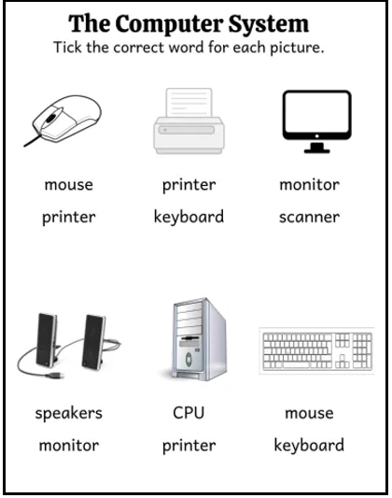

Week 3
Unit : Keyboard
Topic: - Reading + Book Exercise
Objectives: - To enable kids to understand the main features and functions of keys on keyboard.
Starter Activity: - Kids will be asked to brainstorm. Teacher will draw picture of keyboard on whiteboard and explain main keys on keyboard.
Brain storming: - Teacher will explain that a pen or pencil is used to write on page but we need keyboard to write on computer.
Keyboard keys are different from the keys used to open lock .We can type by pressing keys on keyboard. There are 101 on keyboard.
Methodology: - Teacher will ask students about the main keys and their functions.
Wrap up:
- Student will be able identify each part and point out its function.
- Identify the importance of adopting a computer life style.
Resources: -flash cards and book
Class-work: -
Day/Date | Topics | Homework
Day 1:
Day 2:
Day 3: | Reading + Explanation of Unit Keyboard | Test Q/A of Unit Monitor
Day 4:
Day 5: | Test will be conducted + Book Exercise will be done

Week 4
Unit 4: Keyboard
Topic: - Reading + Book Exercise
Objectives: - To enable kids to understand the main features and functions of keys on keyboard.
Starter Activity: - Kids will be asked to brainstorm. Teacher will draw picture of keyboard on whiteboard and explain main keys on keyboard.
Brain storming: - Teacher will explain that a pen or pencil is used to write on page but we need keyboard to write on computer.
Keyboard keys are different from the keys used to open lock .We can type by pressing keys on keyboard. There are 101 on keyboard.
Methodology: - Teacher will ask students about the main keys and their functions.
Wrap up:
- Student will be able identify each part and point out its function.
- Identify the importance of adopting a computer life style.
Resources: -flash cards and book
Class-work: -
Day/Date | Topics | Homework
Day 1:
Day 2:
Day 3: | Title Page + V/W | Test
Day 4:
Day 5: | Question/Answers will be done on N.B+Worksheet
Vocabulary words:
alphabet keys
number keys
enter keys
backspace key
delete
Question/Answers:
Q1: What is a keyboard?
Ans: Keyboard is a device used to type on computer.
Q2: How many types of keys are on keyboard?
ANS: There are 101 keys on keyboard.
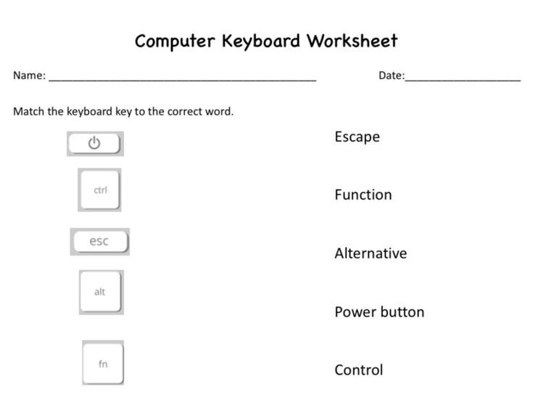

Week 5
Unit : Mouse
Objectives: -. Enable students identify mouse as an input device. They will be able to differentiate between left and right buttons.
Starter Activity: - Enable them to identify each part and point out its function.
Brain storming: - The lesson will be started with brain storming .They will be asked about purpose and uses of mouse orally.
Methodology: - Teacher will explain that computer mouse is different from ho use mouse .Computer mouse has two or more
Buttons ,cursor and mouse pad.
Wrap up:
- Student will be able identify each part and point out its function.
- Identify the importance of adopting a computer life style.
Resources: -flash cards and book
Class-work: -
Day/Date | Topics | Homework
Day 1:
Day 2:
Day 3: | Reading + Explanation of Unit Mouse | Test Q/A of Unit Keyboard
Day 4:
Day 5: | Test will be conducted + Book Exercise will be done
Week 6
Unit : Mouse
Objectives: -. Enable students identify mouse as an input device. They will be able to differentiate between left and right buttons.
Starter Activity: - Enable them to identify each part and point out its function.
Brain storming: - The lesson will be started with brain storming .They will be asked about purpose and uses of mouse orally.
Methodology: - Teacher will explain that computer mouse is different from ho use mouse .Computer mouse has two or more
Buttons ,cursor and mouse pad.
Wrap up:
- Student will be able identify each part and point out its function.
- Identify the importance of adopting a computer life style.
Resources: -flash cards and book
Classwork:
Day/Date | Topics | Homework
Day 1:
Day 2:
Day 3: | Title Page + V/W | Reading of unit mouse
Day 4:
Day 5: | Question/Answers will be done on N.B+Worksheet

Vocabulary Words:
mouse
optical
input
scroll
wireless
Questions/Answers:
Q1: What is a mouse?
ANS: Mouse is an input device.
Q2: How many types mouses are there?
ANS: There are three types of mouses are there.
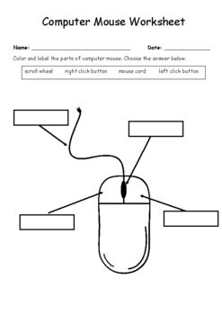

Week 7
Unit: System Unit
Objectives:
To familiarize the children with basic parts of CPU. Enable them to identify different types of computer casing.
Brain Storming:
The lesson will begin with a brain storming session. Children will be asked about major parts
Inside the system unit.
Elicitation:
Teacher will explain that CPU is the brain of Computer ,types of casing and different parts inside system unit.
AFL:System unit will be shown and teacher will ask about parts and function of CPU.
Day/Date | Topics | Homework
Day 1:
Day 2:
Day 3: | Reading + Explanation of Unit System Unit | Reading of Unit System unit
Day 4:
Day 5: | Book Exercise will be done

Week 8
Unit: System Unit
Objectives:
To familiarize the children with basic parts of CPU. Enable them to identify different types of computer casing.
Brain Storming:
The lesson will begin with a brain storming session. Children will be asked about major parts
Inside the system unit.
Elicitation:
Teacher will explain that CPU is the brain of Computer ,types of casing and different parts inside system unit.
AFL:System unit will be shown and teacher will ask about parts and function of CPU.
Day/Date | Topics | Homework
Day 1:
Day 2:
Day 3: | Title Page + Vocabulary Words | Test of Mouse
Day 4:
Day 5: | Test + Question/Answers will be done on N.B+ Worksheet
Classwork:
square, tower, desktop, processor, casing
Questions/Answers:
Q1: What is system unit?
ANS: System unit is the brain of computer. A computer cannot work without CPU.
Q 2: Which is the basic part of computer?
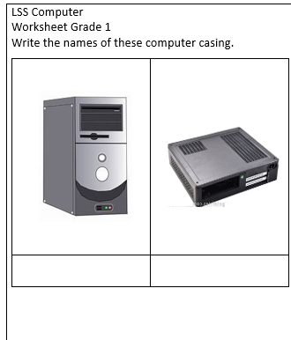
ANS: CPU is the basic part of computer
Worksheet:

Week 9
Unit: 9 Taking Care Of Computer
Objective:
Enable students how to take care of computer and how to keep it up to date.
Introduction:
Computer will be shown to the children and each part will be pointed out. Children will be asked how to clean computer.
Explanation, demo and elicitation:
Children will be shown how each part can be cleaned and they can ask for help from their elders.
AFL:
Teacher will ask ways to clean computer one by one from students.
Classwork:
Day/Date | Topics | Homework
Day 1:
Day 2:
Day 3: | Reading + Explanation of Unit Taking care of Computer | Reading of Unit Taking care of Computer
Day 4:
Day 5: | Book Exercise will be done

Week 10
Unit: 9 Taking Care Of Computer
Objective:
Enable students how to take care of computer and how to keep it up to date.
Introduction:
Computer will be shown to the children and each part will be pointed out. Children will be asked how to clean computer.
Explanation, demo and elicitation:
Children will be shown how each part can be cleaned and they can ask for help from their elders.
AFL:
Teacher will ask ways to clean computer one by one from students.
Day/Date | Topics | Homework
Day 1:
Day 2:
Day 3: | Title Page + V/W | Test of System Unit
Day 4:
Day 5: | Test + Question/Answers will be done on N.B
Classwork:
Vocabulary Words:
clean, handle, errors, elders, crowd

Questions/Answers:
Q1: How should we handle a computer?
ANS: We should handle the computer carefully.
Q 2: Who can help us while using a computer?
ANS: Our elders or teachers can help us.
Q 3: Who should we call if there is a problem with the computer?
ANS: We should call an expert.
MCQs
- What should we keep clean?
- Playground
- Work area
- Road

- How should we use the computer?
- Carelessly
- Carefully
- Roughly

- Who should we call if the computer has a problem?
- Friend
- Expert/ Teacher
- Driver
- Should we crowd near the computer?
- Yes
- No
- Sometimes

- Who can help us while using a computer?
- Elders
- Strangers
- Nobody
2. Fill in the Blanks
1. Keep your work area _____________. (clean)
2. Never handle the computer _________________.(carelessly)
3. Call an _______________ if there is a problem.(expert)
4.Do not ____________near the computer.(crowd)
5. Ask your __________ for help while using a computer. (elders)
3. Write Yes and No
1. We should keep the computer place clean.
2. We should hit the computer if it does not work.
3. We should ask elders for help.
4. We should crowd around the computer.
5. We should handle the computer carefully.

Worksheet:
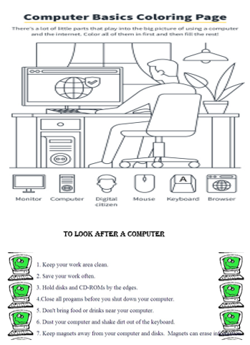

Day/Date | Topics | Homework
Day 1:
Day 2:
Day 3: | Objectives (according the class lesson will be done on N.B+Worksheet) | Test of Taking care of Computer
Day 4:
Day 5: | Test + Revisions

