CURRICULUM
MID TERM SYLLABUS
Computer
Grade 2
Unit :1
Taking care of computer
Unit : 2
Size and uses of computer
Unit : 3
Helpful computer

Week 1
Unit: 1
Topic: - Taking Care of Computer
Students learning Outcomes:
Enable them to understand the ways to take care of your computer. To tell the harmful effects of excessive use of computer.
Starter Activity: - Explain the students how to protect computer from mishandling. Enable kids to understand the use of a computer.

Brain storming: - Lesson will begin with a brain storming session. Students will be asked why they think we use computer.
Methodology: - Students will know the ways to take care of computer, harmful effects of excessive use of computer and how to protect your computer.
Wrap up:
Student will understand that how to use computer and why we use computer in our daily life.

Resources: - book, white board, flash cards.
Class-work: -
Day/Date | Topics | Home work
Day 1: | Reading and explanation of page ;4,5,6,7
Day 2: | Prepare title page.  Vocabulary words on n.book. | -----------------
Day 3: | Pg. no.7 book exercise on book. | Read unit 1 and underline difficult words.
Day 4: | Pg no.8,9 on book.
Day 5: | Pg # 10 on book.
Title Page
Contents:
Reading + explanation
Vocabulary words
Question/Answer
Book exercise
Topic: Vocabulary words
expert, problem, sunlight, virus, infant, unhealthy, screen, monitor, permission
Week 2
Unit: 1
Topic: - Taking Care of Computer
Students learning Outcomes: Enable them to understand that how to use computer.
Starter Activity: - Explain how to take care of computer.
Brain storming: -Students will be asked about the parts of computer.
Methodology: - Showing them different parts of computer so they will know about the computer.
Wrap up:
Student will be able to identify different parts of computer and how to care them.

Resources: - book, white board. Computer parts
Class-work: -
Day/Date | Topics | Home work
Day 1: | Q/A(1,2) on n.book
Day 2: | Q/A(3,4)on n.book | -----------------
Day 3: | Pg. no. 11-part C on book. | Draw a computer on n.book.
Day 4: | Pg no.11 part D on book.
Day 5: | Fill in the blanks on n.book + Worksheet

TOPIC :Question/Answers
Q 1: Why should we take care of our computer?
Ans: We should take care of our computer because it will serve us better and for longer period of time.
Q 2 : Should we keep drink and food items near our computer ?
Ans ; No ,we should not keep our drinks and food items near our computer.
Q 3 : Should we call an expert to fix the problems of computer ?
Ans : Yes ,we should call an expert to fix the problems of computer.
Q 4 ; Should we keep our computer away from sunlight ?
Ans : Yes , we should keep our computer away from sunlight.
Pg. no. 11
C : Say YES or NO.
A . Using computer too much is good for our health. NO
B . We can play games on computer. YES
C . Should we allow an infant to touch the computer ? NO
D . We should keep our computer virus free. YES
E . We should place different items on computer . NO
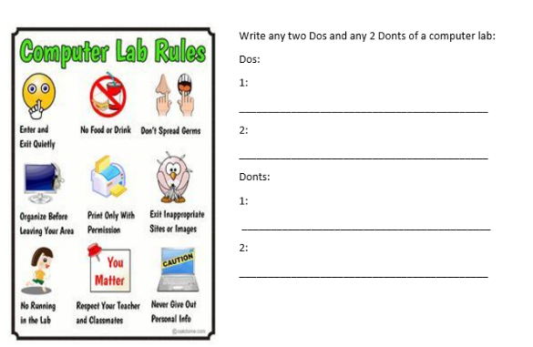
Work Sheet:

Week 3
Unit : 2
Topic: - Size and Uses of Computer.
Students learning Outcomes: - Enable students to understand that there are different types of computer. They will identify that some computers are big and some are small.
Starter Activity: - Asking the students how they use computers in daily life. Telling the kids that computer use is not just limited to the normal PC.
Brain storming: -Practical implications and daily life usage of computer will be discussed.
Methodology: - Guide students to differentiate between computers and describe good behavior while working in computer class.
Wrap up:
They will understand different sizes of computer and how they work. These days computer has become a must part of every organization, school, library or office.
Resources: - book, white board. Pictures of computers that are used in different places mentioned in the chapter.
Class-work: -
Day/Date | Topics | Home work
Day 1: | Reading and explanation of pg. no.12,13 ,14
Day 2: | Title page and vocabulary words on n.book.
Day 3: | Activity pg. no.13,14 on book. | Question/Answers Test of Unit#1
Day 4: | Book exercise pg. no.15 on book
Day 5: | Test

Unit : 2
Size and uses of computer
Vocabulary words :
Medium, information, offices, briefcase, exit, queue, noise, listen, attentively, difficult
document ,internet, video, movie, music, record, ATM machine, learning, maintain, chat
PG # 15
Unit : 2
Book exercise.
B : Say YES or NO.
1 . Big computers are fast. YES
2 . Big computers can hold lots of information. YES
3 . Home and offices use handheld computers. NO
4 . You cannot carry any computer with you. NO
5 . You can carry some computers in your pocket. YES

C : Fill in the blanks. (Answers)
1 . attentively
2 . noise
3 . handheld
4 . carry
5 . fast
6 . information
Week 4
Unit :2
Topic: Size and uses of computer
Students learning Outcomes: Enable students to understand the importance and uses of computers in daily life.
Brain storming: - Encourage the students to adopt a computer life style.
Methodology: - Students will asked about the different size and uses of computer.
Wrap up:
Student will be able to understand the practical implication and daily life usage of computer.
Resources:- book, white board, Work sheets.
Class-work: -
Day/Date | Topics | Home work
Day 1: | Pg no.16 on book.
Day 2: | Q/A 1,2 on n.book | -----------------
Day 3: | Q . 3 on n.book. | Prepare pg no. 15,16 for test.
Day 4: | Test
Day 5: | Fill in the blanks on n.book + Worksheet
Topic : Question/Answers
Q : 1 How many different types of computer are there ?
Ans : There are different types of computer :
1 : Big computer
2 : Small computer
3 : Medium computer
Q : 2 What is the use of big computer ?
Ans : Big computers are fast and can hold alot of information.
Q : 3 Where are medium size computer used ?
Ans : Medium size computers are used at home and offices.
Worksheet:
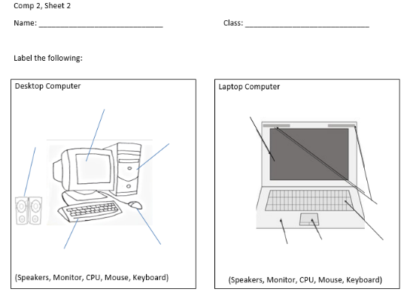
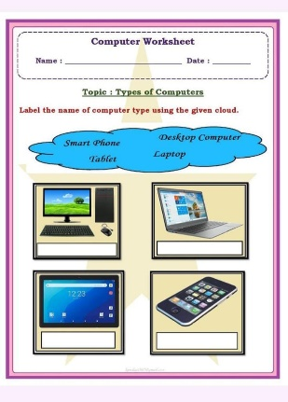

Week 5
Unit: 3
Topic: - Helpful Computer
Students learning Outcomes: -Enable students to understand and identify the different uses of computer. Enable students to know about the basic principles of computer in accordance with daily life examples.
Starter Activity: - List some of the different uses of the computer at different places.
Brain storming: - Before moving towards complex topics, students must understand the primary principles
Methodology: - Students will be asked about different uses of computer at different places in our daily life.
Wrap up:
- Student will be able to know how different computers are helpful and also benefits of using a computer.
Resources:- book, white board.
Class-work:-
Day/Date | Topics | Home work
Day 1: | Reading and explanation of pg. no.17,18,19,20
Day 2: | Practical 1 Pg#33,34,35 | -----------------
Day 3: | Title page and vocabulary words on n.book. | Question/Answers of Unit 2 for test
Day 4: | Q/A 1,2 on n.book.
Day 5: | Q/A 3 on n.book
Topic : Vocabulary words.
machines, electronic, requires, processing, display, binary system, represented,
instructions , language
Topic : Question/Answer
Q 1 : How is computer helpful for us ?
Ans : Computer helps us in doing tasks easily.
Q 2 : How is computer helpful for us at home ?
Ans : At home computer helps us to :
1 : make documents.
2 : use internet.
3 : play games.
4 : watch movies.
5 : draw pictures.

Q 3 : How is computer helpful for us in bank ?
Ans : In bank computer helps us to :
1 : keep accounts.
2 : make passbooks.
3 : get money from ATM.
Week 6
Unit: 3
Topic: - Helpful computer
Students learning Outcomes:
Enable students to know about basics of computer.
Starter Activity: -
Students will be asked about the basics of computer and how computers are helpful.
Brain storming:
Students must understand the primary principle to operate the computer.
Methodology: -
Enable them to operate computer by themselves.
Elicitation:
Practical implications and daily life usage of computer will be discussed. These days computer has become a must part of every organization, school, library, or office. Student will be able to know about the uses of computer in daily life and how are they helpful to us.
Resources:- , book, white board, Work sheets.
Class-work:-
Day/Date | Topics | Home work
Day 1: | Pg# 21,22 on book
Day 2: | Pg no. 21 part C,D on n.book | -----------------
Day 3: | Worksheet | Question/Answers of unit 3 for test
Day 4: | Test
Day 5: | Practical 2

Unit: 3
Topic: - Helpful computer
Students learning Outcomes:
Enable students to know about basics of computer.
Starter Activity: -
Students will be asked about the basics of computer and how computers are helpful.
Brain storming:
Students must understand the primary principle to operate the computer.
Methodology: -
Enable them to operate computer by themselves.
Elicitation:
Practical implications and daily life usage of computer will be discussed. These days computer has become a must part of every organization, school, library, or office. Student will be able to know about the uses of computer in daily life and how are they helpful to us.
Resources:- , book, white board, Work sheets.
Class-work:-
Day/Date | Topics | Home work
Day 1: | Practical 2 Pg#36,37,38
Day 2: | Practical Pg#39,40,41 | -----------------
Day 3: | Practical Exercise# 43 | Question/Answers of unit 3 for test
Day 4: | Test
Day 5: | Revision

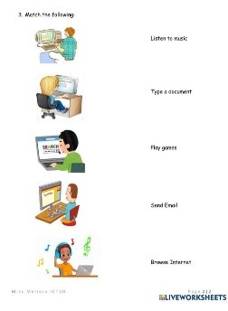
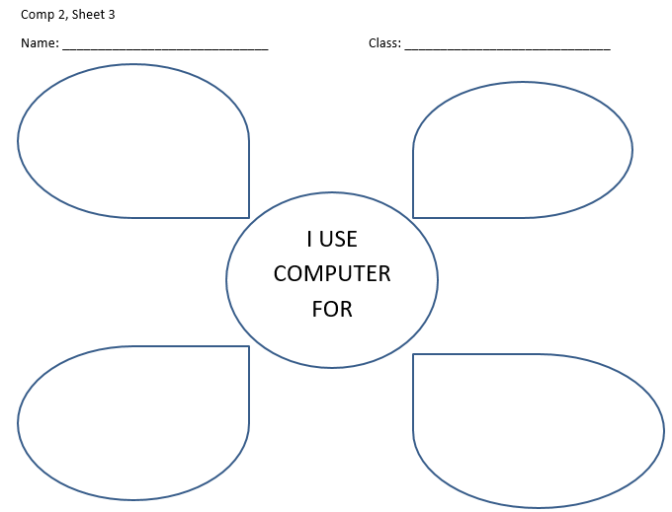
Worksheet:

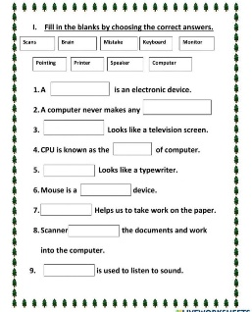

-------------------------------------------------------------------------------------------------------------------------------
Syllabus And DLP For Grade 2
Computer
Unit 4: Parts of Computer
Unit :5 System Unit
Practical number 1,2 and 3
Additional worksheets

Week 1
Unit: 4
Topic: - Parts Of Computer
Students learning Outcomes:
To enable kids to know about the different Input and Output devices of a computer. After reading this chapter students will learn more details about Input and Output devices.
Starter Activity: - Explain the students how to protect computer from mishandling. Enable kids to understand the use of a computer.
Brain storming: - Lesson will begin with a brain storming session. Students will be asked why they think we use computer. Output devices which includes Monitor, Keyboard, Mouse and CPU etc.
Elicitation:The use of these parts will be explained to the students.

Methodology: - Students will know the ways to take care of computer, harmful effects of excessive use of computer and how to protect your computer.
Wrap up: Student will understand that how to use computer and why we use computer in our daily life.

Resources: - book, white board, flash cards.
Class-work: -
Day/Date | Topics | Home work
Day 1: | Reading and explanation of Unit #4 Pg # 23,24
Day 2: | Book Exercise of Unit#4 Pg#24,25,26 | Read unit 4 and underline difficult words.
Day 3: | Title Page+ Vocabulary Words on N.B
Title Page
Contents:
Reading + explanation
Vocabulary words
Question/Answer
Book exercise
Topic: Vocabulary words
1. keyboard
2. mouse
3. CPU
4. information
5. processing
6. keys
7. button
8. system unit
Week 2
Unit: 4
Topic: - Parts Of Computer
Students learning Outcomes:
To enable kids to know about the different Input and Output devices of a computer. After reading this chapter students will learn more details about Input and Output devices.
Starter Activity: - Explain the students how to protect computer from mishandling. Enable kids to understand the use of a computer.
Brain storming: - Lesson will begin with a brain storming session. Students will be asked why they think we use computer. Output devices which includes Monitor, Keyboard, Mouse and CPU etc.
Elicitation:The use of these parts will be explained to the students.

Methodology: - Students will know the ways to take care of computer, harmful effects of excessive use of computer and how to protect your computer.
Wrap up: Student will understand that how to use computer and why we use computer in our daily life.

Resources: - book, white board, flash cards.
Day/Date | Topics | Home work
Day 1: | Question/Answers on N.B
Day 2: | Fill in the blanks from Pg# 25 on N.B | Test of Q/A of Unit # 4
Day 3: | Match the column + Worksheet
Questions/Answers
Q1. How many parts does computer have?
Ans: Computer has four main parts.
1: monitor
2: keyboard
3: mouse
4: CPU
Q2: What is the function of Monitor?
Ans: A monitor shows the result of the processing.
Q3. What does CPU stand for?
Ans: CPU stands for central processing unit.
Q4: What is the function of a mouse?
Ans: Mouse is used to give instructions to the computer.
Match the column.
mouse where we can see results of processing
monitor to type Alphabets and numbers
CPU used to give instructions to computer
keyboard where processing is done
Worksheet:

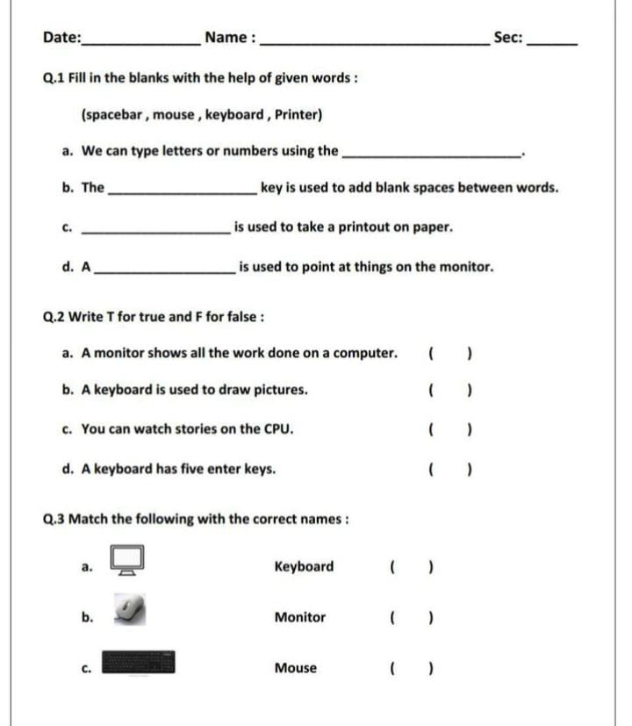
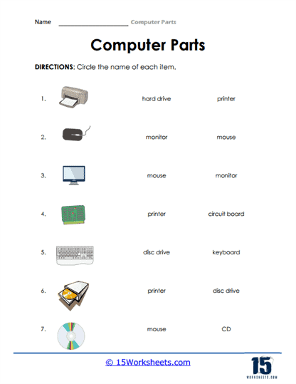

Week 3
Unit: 5
Topic: - System Unit
Students learning Outcomes: Children must be able to know about different types of computer, their functions and use.

Starter Activity: - Define and explain about personal computer, common types of personal computer and main parts of System Unit.
Brain storming: -Students will be asked about the parts of computer.
Methodology: - Explain them about personal computers and their common types.
Wrap up:Student will be able to identify the common types of computer and they will become able to differentiate between a desktop casing and Tower casing,.
Resources: - book, white board. Computer parts
Class-work: -
Day/Date | Topics | Home work
Day 1: | Reading of Unit # 5 System Unit Pg# 27,28,29
Day 2: | Reading of Unit#5 Pg#30 Book Exercise Pg#31,32 | Test of Unit # 4 Book Exercise
Day 3: | Title Page + Vocabulary Words +Test
Vocabulary Words:
- personal
- desktop
- laptop
- pocket
- vertically
- horizontally
- memory
- display
- mother Board
- sound Card
- data
- connect
Week 4
Unit: 5 System Unit
Students learning Outcomes: Children must be able to know about different types of computer, their functions and use.
Starter Activity: - Define and explain about personal computer, common types of personal computer and main parts of System Unit.
Brain storming: -Students will be asked about the parts of computer.
Methodology: - Explain them about personal computers and their common types.
Wrap up: Student will be able to identify the common types of computer and they will become able to differentiate between a desktop casing and Tower casing,
Resources: - book, white board. Computer parts
Class-work: -
Day/Date | Topics | Home work
Day 1: | Question/Answers on N.B
Day 2: | Fill in the blanks from book Pg #31 on N.B | Q/A of Unit # 5 for test
Day 3: | Worksheet + Diagram of tower casing on N.B
Question/Answers:
Q1. What is system unit?
Ans: System Unit is the most Basic part of computer. Computer cannot work without it.
Q2: What are personal computers?
Ans: Computes which are used personally are called personal computers.
Q3: What is laptop computer?
Ans: We can carry laptop from one place to another. It’s shape is like notebook.
Q4: Which is the most common casing these days?
Ans: Tower Casing is the most common type of casing.

Worksheet:
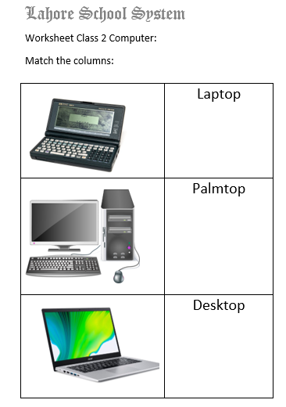

Week 5
Practical 2: More about MS-Word
Students learning Outcomes: Students Learning Outcomes: Children must be able to understand the features of MS Paint, its functions, and practical uses.
Starter Activity: - Introduce MS Paint by explaining its purpose as a basic graphics editing program. Discuss its relevance in creating simple drawings, editing images, and exploring creativity through digital art.
Brainstorming: - Ask students about their previous experiences with drawing or painting programs. Encourage them to share any features they think a graphics program should have, fostering engagement and curiosity.
Methodology: - Provide a detailed overview of MS Paint's interface, including the toolbar, color palette, and various tools available for drawing and editing. Explain functions such as drawing shapes, using text, filling colors, and erasing. Demonstrate how to use each tool in practice.
Wrap Up: - Students will be able to identify the primary features of MS Paint and use various tools effectively to create their own artwork. They will also learn how to save and share their creations.
Resources: - Computers with MS Paint installed, projector for demonstrations, printed guides on MS Paint features, and sample images for students to practice editing.
Day/Date | Topics | Home work
Day 1: | Reading Practical# 2 More about MS-Paint Pg#36-41
Day 2: | Reading Practical# 2 More about MS-Paint Book Exercise Pg#42,43 | Test of Book Exercise of Unit#5
Day 3: | Practical on System

Week 6
Practical 2: More about MS-Word
Students learning Outcomes: Students Learning Outcomes: Children must be able to understand the features of MS Paint, its functions, and practical uses.
Starter Activity: - Introduce MS Paint by explaining its purpose as a basic graphics editing program. Discuss its relevance in creating simple drawings, editing images, and exploring creativity through digital art.
Brainstorming: - Ask students about their previous experiences with drawing or painting programs. Encourage them to share any features they think a graphics program should have, fostering engagement and curiosity.
Methodology: - Provide a detailed overview of MS Paint's interface, including the toolbar, color palette, and various tools available for drawing and editing. Explain functions such as drawing shapes, using text, filling colors, and erasing. Demonstrate how to use each tool in practice.
Wrap Up: - Students will be able to identify the primary features of MS Paint and use various tools effectively to create their own artwork. They will also learn how to save and share their creations.
Resources: - Computers with MS Paint installed, projector for demonstrations, printed guides on MS Paint features, and sample images for students to practice editing.
Day/Date | Topics | Home work
Day 1: | Practice Practical 3 on system
Day 2: | Title Page + Vocabulary Words | Book exercise of Practical 2
Day 3: | Question/Answers on N.B+ Draw the following in copy: pencil tool, Paintbrush tool, colour fill tool
Vocabulary Words:
1: paint
2: curve
3: ellipse
4: rectangle
5: tool bar
6: drawn.
7: screen
8: text
9: click
10: brush
11: drawing
12: blinking
13: cursor
14: pencil
15: eraser
16: shapes.
Question/Answers:
Q1: What is MS-Paint?
Ans: MS-Paint Program is used to draw different shapes and pictures.
Q2: How many tools are there in tool box?
Ans: There are many tools in tool box.
1: Brush Tool.
2: Eraser Tool.
3: Text Tool.
4: Pencil Tool.
5: Line Tool.
Q3: What are different shapes in tool box?
Ans: Rectangle shape tool, curved tool, circle tool, oval shape tool.
Q4: What is color palette?
Ans: In color palette there are different colors to use.

