Curriculum And Syllabus
Class 2 English
Unit 1: Spirit Of Sacrifice
Unit 2: Faiza’s Biscuits
Unit 3: The Trap
Unit 4: The Mice and Elephant
Unit 5: Nasir in Trouble
Unit 6: The Mulla’s Son
Grammar topics
Punctuation, Noun, Preposition, Verbs, Adjectives,
Paragraph: Good Manners, Application (for sick leave), masculine /feminine, singular/plural.
Creative Writing Topics:
My best friend ,My favorite personality, Summer season, My aim in life, My country, My classroom,
My favourite cartoon.
Comprehensions
Picture Descriptions

Week 1
Unit 1: -
Topic: - Orientation + Spirit of sacrifice
Objectives: - Students will learn the value and importance of sacrifice in Islam. Students will be able to understand the concept of sacrifice.
Starter Activity: - energy and its resources topic will be introduced to student.
Brain storming: -Students will be asked about topic sacrifice, what did they know about the concept of sacrifice in Islam, by asking questions related to the topic.
Methodology: - Introducing the chapter with examples of sacrifice.
Explanation about different types of energy
Wrap up:
- Student will be able to recognize that energy is required for doing work
- Different uses of energy
- Identify natural resources of energy
Resources: -flash cards will be used to show the students the martyrs of Pakistan. pictures, and book
.

Class-work: -
Day/Date | Topics | Home Work
Day 1: | Orientation
Day 2: | Orientation
Day 3: | Letter formation will be done + Reading of unit#1 pg:2,3 | Reading of Unit #1
Day 4: | Reading+ Book Exercise Pg# 5 (A,B1+2),

Week 2

Unit 1: -
Topic: - Spirit of sacrifice
Objectives: - Students will learn the value and importance of sacrifice in Islam. Students will be able to understand the concept of sacrifice.
Starter Activity: - energy and its resources topic will be introduced to student.
Brain storming: -Students will be asked about topic sacrifice, what did they know about the concept of sacrifice in Islam, by asking questions related to the topic.
Methodology: - Introducing the chapter with examples of sacrifice.
Explanation about different types of energy
Wrap up:
- Student will be able to recognize that energy is required for doing work
- Different uses of energy
- Identify natural resources of energy
Resources: -flash cards will be used to show the students the martyrs of Pakistan. pictures, and book

Class-work: -
Day/Date | Topics | Home Work
Day 1: | Title Page | Reading
Day 2: | Vocabulary Words | Learn CW
Day 3: | Words/Meanings | Learn spellings of V/W

Title Page: Voc words.
Draw a Pakistan Flag on Title-Page.
Vocabulary words: sacrifice, fluffy, greatest, answered, expensive, slaughter, feasting, tradition, show off
Words Meanings:
Furry | covered with fur
show off | to try to impress others
Sacrifice | to give up something that is important to you for someone else.
Excited | Thrilled
Adored | Loved

Week 3
Unit 2: -
Topic: - Faiza’s Biscuits
Objectives: - Students will learn the value and importance of sharing and caring. Students will be able to understand the concept of sacrifice.
Teaching kids the concept of comprehension
-Enabling the children to identify various punctuation marks
-Familiarizing kids with basic punctuation rules
Starter Activity: - Students will be asked questions regarding unit Individuality. Children will do independent reading after the teacher’s model reading.
Brain storming: -Students will be asked about the concept of sharing, what did they know about the sharing and caring, by asking questions related to the topic.
Methodology: - The concept of sharing and caring will be given. Examples will be shown by videos. Children will be asked to read to the topic and tell in their words what they think the story is about.
Wrap up:
- Student will be able to recognize that energy is required for doing work
- Different uses of energy
- Identify natural resources of energy

Resources: Flash card with definition and examples of punctuations.

Title Page: Draw biscuits on title page.

Vocabulary words:
restaurant
tiffin Carrier
items
empty
poor
hungry
biscuit
Class-work: -
Day/Date | Topics | Home Work
Day 1: | Reading and explanation will be done of Unit #2 | Test of Vocabulary words and W/M of Unit 1
Day 2: | Test+ Book Exercise B1+2 | Reading of Unit#2
Day 3: | Title Page + Vocabulary Words | Learn V/W

Words | Meanings
Restaurant | a place where people go and eat
tiffin carrier | lunch box
Items | Things
Poor | not having money
Empty | having nothing in it

Words | Sentences
restaurant | There is a Chinese restaurant near my home
Tiffin carrier | Mama gives me a lunch in a tiffin carrier
Items | A general store sells many useful items
Empty | I found an empty box
Poor | Faiza was a poor girl

Question Answers:
Q1. What did Faiza see one day?
Ans. One day, Faiza saw people in a restaurant.
Q2: Who gave Faiza some cake and biscuits?
Ans: A little girl gave Faiza some cake and biscuits.
Q3: What did Faiza do the next morning?
Ans: Faiza sold the biscuits next morning.

Week 4
Unit: - 2
Topic: - Faiza’s Biscuits
Objectives: - To enable children, understand, read, comprehend, the lesson, W/M, and answer relevant questions. To tell the kids what a fable is. Fable is a story with a moral, that usually has animal characters in it.
Starter Activity: - Each kid will be asked questions related to fable story and unit.
Brain storming: - Introducing the chapter with the examples of sharing and caring. Q/A will be done orally
Methodology: - Introducing the chapter with examples of sacrifice.
The story will be read first by the teacher and them by the children one by one.
Explanation will be done and meanings of difficult words will be explained.
Wrap up:
- Student will be able to recognize that energy is required for doing work
- Children will be told the title and will be asked what they think the story is about.

Resources: - A4 size white papers. The advertisement materials A4 size.
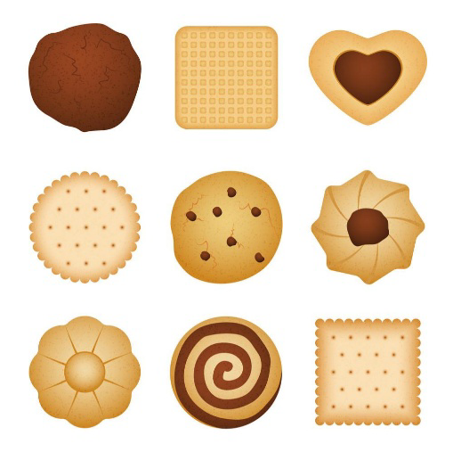
Title Page: Make different shapes of biscuits on Title Pages.

Class-work: -
Day/Date | Topics | Home Work
Day 1: | W/M and W/S will be done on N. B | Test of V/W+W/M
Day 2: | Question/Answers will done on N.B | Test W/S
Day 3: | Test+ Reading of Unit #3 The Trap | Oral reading test of unit 2

Week 5
Unit 3: -
Topic: - The Trap
Objectives: - The children will be able to read words independently.
Starter Activity: - Flash cards of vocabulary words will be showing.
Brain storming: - Reading of Unit:3 will be listened individually from the students to assess their reading skills. Students will be asked about general description of picture description what picture description is.
Methodology: - Flash cards will be shown and each child will be asked to read.
Wrap up:
- Student will be able to recognize that energy is required for doing work
- Different uses of energy
- Identify natural resources of energy
Resources: - cage making, cardboard, tiger and mice toys.

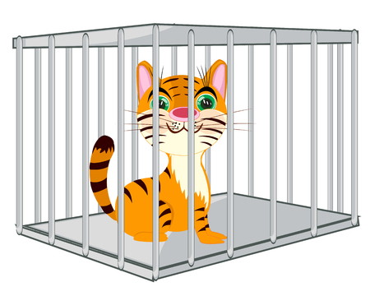
Title Page: Draw cage and tiger on Title Page.

Class-work: -
Day/Date | Topics | Home Work
Day 1: | Book Exercise A2+B2+B5 | Test of Q/A of unit 2
Day 2: | Test+Title Page + Vocabulary Words | Test of Unit #2 book exercise
Day 3: | W/M + W/S on N.B | Reading of Unit 3

Vocabulary words:
-awful
-honest
-replied
-roared
-rubbish
-servant
-perhaps
-immediately
-branches
-great
Topic: Words/Meanings
Words | Meanings
Awful | very bad
Replied | Answered
Servant | Helper
Roar | To make a loud noise
Perhaps | Maybe

Topic: Words/ Meanings
Words | Sentences
Awful | Ahmed’s clothes looked awful after he fell.
replied | The little boy replied loudly when I asked his name.
servant | Oliver was a servant at a big house.
roared | The lion roared loudly when the boys teased him
perhaps | Perhaps I will go to Italy this summer.

Topic: - Question/ Answers
Q1. Why was the road unhappy?
Ans. The road was unhappy because people hurt the road by walking and riding on it.
Q2. Why was the bullock unhappy?
Ans. The bullock did not get enough to eat, so he was unhappy.
Q3. Who put the tiger back in the trap?
Ans. The clever jackal out the tiger back in the trap.

Week 6
Unit 4: -
Topic: - The Trap, The Mice and the Elephants
Objectives: - Students will learn dignity of labor, how to make friends.
- To enable children to identify past tense.
- To enable children to identify story-like text.
-To enable them to identify verb, and nouns in the unit.
Starter Activity: - Students will be asked questions regarding unit Individuality.
Brain storming: -Students will be asked questions related to the topic. The story will be read, children will be explained that it is in past tense, and that the tense can be identified by looking at the form of verb used.
Methodology: - The children’s will be asked about their friends. The story will be read, children will be explained that it is in past tense, and that the tense can be identified by looking at the form of verb used.
Wrap up:
- Kids will be asked questions form Unit Trap what they have learned from it.

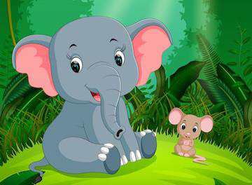
Resources: - Flash cards of vocabulary words will be shown.
Title Page: Draw the mice and elephant.

Day/Date | Topics | Home Work
Day 1: | Question/Answers on N.B | Test of V/W+W/M of unit #3
Day 2: | Reading of Unit # 4+Title Page +V/W will be done on N.B | Test of W/S for test
Day 3: | W/M + W/S on N.B | Test of Q/A
Vocabulary words:
agree, comfortable, feast, hard, weak, whole, festival, elephant, escaped, listened.
Words Meanings:
Words | Meanings
Agree | to think the same as someone else
Escape | to get free from something
Feast | a big meal
Herd | a big group of animals of the same kind
Festival | a celebration
Words Sentences:
Words | Sentences
Agreed | I agreed with what my mother said
Escape | The thief tried but he could not escape from the police.
Feast | We had a feast at Eid dinner.
Herd | The little lamb was separated from its herd
Festival | Eid is a religious festival
Question and Answers:
Q1. Why did everyone leave the palace?
Ans. Everyone left the palace because the king grew old and died.
Q2. Who lived in the cracks in the floors?
Ans. Mice lived in the cracks in the floors
Q3. Why did the mice go to the elephant kings?
Ans. The mice went to tell the kings and other elephants not to walk on the floors.
Q4. What did the elephants agree to do?
The elephants agreed to use another path.

Week 7
Unit 4: -
Topic: - Nasir in Trouble

Objectives: - To enable them to identify various parts of a formal application.
To familiarize kids with format of application writing.

Starter Activity: - Students will be asked questions regarding application.

Brain storming: -Students will be asked about the concept of sharing, what did they know about the sharing and caring, by asking questions related to the topic.

Methodology: A sample application will be read in class and children will be explained what each part stands for.
Children will be brain stormed to come up with various subjects of formal applications.
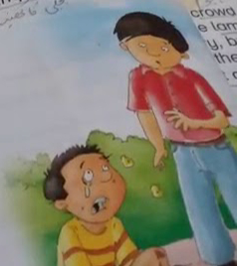
Wrap up:
- Different uses of energy
- Identify natural resources of energy

Resources: -flash cards will be used of V/W.
Topic: - Nasir in trouble
Objectives: - To enable students to identify humor in a piece of writing . Students will learn what adjectives are and how they describe objects and people.
Starter Activity: - Students will be asked questions regarding unit.
Brain storming: -Students will be asked questions related to the topic. The story will be read, children will be explained adjectives. The story will be read and explained and the funny aspects will be highlighted. Each child will read individually after model reading by teacher.
Methodology: - Children will be explained what adjectives are, classroom object’s will be used as an example.
Wrap up:
- Kids will be asked questions form Unit Nasir in trouble what they have learned from it.

Resources: - Flash cards of vocabulary words will be shown.
Title Page: Draw Nasir
Title Page: Draw Mice and Elephant on title page.
Day/Date | Classwork Topics | Homework
Day: 1 | Question/Answers will be done on N.B | Test of V/W+W/M of unit 4
Day: 2 | Reading + Explanation of Unit # 5  Book Exercise Pg.# B1 + B2 | Learn W/S +Q/A
Day: 3 | Title Page + V/W | Test of W/S and Q/A

Vocabulary words:
explained, lead, moustache, pavement, sausages, angry, luckily, dragging.
Words Meanings:
Words  Explain | Meanings  to make meaning clear
moustache | hair above man’s mouth, below his nose.
sausages | mixture of meat and spices pressed into a long shape
pavement | Footpath
dragging | pulling roughly

Words Sentences:
Words | Sentences
explain | My teacher explains very well.
moustache | My father has a moustache.
sausages | I like to eat sausages.
pavement | We should always walk on pavement.
dragging | The man was dragging his dog.

Week 8
Topic: - Nasir in trouble
Objectives: - To enable students to identify humor in a piece of writing . Students will learn what adjectives are and how they describe objects and people.
Starter Activity: - Students will be asked questions regarding unit.
Brain storming: -Students will be asked questions related to the topic. The story will be read, children will be explained adjectives. The story will be read and explained and the funny aspects will be highlighted. Each child will read individually after model reading by teacher.
Methodology: - Children will be explained what adjectives are, classroom object’s will be used as an example.
Wrap up:
- Kids will be asked questions form Unit Nasir in trouble what they have learned from it.

Resources: - Flash cards of vocabulary words will be shown.
Title Page: Draw Nasir
Title Page: Draw Mice and Elephant on title page.

Day/Date | Classwork Topics | Homework
Day: 1 | W/M + W/S | Learn V/W+W/M
Day: 2 | Questions/Answers on N.B | Test of V/W + W/M of Unit#5
Day: 3 | Test +Reading and explanation of U:6 will be done | Reading Of unit 6+ learn Q/A

Question and Answers:
What kind of a man was uncle Sami?
Ans. Uncle Sami was a jolly man who told stories.
2. Where was Nasir going when he me the little boy?
Ans. Nasir was going to Shalimar Bagh when he met the little boy.
3. Why was the little boy crying?
Ans. The little boy was crying because he had hurt his leg.
4. What did the dog do when the boy fell over?
Ans. The dog ran off and started eating sausages from a meat stall.
5. Why did the crowd chase Nasir?
Ans. The crowd chased Nasir because they thought that his dog had stolen the sausages.
Week 9
Unit 6: -
Topic: - Mulla’s Son
Objectives: - Students will learn about trouble and how to dealt with it.
Starter Activity: - Students will be asked questions regarding unit.
Brain storming: -Students will be asked questions related to the topic. The story will be read, children will be explained apostrophe. The story will be read and explained and the important aspects will be highlighted. Each child will read individually after model reading by teacher.
Methodology: - Children will be explained what apostrophe is. Children will be given oral drills of singular and plural nouns and difference in rules while applying apostrophe will be discussed.
Wrap up:
- Kids will be asked questions form Unit Mulla’s Son. what they have learned from it.

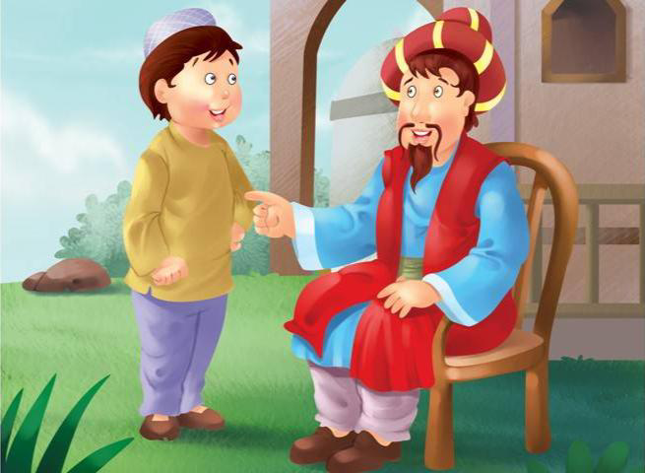
Resources: - Flash cards of vocabulary words will be shown.

PBL (if any) / Details of Work-sheet (if any)
Title Page: Draw Mulla’s Son

Class-work: -
Day/Date | Topics | Home Work
Day 1: | Reading and explanation of U:6 will be done | Test of Q/A
Day 2: | Test +Title Page+V/W | Learn V/W
Day 3: | W/M + W/S | Test of V/W+W/M
Vocabulary words:
Emperor, Palace, musician troubles, surprised, frightened worried immediately , servants shocked
Words Meanings:
Words  emperor | Meanings  ruler
famous | known by people
troubles | problems
immediately | quickly
peeped under shocked | secretly looked at something surprised
frightened | scared

