Math
Mid term Curriculum and Syllabus
Grade 2
Unit: 1 Whole numbers
Unit :2 Addition
Unit: 3. Subtraction
Unit: 4. Multiplication
Unit: 5. Division
Week 1
Unit: 1
Topic: - Whole Numbers
Students learning Outcomes:-Enable students to recapitulate previously learnt concept easily.
Starter Activity: - Brain storming by counting 50-90.
Brain storming: -Students will be asked about concept of greater and smaller numbers.
Methodology: - Guide students to solve the pages in group Ordering number.

Wrap up:
- Student will be able to understand that crocodile always like to eat bigger numbers.
Resources: -flash cards, pictures, book, white board.
Class-work: -
Day/Date | Topics | Home work
Day 1: | Tables will be revised .Oral | Revise tables.
Day 2: | Table of 2 ,3 on N. book. | -----------------
Day 3: | Table of 4,5 on n.book.
Day 4: | Pg no. 2 on book. | write tables of 6,7 on n.book.
Day 5: | Pg no. 3 on book.Tables of 8,9 on n.book. | learn tables 4 to 7

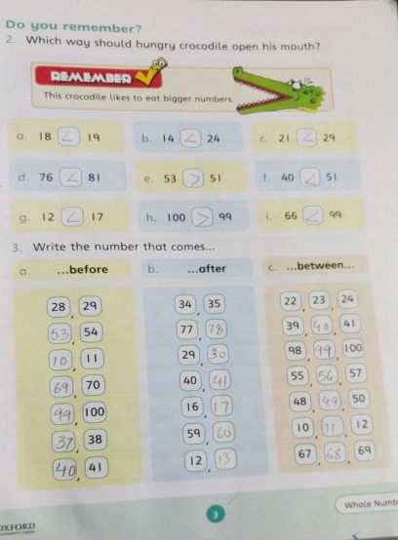
Week 2
Unit: 1
Topic:-Whole Numbers.
Students learning Outcomes:-Enable students to recapitulate previously learnt concept easily.
Starter Activity:-Enable students to understand the order of numbers.Before,After,between.
Brain storming:-Students will be asked about concept of ascending and descending by giving the example of stairs.
Methodology:- Guide students to solve the pages in group Ordering number. Through abacus and beads they learn how to learn hundred tend ones. Enable them to know backward counting and know number names by doing work page on book..
Wrap up: Student will be able to write ascending and descending order. They will recapitulate the concept of hundreds, tens and ones.
Resources:-flash cards, , book, white board. Work sheets.

Class-work:-
Day/Date | Topics | Home work
Day 1: | pg#4 on book. | write counting on n.book.-1-100
Day 2: | pg #5 on book. | -----------------
Day 3: | pg# 7.8 on book.
Day 4: | pg #10,11 , 12 on book . | Do Q ;10 part e,f,g on N.book.pg #8.
Day 5: | Pg # 13 , 14 on book. | prepare test of pg # 4

Q ; Write the number according to the place value.
a . 3 tens and 6 ones 36
b . 0 tens and 6 ones 06
c . 5 tens and 3 ones 53

Q ; Write in words.
a . 4 tens and 5 ones forty-five
b .7 tens and 9 ones seventy-nine
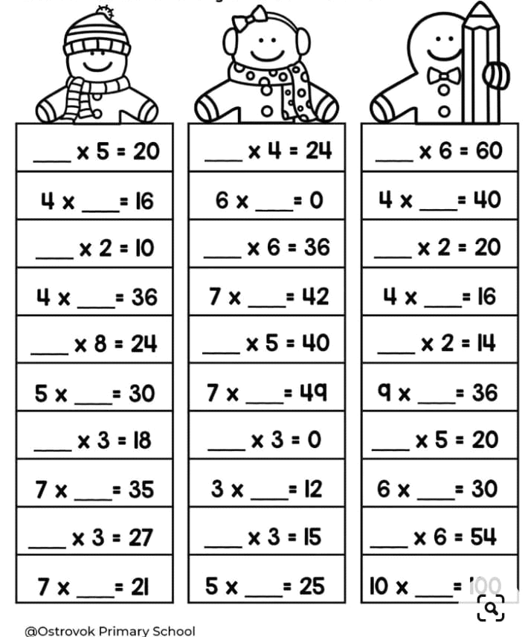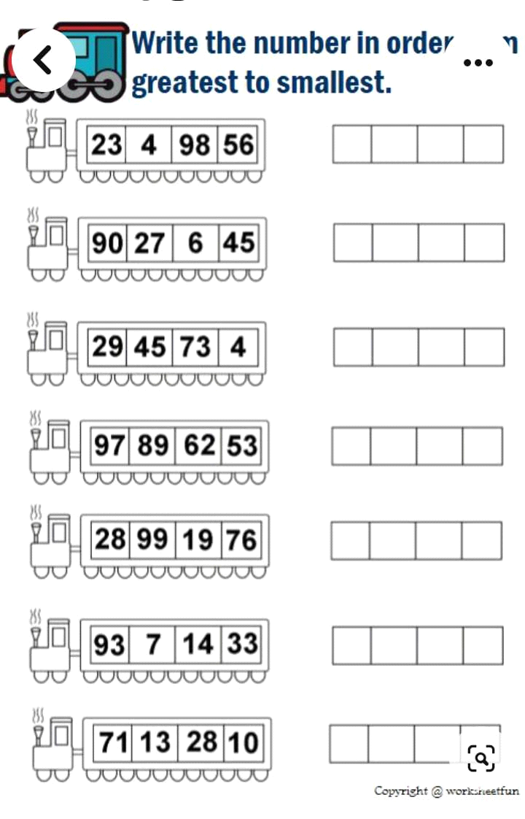
Week 3
Unit: 1
Topic:-Whole Numbers.
Students learning Outcomes: -Enable students to understand that 10 tens =1 hundred (Review of Numbers Hundreds, tens and ones)
Starter Activity: -Recapitulate the concept of {H , T , O.}
Brain storming: -Students will be asked about concept of H, T,O
Methodology: - Guide students to solve the pages in groupS. Review of numbers and number names. Concept of greater and smaller will be given. Crocodile likes to eat bigger numbers.
Wrap up:
They will recapitulate the concept of hundreds, tens , ones and will know how to write number names.
Resources: - book, white board. Work sheets.

Class-work:-
Day/Date | Topics | Home work
Day 1: | pg #14, 15 16,on book.+ Test | write counting in words One to Twenty on n.book.
Day 2: | pg #17,18 on book. | -----------------
Day 3: | pg #19 ,20 ,21 on book .
Day 4: | pg # 22 a-i on book.  pg # 23 on book . | write counting in words Twenty to Fifty on n. book.
Day 5: | Pg # 24 ,25,26on book . | Do part j -o Q ;3 PG # 22 on book.

Q; Write in hundreds, tens and ones.
a. 841 8 hundred, 4 ten, 1 ones
b. 593 5 hundred, 9 ten, 3 ones
Q; Write the number names.
a. 640 Six hundred and forty.
b. 223 Two hundred and twenty-three.
c. 497 Four hundred and ninety-seven.
d. 508 Five hundred and eight.
e. 333 Three hundred and thirty-three.
Q; Write > or < in the empty boxes.
a. 35 < 548
b. 92 < 589
c. 981 > 81
d. 809 > 79
Week 4
Unit: 2 Topic: Addition
Students learning Outcomes: -Enable students to understand that one’s numbers in one’s column and tens numbers in tens column. Enable them to understand the addition of 2 ;3 digits converting ones.
Starter Activity: -Enable students to add the numbers and write the answer in right place.
Brain storming:-If 9 + 3 = 12 students should know that 12 = 1 ten and 2 ones and should write separately in columns.
Methodology: - sums will be solved on book and practice on n.book.
Wrap up:
Student will be able to understand that adding start with Ones first, tens second, hundreds last.
Resources: - book, white board. Work sheets.
Class-work:-
Day/Date | Topics | Home work
Day 1: | pg. #27, 28 on book . | Do pg # 29 , 30 on book.
Day 2: | pg. # 31,33 on book. | -----------------
Day 3: | pg.# 34,35on book.
Day 4: | pg. #36 , 37 on n. book . | Do parts f , g , h , i on n.book pg # 37
Day 5: | Revision of U : 1 | prepare test of U ; 1
Q; Do the given sums. Be careful with your columns;
a. T O b. T O c. T O
7 5 4
+ 3 + 5 + 6
____________ _____________ _____________
1 0 1 0 1 0
Q; A monkey eats 29 bananas and then 12 more. How many bananas does he eat altogether?
Data: Monkey eats bananas = 29
He eat more bananas = 12
Solution:
T O
2 9
+ 1 2
_________________
4 1
Answer: A monkey eats 41 bananas altogether.
Addition, converting ones.
T O T O T O
6 4 1 7 2 4
+ 2 8 + 5 8 + 3 9
_______________ ___________________ ________________
9 2 7 5 6 3
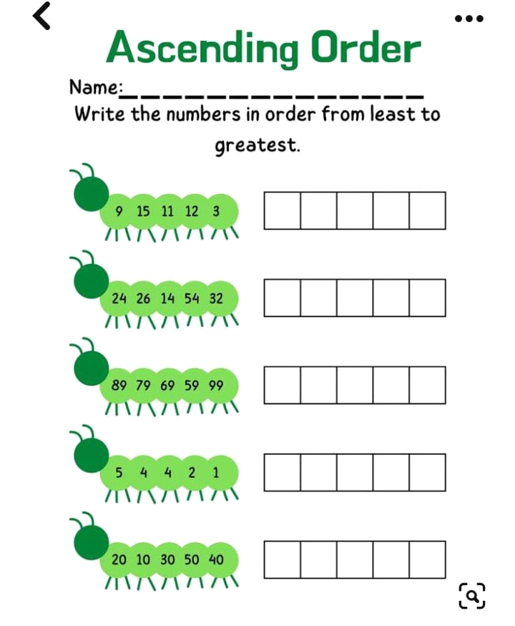
Week 5
Unit: 2 Topic:-Addition
Students learning Outcomes: -Enable students to recapitulate previously learnt concept easily.
Starter Activity: - Brain storming by addition of 2 and 3 digit numbers.
Brain storming: -Students will be asked to add 2 and 3 digit numbers with conversion and no conversion. Sums and word problems.
Methodology: - Guide students to solve the pages in group Ordering number.
Wrap up:
- Student will be able to understand that add ones first,
- Tens next,
- Hundreds last.
Resources: - book, white board.
Class-work: -
Day/Date | Topics | Home work
Day 1: | Pg#38 on n.book .  Real life story sums.  a ,b | Learn tables of 6,7 on .
Day 2: | Pg#38  C ,d ,e on n.book | -----------------
Day 3: | Pg#40 on book.
Day 4: | Pg. no. 43 (a-l)on book | Pg. no. 42 on book
Day 5: | Pg. no. 43 (m-t)on book | learn tables 4 to 7
Real life story sums.
Saima has 151 stamps. She collects 108 more. How many stamps does she have altogether?
Data:
Saima has stamps= 151
She collects more= 108
Altogether = ?
Solution:
H T O
1 5 1
+ 1 0 8
2 5 9
Answer:
Saima have 259 stamps altogether.

Week 6
Unit;
Topic: - Subtraction
Students learning Outcomes: Enable the students to subtract several numbers.
Starter Activity: -Enable students to understand the subtraction of several numbers. Converting tens and hundreds.
Brain storming: -Students will be asked about addition and subtraction. Converting tens and ones.
Methodology: - Enable them to solve and understand that add and subtract ones first, tens next, hundreds last. Sums will be solved on book and practice on N.book.
Wrap up:
Student will be able to solve the sums of subtraction with conversion and no conversion.
Resources:- , book, white board. Work sheets.
Class-work:-
Day/Date | Topics | Home work
Day 1: | Introduction Subtraction Pg # 44 on book. | Do practice of pg#44.
Day 2: | pg # 45 ,46 on book . | -----------------
Day 3: | pg# 47 on book.
Day 4: | pg # 47 real life story sums , a ,b on n.book. | Prepare pg#43,44 for test
Day 5: | Pg # 47 c ,d , on n.book. | Do practice of Pg # 46
Subtraction
Real life story sums.
A. Gibran had 32 toys. He gave 17 to an orphanage. How many are left?
Data:
Gibran had toys = 32
He gave = 17
How many are left = ?
Solution:
T O
3 2
_ 1 7
_____________
1 5
Week 7
Unit: 3
Topic: - Subtraction
Students learning Outcomes: -Enable students to subtract several numbers.
Starter Activity:-Recapitulate the concept of subtraction of 3 digit numbers no conversion and converting hundreds and tens.
Brain storming: -Students will recapitulate the addition and subtraction sums.
Methodology: - Guide students to solve the subtraction sums with conversion and no conversion .
Wrap up:
They will recapitulate the addition and subtraction sums on book and note book.
Resources: - book, white board.
Class-work:-
Day/Date | Topics | Home work
Day 1: | Pg. #48 on book | Do pg# 48 part(i_p) on n.book
Day 2: | Pg. # 49 on book | -----------------
Day 3: | Pg. # 50,54 on book
Day 4: | Pg. # 55 on book | Do practice of Pg #48
Day 5: | Practice of Pg. #50 on n.book. | Prepare pg# 49 for test.
Week 8
Unit : 4
Topic: Multiplication
Students learning Outcomes: Enable students to write tables through number lines.
Starter Activity: -Enable students to count and write missing numbers.
Brain storming: -Solve book pages by using number line
Methodology: - Student s will solve the book pages in groups.
Wrap up:
Student will be able to understand the counting of numbers with the help of number lines and write the missing numbers.
Resources: - book, white board. Work sheets.
Class-work: -
Day/Date | Topics | Home work
Day 1: | pg # 56 on book. | Learn tables 7,8
Day 2: | pg # 57 on book. | -----------------
Day 3: | pg# 59,60 on book.
Day 4: | pg. #61,63 on book. | Do parts b,c of Q.4pg#61 on n.book
Day 5: | Do pg#66 on book. | prepare test of pg#60

Q ; Count in 2s and fill in the missing numbers .
A .0,__,4,6,__,10,12
B. 6,__,10,12,___,16,,___,20
C . 20,__,__,__,28,,__,__.
Pg. #60
Q.2 Write in empty boxes.
A .2+2+2+2=4×2=8
B .2+2+2+2+2=5×2=10
Q. Multiply to answer these.
A. How many eyes do 4 cats have?
4×2=8
B. How many feet do 2 boys have?
2×2=4
C. How many hands do 6 girls have?
6×2=12
Pg #66
Q .4 e.How many wheels on:
4 tricycles? 4×3 =12
- tricycles? 3×3 = 9
9 tricycles? 9×3 = 27
5 tricycles? 6×3 = 18

Week 9
Unit; 4
Topic:- Multiplication
Students learning Outcomes:-Enable students to recapitulate previously learnt concept easily.
Starter Activity:- Revise tables and write dodging tables on board
Brain storming:-Students will solve the book pages .Count and write the missing numbers.
Methodology:- Guide students to solve the pages in groups.
Wrap up:
- Student will be able to know how to multiply.
Resources: - book, white board.
Class-work:-
Day/Date | Topics | Home work
Day 1: | Pg # 67,68 on book. | Learn tables of 6,7,8
Day 2: | Pg#69 on book. | -----------------
Day 3: | Pg#71,72 on book.
Day 4: | Pg #73 ,78 on book. | Prepare pg#69 for test.
Day 5: | Pg no. 79 on book | Do pg# 79 Q.1 part m_r on n.book

Pg # 69
Q 4 . Multiply and find the answer.
A . 6×4=24
B . 2×4=8
C . 10×4=40
D . 4×4=16
Week 10
Unit; 4
Topic:- Multiplication
Students learning Outcomes: Enable students to understand that in multiply 2 numbers, the number can be put in any order, the answer will remain the same.
Starter Activity:-Enable students to understand the multiplication by mental maths.
Brain storming: -Students will be asked to use multiplication in daily life and relate different objects with it.
Methodology:- Enable them to solve and understand multiplication .Sums will be solve on book and practice on n.book.
Wrap up:
Student will be able to solve the real life story sums of multiplication.
Resources:- , book, white board.work sheets.
Class-work:-
Day/Date | Topics | Home work
Day 1: | Pg # 80 on book. | Do part i_p of pg#80 on n.book
Day 2: | pg # 81 on book. | -----------------
Day 3: | pg# 82 on book.
Day 4: | Pg#83 (a-c)on book | Prepare pg#80 for test
Day 5: | Test + Pg#83(d-f) on book. | Do parts d,e,f on n.book pg#83

Multiplication:Vertical form
T O
8
×. 2
1 6
T O
5
× 4
2 0
Q; Solve the real- life story sums.
- Aslam has 8 bowls with seven goldfish in each bowl.How many fish are there altogether?

Grade: 2 Subject:Maths
Week 11
Unit : 5
Topic: - Division
Students learning Outcomes:-Enable students to understand the division and multiplication facts.
Starter Activity:-Recapitulate the concept of multiplication.
Brain storming:-Students will able to know that division is opposite of multiplication.
Methodology:- Book and copy work will make them practice the sums easily and clearly.
4×2=8 2×4=8
8÷2=4 8÷4=2
Wrap up:
They will understand that division is opposite of multiplication
Resources:- book, white board.

Class-work:-
Day/Date | Topics | Home work
Day 1: | Pg #90 on book | Do pg# 90 part(i_p) on n.book
Day 2: | Pg # 90,91 on book | -----------------
Day 3: | Pg # 92 on book | Do practice of Pg #90
Day 4: | Pg # 93,94 on book | Do part j_r of pg#94 on n.book
Day 5: | Pg#94 on book | Prepare pg# 90 for test

PG #90
Q: Divide the numbers to answer these.
    - 16÷2=8
    - 25÷5=5
    - 12÷4=3
    - 18÷3=6
Pg#92 (Introduction)
Real life story sums.
b. 20 balloons are shared equally among 5 children. How many balloons does each child get?

