  - Mid Term Planner
  - Grade 7th Science
Mid Term Syllabus
- Unit 1 | - Plant system
- Unit 2 | - Human respiratory system
- Unit 5 | - Structure of an Atom
- Unit 6 | - Physical and Chemical changes
- Unit 7 | - Chemical bonds

  - Grade: 7 Subject: Science
Week 1
Unit 1
Topic: Plant systems
Objectives: To introduce and reinforce the root and shoot systems in plants
Predict the role of xylem and phloem in plants.
Starter Activity: bring a plant and identify its different parts.
Brain storming: Students will be asked about different parts of plants, their function and importance in food making process
Methodology: Model reading will be done as well as individual reading. All the difficult words will be explained. Identification of different parts of plants will be done by means of a real plant. Root, shoot and transport systems will be explained.
Explanation about process of photosynthesis.
Resources: Plant, board marker, whiteboard and book
Class-work:
Day/Date | Topics
Day 1: | Introduction of lesson, reading and explanation
Day 2: | Explanation of root and transport system
Day 3: | Explanation of shoot system
Day 4: | Explanation structure of leaves and process of photosynthesis
Day 5: | Questions 1
Q1. Enlist and explain two main complex systems of plant.
Ans. A plant has two main complex systems that keeps it living and growing
- The root system
- The shoot system
Root system
Root systems are of two basic types.
- The fibrous root system
- The tap root system
The fibrous root system
It has many roots of equal size starting from the bottom of the stem.
The tap root system
It has one main root and smaller roots growing out of it.
Functions of root system
- It absorbs water and dissolved minerals from the soil and transports them up into the stem of the plant.
- It provides the plant with anchorage. They prevent the plant from being blown down or uprooted by floods and heavy rains.
The Shoot system
The shoot system consists of stems, leaves, fruits and flowers. It always grows upwards
Stem
Stem connects the plant leaves to its roots. The tubes inside the stem are stiff and strong. They help stems hold the leaves up towards the sunlight.
Leaves
Leaves are thin and flat. They consists of a petiole, midrib and a network of veins
Function of shoot system
- Support the plant as well as plant parts
- Transport materials i.e water and minerals
Evaluation

Grade: 7 Subject: Science
Week 2
Unit 1
Topic: Plant systems
Objectives: Define the process of photosynthesis and derive word equation for it.
To know that why the structure of leaves is adapted for the process of photosynthesis
Describe the process of respiration and compare process of photosynthesis and respiration.
Starter Activity: Students would be asked questions related to previous topic to keep them active.
Brain storming: Students will be asked about things necessary for photosynthesis and the role of stomata in plants.
Methodology: Model reading will be done as well as individual reading. All the difficult terms will be explained. Importance of leave in the process of photo synthesis along with its internal structure and the process of respiration will be explained.
Basic concept of transpiration will be explained.
Resources: board marker, whiteboard and book

Class-work:
Day/Date | Topics
Day 1: | Reading and explanation pg 6
Day 2: | Explanation of comparison between respiration and photosynthesis
Day 3: | Q 2 LONG
Day 4: | Explanation transpiration, its factors and importance pg 8
Day 5: | Short Questions 1,2,3,4,5

Q2 Define Transpiration. Explain transpiration stream and its importance.
Ans. Book pg. 8,9

Q1. Distinguish between xylem and phloem.
Ans.
Xylem | phloem
Xylem transport water with dissolved minerals from roots to leaves. | Phloem transport food made by plants from leaves to all parts of plants.

Q2. Distinguish between Photosynthesis and respiration.
Photosynthesis.
The process by which green plants make their food is called photo synthesis. Photo means light and synthesis means putting together.so photosynthesis means putting things together.
Equation
Carbon dioxide + Water → Glucose + Oxygen
Respiration
Respiration is chemical breakdown (oxidation) of food materials to provide energy from living things. This process occurs inside the living cells of plants and animals therefore it is called internal or cellular respiration.
Equation:
Glucose + Oxygen → Carbon dioxide + water
Q3. How are leaves adapted for photosynthesis?
Many leaves are broad and flat so that they can absorb plenty of light. Leaves are thin so that carbon dioxide can reach the inner cells easily. They have a system of veins that carry water to the photosynthesizing cells and carry the food away.
Q4. What are stomata?
Stomata are tiny holes surrounded by parts of kidney shaped epidermal cells called guard cells. The guard cells control gas diffusion by regulating the opening and closure of stomatal pores.

Q5. What are the components that influence transpiration?
- Wind: The rate of transpiration is faster as the water vapor is blown away while passing out of the leaves
- Temperature: On a warm day water evaporates faster.
- Humidity: On a rainy-day evaporation of water from the leaves is slower.
- Time of the day: Stomata are open during the day time and usually closed at night.
Evaluation
- Student will be able to identify importance of leaves in photosynthesis.
- How are leaves suited for photosynthesis
- Identify how energy is produced by the process of respiration.

Grade: 7 Subject: Science
Week 3
Unit 1
Topic: Plant systems
Objectives: To explain the effects of minerals on plant growth
Starter Activity: Recall the previous topics and questioning about transpiration will be done.
Brain storming: Students will be asked about different factors on which transpiration depends and some minerals which play an important role in plant growth
Methodology: Model reading will be done as well as individual reading. All the difficult words will be explained. Identification of different minerals and their effects on plant growth will be explained.
Resources: Plant, board marker, whiteboard and book
Class-work:
Day/Date | Topics
Day 1: | Test short Questions
Day 2: | Explanation of effects of minerals on plant growth
Day 3: | Book objective pg. 12
Day 4: | Question book pg. 13 recall and analyze
Day 5: | Activity
Q: Sana wanted to test a hypothesis. She took two potted plants. She placed one plant under the bright sun and the other pot in the dark cupboard for a week.
- What do you think would be plants state after a week?
Ans: The plant under the bright sun will grow as a normal plant and will be so fresh while the plant placed in dark cupboard will not grow and will be wilted.
- What could be the reason behind such states of plant?
Ans: The plant placed in bright sunlight is growing properly because all the conditions are favourable for photosynthesis so plant is fresh.
The plant placed in dark cupboard will wilt and die because there is no sunlight so the process of photosynthesis will not take place.
Evaluation:
Grade: 7 Subject: Science
Week 4
Unit 2
Topic: Human respiratory systems
Objectives: Differentiate between the process of respiration and breathing.
Starter Activity: Sit and stand activity to keep students active.
Brain storming: Students will be asked about inhaling and exhaling and identify which gas is inhaled and which is exhaled.
Methodology: Model reading will be done as well as individual reading. All the difficult words will be explained. Process of respiration will be explained by means of lecture.
Resources: board marker, whiteboard and book.
Class-work:
Day/Date | Topics
Day 1: | Reading and explanation of respiration and breathing
Day 2: | Explanation of structure and function of lungs
Day 3: | Quick review pg. 17
Day 4: | Explanation of comparison between respiration and breathing
Day 5: | Question 1 long

Q1. Compare the process of respiration and breathing.
Ans. Pg. 18 (follow the table mentioned on this page)
Evaluation:

Grade: 7 Subject: Science
Week 5
Unit 2
Topic: The human respiratory system
Objectives:
• To give the concept of respiration with and without oxygen in nature
• To give awareness of respiratory diseases and their prevention and treatment
Starter Activity: Students would be asked about fresh and polluted air and gases present in the air.
Brain storming: Students will be asked about breathing in and breathing out and the importance of oxygen along with the presence of different gases in the air.
Methodology: Model reading will be done as well as individual reading. All the difficult words will be explained. The teacher will then elaborate on the lesson and explain the vital concepts. After explanation of topics discussion on respiratory diseases, their prevention, and treatment will take place. A quick analysis of the topic would be done at the end.
Resources: board marker, whiteboard and book
Class-work:
Day/Date | Topics
Day 1: | Test
Day 2: | Explanation of Aerobic and anaerobic respiration
Day 3: | Quick review pg. 20 and Explanation of respiratory diseases their prevention and treatment
Day 4: | Book exercise pg. 24,25
Day 5: | Questions 1,2 ,3

Choose the correct answer
1. c. Trachea 2. d. Oxygen 3. a. Carbon dioxide 4. b. larynx 5. c. Diaphragm
Vocabulary review
- Bronchi
- Diaphragm
- Bronchitis
Observe and answer
• The nose filters the air and moistens it.
• Trachea carries the air down from nose and mouth into the bronchi.
• Bronchus leads to the lungs and passes through them.
• In the lungs, gaseous exchange takes place
Q1. What are some of the respiratory disorders. Explain any three.
. Respiratory disorders are diseases related to the respiratory system which can include
1. Bronchitis
2. Asthma
3. Emphysema
. Emphysema is a lung condition in which the alveoli become thin and weak. Large empty spaces in the lungs because of which breathing becomes difficult and painful and it can be caused by heavy smoking.
Asthma is a disease in which the muscles of the bronchioles are irritated by air carrying dust, smoke. Bronchioles become narrower so less air is able to enter the lungs thus causing problem in breathing.
Bronchitis is the inflammation of the air passages in the lung is reduces the ability of the lungs to absorb oxygen and the disease is usually caused by bacteria but smoking can make the condition worse
Q2. How are respiratory diseases prevented and treated
Ans. The best way to avoid getting respiratory diseases include: to maintain your physical health, eat a nourishing and well died, and to avoid overcrowded and poor ventilated places. Treatment of respiratory diseases include antibiotic medicines described by doctors
Q3. Why is your nose so important in breathing process.
Ans. • The nose plays an important role in breathing because when we breathe in, the air enters through the nose and in the nose the air is filtered and moistened and when we breathe out the air containing more carbon dioxide and water vapor is exhaled out into the environment from our body.

Grade: 7 Subject: Science
Week 6
Unit 2
Topic: The human respiratory system
Objectives:
Starter Activity: Students would be asked to open their notebooks and books and be ready for written work
Brain storming: Students will be asked about the answers of Questions before writing their answers on board
Methodology: Teacher will write short Question and their Answers on board while long question will be marked in their books and they will do it from book
Resources: board marker, whiteboard and book
Class-work:
Day/Date | Topics
Day 1: | Test
Day 2: | Q4 and 5
Day 3: | Q6,7,8 and 9
Day 4: | Question 2 long
Day 5: | Draw diagram of human respiratory system
Q.4. Define the following:
• Respiration It is the breakdown of food molecule (glucose) in the presence of oxygen to release energy.
• Breathing It is the inhale and exhale of air to get oxygen and release carbon dioxide during respiration
Q5. Name any three aerobic exercises.
Ans. i. swimming ii. jogging iii. cycling.
Q6. Write equations for aerobic respiration.
Glucose + oxygen → carbon dioxide + water + energy
C6H12O6 + 6O2 → 6CO2 + 6H2O + energy
Q7. Write equations for anaerobic respiration.
Glucose → lactic acid + energy
C6H12O6 → 2C3H6O3 + energy
Q2LONG.Write a note on structure and function of lungs.
Ans. book page 15,16

Grade: 7 Subject: Science
Week 7
Unit 5
Topic: Structure of an atom
Objectives:
Describe the structure of an atom
Differentiate between atomic number and mass number
Show the arrangement of electrons in K, L, & M shells of elements
Starter Activity: Students would be asked questions about atom and three sub atomic elements to recall their previous knowledge
Brain storming: Students will be asked about the answers of Questions before writing their answers on board
Methodology: Topis would be explained by means of lecture and diagram drawn on the board to give clear concept about structure of an atom and the arrangement of electrons, protons, and neutrons in an atom.
Resources: board marker, whiteboard and book
Class-work:
Day/Date | Topics
Day 1: | Test
Day 2: | Reading and explanation Pg# 51
Day 3: | Explanation pg#52, Applying Math pg#53
Day 4: | Explanation pg#53
Day 5: | Q#1 long

Q.1. What is an atom? Describe the structure of an atom.
Atom: The word atom comes from the Greek word atomos. It means something that can not be divided
Structure of an atom: The three sub atomic particles are
- Protons
- Neutrons
- Electron
Protons: These are in the nucleus. Each proton has one positive charge written as +1. The Number of protons in the nucleus is the characteristic of each kind of element. For example, A carbon atom has 6 protons and oxygen has 8 protons
Neutrons: These are also in the nucleus. They are neutral. They do not have any charge. All atoms of the same element have the same number of protons an electrons but may have a different number of neutrons. For example, Hydrogen, Carbon, & Chlorine.
Electrons: These are found in orbits around the nucleus. Each one has a negative charge written as e⁻. They are minute.
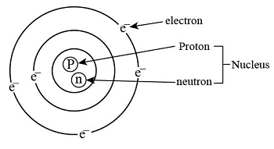

Pg # 53:
Applying Math:
- a. 9 , b. 19-9=10, c. 9
- Mass Number = protons + neutrons = 18 + 20 = 38

Grade: 7 Subject: Science
Week 8
Unit 5
Topic: Structure of an atom
Objectives:
Show the arrangement of electrons in K, L, & M shells of elements
Explain the periodic table
Recognize Periods and Groups in the periodic table
Starter Activity: Students would be asked about atomic and mass number of different elements.
Brain storming: Students will be asked to arrange elements in order of their increasing atomic masses
Methodology: Topics would be explained by means of lecture and a model of the periodic table
Resources: board marker, whiteboard and book, model of periodic table
Class-work:
Day/Date | Topics
Day 1: | Test
Day 2: | Reading and explanation Pg#53
Day 3: | Explanation Pg # 54
Day 4: | Quick Review Pg # 55, Scientific Enquiry + Book Obj
Day 5: | Question/Answers Q#1,2,3

Q.1. Differentiate between atomic number and mass number
Atomic Number | Mass number
- The number of protons preset in the nucleus of an atom is called Atomic Number  - It is represented by symbol Z.  - Example: Oxygen has 8 protons in its nucleus so its atomic number is 8 | - The number of protons and neutrons in the nucleus of an atom is called maas number.  - It is represented by A.  - Example: Oxygen has 8 protons and 8 neutrons so its mass number is 16

Quick Review:
Page # 55
Neutrons Protons nucleon positive no electrons shells equal
Pg # 58
Recall and Analyze:
1. Yes, we can predict as both particles carry opposite charges and it is in balance. Though they differ in size they carry equal charges.
2. No, as the number of neutrons in the nucleus of an atom are sometimes different

Choose the correct answer
1. a. protons have a positive charge
2. c. protons
3. d. 4
4. b.18
5. Group
Vocabulary Review
1. Shells
2. Protons
3. Nucleus
Observe and Answer
Answer
The neutral atoms are:
A, B and E
Recall and Apply
Q1.
1. Ne(Neon) with 10 electrons.
2. The special thing is that the L shell has 8 electrons and it is complete.
3. This element belongs to Group Zero.
4. It is Ar (Argon) has same number 18 in its outermost shell
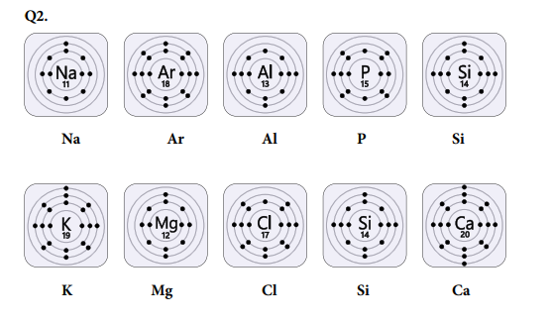

Recall and Response
Answer
A. P
B. N
C. E
D. Isotopes
E. E
F. E
G. N
H. N

Grade: 7 Subject: Science
Week 9
Unit 6
Topic: Physical and Chemical changes
Objectives:
- Differentiate between physical and chemical changes while considering daily life examples.
- Recognize that oxygen is needed in combustion, rusting and tarnishing.
Starter Activity: Students would be asked about physical and chemical changes to recall their previous knowledge.
Brain storming: Students would be asked about physical and chemical changes to recall their previous knowledge.
Methodology: Topics would be explained by means of lecture and activity showing physical and chemical change Important terms would be explained.
Resources: board marker, whiteboard, book, water, cattle, matchbox, and paper
Class-work:
Day/Date | Topics
Day 1: | Test
Day 2: | Explanation of pg. 60 and 61
Day 3: | Explanation of pg. 62, 63 and 64
Day 4: | Quick review (Q.1, 2) + activity
Day 5: | Q: 3,4, 5 and 6
Q1. Define the term physical change.
Ans. Physical Change: Substance change when they are heated, cooled, placed under pressure or even mixed with other substances. It is a physical change when no new substances are formed.
Q2. Identify some physical changes that are easy to reverse.
Ans. • Solution of salt in water.
• Expansion of Mercury in thermometer
• Change of water into ice
Q3. The wax in a burning candle can be escribed by both physical and chemical properties.
- Describe what are the physical properties of wax in a burning candle.
Ans. When wax in a burning candle, melts, it is a physical change. It melts without any decomposition. It deforms and comes back to its shape when pressure is applied.
- Why is melting a physical property of the wax, but flammability is a chemical property?
Ans. Flammability is a chemical property because the wax burns and vaporizes and it is a chemical change.
Q4. Look at the various objects in the kitchen. State why they are made of a particular material.
Ans. If we take example of cooking utensils in the kitchen, they are made of metal or clay (earthen pots) which conduct the heat and the food gets cooked. Therefore, a particular type of utensils are useful in the kitchen.
Q5. How could you prove that dissolving table salt in water is a physical change not a chemical change?
Ans. Dissolving table salt in water is a physical change. If we make a salt solution and boil it, the liquid will evaporate and salt will be left at the bottom of the container, unchanged. This proves that it’s a physical change.
Q6. When melted chocolate is put in the fridge, it cools quickly producing small crystals that were not present before. This changes the taste of the chocolate. Is this a chemical or a physical change?
Ans. The formation of crystals is known as sugar bloom which is the result of condensation as melted chocolate is kept in fridge. It is a physical change.

Grade: 7 Subject: Science
Week 10
Unit 6
Topic: Physical and Chemical changes
Objectives:
• Recognize that oxygen is needed in combustion, rusting and tarnishing.
• Explore methods of preventing rusting.
• Relate use of materials to their chemical properties (e.g., tendency to rust, flammability)
• Evaluate impact of combustion reaction on environment.
Starter Activity
• Bring a bottle of fizzy drink and ask students to observe. Open Teacher Ideas 66 the cane or bottle of fizzy drink. Bubbles of Carbon dioxide will be released.
• Ask students about the change.
• A chemical change took place as the gas was formed and released.
• Write chemical change on the board.
Brain storming: Students would be asked about chemical change like combustion and rusting.
Methodology
• Explanation will be done. The charts and images in the book would be used affectively.
• Quick analysis will be done at the end.
Resources: board marker, whiteboard, book and fizzy drink.
Class-work:
Day/Date | Topics
Day 1: | Test
Day 2: | Explanation of pg. 64,66,67 and 68
Day 3: | Explanation of pg. 69, 70, 71 and 72
Day 4: | Q: 7,8 and 9
Day 5: | Q: 1 and 2 long

Q7. Differentiate between physical and chemical change.
Ans.
Physical Change | Chemical Change
Temporary change | Permanent change
No new substance is formed | A new substance is formed
Reversible | Irreversible
Brings about a change in the physical properties | Brings about a change in both chemical and physical properties
The constituents of the new substance can be easily restored to their original states | The constituents of the new substance cannot be restored to their original states

Q8. Define density.
Ans. Density is the mass per unit volume of a substance. The density of material measures the amount of matter packed in a fixed volume of the material. For example, 1 cm³ of water has mass of 1 g Hence, the density of water is 1 g/cm³
Density = Mass/Volume
Q9. What is global warming?
Ans. Global warming is defined as the rise in the earth’s average temperature. This is caused by the presence of greenhouse gases in the atmosphere, which causes changes in climate patterns across the globe.
LONG
Q1. What is rusting? Explain methods of prevention of rusting.
Ans. Write answer from book page 65 and 67.
Q2. What is acid rain? What are its environmental effects?
Ans. Write answer from book page 72.

Grade: 7 Subject: Science
Week 11
Unit 6,7
Topic: Physical and Chemical changes
Chemical Bonds
Objectives:
• Define valency and explain the formation of ions.
• Write chemical formulae on the basis of valency of the constituent elements, such as H₂O, NaCl, NH₃, CO₂, CO, etc.
• Discuss formation of ionic bond as a result of electrostatic forces between atoms (e. g, NaCl).
Starter Activity
• Place charts of atomic structure on the board.
• Ask students some questions to recall previous learning of atoms.
• What are elements?
• What is the basic building block of an atom?
• Do atoms exist singly in nature or not?
Brain storming: Students would be asked about valency and chemical formulas or compounds.
Methodology
• Explanation will be done. The charts and images in the book would be used affectively.
• Quick analysis will be done at the end.
Resources: board marker, whiteboard and book
Class-work:
Day/Date | Topics
Day 1: | Test
Day 2: | Exercise of pg. 74 and 75 (Unit 6)
Day 3: | Explanation of pg. 76 and 77
Day 4: | Explanation of pg. 78 and 79
Day 5: | Q1. Definitions

Unit 6 Review
Choose the correct answer
1. a. mass per unit volume
2. Both a and b, steam cooled to water and Salt dissolved in water
3. a. aluminum
4. a. physical properties
5. d. burning wood
Vocabulary Review
1. hardness
2. Combustion
3. Carbon dioxide
Observe and Answer
a. The nail in first tube will rust as it is in water.
b. The nail covered in oil will not rust as oxygen and water will not reach the nail.
c. The painted nail will be protected by paint so water and oxygen will not get in contact with it.
d. The nail wrapped in foil will not get rusty as it will not get in contact with oxygen and water. Rusting can be prevented by:
• Alloying
• Painting
• Metal Painting
Recall and Response
Q1. Answer
• New
• Physical
• New
• Different

Q2.
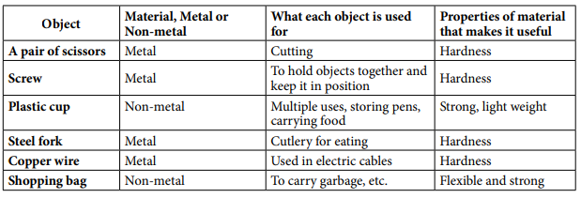
Unit 7
Q1. Definitions
- Noble Gases
Some elements have full outer shells of electrons. These are known as Noble Gases due to their properties.

- Valency
It can be defined as number of electrons in their outer most shells which can be added or shared in a reaction.

- Ionic bond
Chemical bond formed using the electrical pull between positive and negative ions. The electrons are transferred.

- Covalent bond
A covalent bond forms through sharing of electrons.

- Electrostatic attraction
The opposite charges are strongly attracted to each other. This force of attraction between the atoms is known as electrostatic force.

Grade: 7 Subject: Science
Week 12
Unit 7
Topic: Chemical Bonds
Objectives:
• Discuss types and formation of covalent bond as a result of mutual sharing of electrons between atoms (e. g, H₂, O₂, N₂).
• Name certain ionic and covalent compounds.
• Draw cross and dot structures showing formation of ionic compounds and covalent compounds

Starter Activity: Sit and stand activity to keep the students active.
Brain storming:
• Discuss formation of an ionic bonds as a result of electrostatic forces between atoms (e.g., Hydrogen, Oxygen and Nitrogen.)
• Name certain ionic and covalent compounds
Methodology
• Explanation will be done with charts and models. Book as the main resource will also be used. • At the end Quick Analysis will be done.
Resources: board marker, whiteboard and book
Class-work:
Day/Date | Topics
Day 1: | Test
Day 2: | Explanation of pg. 80, 81 and 82
Day 3: | Quick review of pg. 77,80 and 82
Day 4: | Book exercise pg. 84 and 85 (Short Q/A)
Day 5: | Long Q/A (1)

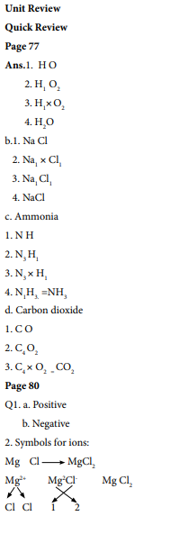

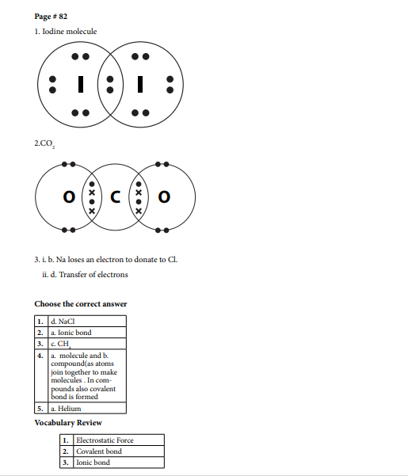

Long Q/A
- Define Ionic and covalent bonding? Give two examples of each and draw their dot and cross structure.
Ans. From book.

