|  |  |  |  |
| --- | --- | --- | --- |
|  | FAST-NUCES  Address: Jamrud Road 160 Industrial Estate Road, Peshawar  Phone (091) 111 128 128 |  |  |
| API-m written Test | | | | |
| Project Summary | | | | |
|  | | | | |

|  |  |  |
| --- | --- | --- |
| TEST DATE | Test | Prepared By |
| June -28 -2022 | Online Test | Muhammad Aamir Khan 18P-0121 |

|  |
| --- |
| Json format |
|  |

{

“id” : ______

“balance”:______

“status”:__________

Mailing_address[ {

address1:________

address2:_________

postal_code:_________

province:_________

country:___________

}]

Order[ {

Phone_number:______

status:_______

price_plan:______

}]

}

|  |
| --- |
| Yaml |
|  |

Apiverson:____

Basepath:_____

Resourcepath : /customers

Produces : /json

Apis:

_path: “/customers/{id}”

Method: GET

Parameters:

_______

_______

Models:

Title: mailing_address

Customers:

Properties:

Balance:

type:string

status:

type:string

mailing_address:

type:array

Orders:

type:array

|  |
| --- |
| UML Diagram |
|  |

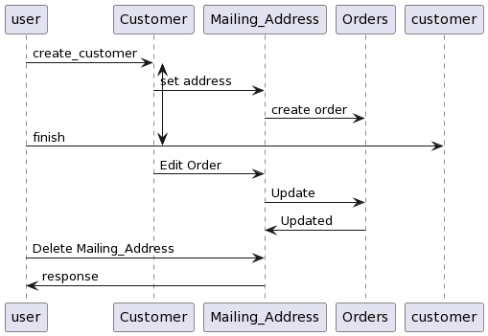

|  |
| --- |
| Thank you |
|  |