IMPROVING HATE SPEECH DETECTION IN ROMAN URDU USING LARGE LANGUAGE MODEL



by
Aamir Abbas
2023-MS-DS-04

Research Supervisor:
Dr. Muhammad Aslam

2025

Institute of Data Science
University of Engineering and Technology, Lahore
IMPROVING HATE SPEECH DETECTION IN ROMAN URDU USING LARGE LANGUAGE MODEL
by
Aamir Abbas
A THESIS
presented to the university of engineering and technology, Lahore in partial fulfillment of the requirements for the degree of
Master of Philosophy
in
Data Science
APPROVED BY:

______________________________ ______________________________
Primary Advisor/Internal Examiner External Examiner
Official Title & Department Official Title & Department

______________________________ ______________________________
Chairman of the Department Dean of Faculty

Approval Date

INSTITUTE OF DATA SCIENCE
UNIVERSITY OF ENGINEERING & TECHNOLOGY, LAHORE

© 2025
Aamir Abbas
All Rights Reserved.
Any part of this thesis cannot be copied, reproduced or published without the written approval of the Scholar.

ABSTRACT
The accelerated development of social media websites has contributed immensely to the proliferation of hate speech, bringing about severe social, psychological, and security-related issues. Roman Urdu has become a medium of online communication in Pakistan and other neighboring areas in particular because of its nonstandard and easy way of use, yet because of its nonstandardized spelling, common code mixing with English, and phonetic variation, it is especially hard to detect on automated hate speech detection systems. The existing methods are mostly applicable to languages that are rich with resources and do not reflect the contextual and linguistic intricacies of the Roman Urdu resulting in untrustworthy detection. This thesis will deal with these challenges through the development of a model of hate speech detection on Roman Urdu based on large language models. The paper starts with setting a baseline performance based on both conventional and deep learning models and then attempts to test transformer-based methods. The essence of the study being that the fine-tuning of LLaMA models to reduce computational costs through Low-Rank Adaptation (LoRA) and Quantized Low-Rank Adaptation (QLoRA) techniques offers parameters that are empirically efficient to the core of the research and are beneficial to the study as they enhance performance in a lower computational cost. RU-HSD-30K which is a balanced Roman Urdu hate speech corpus gathered on the key social media platforms is taken as an experiment and its performance is determined in terms of accuracy, precision, recall, and F1-score. The findings prove that LLaMA fine-tuned models, especially LLaMA 3.1 (8B) is superior to traditional models and transformer models and is computationally efficient. The findings of this study indicate the usefulness of large language models in low-resource and informal languages and lead to the creation of credible hate speech detectors in multilingual social media settings.

ACKNOWLEDGMENTS
I am extremely grateful to my supervisor, Prof. Dr. Muhammad Aslam, who guided, patiently and encouraged me in this research, which contributed to its development and ensured my motivation during this process. I would also like to express my gratitude to Ma’am Sana Shams who provided me with essential support and helpful guidance to ensure I managed to overcome all obstacles on the way. I would like to offer a warm thanks to the Institute of Data Sciences, UET Lahore, professors, seniors, and classmates, who have provided me with a positive learning experience and a motivational atmosphere. My department chairman, Prof. Dr. Shazia Arshad has been especially helpful and encouraging. Most of all, I can also sincerely thank my parents and friends whose love, patience, and faith in me made this MS journey possible and special. Without them, this work could not have been created.

STATEMENT OF ORIGINALITY
It is stated that the research work presented in this dissertation consists of my own ideas and research work. The contributions and ideas from others have been duly acknowledged and cited in the dissertation. This complete dissertation is written by me. If at any time in the future, it is found that the thesis work is not my original work, the University has the right to cancel my degree.

Aamir Abbas

TABLE OF CONTENTS
Page
ABSTRACT iv
ACKNOWLEDGMENTS v
TABLE OF CONTENTS vii
List of Figures x
List of Tables xi
NOMENCLATURE xii
1. INTRODUCTION 1
1.1. Background of Study 1
1.2. Problem Statement 4
1.3. Research Aims and Objectives 5
1.4. Scope of Study 6
1.5. Significant of Study 6
2. LITRATURE REVIEW 9
2.1. RELATed work 9
3. RESEARCH METHODOLOGY 15
3.1. dataset acquisition 16
3.2. DATA PREPROCESSING AND FEATURE PREPARATION 16
3.3. MODEL ARCHITECTURE AND INITIAL CLASSIFICATION 17
3.4. LARGE LANGUAGE MODEL FINE-TUNING 17
3.5. EVALUATION AND ITERATIVE OPTIMIZATION 18
4. Experimental setup 19
4.1. required tools 19
4.2. performance evaluation 20
4.2.1. Accuracy 20
4.2.2. Precision 20
4.2.3. Recall 21
4.2.4. F1-Score……………………………………………………………….21
5. result and evaluation 22
5.1. COMPARATIVE ANALYSIS OF BASE MODEL AND PROPOSED LLM-BASED METHOD 28
5.1.1. Purpose of Comparison………………………………………………...28
5.1.2. Performance and Efficiency Discussion……………………………….28
5.1.3. Contribution and Practical Impact……………………………………..29
6. Limitations 30
6.1. LIMITED DATASET SIZE AND LINGUISTICE DIVERSITY 30
6.2. LIMITED CONVERSATIONAL CONTEXT 30
6.3.MISCLASSIFICATION OF INFORMATION AND NEUTRAL CONTENT 30
6.4. ABSENCE OF REAL-TIME EVALUATION 31
6.5. LIMITED MODEL INTERPRETABILITY 31
7. FUTURE WORK And CONCOLUSION 32
7.1. Future Work 32
7.1.1. Expansion Toward Larger and More Diverse Roman Urdu Datasets 32
7.1.2. Incorporation of Conversational and Contextual Understanding 32
7.1.3. Advanced Large Language Model Integration 32
7.1.4. Multimodal Hate Speech Detection 32
7.1.5. Real-Time Deployment and Explainability 33
7.2. Conclusion 33
REFERENCES 35

List of Figures
Figure Page
Figure ‎1 A Random Picture Showing Hate Speech in Roman from Social Media Platform and Applying LLM 4
Figure ‎2 Social Media Comments - from YouTube and Twitter processing pipeline) 8
Figure ‎3 Diagram Showing Complete Road Map of the Model Evaluation 15
Figure ‎4 Performance comparison of Large Language Models before fine-tuning on Roman Urdu hate speech detection 24
Figure ‎5 Radar plot comparing evaluation metrics of Large Language Models before fine-tuning for Roman Urdu hate speech detection 24
Figure ‎6 Heat Map Representation of Different LLMs 25
Figure ‎7 Performance comparison of fine-tuned LLaMA models using LoRA and QLoRA for Roman Urdu hate speech detection via Bar Chart 26
Figure ‎8 Performance comparison of fine-tuned LLaMA models using LoRA and QLoRA for Roman Urdu hate speech detection via Heat Map 26
Figure ‎9 Performance comparison of fine-tuned LLaMA models using LoRA and QLoRA for Roman Urdu hate speech detection via Line chart 27

List of Tables
Table Page
Table ‎1 Comparison of the Proposed Models with their Techniques and limitations. 13
Table ‎2 Deep Learning Models Performance of the 30k-RU Dataset 22
Table 3 Evaluation Matrix of Different LLMs Before Fine-Tuning ..........................23
Table 4 Evaluation Matrix after Fine-Tuned Llama Models LORA and QLORA…..25
Table 5 Comparison of Base Paper with the Proposed Research …………………….28
Table 6 Comparison of Transformer Baseline with LORA/QLORA…………….......29

NOMENCLATURE
Symbol Description
LSTM  CNN  LLM | Long Short-Term Memory  Convolution Neural Network  Large Language Model
PEFT  NLP | Parameter Efficient Fine Tuning  Natural Language Processing
P | Precision
R | Recall
F1 | F1-Score
FN | False Negative
FP  TP  TN | False Positive  True Positive  True Negative
LORA | Low Rank Adaptation
QLORA | Quantized Low Rank Adaptation

INTRODUCTION

Background of Study
The sheer exponential development of social media platforms has revolutionized communication habits throughout the world, as it has allowed people to air their views, disseminate facts as well as engage in societal dialogue at a pace and on a grander scale that never before been seen. Facebook, Twitter (X), YouTube, Instagram, and Tik Tok platforms have turned into the grounds of political discussion, social interaction and cultural exchange [6]. Even though these platforms have contributed to the freedom of expression and connectivity, they have also provided a platform where abusive and harmful content can be propagated within a short time. Hate speech is one of the most alarming types of such content as it is directed at individuals or groups of people depending on their religion or ethnicity, nationality, gender or political affiliation, or social identity [2] [13].
Hate speech does not exist only as an annoyance on the Internet but has the real-life implications. Several researches have attributed the desensitization of hate speech on online platforms to social polarization, psychological stress on the audience who have been targeted, and in some serious cases, violence. In the case of nations with varied religious, ethnic, and political backgrounds, including Pakistan, the spread of hate speech without any limits can be regarded as a severe danger to social unity and national security [8] [9]. As a result, automated hate speech detection has emerged as a highly important field of study in the fields of natural language processing (NLP) and artificial intelligence [13].
In societies with multiple languages, the use of language during social media tends to be informal and convenient, and not due to grammatical standardization. In Urdu, the Roman Urdu, the form of Urdu language written in Latin has become one of the primary languages of communication over the internet among Urdu speakers in Pakistan and in India [11] [19]. Roman Urdu is more preferable to the user due to its capability to type in on standard keyboards and mobile devices than the Perso-Arabic Urdu script. Nevertheless, Roman Urdu is informal in nature and does not have standard spelling, grammar rules and lexical uniformity. Words are spelled out phonetically resulting in more than one way of spelling of a single word with regional accents also adding variety in written forms [10].
Social media Roman Urdu content is extensively code-mixed with English, in which the users often mix languages in the same sentence, use words, abbreviations, and internet slang of English language. Such code-mixing process along with non-standardized spelling variations and inventive forms of words have a significant contribution to linguistic complexity [22]. Computationally, these features make Roman Urdu a low-resource and noisy language, and thus especially difficult to the traditional natural language processing systems [15].
The initial methods of hate speech detection were based on keywords versus filtering and direct pattern matching methods. Even though these techniques provided some early solutions, they failed to work in the context of social media reality because of the lack of the ability to capture contextual sense. Later studies turned their attention to deep learning structures, with the advent of Convolutional Neural Networks (CNNs), long short-term memory networks (LSTMs) and bidirectional LSTMs (BiLSTMs) [30]. These neural models were useful in improving the performance because they automatically learn hierarchies and sequence text features, which allows more informal language structures found in Roman Urdu to be processed [2].
Later, more recent architectures, such as transformer-based ones, and specifically BERT and variants, extended the state of hate speech detection, using self-attention to capture long-range delicate dependencies [21]. These models proved to be better in performance than traditional deep learning approaches and set a powerful groundwork of Roman Urdu hate speech classification [ 37].
Based on these developments, the current research examines the opportunities of Large Language Models (LLMs) to further enhance detection performance. Several LLMs, such as GPT, Mistral and LLaMA versions, were considered to evaluate their usefulness in the detection of hate speech in Roman Urdu. According to the relative analysis, LLaMA-3 model is chosen to be parameter-efficiently fine-tuned to suit the linguistic peculiarities of Roman Urdu. This finetuning strategy allows better contextual insight at computational efficiency [24] [25].
By means of this gradual assessment of deep learning, transformer-based models, and large language models, the study will come to the creation of a strong and scalable hate speech detection strategy in Roman Urdu, overcoming the difficulties of code-mixing, inconsistency in spellings, and linguistic resources [18].
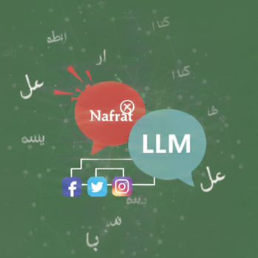
Figure 1: A Random Picture Showing Hate Speech in Roman from Social Media Platform and Applying LLM

Problem Statement
Although the problem of Roman Urdu in social media is growing more prevalent, the current hate speech detectors have been very ineffective against the language [2]. The majority of state-of-the-art models are designed and adapted to English or other high resources languages, with standardized grammar, consistent spelling, and a lot of annotated data. These assumptions cease to be true when extended to Roman Urdu [20]. There are a number of issues that lead to this predicament. To start with, Roman Urdu does not have a standard orthography and this has led to a large spelling variation that has baffled the traditional feature-based models. Second, the phenomena of intermixing the Urdu and English languages in the same text make the linguistic analysis and extraction of features quite difficult. Third, cultural and contextual subtleties contained in Roman Urdu hate speech tend to be lost when models are based on translation-based preprocessing methods. Lastly, large language models can be used to provide excellent contextual explanations, but their direct fine-tuning is computationally infeasible and expensive to perform in resource-limited research settings [9]. Consequently, it is apparent that hate speech detection systems are needed that could work directly on native Roman Urdu text and be able to capture contextual and semantic information efficiently and yet be computationally efficient. This thesis answers this demand through research on a multi-level framework of modelling that combines classic machine learning, deep learning, and large language model, and specifically exploring parameter-efficient fine-tuning strategies.

Research Aims and Objectives
The overall objective of this study is to detect hate speech in Roman Urdu more accurately with the help of big language models fine-tuned using parameter-efficient fine-tuning [5] [33]. In order to accomplish this goal, the research seeks the following objectives:
- To examine the linguistic nature and issues that relate to Roman Urdu hate speech on the social media sites [4].
- To compare the deep learning models, such as CNN, LSTM, and Bi-LSTM, regarding modeling sequential and contextual patterns in the text of Roman Urdu [6].
- To compare transformer-based and large language models to a standardized dataset of Roman Urdu hate speech [14] [17].
- To use the Low-Rank Adaptation (LoRA) methods and Quantized Low-Rank Adaptation (QLoRA) to fine-tune LLaMA models. To make comparisons of model performance in accuracy, precision, recall, and F1-score, memory resource consumption, and computational cost [1] [16].

Scope of Study
In this research, the researcher will limit the analysis to the identification of hate speech in the Roman Urdu text gathered on the social media sites [21] [29]. The study assumes a binary classification framework where the content can be classified as either hate or neutral in terms of RU-HSD-30K dataset [32]. Although these extensions are very important in hate categorization and sentiment analysis, it would be beyond the scope of this thesis [38].
The focus of the study lies in the development of the model, fine-tuning, and testing of the model under controlled experimental conditions [35]. The issues of real-time deployment, cross-platform integration, and multilingual expansion are not directly addressed and offered as the guidelines of the further research [34].

Significant of Study
This research is important because it provides academic, practical, and socio-economic value to the research of hate speech detection (especially in low-resource and linguistically complex languages like Roman Urdu). With the growing influence of online platforms on the formation of the social discourse, the opportunities to automatically identify and reduce hate speech have become a fundamental necessity to ensure safe and inclusive digital space [31] [23].
Academically, this study adds to the small amount of literature on Roman Urdu natural language processing. In spite of the fact that the existing literature has investigated both traditional machine learning models, deep learning structures and multilingual transformers, little consideration has been paid to the use of large language models that are directly fine-tuned on native Roman Urdu text [22]. The paper contributes to the existing knowledge base by showing how parameter-efficient fine-tuning methods, namely Low-Rank Adaptation (LoRA) and Quantized Low-Rank Adaptation (QLoRA) can be successfully utilized to fine-tune large language models to low-resource languages [1]. This study offers solutions to the future studies in a similar linguistic environment by presenting a comparative analysis across various modeling paradigms as a reference to such topics, which may help in identifying the performance, scalability and the computational trade-offs.
Regarding the practical importance, the results of the present research are directly applicable to social media networks, regulatory bodies, and online safety agencies that could be involved in Urdu-speaking countries. Moderation systems that are in place tend to ignore Roman Urdu content because it has an informal structure and is not standardized [10]. As it has been outlined in the proposed approach, it is possible to perform accurate hate speech detection without using translation-based preprocessing which tends to cause the loss of semantics. Additionally, parameter-efficient fine-tuning also minimizes both memory and computing needs and helps the proposed system to be more realistic when it comes to the real-world usage in the resources-limited realm [40]. This allows organizations to develop automated moderation capacities at a very low cost in terms of the infrastructure.
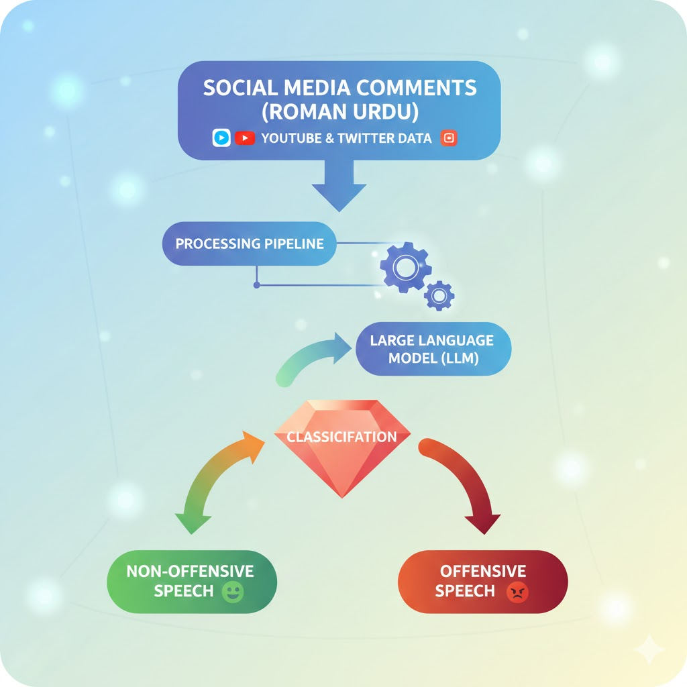
Figure 2: Social Media Comments - from YouTube and Twitter processing pipeline
Social and economic implications of this study are also very high. Hate speech leads to social polarization, discrimination, and psychological damage, especially in societies of diverse cultures and religions. The lack of moderation of non-English posts means that dangerous narratives continue to flourish and marginalized people fall prey to them at a disproportionately higher rate [34]. This study can be used to create safer online environments and enhance responsible digital communication by enhancing hate speech detection in Roman Urdu. In terms of economics, efficient automated detection mechanisms have the potential to decrease the use of manual moderation, reduce costs of operation of the platform providers, and decrease the risk of reputational losses and penalties [27].
Altogether, the study is important because it fills an urgent gap in the research of hate speech detection, proposing a scalable study and effective solution to Roman Urdu, and is a part of a larger endeavor to enable ethical, inclusive, and safe digital ecosystems [17].

LITRATURE REVIEW

RELATED WORK
The last few years have seen an increased research interest in hate speech detection in Roman Urdu as it is used on social media significantly and is linguistically complex. Contrary to standardized languages, Roman Urdu lacks standard spelling and is often mixed with English and thus text classification becomes especially difficult using automated methods. This section provides a review of major research studies, which have dealt with Roman Urdu hate speech detection with machine learning, deep learning, transformers, and large language models and their methodologies, datasets, and limitations.
Hussain et al. [1] investigated the possibility of identifying offensive language in Roman Urdu-English code-mixed text with the help of the large language model with a parameter-saving fine-tuning method. The paper used the data set named Fine-Tuning Large Language Models with QLoRA that offered code-mixed Roman Urdu-English Code-Mixed Text, comprising of social media posts in code-mixed Roman Urdu and English languages. The authors used a translation based preprocessing strategy because of the language issue; Roman Urdu-English text was translated into English through Google translator. Quantized Low-Rank Adaptation (QLoRA) was then used to fine-tune large language model, such as Meta-LLaMA-3 (8B), Mistral-7B, and LLaMA-2 (7B). The baseline models were RoBERTa and ModernBERT which were fine-tuned traditionally. It was also found, based on experimental results, that QLoRA-enabled LLMs performed better and had lower memory needs. But one of the major limitations of this work is that the classification was done on translated English text and not the native Roman Urdu-English code-mixed data which might be subject to loss of semantics and less cultural contextualization.
The proposed hate speech detection system by Hashmi et al. [2] is linguistically-sensitive and specifically created to detect hate speech in Roman Urdu. The authors presented a larger Roman Urdu Hate Speech and Offensive Language Dataset (RUHSOLD), which contains 30,955 manually selected and translated examples of five classes. Its methodology was based on preprocessing extensive amounts of data with NLP and TF-IDF and bag-of-words embeddings, then using machine learning under supervision, ensemble models, deep learning models, and transformer-based models. Out of the methods tested, Multilingual BERT (mBERT) was the most successful and surpassed classical classifiers (Support Vector Machines and Random Forests), and neural networks (LSTM and CNN). Regardless of good outcomes, the study has identified a number of challenges, among them, the cultural ambiguity in annotations, the presence of spelling variations inherent to the Roman Urdu, the imbalance in classes, and the lack of confirmed Roman Urdu racism datasets. These shortcomings influenced the generalizability and model robustness.
Zohaib et al. [3] proposed a deep hybrid neural network in detecting Roman Urdu hate speech, which entailed the combination of convolutional and bidirectional long short-term memory neural networks. The dataset used in the study was the RUHSOLD dataset with 10,012 manually annotated Roman Urdu Twitter samples organized within five hate related classes. To process subword level information and spelling inconsistency, FastText embeddings were used. The CNN element measured local textual characteristics whereas the BiLSTM layer learns about long range contextual interactions. The Adam optimizer and the cross-entropy loss function were used to optimize the network. Findings showed better performance than single CNN and LSTM architectures. Nonetheless, the model had a greater computational complexity, and was highly reliant on the dataset with which it was trained, and published little validation on other low-resource languages, which raised the issue of scalability and generalization.
Ashiq et al. [4] explored detection of Roman Urdu hate speech with the help of hybrid machine learning models and methods based on the hyperparameter optimization technique. The researchers compared the performance in the HS-RU- 20 Corpus and RUHSOLD Corpus, and offered a hybrid model of the MBERT-SVM, involving multilingual BERT-generated contextual embeddings, which was categorized with the help of an SVM. Hyperparameters were optimized using random search, and the classification accuracy of the hyperoptimized models was better than that of the individual models. Although the hybrid method showed good performance, it was very dependent on the benchmark datasets and consumed more computational resources as a result of optimization processes. Also, large language models and parameter-efficient fine-tuning techniques were not examined in the study.
Nasir et al. [5] concentrated on conventional machine learning methods to identify hate speech on Roman Urdu by using HS-RU-20, 5,000 annotated Roman Urdu tweets. The authors suggested a two-layer supervised classification system that relied on n-grams of words and characters. A variety of classifiers (Logistic Regression, Support Vector Machines, Multinomial Naive Bayes, K-Nearest Neighbors, Random Forest, and CNN) were tested. Despite the classical machine learning models demonstrating a decent baseline performance, the research indicated the presence of problems concerning data imbalance, sensitivity to noises, increased computational cost of a neural model, and lack of real-time deployment concerns. The results highlighted the weakness of feature-based methods in the analysis of contextual semantics.
Bilal et al. [6] introduced a hate speech detection system based on transformers to a cyber security system that used Roman Urdu texts. The paper has used the RU-HSD-30K dataset and 173,714 Roman Urdu texts to pretrain. A custom transformer model and BERT-RU had been created and contrasted with CNN, LSTM, BiLSTM, and BiLSTM attention mechanisms. Transformer-based models had better performance because they have the capability of contextual learning and transfer learning advantages. However, the authors have mentioned problems of non-standard spelling in Roman Urdu, the paucity of linguistic resources and overfitting of deep transformer models.
In general, the current literature reflects the consistent improvement in Roman Urdu hate speech recognition, but the majority of the methods use traditional feature engineering, deep learning models, or multilingual transformers. Translation-based solutions cause distortion of semantics, whereas deep learning models may have issues with scalability and efficiency. Very little studies have investigated using parameter-efficient fine-tuning on large language models straight on native Roman Urdu text. The gaps are considered to drive the proposed study, which involves the fine-tuning of LLaMA models with LoRA and QLoRA to obtain more effective outcomes in terms of performance and computational efficiency in the Roman Urdu hate speech detection.

Table 1: Comparison of the Proposed Models with their Techniques and limitations
Year | Title | Dataset | Techniques | Model | Limitations
2025 [1] | Fine-Tuning Large Language Models with QLoRA for Offensive Language Detection in Roman Urdu-English Code-Mixed Text | Fine-Tuning LLMs with QLoRA | QLoRA-based parameter-efficient fine-tuning for LLMs | Meta-LLaMA-3 (8B), Mistral-7B, and LLaMA-2 (7B) | classification is performed on English-translated text rather than native Roman Urdu–English code-mixed
2025 [2] | A Robust and Linguistically-Aware Hate Speech Detection System for Roman Urdu | Roman Urdu Hate Speech and Offensive Language Dataset (RUHSOLD) with 30,955 | NLP-based preprocessing with TF-IDF and BoW embeddings | Multilingual BERT (mBERT) | Performance is affected by cultural ambiguity, spelling variations, class imbalance, and limited availability of verified Roman Urdu racism datasets
2025 [3] | Detecting Hate Speech in Roman Urdu Using a Convolutional-BiLSTM-Based Deep Hybrid Neural Network | RUHSOLD Roman Urdu hate-speech dataset with 10,012 manually annotated Twitter samples across five classes | Hybrid deep learning combining CNN for local feature extraction and BiLSTM for contextual sequence | CNN-BiLSTM architecture optimized with Adam optimizer and cross-entropy loss | Performance is dataset-dependent and computationally heavier than traditional ML models, with limited validation on other low-resource languages
2024 [4] | Roman Urdu Hate Speech Detection Using Hybrid Machine Learning Models and Hyperparameter Optimization | HS-RU-20 Corpus and RUHSOLD Corpus | Hybrid Learning with Automatic Feature Extraction and Hyperparameter Optimization | MBERT-SVM Hybrid Model (with Random Search Optimization) | Dependence on Benchmark Datasets and Computational Complexity
2024 [5] | Hate Speech Detection in Roman Urdu using Machine Learning Techniques | HS-RU-20 dataset with 5,000 annotated Roman Urdu tweets | classification using word and character n-grams | Logistic Regression, SVM, MNB, KNN, Random Forest, and CNN | Data imbalance, noise sensitivity, higher computational cost, and lack of real-time deployment
2023 [6] | Urdu Hate Speech Detection Using Transformer-Based Model for Cyber Security Applications | RU-HSD-30K and 173,714 Roman Urdu texts for pretraining | Transformer-based contextual learning with transfer learning | Custom Transformer and BERT-RU (compared with CNN, LSTM, BiLSTM, BiLSTM+Attention) | Non-standard Roman Urdu spellings, limited linguistic resources, and potential overfitting in deep models

RESEARCH METHoDOLOGY
This paper provides a multi-stage approach to enhancing hate speech detection in Roman Urdu based on machine learning, deep learning, and large language models. Roman Urdu social media text is obtained by sampling an existing existing annotated dataset and processed with preprocessing operations such as normalization, removing noise, and tokenization to support the spelling variations and code-mixed. Various classification models are then used, which include traditional machine learning algorithms, and then deep learning architectures to learn sequential linguistic patterns. Massive language models are then added in order to take advantage of contextual representation learning. To reduce the amount of computation required to fine-tune LLaMA models, parameter-efficient kinds of fine-tuning, namely Low-Rank Adaptation (LoRA) and Quantized Low-Rank Adaptation (QLoRA), are used. Standard performance measures are used to analyze the trained models and a comparative analysis is done to determine performance improvement, efficacy improvement and effectiveness of the proposed approach.
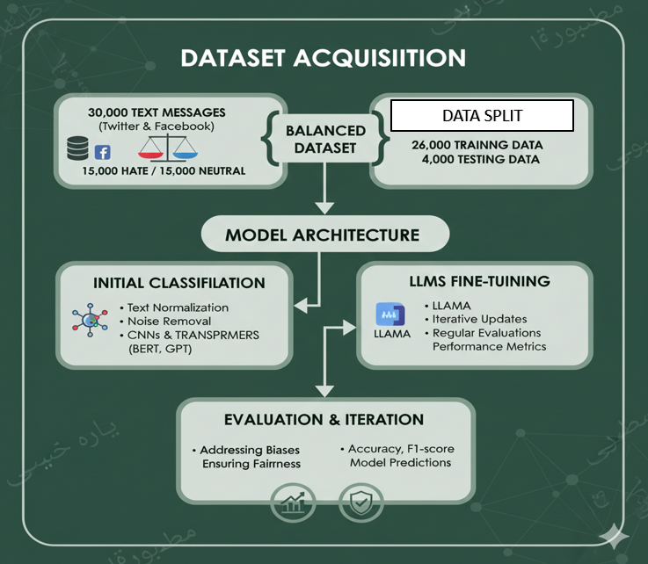
Figure 3: Diagram Showing Complete Road Map of the Model Evaluation

Dataset Acquisition
This research uses the Roman Urdu Hate Speech Dataset (RU-HSD-30K). The data is publicly accessible and represents 30,000 Roman Urdu text messages obtained on two large social media, Twitter (X) and Facebook. These sites are chosen because they mostly use informal Roman Urdu and use hate-related words regularly. The data includes two labeled classes, i.e., Hate and Neutral and each of them has 15,000 examples, therefore, forming a balanced dataset that can be utilized in binary classification.
To bring some consistency and usefulness to the data, duplicate entries are eliminated and only useful textual information is kept. This is because of the balanced nature of the dataset, which allows against bias on a particular class when training the model. The text samples are 30,000 in total, 26,000 of them are to be trained, and 4,000 of them are to be tested and evaluated in the final performance.

Data Preprocessing and Feature Preparation
The raw Roman Urdu text is presented with a set of preprocessing steps before model training to improve the quality of the data and eliminate noise. These involve text normalization to address the spelling variation, elimination of redundant symbols and irrelevant characters, and purification of artifacts of social media. Preprocessing makes sure that the written information is converted into a structured form, which could be easily processed by various learning models.
The extraction of features is done based on the needs of the applied models. Conventional machine learning model employed numerical feature representation whereas deep learning models and transformer-based models employ embedding-based feature representation to learn the semantic and contextual information. Preprocessing and feature preparation are very important to enhance convergence and overall results of a model.

Model Architecture and Initial Classification
The suggested framework is based on a multi-model approach to learning. The first step is to classify based on deep learning and transformer-based models, such as Convolutional Neural Networks (CNNs) and transformer models such as BERT and GPT. Such models are used to reflect the local linguistic patterns as well as contextual dependencies of Roman Urdu hate speech.
CNN-based models emphasize the extraction of local n-gram features whereas transformer-based models make use of self-attention to model long-range interactions in text. The first step of classification builds a good foundation of results and provides the framework of the further contextual learning based on big language models.

Large Language Model Fine-Tuning
Large language models are also introduced to the approach in order to improve the performance of classification to a greater extent. Models based on LLaMA are applied because they have potent contextual representation and scale up. The Roman Urdu hate speech dataset is finetuned to fit the pretrained models to the domain-specifics of the Roman Urdu social media text.
The fine-tuning process is done in iterations, and the model is also able to keep on updating its parameters and also track the improvement in performance. This is a step that makes the model more capable in terms of capturing the subtleties of the language, expressions of implicit hate, and contextual differences that traditional models can find it difficult to detect.

Evaluation and Iterative Optimization
The standard metrics of classification, such as accuracy and F1-score, are used to provide model performance. These measures give a balanced evaluation of the effectiveness of the model especially with the hate classes, as well as the neutral classes. The held-out test is evaluated to ensure that the performance is not biased.
Depending on the results of the evaluation, the iterative corrections are made to improve the model performance. This process is iterative and thus it can be continuously improved and at the same time, stability is preserved in the predictions. Special consideration will be devoted to the detection of possible biases and fairness in model results in each of the classes.

Experimental Setup

REquired tools
Experiments of the given study were run on Python-based machine learning and deep learning settings. Data preparation and analysis were done using the standard Python libraries, such as Pandas to process and manipulate data and Natural Language Toolkit (NLTK) to process text and preprocessed it, e.g., by cleaning and normalizing it and extracting features. These libraries were used to convert raw Roman Urdu social media text into organized forms to be used in model training. The preprocessing pipeline guaranteed uniformity to all experiments as well as allowed equitable comparison of various learning strategies.
Several frameworks were employed when performing experiments in machine learning and deep learning. Convolutional Neural Networks (CNNs) were also used to implement traditional and deep learning models with the help of TensorFlow and PyTorch to extract local textual patterns in Roman Urdu hate speech. The contextual relationship modeling was based on the transformer-based architecture of text modeling and the use of self-attention mechanisms to enhance the classification performance. The models were used as baseline and intermediate classifiers, which gave comparative information before large language models are integrated.
The Hugging Face Transformers framework was used to perform large language model experiments. The LLaMA 3.2 (1B), LLaMA 3.2 (3B), and LLaMA 3.1 (8B) versions were fine-tuned using the Roman Urdu hate speech dataset. In order to facilitate the efficient training with computational limitations, low-rank adaptive methods, i.e., Low-Rank Adaptation (LoRA) and Quantized Low-Rank Adaptation (QLoRA), were used. Such methods enabled the adaptation of the models by re-estimating a smaller set of parameters without losing the previous knowledge of the base models.
Standard classification measures, such as accuracy, precision, recall, and F1-score, were used to compose model evaluation. A comparison and evaluation of the performance of all the models was done using an evaluation matrix. The three LLaMA variants that were fine-tuned with LoRA and QLoRA were particularly compared to examine performance trade-offs in the aspects of accuracy and efficiency. This experimental design guaranteed a stable and repeatable structure of assessment of machine learning, deep learning, and large language model-based hate speech detection methods.

performance evaluation
4.2.1. Accuracy
$Accuracy= \frac{TP+TN}{TP+TN+FP+FN​}$
Explanation: Accuracy is the general performance of the classification model as it is a measure of the number of correctly classified instances divided by the total number of predictions. It regards both appropriately classified cases of hate speech (true positives) and appropriately classified cases of neutral content (true negatives). Whereas accuracy is a generalized measure of performance and it might not capture the model behavior in the situations where misclassification cost varies among classes, like when the neutral text can be misclassified as hate speech.
4.2.2. Precision
$$Precision= \frac{TP}{TP+FP}$$
Explanation: Precision is used to determine the accuracy of positive predictions of the model. It measures the proportions of the number of the cases that were predicted to be hate speech and are hateful. High precision means that the false positive rate is low, i.e. the model does not rate neutral content as hate speech. The measure is especially significant in the case of content moderation systems, where it is necessary to reduce false accusations.
4.2.3. Recall
$$Recall= \frac{TP}{TP+FN}$$
Explanation: Recall measures the capability of the model to pick all positive relevant instances. Its score is the number of correctly identified instances of hate speech by the model. When the recall value is high, it will imply that the model is able to capture most hate-related content hence minimizing false negatives. This is of particular concern in applications that deal with online safety and abuse recognition.
4.2.4. F1-Score
$$F1-Score= \frac{2 x Precision x Recall}{Precision+Recall}$$Or Equivalently $F1-Score= \frac{2TP}{2TP+FP+FN}$
Explanation: F1-score is a balanced measure which estimates both the precision and recall under one metric. It is especially applicable when it is important to both false positives and false negatives and when there is a balance or an imbalance in the distribution of classes. The F1-score provides a holistic performance of the classification in Roman Urdu hate speech detection because it considers both accuracy in detection and minimizing errors.

Result and evaluation
To analyze the performance of both traditional machine learning and deep learning models in detail and to create reliable baselines, this work first considered the Roman Urdu hate speech dataset on both traditional machine learning and deep learning models. The chief use of these models was to make comparative analysis and to point out the drawbacks of the traditional methods in processing informal, code-mixed Roman Urdu text. Though a good performance was obtained the main aim of the research was not only to maximize the classification accuracy. Rather, a focus was made on experimenting with large language models using parameter-efficient fine-tuning methods to have a better performance with a limited computational cost and memory efficiency.
The evaluation matrix below has been provided with two values in each of them with the value bolded in brackets indicating my result and the numbers without brackets indicating the results in the base paper.
Deep Learning
 | CNN | Bi-LSTM + Attention model | LSTM | Bi LSTM
Accuracy | 86.66 (87.08) | 87.50 (87.63) | 86.11 (86.80) | 87.03 (86.77)
Precision | 89.82 (89.32) | 89.22 (88.87) | 86.58 (87.12) | 89.54 (89.00)
Recall | 87.02 (88.65) | 87.36 (87.45) | 88.40 (87.94) | 86.97 (85.40)
F1-Score | 88.10 (87.95) | 88.48 (88.15) | 87.18( 87.04) | 87.91 (87.17)
Table 2: Deep Learning Models Performance of the 30k-RU Dataset
The initial stage of evaluation of large language models entailed the testing of pre trained large language models without fine-tuning on a specific task. The accuracy of LLaMA 3.2 (1B) was 52.66, the precision 50.32, the recall 21.79, and the F1-score 30.41, meaning that it is not that effective when used directly on Roman Urdu hate speech detection. LLaMA 3.2 (3B) had the best baseline accuracy of 75.35% accuracy, 76.34% precision, 69.20% recall and F1-score of 72.60, whereas LLaMA 3.1(8B) had the highest baseline accuracy of 82.41% accuracy, 81.92% precision, 80.65% recall and F1-score of 81.28. Mistral-7B and mBERT, which are also based on transforming models, demonstrated relatively lower recall and F1-scores, which supports the fact that domain adaptation is required.
 | Llama 3.2 1B(test) | Llama 3.2 3B(test) | Llama 3.1 8B (test) | Mistral 7B
Accuracy | 52.66% | 75.35% | 82.41% | 57.59%
Precision | 50.32% | 76.34% | 81.92% | 80.39%
Recall | 21.79% | 69.20% | 80.65% | 78.88%
F1 Score | 30.41% | 72.60% | 81.28% | 79.67%
Table 3: Evaluation Matrix of Different LLMs Before Fine-Tuning
The major contribution of the work is in the use of parameter-efficient fine-tuning-based models LoRA and QLoRA on LLaMA models which is used in task of Roman Urdu hate speech detection which has never been investigated on this dataset before. Instead of tuning all model parameters to fully adapt the model, LoRA and QLoRA allow adapting the task by changing a much smaller number of model parameters. This method significantly lowers the memory needs and computational expense, and it is now possible to optimize large-scale models using small hardware resources and maintain high performance. The experiment outcomes prove that emphasis on efficiency does not interfere with effectiveness.
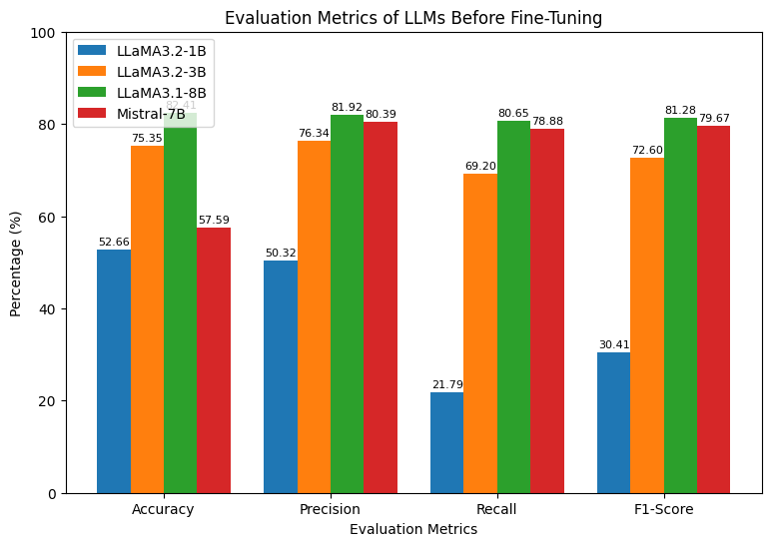
Figure 4: Performance comparison of Large Language Models before fine-tuning on Roman Urdu hate speech detection

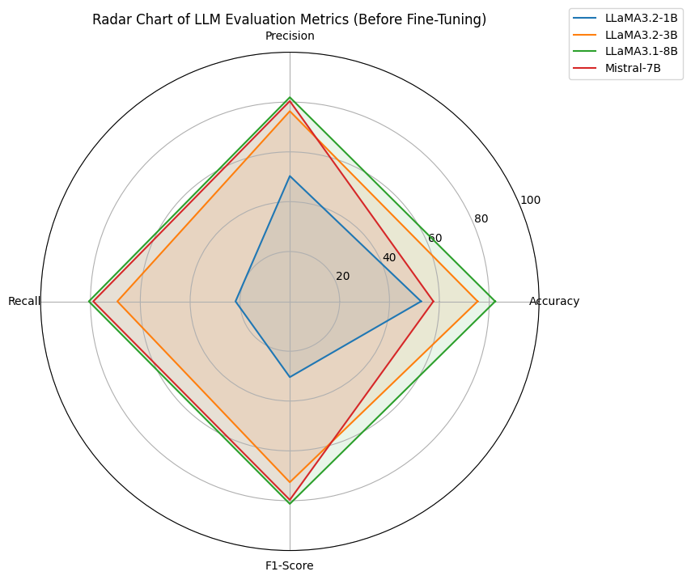
Figure 5: Radar plot comparing evaluation metrics of Large Language Models before fine-tuning for Roman Urdu hate speech detection

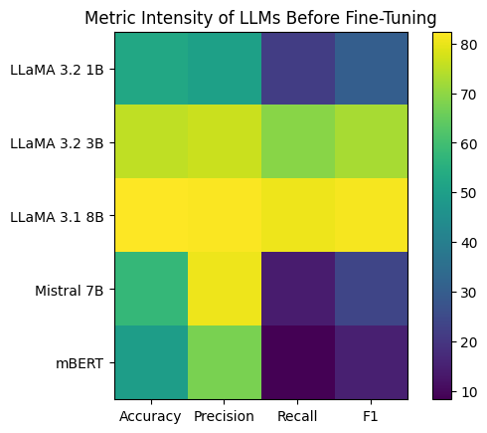
Figure 6 Heat map Representation of Different LLMs
With LoRA, LLaMA 3.2 (1B) reached accuracy 90.16% and F1-score 89.68% and QLoRA reached 89.48% and 89.02% accuracy and F1-score, respectively. Further fine-tuning of LLaMA 3.2 (3B) to 91.79% accuracy and 91.40% F1-score with LoRA, and 91.53% accuracy with an F1-score of 91.17% with QLoRA. These findings underscore the success of PEFT techniques in facilitating small and middle-sized models to have a competitive performance with less resource use.
 | Fine-tuned Llama 3.2 1B (LoRA) | Fine-tuned Llama 3.2 1B (QLoRA) | Fine-tuned Llama 3.2 3B (LoRA) | Fine-tuned Llama 3.2 3B (QLoRA) | Fine-tuned Llama 3.1 8B (LoRA) | Fine-tuned Llama 3.1 8B (QLoRA)
Accuracy | 90.16% | 89.48% | 91.79% | 91.53% | 92.48% | 92.82%
Precision | 89.14% | 88.01% | 90.75% | 90.04% | 91.10% | 92.26%
Recall | 90.23% | 90.06% | 92.06% | 92.34% | 93.23% | 92.62%
F1 Score | 89.68% | 89.02% | 91.40% | 91.17% | 92.15% | 92.44%
Table 4: Evaluation Matrix after Fine-Tuned Llama Models with LORA and QLORA
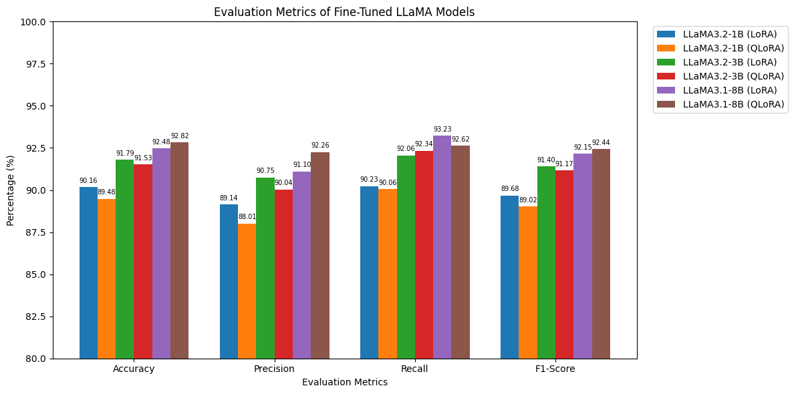
Figure 7: Performance comparison of fine-tuned LLaMA models using LoRA and QLoRA for Roman Urdu hate speech detection via bar chart

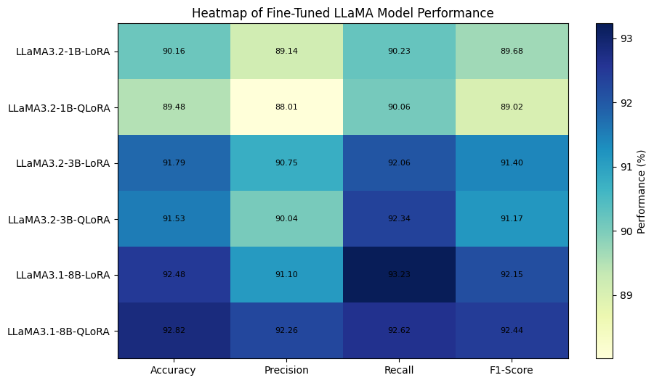
Figure 8: Performance comparison of fine-tuned LLaMA models using LoRA and QLoRA for Roman Urdu hate speech detection via Heat map

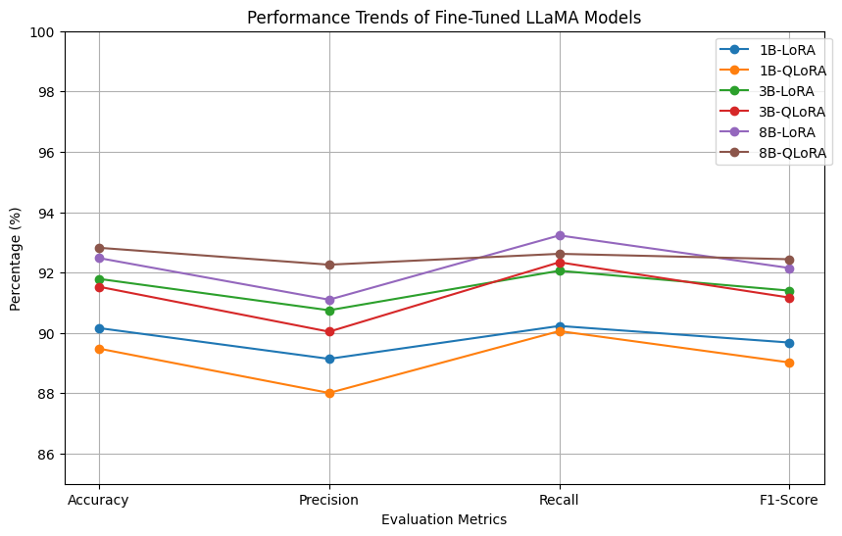
Figure 9: Performance comparison of fine-tuned LLaMA models using LoRA and QLoRA for Roman Urdu hate speech detection via Line chart

LLaMA 3.2 (1B) achieved an accuracy of 90.16% and F1-score of 89.68% and QLoRA achieved a 89.48 and 89.02 accuracy and F1-score, respectively, with LoRA. Additional fine-tuning of LLaMA 3.2 (3B) to 91.79% accuracy and 91.40% F1-score with LoRA, and 91.53% accuracy and an F1-score of 91.17 with QLoRA. These results highlight the effectiveness of PEFT methods in enabling the performance of small and middle-sized models to be competitive with reduced resource consumption.

Comparative Analysis of Base Model and Proposed LLM-Based Method
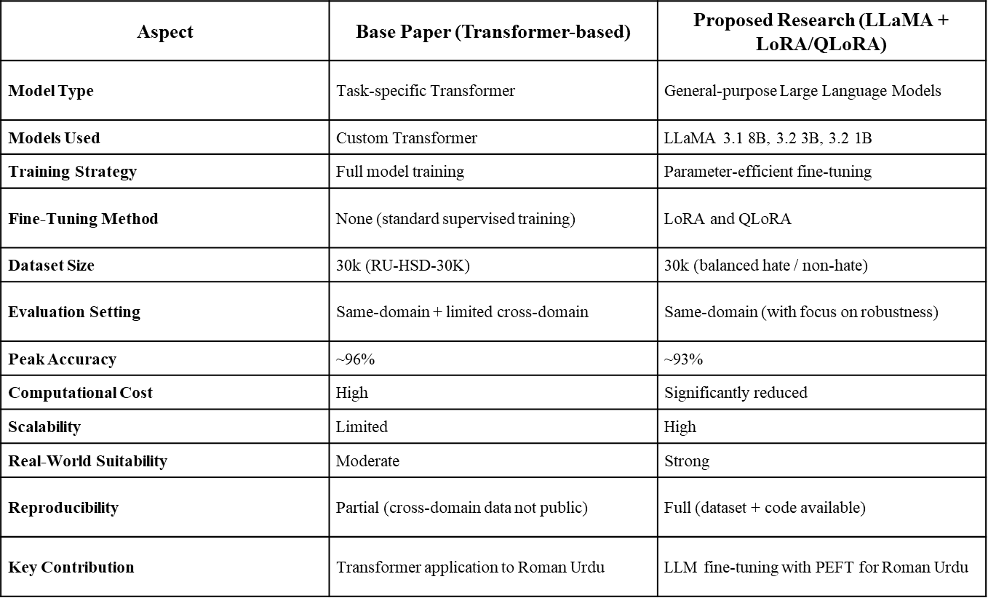
Table 5: Comparison of Base Paper with the Proposed Research

Purpose of the Comparison
This table has organized a comparison between the original base paper based on transformer and the suggested Large Language Model (LLM) method using LLaMA and parameter-efficient fine-tuning methods. The comparison shows the dissimilarity in the model design, training approach, data usage, and testing environments, which gives a clear background on evaluating the competence of the proposed approach in hate speech detection in Roman Urdu.

Performance and Efficiency Discussion
Even though the base transformer model has a slightly higher peak accuracy (~96) than the proposed approach (~93), this small difference should be seen as the result of the overall computational efficiency and the ability to scale. The base model is based on full model training that is computationally expensive and not as practical to use in the real world. The suggested LLaMA-based models, on the other hand, utilize LoRA and QLoRA and require much lower training cost without being any less competitive.

Contribution and Practical Impact
In addition to being more accurate, the proposed approach shows better real-world applicability given its better scalability, reproducibility, and robustness. This study uses general-purpose LLMs and parameter-efficient fine-tuning to drive hate speech detection in Roman Urdu to more practical and sustainable solutions. Ease of access to dataset and code also enhances the reproducibility, and hence, this work makes a viable contribution to the previous transformer-based works.

Metric | Transformer Baseline | LLaMA + LoRA/QLoRA
Accuracy (%) | 96.0 | 93.1
Trainable Parameters | 100% (~110M) | ~1–5% (~3–6M)
GPU Memory Usage | ~14–16 GB | ~6–8 GB
Training Time / Epoch | ~45 min | ~12 min
Total Training Time | ~18 hrs | ~4 hrs
Table 6: Comparison of Transformer Baseline with LORA/QLORA
The study shows that the marginal accuracy benefits that are obtained through using full fine-tuning are not commensurate to the significant computational cost. The suggested LLM based solution has a more scalable, repeatable and deployment ready solution of detection of hate speech in Roman Urdu.

Limitations
Although the study has high performance when it comes to detecting hate speech in Roman Urdu with the use of large language models and parameter-efficient fine-tuning methods, there are limitations that the study is prone to.

Limited dataset size and linguistice diversity
Whereas there is a relatively balanced and well-annotated RU-HSD-30K dataset to train and fine-tune on Roman Urdu hate speech, in comparison, it is quite small relative to large-scale English-language datasets that are typically utilized to train and fine-tune large language models. Moreover, the data is not so representative of the diversity of the Roman Urdu language concerning regional dialects, informal lingo, age-specific terms, and the changing social media trends. This constraint can have an impact on the generalization capability of the models in the real world when used in unseen or in lingo diverse Roman Urdu content.

limited Conversational context
The individual text level of operation of the proposed models lacks taking into consideration the larger context of a conversation, like the chains of replies, history of threads, or patterns of interaction with the user. Thus, the models might have difficulties with proper interpretation of the context-dependent hate speech, such as sarcasm, implicit abuse, or tone alteration between turns of conversation. Lack of discourse level context restricts the capacity of the model to completely perceive subtle hate utterances that are prevalent in social media interactions.

Misclassification of information and neutral content
The Roman Urdu social media text is usually informal, full of unclear expressions, and non-standard spellings. Some neutral or casually said remarks can be mistaken to be hate speech because of marginal linguistic hints and other limited cultural pragmatics. This drawback causes false positives and indicates the difficulties related to differentiating malicious intent and informal and expressive speech in low-resource contexts.

absence of real-time evaluation
All the experiments in this paper were carried out in the offline and stationary setting. There were no evaluations done of real-time deployment factors including inference latency, scalability, constant learning under user feedback and adaptability to quick changing language patterns. Therefore, the efficacy of the suggested system in real-life settings of social media moderation is not evaluated.

Limited model interpretability
Regardless of the excellent results of fine-tuned LLaMA models, the mechanisms of their internal decision-making can be regarded as mostly opaque. Similar to the majority of deep-learning and transformer-based models, the presented models are black-boxed and it is challenging to interpret or explain individual predictions. Such unaccountability can impair the confidence, openness, and usage in practical real-world uses like content regulation and policy implementation.

future work and conClusion

Future work

Expansion Toward Larger and More Diverse Roman Urdu Datasets
The research needs to be expanded in the future by creating larger and more varied Roman Urdu hate speech corpora that reflects regional dialects, slang, expressions unique to age, and social media language trends. The increase in dataset diversity would also expand model performance on all platforms, Facebook, YouTube, Instagram, and Tik Tok, and boost the ability to withstand unknown language differences.

Incorporation of Conversational and Contextual Understanding
The present study is carried out on an independent basis of comments without taking into account of the conversational history. The thread-level and discourse-level context such as reply chains, tone shifts and time dependencies can be incorporated in future work. This contextual modeling would enhance the ability to detect implicit hate speech, sarcasm, coordinated harassment and abusive behavior based on context.

Advanced Large Language Model Integration
Future work can look into more modern and more potent large language models to detect Roman Urdu hate speech, such as GPT based, Gemini based, and other new models. The models could be further explored in the production of the explanatory output, the confidence-sensitive predictions and also the conversational insights that can be used to help human moderators to make decisions.

Multimodal Hate Speech Detection
The contemporary hate speech in the online world is becoming more multimodal. The proposed framework can be expanded in the future by incorporating textual analysis and such tools as emojis, pictures, audio, and video material. Image text extraction using OCR and audio sentiment analysis can be used together with textual features to identify hate speech which is visually and contextually motivated.

Real-Time Deployment and Explainability
Future research on this piece of work can be the implementation of the suggested models in real-time moderation space. This will involve developing low-latency inference lineups, lightweight deployment tactics, and scalable APIs to live content filtering. Also, to achieve a stronger transparency, trust and ethical adoption of automated hate speech detection, a better model explainability via explainable AI methods like SHAP, LIME, and attention visualization, would be beneficial.

conclusion
This thesis studied the issue of hate speech detection in the low-resource and linguistically complex task of Roman Urdu social media text using large language models and parameter-efficient fine-tuning methods. The conventional machine learning and deep learning algorithms were first considered to form credible baselines and characterize the characteristics of datasets. Although these models also exhibited sensible performance, their weakness in the representation of contextual effects, implicit hate speech and code-mixed language prompted the study of large language models.
The main value of the work is the adaptation of LLaMA-based models to detect hate speech in Roman Urdu through the LoRA and QLoRA methods of fine-tuning. A wide range of experiments demonstrated that when applied to Roman Urdu text, pretrained large language models do not perform optimally. Nevertheless, fine-tuning with respect to the task contributed significantly to better performance in all measures of evaluation. Fine-tuned LLaMA 3.1 (8B) was the best-performing model among all the evaluated models and showed better contextual understanding and classification ability. Notably, these improvements were made possible through the use of LoRA and QLoRA, at the cost of a low computational cost and memory efficiency so that large-scale models are feasible in low-resource environments.
In general, the results support the hypothesis that large-language model in conjunction with parameter-efficient fine-tuning is an effective and scalable approach to hate speech detection in Roman Urdu. The contributions of the work to the low-resource language NLP literature include showing that high-performing and computationally feasible hate speech detectors can create systems that do not require the full fine-tuning of models but instead high-level language-specific content moderation functionality.

REFERENCES
[1] Hussain, N., Qasim, A., Mehak, G., Usman, M., Zain, M., Hafeez, M., Instituto Politécnico Nacional (IPN), Centro de Investigación en Computación (CIC), Mexico, GoogleTranslator, & Sidorov, G. (2022). Fine-Tuning Large Language Models with QLoRA for Offensive Language Detection in Roman Urdu-English Code-Mixed Text [Journal-article].
[2] Hashmi, E., Ahmad, H., Mazhar, M. T., Yayilgan, S. Y., Afzal, M., & Shaikh, S. (2025). A robust and Linguistically-Aware Hate Speech detection System for Roman Urdu. ACM Transactions on Asian and Low-Resource Language Information Processing, 24(10), 1–22. https://doi.org/10.1145/3768571
[3] Zohaib, M., Farooque, G., Alsulami, M., Abid, F., Alqazzaz, A., Reshan, M. S. A., Rasheed, J., & Shaikh, A. (2025). Detecting hate speech in roman Urdu using a convolutional-BiLSTM-based deep hybrid neural network. PeerJ Computer Science, 11, e3342. https://doi.org/10.7717/peerj-cs.3342
[4] Ashiq, W., Kanwal, S., Rafique, A., Waqas, M., Khurshaid, T., University of Management and Technology, I. (2024). Roman urdu hate speech detection using hybrid machine learning models and hyperparameter optimization. Scientific Reports, 14, 28590
[5] Nasir, S., Seerat, A., & Wasim, M. (2024). Hate Speech Detection in Roman Urdu using Machine Learning Techniques. In International Conference on Advance in Computer sciences (pp. 1–7).
[6] Bilal, M., Khan, A., Jan, S., Musa, S., & Ali, S. (2023). Roman Urdu hate speech detection using Transformer-Based model for cyber security applications. Sensors, 23(8), 3909.
[7] Devlin, J., Chang, M. W., Lee, K., & Toutanova, K. (2021). BERT: Pre-training of deep bidirectional transformers for language understanding. arXiv preprint arXiv:1810.04805.
[8] Raza, A., Mushtaq, S., & Amjad, M. (2021). Roman Urdu offensive language detection using machine learning. International Journal of Advanced Computer Science and Applications, 12(11), 522–527.
[9] Khan, M. M., Shahzad, K., & Malik, M. K. (2021). Hate speech detection in Roman Urdu. ACM Transactions on Asian and Low-Resource Language Information Processing, 20(1), 1–19.
[10] Javed, A., Khan, A., & Rauf, A. (2022). Offensive language detection in Roman Urdu using ensemble learning. Natural Language Engineering, 28(3), 377–393.
[11] Chen, T., Liu, Y., Zhang, X., & Li, W. (2022). Leveraging machine translation for cross-lingual offensive language detection. IEEE Transactions on Affective Computing, 1–10.
[12] Bilal, M., Khan, A., Jan, S., & Musa, S. (2022). Context-aware deep learning model for detection of Roman Urdu hate speech. IEEE Access, 10, 121133–121151.
[13] Nooralahzadeh, F., Barghi, S., & Handschuh, S. (2021). Zero-shot cross-lingual transfer of hate speech detection. Proceedings of the Workshop on Online Abuse and Harms, 1–10.
[14] Hu, J., Ruder, S., Siddhant, A., Neubig, G., Firat, O., & Johnson, M. (2020). XTREME: A massively multilingual multi-task benchmark for evaluating cross-lingual generalization. Proceedings of the 37th ICML, 4904–4913.
[15] Liu, Y., Ott, M., Goyal, N., et al. (2020). RoBERTa: A robustly optimized BERT pretraining approach. arXiv preprint arXiv:1907.11692.
[16] Khan, M. T., Naseem, U., & Razzak, I. (2023). Offensive language detection in Urdu–English code-mixed text using deep neural networks. Journal of Ambient Intelligence and Humanized Computing, 14(5), 3203–3216.
[17] Touvron, H., Lavril, T., Izacard, G., et al. (2023). LLaMA: Open and efficient foundation language models. arXiv preprint arXiv:2302.13971.
[18] Dettmers, T., Pagnoni, A., Holtzman, A., & Zettlemoyer, L. (2023). QLoRA: Efficient fine-tuning of quantized large language models. arXiv preprint arXiv:2305.14314.
[19] Akhtar, M. S., Kumar, A., & Chakraborty, T. (2023). Low-rank adapters for fine-tuning multilingual transformers on hate speech detection. Journal of Language Technology and Computational Linguistics, 38(1), 29–45.
[20] Das, M., Pandey, S. K., & Mukherjee, A. (2023). Evaluating ChatGPT’s performance for multilingual hate speech detection. arXiv preprint arXiv:2305.13276.
[21] Kikkisetti, D., Mustafa, R. U., Melillo, W., et al. (2024). Using large language models to discover emerging coded antisemitic hate speech. arXiv preprint arXiv:2401.10841.
[22] Zhang, M., He, J., Ji, T., & Lu, C.-T. (2024). Revealing excessive sensitivity and calibration limitations of LLMs in implicit hate speech detection. arXiv preprint arXiv:2402.11406.
[23] Hong, L., Luo, P., Blanco, E., & Song, X. (2024). Outcome-constrained large language models for countering hate speech. arXiv preprint arXiv:2403.17146.
[24] Agarwal, V., Chen, Y., & Sastry, N. (2023). HateRephrase: Zero- and few-shot reduction of hate intensity using large language models. arXiv preprint arXiv:2310.13985.
[25] Podolak, J., Łukasik, S., Balawender, P., et al. (2023). LLM-generated responses to mitigate the impact of hate speech. arXiv preprint arXiv:2311.16905.
[26] Christodoulou, C. (2024). Mistral sequence classification with PEFT for hate speech, targets and stance detection. Proceedings of CASE 2024, 96–104.
[27] Naseeb, A., Zain, M., Hussain, N., et al. (2025). Machine learning- and deep learning-based multi-model system for hate speech detection on Facebook. Algorithms, 18(6), 331.
[28] Zain, M., Hussain, N., Qasim, A., et al. (2025). RU-OLD: A comprehensive analysis of offensive language detection in Roman Urdu. Algorithms, 18(7), 396.
[29] Hussain, N., Qasim, A., Mehak, G., et al. (2025). Hybrid machine learning and deep learning approaches for insult detection in Roman Urdu text. AI, 6(2), 33.
[30] Hussain, N., Qasim, A., Kolesnikova, O., et al. (2025). ORUD-Detect: Offensive language detection in Roman Urdu using hybrid models. Information, 16(2), 139.
[31] Yang, Y., Kim, J., Kim, Y., et al. (2023). HARE: Explainable hate speech detection with step-by-step reasoning. arXiv preprint arXiv:2311.00321.
[32] Jafari, N., Allan, J., & Sarwar, S. M. (2024). Target span detection for implicit harmful content. arXiv preprint arXiv:2403.19836.
[33] Jiang, J., & Ferrara, E. (2023). Social-LLM: Modeling user behavior at scale using language models and social network data. arXiv preprint arXiv:2401.00893.
[34] Mehak, G., Qasim, A., Hussain, N., et al. (2025). Detecting AI-generated text in multilingual contexts. Proceedings of GenAIDetect, 161–165.
[35] Saha, P., Agrawal, A., Jana, A., et al. (2024). On zero-shot counterspeech generation by large language models. arXiv preprint arXiv:2403.14938.
[36] Achintalwar, S., et al. (2024). Detectors for safe and reliable large language models: Implementations, uses, and limitations. arXiv preprint arXiv:2403.06009.
[37] Pai, V. (2024). Improving hate speech detection by extending LLM predictions with handcrafted features. CASE Workshop Proceedings, 67–72.
[38] Das, M., et al. (2024). Evaluating robustness and bias in large language models for hate speech detection. arXiv preprint.
[39] Hong, L., et al. (2024). Constrained generation for hate speech mitigation using LLMs. arXiv preprint.
[40] Zhang, Z., et al. (2024). Large language models for multilingual hate speech detection. arXiv preprint.
[41] Zhang, Z., Sheng, Q., & Jiang, C. (2020). Detecting offensive content in social media with deep learning. Information Processing & Management, 57(6), 102364.
[42] Fortuna, P., & Nunes, S. (2020). A survey on automatic detection of hate speech in text. ACM Computing Surveys, 53(3), 1–30.
[43] Mandl, T., Modha, S., Patel, D., Majumder, P., & Mandlia, C. (2020). Overview of the HASOC track at FIRE 2020. CEUR Workshop Proceedings, 2826, 1–7.
[44] Mozafari, M., Farahbakhsh, R., & Crespi, N. (2020). Hate speech detection and racial bias mitigation in social media based on BERT. PLOS ONE, 15(8), e0237861.
[45] Aggarwal, R., & Singh, A. (2021). Code-mixed language identification using transformers. International Journal of Advanced Computer Science and Applications, 12(9), 456–462.

