A Project Report

On

# SELF DRIVING AND OBSTACLE

# DETECTING CAR ( SMART CAR)

Submitted in partial fulfillment of the requirement of

University of Mumbai for

**IoT Mini Project**

In

**Information Technology**

Submitted By

**SHAIKH HUMAIRAA MOHD ARIF**

**SHAIKH MEHVISH SABIR**

**ZUNZUNIA ARSIL MUSTUZAB**

Supervisor

**(Er. FARIDA ATTAR)**



**Department Of Information Technology**

**M.H. SABOO SIDDIK COLLEGE OF ENGINEERING**

**BYCULLA,MUMBAI – 400008.**

**UNIVERSITY OF MUMBAI**

**Academic Year 2019 – 2020**



Department of information technology

M.H .Saboo Siddik College of Engineering.

Byculla, Mumbai – 400008.

CERTIFICATE

This is to certify that the requirements for the report entitled **SELF DRIVING AND OBSTACLE**

**DETECTING CAR ( SMART CAR)** have been successfully completed by the following students:

**Name Roll No.**

**SHAIKH HUMAIRAA MOHD ARIF 6117049**

**SHAIKH MEHVISH SABIR 6117050**

**ZUNZUNIA ARSIL MUSTUZAB 6117062**

in partial fulfillment of IoT mini Project in the Department of Information Technology, M.H Saboo Siddik college of Engineering,Byculla,Mumbai-400008. during the Academic Year 2019 – 2020.

**_____________________**

**Supervisor**

**(Er. FARIDA ATTAR)**



## Department of information technology

M.H Saboo Siddik College of Engineering,

Byculla,Mumbai-400008.

PROJECT APPROVAL FOR

This project entitled SELF DRIVING AND OBSTACLE DETECTING CAR ( SMART CAR) by SHAIKH HUMAIRAA, SHAIKH MEHVISH and ZUNZUNIA ARSIL are approved for the degree of Bachelor of Engineering in Information Technology.

Examiners:

1. ________________

2. ________________

3. ________________

Date:

Place:



## Department of information technology

M.H Saboo Siddik College of Engineering.

Byculla, Mumbai-400008.

DECLARATION

We declare that this written submission for IoT Mini Project entitled SELF DRIVING AND OBSTACLE DETECTING CAR ( SMART CAR) represent our ideas in our own words and where others' ideas or words have been included. We have adequately cited and referenced the original sources. We also declare that we have adhered to all principles of academic honesty and integrity and have not misrepresented or fabricated or falsified any ideas / data / fact / source in our submission. We understand that any violation of the above will cause for disciplinary action by institute and also evoke penal action from the sources which have not been properly cited or from whom prior permission have not been taken when needed.

Project Group Members:

SHAIKH HUMAIRAA __________________________

SHAIKH MEHVISH__________________________

ZUNZUNIA ARSIL __________________________

Date:

Place: MUMBAI

**Table of Contents**

|  |  |  |  |
| --- | --- | --- | --- |
| Abstract................................................................................................................................ | | | I |
| List of Figures...................................................................................................................... | | | i |
| List of Tables....................................................................................................................... | | | ii |
| **1.** | **Introduction**................................................................................................................. | | 1 |
|  | **1.1** | IoT Introduction.......................................................................................... | 2 |
|  | **1.2** | Literature Survey............................................................................................. | 3 |
|  | **1.3** | Problem Statement............................................................................................ | 4 |
|  | **1.4** | Objectives…………………………................................................................ | 4 |
|  | **1.5** | Circuit Design & Block Diagram …............................................................... | 5 |
|  | **1.6** | H/W and S/W Requirements ……............................................................ | 6 |
| **2.** | **Implementation of Mini Project**............................................................................... | | 13 |
|  | **2.1** | Coding implementation of mini project............................................................. |  |
|  | **2.2** | Snapshots of working of project………............................................................ |  |
| **3** | **Conclusion and Future Scope** | |  |
| **4** | **References** | |  |
| **5** | **Acknowledgement** | |  |

## **Abstract**

The project describes an obstacle avoiding vehicle. The vehicle is made using an Ultrasonic sensor and is controlled by Arduino-Uno microcontroller. Ultrasonic sensor is fixed in front of the vehicle and it senses the data from the surrounding. The sensor senses an obstacle and deviates it's path to choose an obstacle free path. The wheel movement and direction will be according to the sensing done by ultrasonic sensor. The vehicle will be used for detecting the obstacle and avoiding any kind of collision. We have programmed the microcontroller in a way that the vehicle will run automatically without the use of any application.

**1.2 Literature Survey**

Trajectory planning is one of the most important pivotal point in pick and place tasks done by robotic manipulators. In this work, we have presented a car, which is compact, autonomous and fully functional.

This smart car is built to sense any obstacle in its path, to avoid it and resume its running involving pre-computation of an obstacle free path. Ultrasonic sensors were adapted to implement a real-time obstacle avoidance system for wheeled robots, so that it can continually detect surroundings, avoid obstacles, and move towards the target area.

This model has various other applications as well like, in vaccum cleaners, avoiding concealed paths, parking systems, assembling automobiles in industries, in scientific exploration and many more.

In conclusion, through this project, we aim to construct a model of a smartcar that is beneficial to the quotation problems of the present generation.

**1.3 Problem statement**

**ARDUINO BASED SELF DRIVING AND OBSTACLE DETECTING CAR (SMART CAR)**

**1.4 Objectives**

* To detect obstacles and avoid them in the trajectory.
* Uses Ultrasonic Sensor which is capable of detecting obstacles which may appear suddenly, for instance, an animal on the road.
* To operate in the environment without much interference.
* To detect very minute details, which human eye may neglect.
* To map various topographies and terrains.

**1.5 Circuit design and block diagram**

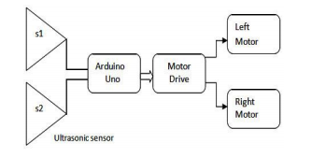

**1.6 Hardware and Software requirements**

1. **Hardware Requirements**
2. **A TOY CAR (REMOTE CONTROL CAR)**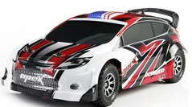

Radio-controlled cars (or RC cars for short) are battery/gas-powered model cars or trucks that can be controlled from a distance using a specialized transmitter or remote.

1. **ARDUINO UNO MICROCONTROLLER (An open source microcontroller board)**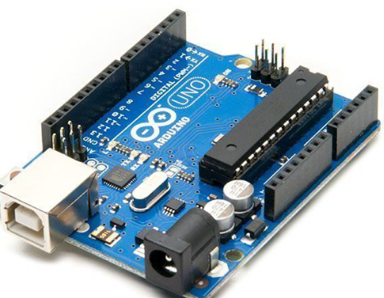

The Arduino Uno is a microcontroller board based on the ATmega328 (datasheet). It has 14 digital input/output pins (of which 6 can be used as PWM outputs), 6 analog inputs, a 16 MHz ceramic resonator, a USB connection, a power jack, an ICSP header, and a reset button

1. **BLUETOOTH MODULE ( HC-06 ) (To establish wireless connection between Arduino and other devices)**

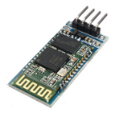

The HC-06 is a class 2 slave Bluetooth module designed for transparent wireless serial communication. Once it is paired to a master Bluetooth device such as PC, smartphones and tablet, its operation becomes transparent to the user.

1. **MOTOR DEVICE SHIELD ( L293-D ) (Used to control motor speed and direction)**

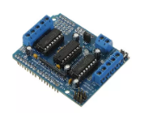

It lets you drive two DC motors with your Robomart Arduino board, controlling the speed and direction of each one independently.

1. **ULTRASONIC SENSOR (HCSR0-4 ) (Used for detecting obstacle)**

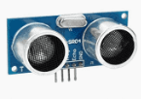

An ultrasonic sensor is an instrument that measures the distance to an object using ultrasonic sound waves. An ultrasonic sensor uses a transducer to send and receive ultrasonic pulses that relay back information about an object’s proximity**.**

1. **BATTERY (POWER SOURCE)**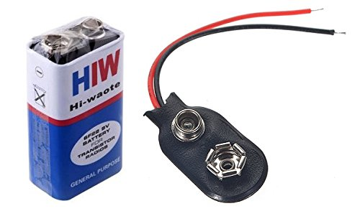

A battery is a device consisting of one or more [electrochemical cells](https://en.wikipedia.org/wiki/Electrochemical_cell) with external connections provided to power electrical devices such as [flashlights](https://en.wikipedia.org/wiki/Flashlight), [mobile phones](https://en.wikipedia.org/wiki/Mobile_phone), and [electric cars](https://en.wikipedia.org/wiki/Electric_car).

1. **JUMPER WIRES (CONNECTION PURPOSE)**

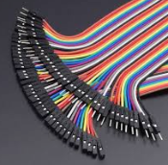

Jumper wires are simply wires that have connector pins at each end, allowing them to be used to connect two points to each other without soldering.

1. **Software Requirements**
2. **ARDUINO IDE ( Integrated Development Environment )**



Arduino IDE. The Arduino integrated development environment (IDE) is a cross-platform application (for Windows, macOS, Linux) that is written in the programming language Java. The Arduino IDE supplies a software library from the Wiring project, which provides many common input and output procedures.