***COFFEE CO-OP* CLEANING PROMO!**

**CLEAN THE FRIDGE?** $7* credit!

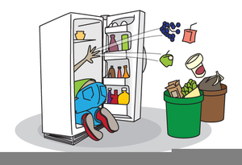

**EMPTY THE DISH RACK?** $0.5* credit!

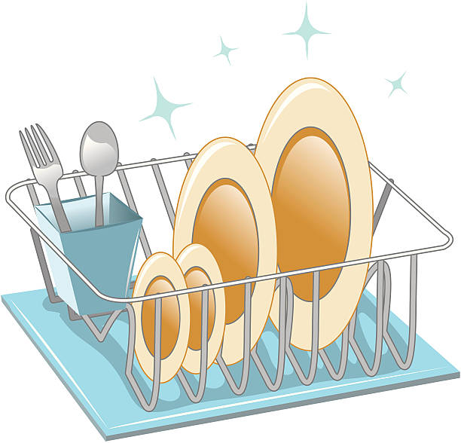

*Max $10 per update period! Sign up 🡪

|  |  |  |  |
| --- | --- | --- | --- |
| **NAME** | **ID #** | **TASK** | **DATE** |
|  |  |  |  |
|  |  |  |  |
|  |  |  |  |
|  |  |  |  |
|  |  |  |  |
|  |  |  |  |
|  |  |  |  |
|  |  |  |  |
|  |  |  |  |
|  |  |  |  |
|  |  |  |  |
|  |  |  |  |
|  |  |  |  |
|  |  |  |  |
|  |  |  |  |
|  |  |  |  |
| **NAME** | **ID #** | **TASK** | **DATE** |
|  |  |  |  |
|  |  |  |  |
|  |  |  |  |
|  |  |  |  |
|  |  |  |  |
|  |  |  |  |
|  |  |  |  |
|  |  |  |  |
|  |  |  |  |
|  |  |  |  |
|  |  |  |  |
|  |  |  |  |
|  |  |  |  |
|  |  |  |  |
|  |  |  |  |
|  |  |  |  |

|  |  |  |  |
| --- | --- | --- | --- |
| **NAME** | **ID #** | **TASK** | **DATE** |
|  |  |  |  |
|  |  |  |  |
|  |  |  |  |
|  |  |  |  |
|  |  |  |  |
|  |  |  |  |
|  |  |  |  |
|  |  |  |  |
|  |  |  |  |
|  |  |  |  |
|  |  |  |  |
|  |  |  |  |
|  |  |  |  |
|  |  |  |  |
|  |  |  |  |
|  |  |  |  |

|  |  |  |  |
| --- | --- | --- | --- |
| **NAME** | **ID #** | **TASK** | **DATE** |
|  |  |  |  |
|  |  |  |  |
|  |  |  |  |
|  |  |  |  |
|  |  |  |  |
|  |  |  |  |
|  |  |  |  |
|  |  |  |  |
|  |  |  |  |
|  |  |  |  |
|  |  |  |  |
|  |  |  |  |
|  |  |  |  |
|  |  |  |  |
|  |  |  |  |
|  |  |  |  |