## List of figures

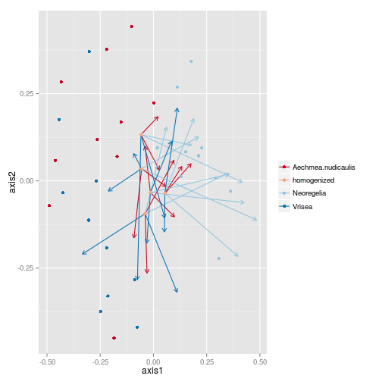

### Figure 1 Insect community

change over time in the inter-species experiment. The graph is based on a non- metric multidimensional scaling of a euclidian distance matrix among communities. Each dot represents the initial (observed) community composition of each bromeliad; dots are coloured according to species. We formed 'homogenized' communities by allocating six bromeliads (two of each species) to blocks and dividing the combined invertebrate community evenly among them. Arrows show the change from this identical starting community to the composition at the end of the experiment (position of the arrow head).A test of our hypothesis requires these arrows (representing community 'relaxation' back to the original composition) be both in a nonrandom direction (ie tending to point to intial compositions) *and* longer for insects than for zooplankton, which in turn show larger change than bacteria.

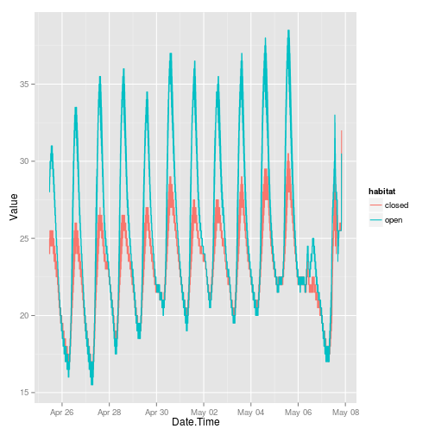

### Figure 2

The temporal variation in temperature between two habitats -- open and closed. The effect of a very cold day can be seen on the right.