Pentagon: An Ecommerce Web Application

Software Requirements Specification

1st November 2023

Debayan Chattopadhyay
Reg: 12100349
Roll No: 2
Section: K21WM

Prepared for
Continuous Assessment 3
Autumn 2023

Revision History

Date | Description | Author | Comments
03.11.2023 | V1.1 | Debayan Chattopadhyay | Version 1.1 is released
03.11.2023 | V1.2 | Debayan Chattopadhyay | Version 1.2 is released
04.11.2023 | V1.3 | Debayan Chattopadhyay | Version 1.3 is released

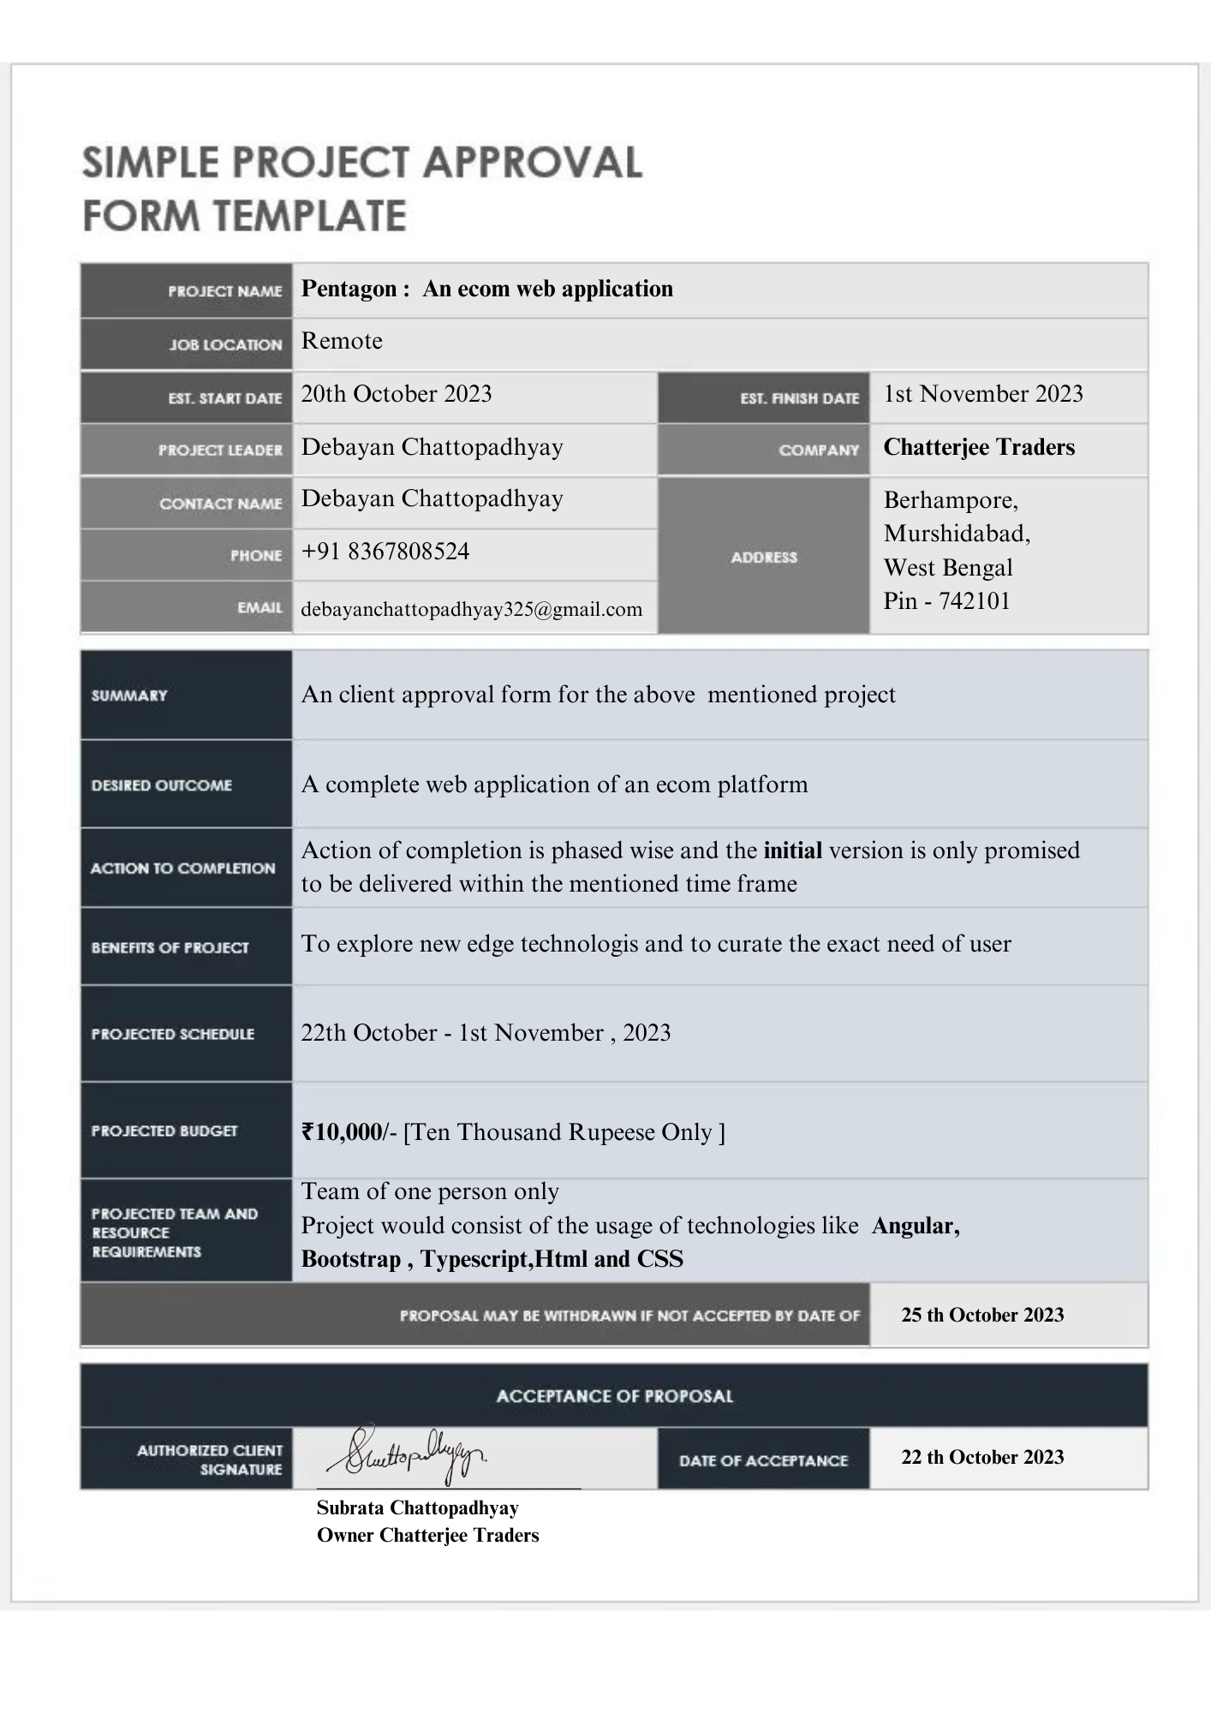
Table of Contents

Revision History ii
CLIENT Approval Error! Bookmark not defined.
1. Introduction 1
1.1 Purpose 1
1.2 Scope 1
1.3 Definitions, Acronyms, and Abbreviations 2
1.4 References 3
1.5 Overview 3
2. General Description 4
2.1 Product Perspective 4
2.2 Product Functions 4
2.3 User Characteristics 4
2.4 General Constraints 5
2.5 Assumptions and Dependencies 6
3. Specific Requirements 7
3.1 External Interface Requirements 7
3.1.1 User Interfaces 7
3.1.2 Hardware Interfaces 7
3.1.3 Software Interfaces 7
3.1.4 Communications Interfaces 7
3.2 Functional Requirements 8
3.2.1 <Functional Requirement or Feature #1> 8
3.2.2 <Functional Requirement or Feature #2> 9
3.5 Non-Functional Requirements 10
3.5.1 Performance 10
3.5.2 Reliability 10
3.5.3 Availability 10
3.5.4 Security 10
3.5.5 Maintainability 10
3.5.6 Portability 11
3.7 Design Constraints 11
3.9 Other Requirements 12
4. Analysis Models 13
4.1 Data Flow Diagrams (DFD) 14
5. Github link……………………………………………………………………...……………………………16
A. Appendices 16
A.1 Appendix 1 16

1. Introduction

The introduction of an e-commerce website's Software Requirement Specification (SRS) sets the stage for the entire document. It serves as a concise overview of the project, highlighting the purpose and significance of the SRS. In this section, we define the e-commerce website as a digital platform designed to enable online shopping and transactions. The primary goal is to create an intuitive, secure, and efficient online shopping experience for customers. This SRS outlines the essential details, functionalities, and features that will drive the development of this web application. It is a crucial reference for all stakeholders involved in the project, providing a clear roadmap for the successful creation of this e-commerce solution.

Purpose

The purpose of this SRS is to define the requirements for the e-commerce website's development. It serves as a guide for the project team, including developers, designers, project managers, and quality assurance teams, ensuring a shared understanding of the project's scope and objectives.

1.2 Scope

1. Software Product Name: E-Commerce Web Application

2. What the Software Will Do:

The software will facilitate online shopping and transactions, providing users with a secure and efficient platform to browse products, make purchases, manage their accounts, and access customer support. It will include features such as product catalog, shopping cart, user authentication, order processing, payment processing, and user support.

3. What the Software Will Not Do:

The software will not handle physical product delivery or logistics; it will not engage in financial transactions beyond payment processing (e.g., it won't manage users' bank accounts); it won't provide third-party services unrelated to e-commerce, such as social media integration.

4. Application of the Software:

(a) The software aims to provide users with an exceptional online shopping experience, offering a wide range of products, user-friendly navigation, and efficient order processing.

(b) Specific goals include ensuring a responsive website with fast page load times, secure payment handling, and an intuitive user interface.

(c) This scope aligns with the objectives outlined in higher-level specifications, maintaining consistency across the System Requirement Specification and other related documents

1.3 Definitions, Acronyms, and Abbreviations

This subsection provides essential definitions, acronyms, and abbreviations to aid in understanding the SRS. Detailed explanations and references can be found in the appendices or related documents.

Terms:

E-commerce Website: The web application under development, allowing users to shop online and perform transactions.

Shopping Cart: A virtual container for users to store selected items before making a purchase.

User Authentication: The process of verifying user identities during login.

Order Processing: The steps involved in receiving, confirming, and fulfilling user orders.

Payment Processing: Handling financial transactions, ensuring secure payment methods.

Acronyms:

SRS: Software Requirement Specification

UI: User Interface

UX: User Experience

Abbreviations:

DBMS: Database Management System

QA: Quality Assurance

For detailed definitions and further references, please consult the relevant appendices and associated documentation

.

1.4 References

The following is a list of documents referenced in this SRS, along with their titles, report numbers, dates, and publishing organizations. Sources to obtain these references are available in the appendices or related documentation:

1. "Software Requirements Specification document with example by Ravi Bandakkanavar" - Report Number: NA - Date: [May 8 , 2023] - Published by: [KrazyTech]

2. "Angular powered bootstrap" - Date: [23.10.2023] - Published by: [Open source]

For access to the complete references and additional details, please refer to the respective appendices or documents provided in the project's reference materials.

1.5 Overview

The SRS document is structured to provide a comprehensive understanding of the requirements for our e-commerce website. It begins by outlining the document's purpose and intended audience in the "Purpose" section, followed by a clear definition of the project's scope in "Scope." In "Definitions, Acronyms, and Abbreviations," essential terms and their references are provided. The "References" section catalogues external documents cited in this SRS. This section, "Overview," serves as an introduction to the document's organization. Subsequent sections delve into detailed functional and non-functional requirements, system architecture, data models, user interfaces, security, performance, testing, maintenance, and legal and regulatory compliance. This structured approach ensures that all stakeholders have a clear and systematic reference for the e-commerce website's development and maintenance.

2. General Description

In this section, we provide an overarching view of the e-commerce web application, focusing on factors that influence its requirements. It is essential to emphasize that this section does not specify detailed requirements but rather offers a contextual understanding. We outline the system's perspective within the broader technological landscape, highlight major functions, consider user characteristics, acknowledge constraints, and address any assumptions and dependencies. This foundation sets the stage for the more specific requirements detailed throughout the document.

2.1 Product Perspective

This subsection of the SRS situates the e-commerce web application within the context of related products or projects, ensuring a clear understanding of how it interfaces and interacts within the broader technological landscape.

2.2 Product Functions
The following software is an e-commerce website with various features and functionalities:

- Landing page: Where the hero products of the market of the specific seller gets displayed over the carousel and the trending products are displayed bellow.
- Functional Navigation bar: The nav bar is well functional and dynamic and well represented for various cases.
- Cart feature: User can make a choice and add their desired products into the cart.
- Seller Authentication: Seller can make login or sign-up process
- User Authentication: User can make login or sign-up process
- Seller Page: It consists of various options like List products, Add products, Update product, Delete product.
- User Page: It consists of various functions like Add to cart, Checkout page , and My Orders.

02.3 User Characteristics

The intended users of the e-commerce website can be categorized into two main groups: sellers and buyers. Sellers are individuals or businesses who want to showcase and sell their products on the platform, while buyers are the customers looking to browse, select, and purchase products. These user characteristics will influence specific requirements, as sellers will need features for product management, authentication, and account management, while buyers will require features like adding products to their cart, a seamless checkout process, and order tracking. Additionally, the platform should be user-friendly and accessible to a wide range of audiences, considering varying levels of technical proficiency and familiarity with e-commerce websites.

2.4 General Constraints

The general constraints for the e-commerce website project include:

1. Budget Constraints: The project will have a specific budget that will limit the resources available for development, including software and hardware acquisition, staffing, and other associated costs.

2. Time Constraints: There may be a tight timeline for the development of the e-commerce website, which could impact the choice of technologies, development methodologies, and the overall project schedule.

3. Technology Stack: The use of specific technologies or frameworks may be constrained by the organization's existing infrastructure, expertise, or licensing agreements.

4. Security and Privacy Regulations: The system must adhere to legal and industry-specific regulations related to data privacy and security, such as GDPR or PCI DSS, which can influence the design and implementation of features.

5. Scalability Requirements: The system should be designed to accommodate future growth, and this scalability constraint can affect architectural decisions and infrastructure choices.

6. Third-Party Integrations: If the system needs to integrate with external services, APIs, or third-party software, constraints may be imposed by the availability and compatibility of those external components.

7. Accessibility Requirements: The website should comply with accessibility standards (e.g., WCAG) to ensure it is usable by individuals with disabilities, which may impose design and development constraints.

8. Geographic or Language Constraints: If the platform targets a global audience, there may be constraints related to language support and localization.

9. Hardware Limitations: The system's performance may be constrained by the hardware available for hosting and running the website, impacting scalability and performance optimization strategies.

10. User Experience Constraints: The user interface and experience must align with specific design and branding guidelines, which may impose constraints on the visual and interactive aspects of the website.

11. Data Storage and Retention Policies: The system may need to adhere to specific data storage and retention policies, which can influence database design and data management.

These general constraints need to be considered throughout the software development process to ensure that the resulting e-commerce website meets its objectives while adhering to these limitations.

2.5 Assumptions and Dependencies

Assumptions:

Local Database: It is assumed that the website will utilize a local database for storing product information, user data, and order details, rather than relying on external database services.

Manual Payment Handling: As there are no payment gateways, it is assumed that payments for products will be processed manually, such as through cash on delivery or other offline payment methods.

No Logistics Tracking: Since there is no logistics tracking, it is assumed that users and sellers will be responsible for managing product delivery and tracking outside the system.

Limited Geographic Scope: The e-commerce platform assumes that it will serve a limited geographic area, given the absence of extensive logistics tracking and payment processing capabilities.

Dependencies:

Local Database System: The system's functionality heavily depends on the local database system, and any changes or issues with the database can directly impact the website's performance and data management.

Manual Payment Handling: The process of handling payments manually will be a critical dependency, as it affects the order processing workflow.

Local Logistics: As there is no logistics tracking, the website's functionality will depend on local logistics and delivery systems to fulfill orders and communicate delivery status to users.

Geographic Limitations: The website's scope and operations will be constrained by the specific geographic area it serves, as extensive shipping and logistics services are not integrated.

Local Infrastructure: The hosting and network infrastructure for the website will be localized to the specific region it serves, which is a critical dependency for its availability and performance.

These adjusted assumptions and dependencies reflect the project's unique characteristics without payment gateways, logistics tracking, and a reliance on a local database. The project's requirements and functionality should be tailored to suit these constraints and dependencies accordingly.

3. Specific Requirements

3.1 External Interface Requirements

3.1.1 User Interfaces
- The user interface shall be intuitive and user-friendly, ensuring ease of navigation for both buyers and sellers.
- The landing page shall prominently display featured products in a carousel format and trending products below, facilitating user engagement.
- The navigation bar shall provide clear and dynamic access to various sections of the website, including user and seller pages.
- User authentication and registration processes shall be straightforward and include password recovery options.
- Sellers shall have a dedicated user interface for product management, including listing, adding, updating, and deleting products.
- Buyers shall have a user interface for adding products to their cart, proceeding to the checkout page, and viewing their order history.

3.1.2 Hardware Interfaces
- The website shall be hosted on a server with sufficient capacity to handle expected user traffic and database storage requirements.
- The website shall support standard web browsers, including but not limited to Chrome, Firefox, Safari, and Edge, for optimal compatibility.

3.1.3 Software Interfaces
- The website shall interact with the local database for storing and retrieving product information, user data, and order details.
- The system shall utilize a local database management system for efficient data management.
- The website shall not integrate external payment gateways, and payments shall be handled manually.
- There will be no third-party logistics tracking services integrated into the system.
- The website shall be designed to operate within the specific geographic limitations defined, serving a local area.

These requirements outline the software interfaces that the e-commerce website will utilize, including its reliance on a local database, exclusion of external payment gateways and logistics tracking, and adherence to specific geographic constraints.

3.1.4 Communications Interfaces
- The website shall rely on standard internet protocols for communication, including HTTP and HTTPS for secure data transmission.
- User and seller authentication shall involve secure communication channels to protect user credentials.

These requirements specify the communication interfaces that the e-commerce website will use, emphasizing the use of standard internet protocols and security measures for protecting user information during authentication.

3.2 Functional Requirements
This section describes specific features of the software project. If desired, some requirements may be specified in the use-case format and listed in the Use Cases Section.

3.2.1 Adding Items to the cart and checkout

3.2.1.1 Introduction

This functional requirement outlines the ability for users to add products to their shopping cart on the e-commerce website.

3.2.1.2 Inputs

User input: The user selects a product and specifies the quantity they want to add to the cart.

3.2.1.3 Processing

When the user selects a product and specifies the quantity, the system adds the selected product to the user's shopping cart.

The system updates the total cost of items in the cart based on the selected products and quantities.

3.2.1.4 Outputs

The system displays the updated shopping cart, showing the added product, quantity, and the total cost.

The system may provide a "Proceed to Checkout" option for the user to complete the purchase.

3.2.1.5 Error Handling

If the selected product is out of stock, the system displays an error message to the user and does not add the product to the cart.

If there are issues with the processing of the user's request, such as a network error, the system should provide an error message and offer options for the user to retry.

3.2.2 Modification of Products by Seller

3.2.2.1 Introduction
This functional requirement pertains to the ability of users to add and update products in their product listings on the e-commerce website.

3.2.2.2 Inputs
User input: Users specify the product they want to add or update and provide relevant details such as product information, pricing, and quantity.

3.2.2.3 Processing
Upon the user's product addition or update request, the system processes the provided information, ensuring that the product listing is added or updated accordingly.

3.2.2.4 Outputs
The system confirms the addition or update of the product, reflecting the changes in the product listings as necessary.

3.2.2.5 Error Handling
In the event of any errors or issues during the addition or update process, the system provides relevant error messages or notifications to the user for resolution.

3.5 Non-Functional Requirements

3.5.1 Performance

The system must load web pages within 2 seconds on average.

Concurrent user capacity: The system should handle a minimum of 1,000 concurrent users during peak hours.

Response time for processing transactions should not exceed 500 milliseconds.

3.5.2 Reliability

The system shall have a Mean Time Between Failures (MTBF) of at least 30 days.

In case of a system failure, data recovery and system restoration should occur within 30 minutes.

3.5.3 Availability

The system should have 99.9% uptime, allowing a maximum of 8 hours of downtime per year, mainly during scheduled maintenance.

Backup systems must be available and functional within 15 minutes in case of a primary system failure.

3.5.4 Security

All user data and transactions must be encrypted using industry-standard security protocols (e.g., TLS) during transmission.

User passwords must be securely hashed and stored to prevent unauthorized access.

The system should have intrusion detection and prevention mechanisms in place to safeguard against cyberattacks.

3.5.5 Maintainability

Codebase should be well-documented with inline comments, making it comprehensible for future development and maintenance.

The system's architecture should be modular, allowing for efficient updates and scalability.

Software updates and patches should be deployable within 24 hours of release.

3.5.6 Portability

The system should be compatible with modern web browsers (e.g., Chrome, Firefox, Safari, Edge) on various operating systems (e.g., Windows, macOS, Linux).

3.7 Design Constraints
The provided design constraints offer valuable insights into how the software project should be approached. Let's further elaborate on how these constraints might influence the design and development of the software:

1. Minimalistic UI Design:
- The company's policy for a minimalistic UI design indicates that the user interface should be clean, simple, and uncluttered. This constraint can have several implications:
- User Interface (UI) elements should be straightforward and intuitive.
- Visual design should prioritize simplicity and ease of use.
- Emphasis on a responsive design that works well on various devices and screen sizes.
- Use of a consistent and minimalist color palette, typography, and layout.
- Reducing unnecessary features and options to streamline the user experience.

2. Shifting to Remote Cloud Database:
- The plan to migrate from a local database to a remote cloud database in the future introduces several design considerations:
- Data Migration: The software should be designed to facilitate a smooth transition from a local database to a cloud-based solution without data loss or disruption.
- Network Connectivity: The software must be able to handle potential variations in network connectivity when accessing a remote database. This could involve implementing strategies for handling unreliable or slow connections.
- Data Security: Ensuring data security and privacy during transmission to and storage in the cloud is paramount. Encryption and authentication mechanisms may be necessary.
- Scalability: The software should be designed to take advantage of cloud scalability, allowing for easy scaling of resources as the data and user load increase.
- Cost Considerations: The transition to a cloud database may introduce new cost considerations. The software should be designed to monitor and optimize database usage to control costs.

These design constraints play a crucial role in shaping the software's user interface and database architecture. They will influence decisions related to UI/UX design, database design, security measures, and future scalability. Adhering to these constraints will help align the software with the company's policies and its future technology infrastructure plans. It's important to communicate these constraints clearly to the development team to ensure that they are considered throughout the project's lifecycle.

3.9 Other Requirements

Other requirements encompass a wide range of non-functional or auxiliary considerations that are important for the successful development and operation of a software project. These requirements may not directly impact the core functionality of the software but are essential for overall effectiveness, user satisfaction, and compliance with standards. Here are some examples of other requirements that can affect a software project:

Documentation Requirements:

Specifications, user manuals, API documentation, and other forms of documentation are essential for developers, users, and support personnel.

Training and Onboarding Needs:

If the software is complex or serves specialized purposes, training and onboarding materials for users or administrators may be required.

Support and Maintenance Requirements:

Outlining plans for ongoing support and maintenance, including bug fixes, updates, and patches, is crucial for post-launch operations.

Data Backup and Recovery:

Requirements for data backup, disaster recovery, and business continuity planning, especially for applications that handle critical data.

Scalability and Capacity Planning:

Specify how the software should handle an increase in users or data over time and any additional infrastructure requirements.

Monitoring and Logging:

Requirements for real-time monitoring, logging, and analytics to track system performance and diagnose issues.

User Feedback and Enhancement Requests:

Define a system for collecting and prioritizing user feedback and feature requests.

Third-Party Integrations:

Requirements for integrating with external services, APIs, or software, including considerations like API versioning, compatibility, and data exchange formats.

Compliance with Accessibility Standards:

Ensure that the software meets accessibility standards, making it usable for people with disabilities.

User Acceptance Testing (UAT):

Define procedures and criteria for UAT, allowing stakeholders to verify that the software meets their requirements and expectations.

User Experience (UX) Guidelines:

Adhere to specific UX design principles, branding guidelines, and usability standards.

Deployment and Release Procedures:

Outline the process for deploying updates, new features, and releases, including version control and change management.

Compliance with Industry Standards:

Requirements to ensure the software complies with specific industry standards or certifications.

Feedback and Improvement Loop:

Establish a mechanism for continuously gathering feedback, assessing performance, and making iterative improvements to the software.

These other requirements are essential for creating a well-rounded and successful software project that not only functions correctly but also meet user expectations, legal and regulatory standards, and business goals. They often require careful planning and coordination to ensure they are adequately addressed throughout the software development lifecycle.

4. Analysis Models

Data Flow Diagrams (DFD):

Introduction: DFDs illustrate how data flows through a system and how various processes manipulate that data. They are helpful for understanding data processing requirements.

Narrative Description: DFDs depict data sources, processes, data stores, and data flows. They help in identifying data input and output requirements, data transformations, and data storage needs within the system.

4.1 Data Flow Diagrams (DFD)

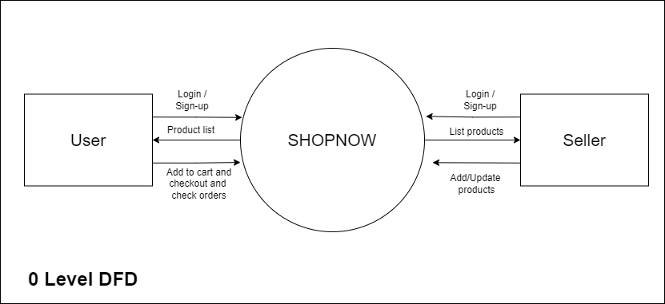

Fig4.1: 0 level DFD

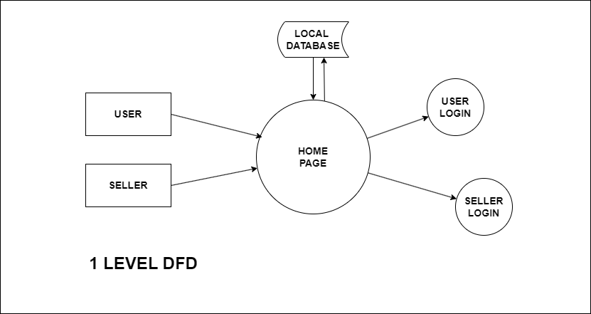
Fig4.2: 1 level DFD

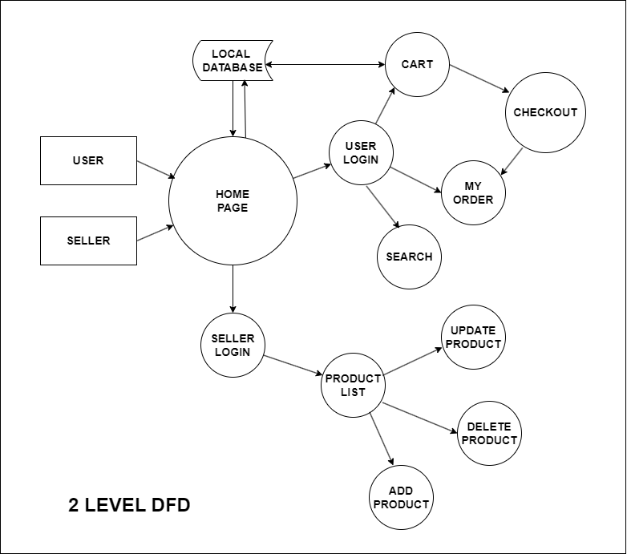
Fig4.3: 2 level DFD

5 GitHub Link
5.1 Repository link

https://github.com/codexdebayan/ecom

A. Appendices

A.1 Appendix 1

The client for which the product is developed is a business firm situated in West Bengal, India, named “Chatterjee Traders” which had a requirement for an e-com website with a basic functionality. We had a round of two to three online meets over internet to understand the requirements and I took the challenge to deliver the initial version in about a week.

