# LAB 7 : ExpressJS

**Submitted by: Aamna Sarosh (218953)**

**Class/Sec: BSCS-7A**

**Lab Tasks**

**Task 1:** Create Index.html file in the root folder of your application and write the HTML FORM POST method code in it. Modify server.js to handle home page requests as well as the input sent by the HTML form.

**Hint:** To handle HTTP POST request in Express.js version 4 and above, you need to install middleware module called body-parser. The middleware was a part of Express.js earlier but now you have to install it separately. This body-parser module parses the JSON, buffer, string and url encoded data submitted using HTTP POST request. Install body-parser using NPM as shown below.

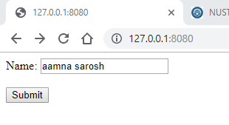

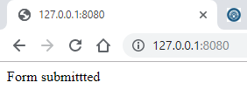

<html>

    <body>

        <form method="POST" action="/" >

            Name: <input type="text" name="name"><br><br>

            <input type="submit" name="submit" value="Submit">

        </form>

    </body>

</html>

var express = require("express");

var app = express();

var bodyParser = require("body-parser");

app.use(bodyParser.urlencoded({ extended: true }));

app.get("/", function(req,res){

    res.sendfile('index.html');

});

app.post("/", function(req, res){

    res.send("Form submittted");

    console.log(req.body);

})

app.listen(8080);

**Task 2:** Create a file uploader form in an html file. This form has method attribute set to POST and enctype attribute is set to multipart/form-data. Modify server.js to handle home page requests as well as file upload.

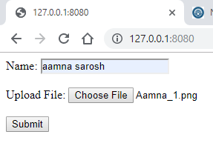

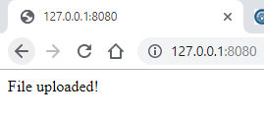

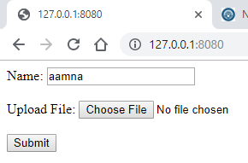

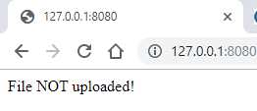

<html>

    <body>

        <form method="POST" action="/" enctype="multipart/form-data">

            Name: <input type="text" name="name"><br><br>

            Upload File: <input type="file" name="upload"><br><br>

            <input type="submit" name="submit" value="Submit">

        </form>

    </body>

</html>

var express = require("express");

var app = express();

var bodyparser = require("body-parser");

var multer = require("multer");

var upload = multer();

app.use(bodyparser.json());

app.use(bodyparser.urlencoded({ extended: true }));

app.get("/", function(req,res){

    res.sendfile('index.html');

});

app.post("/", upload.single("upload"), function(req, res){

   file = req.file;

   if(!file){

      res.send("File NOT uploaded!");

   }

   else{

      res.send("File uploaded!");

      console.log(req.body);

      console.log(file);

   }

});

app.listen(8080);

**Task 3:** By using the Pug templating engine create an HTML registration form.

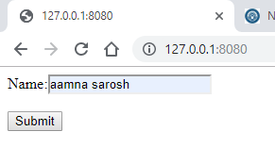

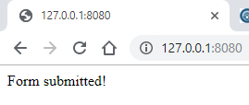

html

    body

        form(action="/", method="post")

            label(for="name") Name:

            input(type="text", name="name")

            br

            br

            input(type="submit")

var express = require("express");

var app = express();

var bodyparser = require("body-parser");

app.use(bodyparser.urlencoded({ extended: true }));

app.set("view engine", "pug");

app.set("views", "./views");

app.get("/", function(req,res){

    res.render('form_index');

});

app.post("/", function(req, res){

   res.send("Form submitted!");

   console.log(req.body);

});

app.listen(8080);