**Department of Computing**

**CS-213: Advanced Programming**

**Submitted by: Aamna Sarosh**

**Cms ID: 218953**

**Lab 08: ReactJS States**

**Lab Tasks**

1. You have to practice the states codes covered in class lecture

Practice 1:

import React,{Component} from 'react';

class Welcome extends Component {

constructor(){

super()

this.state={message:'welcome visitor'}

}

changeMessage(){

this.setState({

message: 'Thank you for subscribing'

})

}

  render(){

  return (

<div>

<h1>{this.state.message}</h1>

<button onClick={()=>this.changeMessage()}>Subscribe</button>

</div>);

}}

export default Welcome;

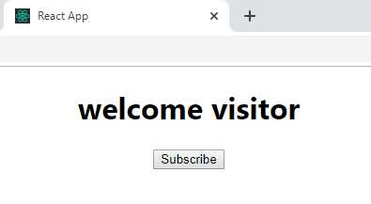

After clicking ‘subcribe’ button.

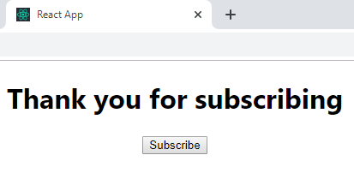

Practice 2:

import React,{Component} from 'react';

class Counter extends Component {

constructor(props){

super(props)

this.state={count:0 } }

Increment(){

this.setState( {count:this.state.count+1} , ( )=>{console.log('call back value',this.state.count) })

console.log(this.state.count)

}

 render(){

return (

<div>

<h1>counter - {this.state.count}</h1>

<button onClick={()=>this.Increment()}>Increment</button>

</div> ); }}

export default Counter;

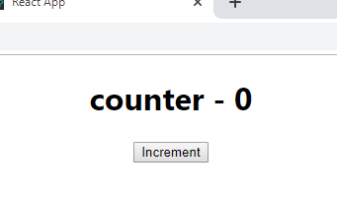

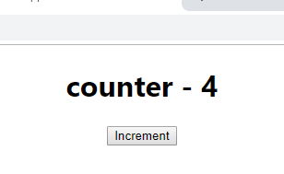

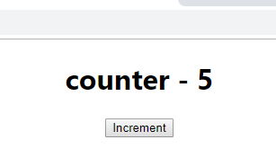

1. Create a timer application which asks the user for minutes. The user then click Start button and starts the timer count down. Preview @ <https://7zyz2y4p5j.csb.app/>

import React, { Component } from 'react';

class Timer extends Component {

    constructor() {

        super();

        this.state = {

            min: 0,

            sec: 0

        };

    }

    showTimer = (event) => {

        var time = parseInt(event.target.value);

        this.setState({

            min: time,

            sec: 0

        })

    }

    startCountDown = (event) => {

        this.update = setInterval(() => {

            var sec = this.state.sec;

            var min = this.state.min;

            sec = sec-1;

            if (sec == -1) {

                min = this.state.min - 1;

                sec = 59;

            }

            if (min == -1) {

                min = 0;

                sec = 0;

                clearInterval(this.update);

            }

            this.setState({

                min: min,

                sec: sec

            })

        }, 1000);

    }

    render() {

        return (

            <div>

                <p>enter desired time</p>

                <input type='number' onChange={this.showTimer}></input>

                <h1>{this.state.min}:{this.state.sec}</h1>

                <input type='button' onClick={this.startCountDown} value='Start'></input>

            </div>

        );

    }

}

export default Timer;

