שאלה 1

# Functional Requirements

## Adding an order

* + 1. A person placing an order (henceforth called the End-user) shall enter the following information into the system, about the desired order:
       1. End-user's name
       2. Desired meal
       3. Date range of the order (can be a single date)
       4. Order type – one of the following:
          1. Shipping order –an address to which the order shall be delivered to.
          2. Sit & Eat order – the End-user shall receive and consume the order inside the restaurant
       5. Shipping address - if the order type is ‎1.1.1.4.1
       6. Pay method – one of the following:
          1. Cash
          2. Credit card
          3. End-user's company
    2. When the End-user instructs the system to complete the order:
       1. If the order pay method is ‎1.1.1.6.1, then the system shall perform the following actions:
          1. If the order type is ‎1.1.1.4.2, then:

The system shall verify that enough tables are available at the desired End-user date (‎1.1.1.3)

If there are enough tables available, then the system shall add the order information to its database, and assign an order-id to the order

If there are not enough tables available, then the system shall notify the End-user

The system shall verify that the order is valid, as per ‎1.11

* + - 1. If the order pay method is ‎1.1.1.6.2, then End-user shall enter the relevant information and the system shall complete the transaction
         1. If the transaction cannot be completed, the system shall notify the End-user
      2. When the transaction is completed, the system shall perform the actions from ‎‎1.1.2.1.1.1.1 (including) to ‎1.1.2.1.1.2 (including)
      3. If the order pay method is ‎1.1.1.6.3, then the End-user shall select the company name and the system shall verify that:
         1. The End-user's name exists in the company

If the End-user's name does not exist in the company, or the company does not exist, the system shall notify the End-user

* + - 1. When the transaction is completed, the system shall perform the actions from ‎‎1.1.2.1.1.1.1 (including) to ‎1.1.2.1.1.2 (including)
    1. When the system assigns an order-id to an order, it shall notify the End-user who placed the order, and display the order-id

## Removing an order

* + 1. An End-user shall enter the following information into the system, about the desired order:
       1. End-user's name
       2. Order-id
    2. If an order with this information exists in the system, then the system shall perform the following actions:
       1. If the order pay method is ‎1.1.1.6.2, then the system shall cancel the transaction
       2. The system shall remove the order from its database
       3. The system shall notify the user

## Editing an order

* + 1. An End-user shall enter the following information into the system, about the desired order:
       1. Order-id
       2. End-user's name
    2. If an order with this information exists in the system, then the system shall allow the End-user to change the following information about the order:

1. ‎1.1.1.2
2. ‎1.1.1.3
3. ‎1.1.1.4
4. ‎1.1.1.5
5. ‎1.1.1.6
   * 1. When the End-user instructs the system to complete the order:
        1. If the order pay method was changed by the End-user:
           1. If the order pay method was ‎1.1.1.6.2, before the change, then the system shall cancel the transaction
        2. The system shall perform the actions from ‎1.1.2.1 (including) to ‎1.1.3 (excluding)

## Changing company employee list

* + 1. A human resource person (henceforth called the HR-user) shall enter the following login information into the system:
       1. Company name
       2. Company password
    2. The system shall verify this login information and perform the following actions:
       1. If the login information is correct, then the system shall display a list of End-users which are authorized to pay for orders via ‎1.1.1.6.3
          1. The system shall allow the HR-user to add and remove entries from this list
       2. If the login information is incorrect, then the system shall notify the HR-user

## Displaying and editing Sit & Eat orders

* + 1. A waiter who works at the restaurant (henceforth called the Waiter) shall enter the following login information into the system:
       1. Waiter's name
       2. Waiter's password
    2. The system shall verify this login information and perform the following actions:
       1. If the login information is correct, then the system shall display a list of orders that are booked to the current date
          1. The system shall allow the Waiter to remove orders which are payed for via ‎1.1.1.6.1, from the system
          2. If the system detects that there are currently available tables at the restaurant, and that there is a surplus of raw food ingredients, then the system shall allow the Waiter to add orders (as per ‎1.1) with the following changes:

The order type (‎1.1.1.4) must be ‎1.1.1.4.2

The End-user's name shall be the Waiter name

* + - 1. If the login information is incorrect, then the system shall notify the Waiter

## Adding a VIP order

A VIP-user is an End-user who is allowed by the Admin (‎1.10) to add, remove and edit orders for multiple End-users at once, under a single order.

* + 1. A VIP-user shall enter the following login information into the system:
       1. VIP-user's name
       2. VIP-user's password
    2. If the login information is correct, then the system shall allow the VIP-user to add multiple orders (as per ‎1.1) with the following changes:
       1. All the following fields must be identical for all the orders:

1. ‎1.1.1.3
2. ‎1.1.1.4
3. ‎1.1.1.5
4. ‎1.1.1.6
   * + 1. The system shall add the VIP-user's name to all the orders
     1. If the login information is incorrect, then the system shall notify the VIP-user

## Removing a VIP order

* + 1. A VIP-user shall enter the following login information into the system:
       1. VIP-user's name
       2. VIP-user's password
    2. If the login information is correct, then the system shall allow the VIP-user to remove orders from the VIP order
    3. the login information is incorrect, then the system shall notify the VIP-user

## Editing a VIP order

* + 1. A VIP-user shall enter the following login information into the system:
       1. VIP-user's name
       2. VIP-user's password
    2. If the login information is correct, then the system shall allow the VIP-user to edit orders from the VIP order
    3. the login information is incorrect, then the system shall notify the VIP-user

## Displaying and editing companies

* + 1. The system administrator (henceforth called the Admin) shall enter the following login information into the system:
       1. Master password
    2. The system shall verify this login information:
       1. If the login information is incorrect, then the system shall notify the Admin
       2. If the login information is correct, then the system shall perform the following actions:
          1. The system shall display a list of the companies, and their respective HR-users
          2. The system shall allow the Admin to add companies to this list
          3. The system shall allow the Admin to remove companies from this list
          4. The system shall allow the Admin to add HR-users to companies in this list
          5. The system shall allow the Admin to remove HR-users from companies in this list

## Displaying and editing VIP-users

* + 1. The Admin shall enter the following login information into the system:
       1. Master password
    2. The system shall verify this login information:
       1. If the login information is incorrect, then the system shall notify the Admin
       2. If the login information is correct, then the system shall perform the following actions:
          1. The system shall display a list of the VIP-users
          2. The system shall allow the Admin to add VIP-users to this list
          3. The system shall allow the Admin to remove VIP-users from this list

## Displaying and editing valid orders rules

* + 1. The Admin shall enter the following login information into the system:
       1. Master password
    2. The system shall verify this login information:
       1. If the login information is incorrect, then the system shall notify the Admin
       2. If the login information is correct, then the system shall perform the following actions:
          1. The system shall display the minimum time before an order date, in which an End-user can add an order with that date, e.g. if this minimum time is one day, then last date which an End-user is able to add an order for date 9.9.2009 is 8.9.2009
          2. The system shall allow the Admin to modify this minimum time

## Displaying reports

* + 1. The Admin shall enter the following login information into the system:
       1. Master password
    2. The system shall verify this login information:
       1. If the login information is incorrect, then the system shall notify the Admin

If the login information is correct, then the system shall display statistical information about the following:

* + - * 1. Number of orders per End-user (‎1.1.1.1)
        2. Number of orders with per desired meal (‎1.1.1.2)
        3. Number of orders per date (‎1.1.1.3)
        4. Number of orders per order type (‎1.1.1.4)
        5. Number of orders per pay method (‎1.1.1.6)
        6. Number of Sit & Eat (‎1.1.1.4.2) orders per date
        7. Number of completed Sit & Eat (‎1.1.1.4.2) orders, i.e. orders that were removed as per ‎1.5.2.1.1
        8. Number of Sit & Eat (‎1.1.1.4.2) orders which were not added due to unavailable tables, i.e. orders that were not added as per ‎1.1.2.1.1.1.2

## Sending reports

* + 1. For each company, the system shall send the following reports at the end of each month, to each HR-user of that company:
       1. A report containing a list of all the orders which were payed off via that company (‎1.1.1.6.3)
       2. A report containing a list of all the Sit & Eat (‎1.1.1.4.2) orders which were payed off via that company (‎1.1.1.6.3) and were not completed, i.e. orders that were not removed as per ‎1.5.2.1.1

# Assumptions

## General

* + 1. We assume the system will have a server and multiple clients. The communication between the server and the clients will be via the Internet

## Users classification

* + 1. We assume that only special users will need to enter some login credentials, i.e. End-users will not need to enter any login credentials

שאלה 2

# Actors

* End-user – a person who can add, remove and edit orders for himself/herself
* VIP-user – an End-user who can add, remove and edit orders for multiple End-users at once, under a single order
* HR-user – a human resource person of a company, who can add and remove employees from that company's list in the system
* Waiter – a person who works at the restaurant, who can add and remove Sit & Eat orders
* Admin – the owner of the restaurant, who can add and remove VIP-users, HR-users and Waiters from the system, and view statistical reports of the system

# Use cases

## Add order

|  |  |
| --- | --- |
| **Actors:** | End-user |
| **Description:** | The End-user adds an order with particular information |

## Remove order

|  |  |
| --- | --- |
| **Actors:** | End-user |
| **Description:** | The End-user removes an order after entering its information |

## Edit order

|  |  |
| --- | --- |
| **Actors:** | End-user |
| **Description:** | The End-user changes an order after entering its information |

## Add VIP order:

|  |  |
| --- | --- |
| **Actors:** | VIP-user |
| **Description:** | The VIP-user adds an order with particular information, after entering his/her information |

## Remove VIP order

|  |  |
| --- | --- |
| **Actors:** | VIP-user |
| **Description:** | The VIP-user removes an order after entering its information, after entering his/her information |

## Edit VIP order

|  |  |
| --- | --- |
| **Actors:** | VIP-user |
| **Description:** | The VIP-user changes an order after entering its information, after entering his/her information |

## View company employee list

|  |  |
| --- | --- |
| **Actors:** | HR-user |
| **Description:** | The HR-user views a company's list, after entering the company information |

## Add company employee

|  |  |
| --- | --- |
| **Actors:** | HR-user |
| **Description:** | The HR-user adds an employee to a company's list, after entering the company information |

## Remove company employee

|  |  |
| --- | --- |
| **Actors:** | HR-user |
| **Description:** | The HR-user removes an employee from a company's list, after entering the company information |

## View Sit & Eat orders

|  |  |
| --- | --- |
| **Actors:** | Waiter |
| **Description:** | The Waiter views the list of Sit & Eat orders for the day, after entering his/her information |

## Add Sit & Eat order

|  |  |
| --- | --- |
| **Actors:** | Waiter |
| **Description:** | The Waiter adds a Sit & Eat order for the day, after entering his/her information |

## Remove Sit & Eat order

|  |  |
| --- | --- |
| **Actors:** | Waiter |
| **Description:** | The Waiter removes a Sit & Eat order for the day, after entering his/her information |

## View companies

|  |  |
| --- | --- |
| **Actors:** | Admin |
| **Description:** | The Admin views the companies list, after entering his/her information |

## Add company

|  |  |
| --- | --- |
| **Actors:** | Admin |
| **Description:** | The Admin adds a company to the companies list, after entering his/her information |

## Remove company

|  |  |
| --- | --- |
| **Actors:** | Admin |
| **Description:** | The Admin remove a company from the companies list, after entering his/her information |

## Change VIP-users

|  |  |
| --- | --- |
| **Actors:** | Admin |
| **Description:** | The Admin views the VIP-users list, after entering his/her information |

## Add VIP-user

|  |  |
| --- | --- |
| **Actors:** | Admin |
| **Description:** | The Admin adds a VIP-user to the VIP-users list, after entering his/her information |

## Remove VIP-user

|  |  |
| --- | --- |
| **Actors:** | Admin |
| **Description:** | The Admin removes a VIP-user from the VIP-users list, after entering his/her information |

## View report

|  |  |
| --- | --- |
| **Actors:** | Admin |
| **Description:** | The Admin selects which report to view, after entering his/her information |

# Use Case 1

|  |  |
| --- | --- |
| **Name:** | Add Sit & Eat Order |
| **Actors:** | End-user |
| **Goal Description:** | The End-user adds a Sit & Eat order with particular information |
| **Reference to Requirement Document:** | ‎1.1 (‎1.1.1.4.2) |
| **Preconditions:** | None |
| **Description:** | 1. The End-user requests to add a new order 2. The system asks for the End-user name 3. The End-user enters his/her name 4. The system displays the available meals 5. The End-user chooses the desired meal 6. The system displays for the date range of the order 7. The End-user enters the date range 8. The system displays the available order types 9. The End-user chooses Sit & Eat 10. The system displays the available pay methods 11. The End-user chooses the pay method and enters the required extra information, based on the chosen pay method 12. The system assigns an order-id and displays the order-id |
| **Postcondition:** | The system assigns an order-id to the order, and the order is added to the database. |
| **Variations:** | 1. In step 9 – the system cannot find an available table in at least one of the dates in the entered date range: the End-user is notified and can repeat from step 7. 2. In step 11 – the system cannot complete the credit card transaction: the End-user is notified and he/she can repeat from step 11. 3. In step 11 – the system cannot confirm the existence of the End-user in the company: the End-user is notified and he/she can repeat from step 11. 4. The End-user may decide to go back any number of steps, at any time during steps 1-11. In this case, the system goes back to the desired step, while keeping the data that the End-user entered. |
| **Exceptions:** | 1. If a communication error occurs during steps 11-12, the system saves the data that the End-user entered up until that step, notifies the End-user, and prompts the End-user to try again later. |

# Use Case 2

|  |  |
| --- | --- |
| **Name:** | Add company employees |
| **Actors:** | HR-user |
| **Goal Description:** | The HR-user adds employee names to a company |
| **Reference to Requirement Document:** | ‎1.4 |
| **Preconditions:** | The HR-user has successfully logged in to the system, and the system has displayed the list of company employees |
| **Description:** | 1. The HR-user requests to add an employee 2. The system asks for the employee name 3. The HR-user enters the employee name 4. The system adds the employee to the database, and displays the updated company employees list |
| **Postcondition:** | Success: The system successfully added the employee to the company  Failure: In step 4 – if the desired employee name already exists in the list, then the system notifies the HR-user and returns to step 1. |
| **Variations:** | None |
| **Exceptions:** | 1. If a communication error occurs during any step, the system returns to step 1 |

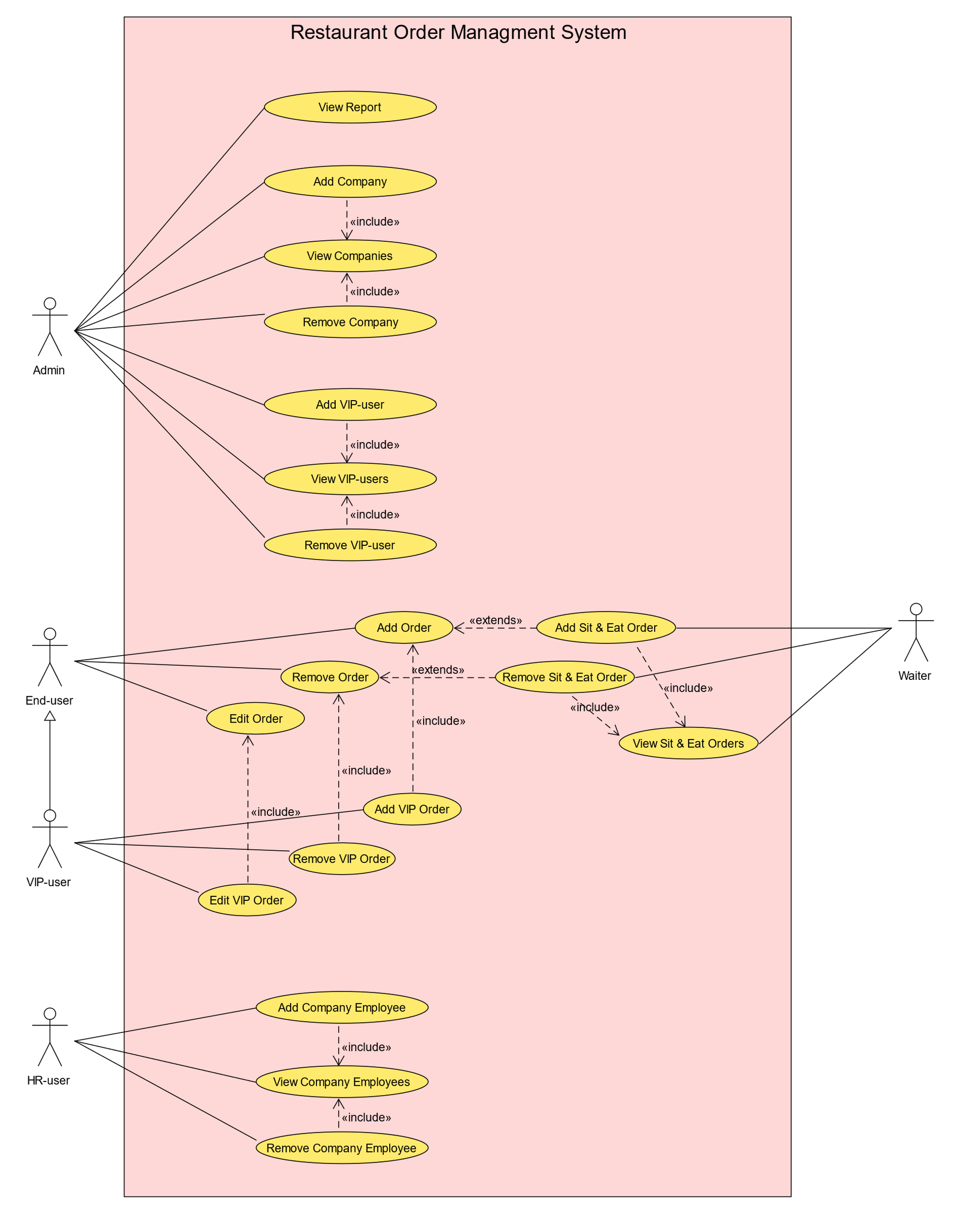

שאלה 3

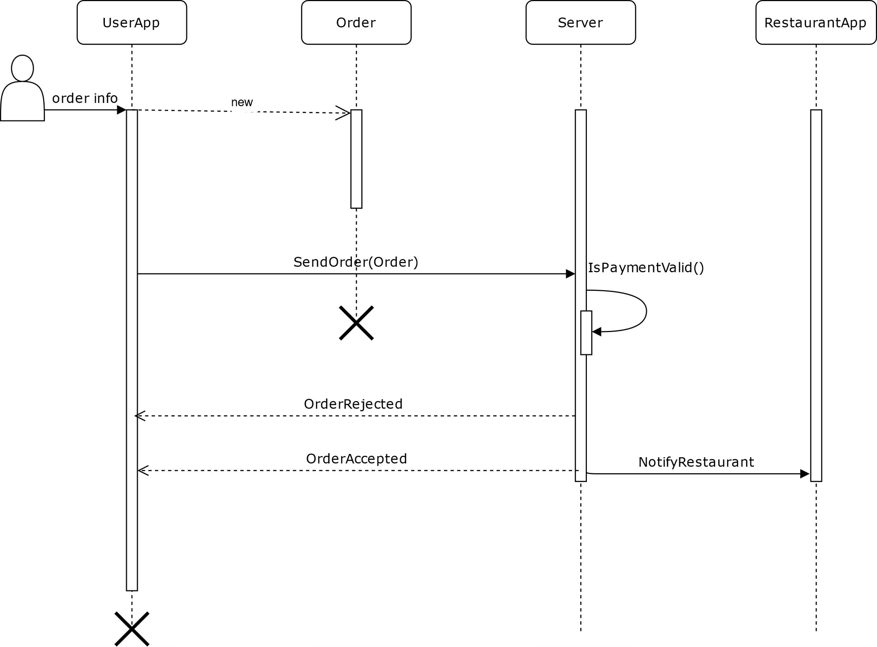

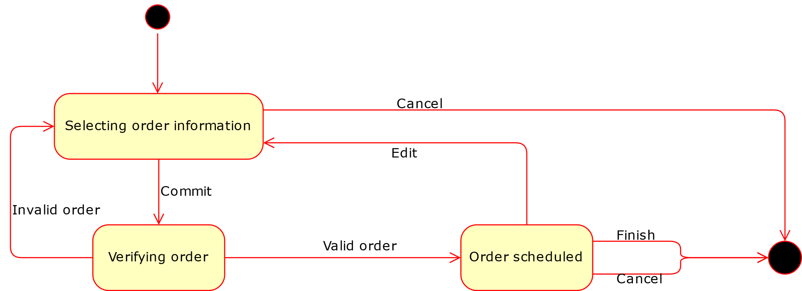

שאלה 4

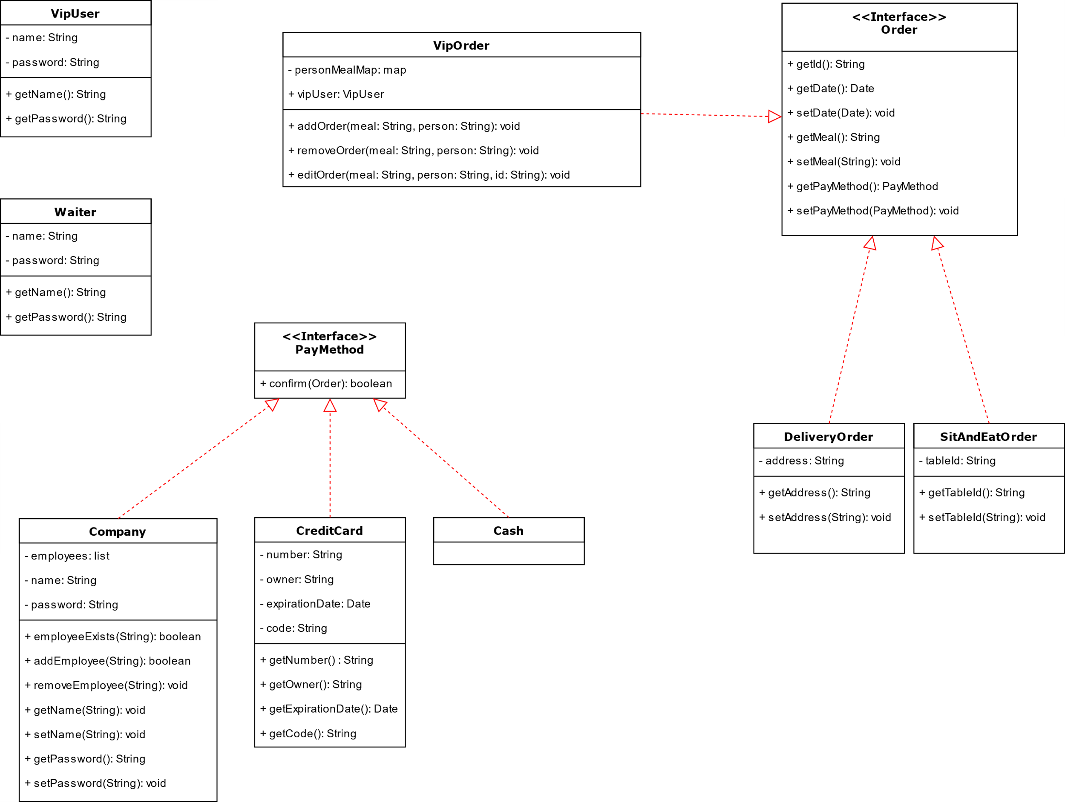

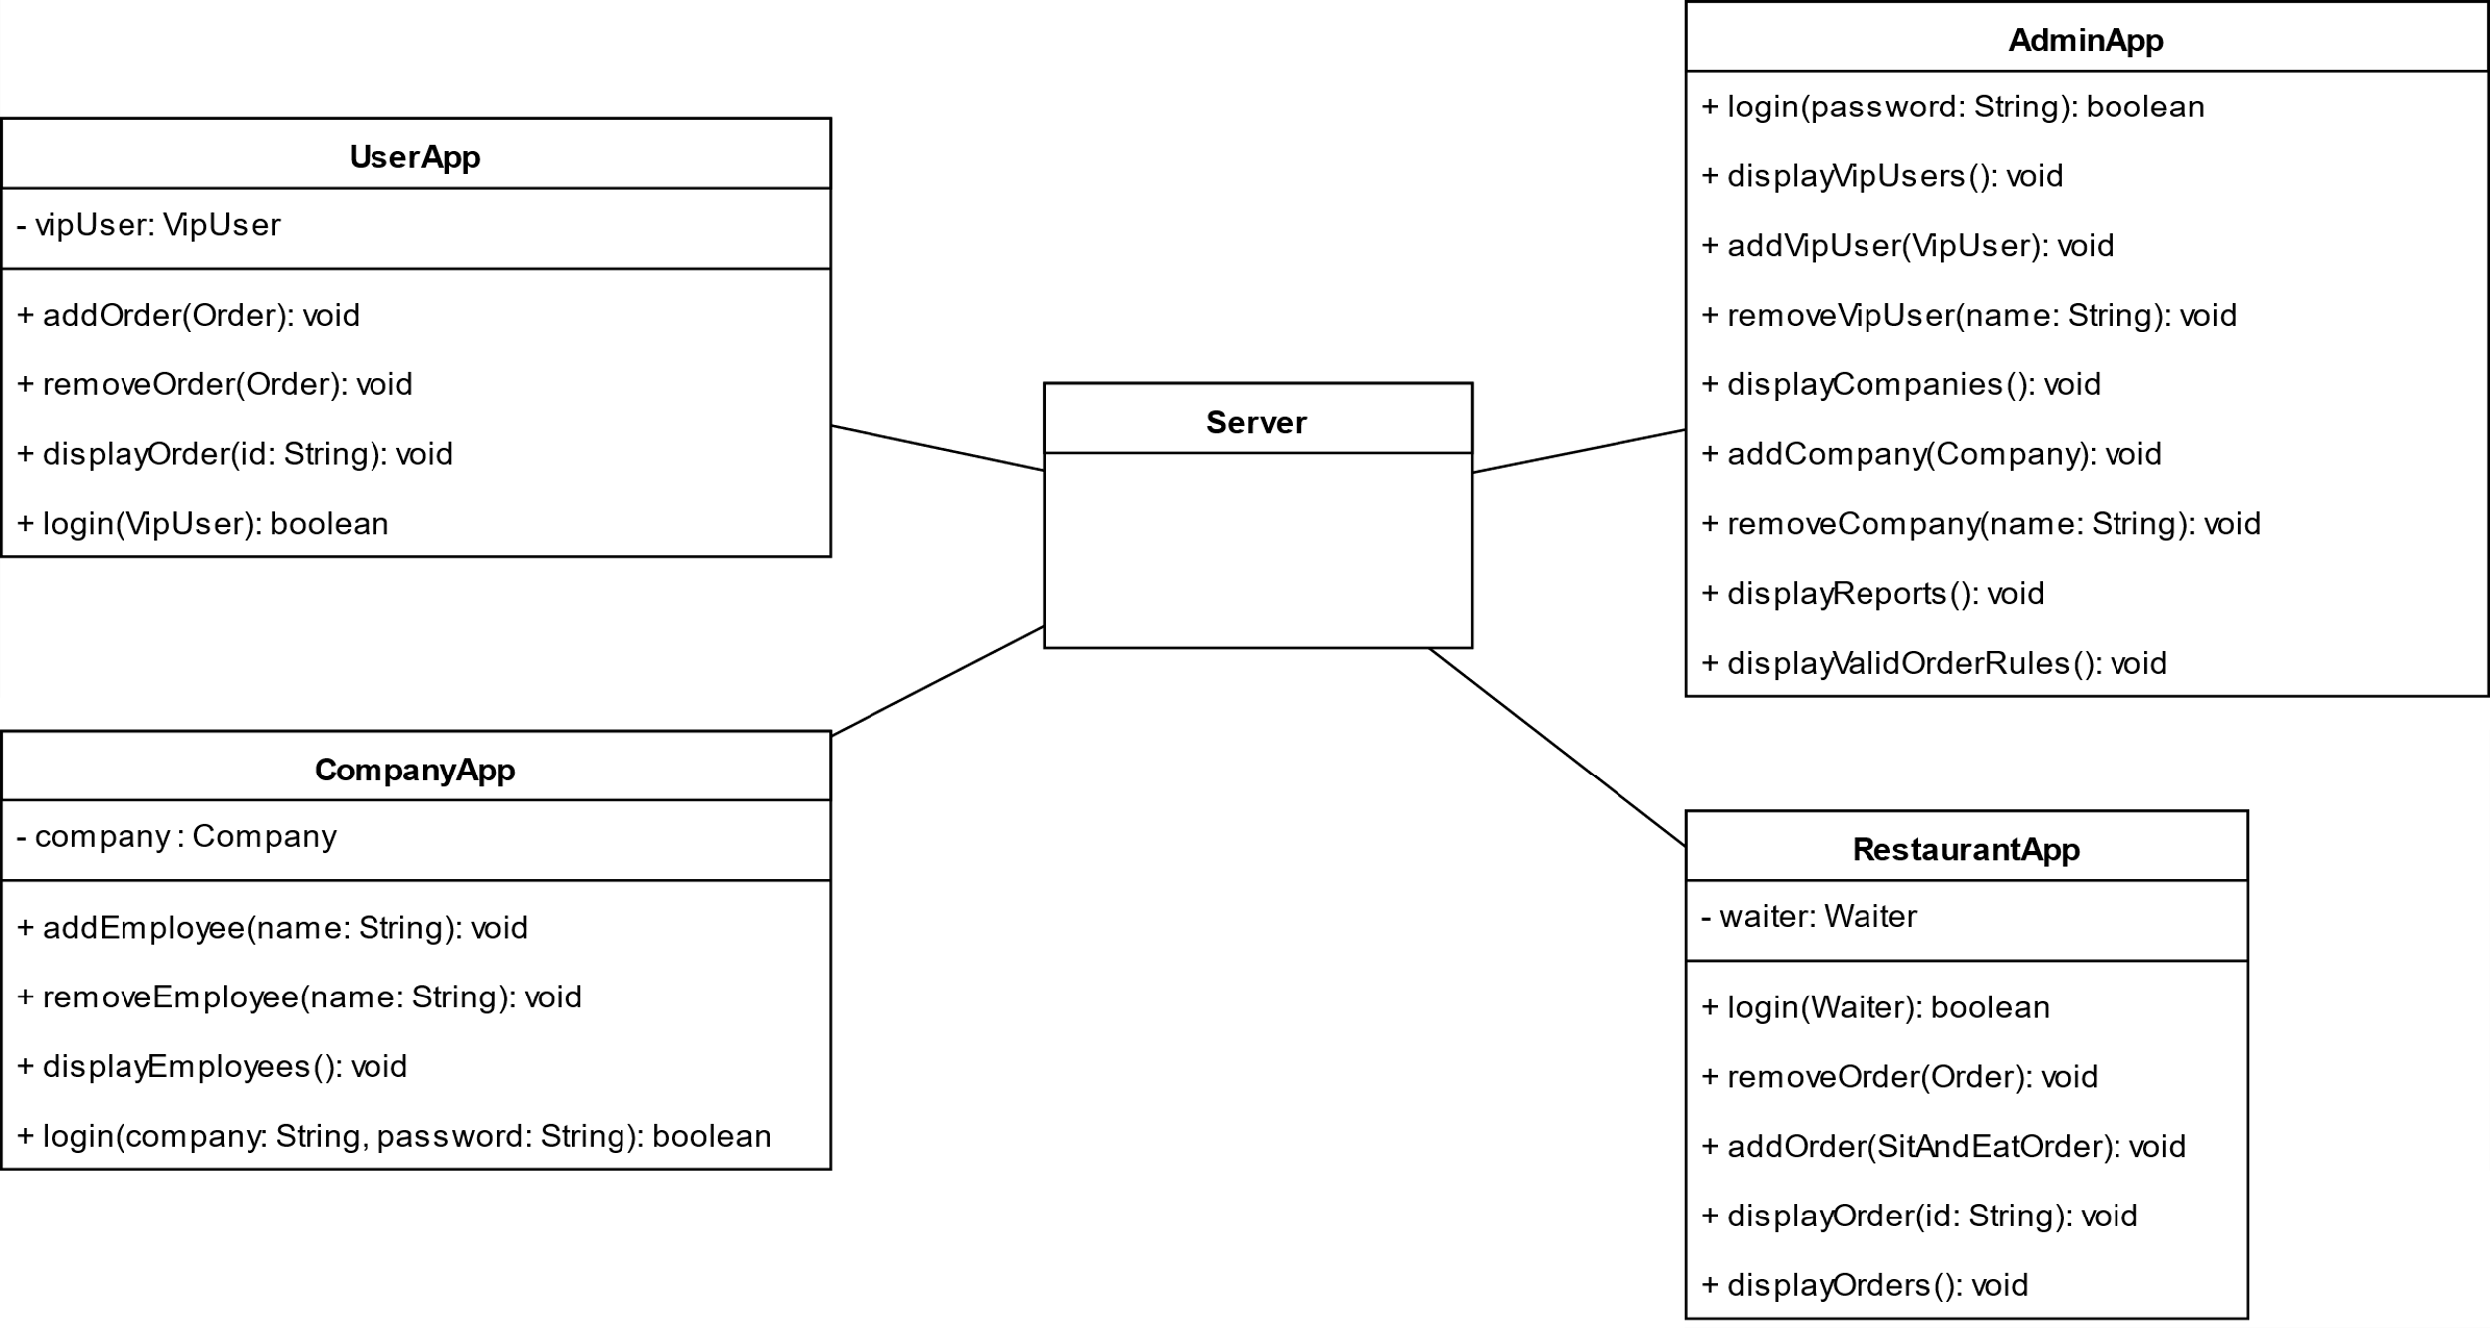

|  |  |
| --- | --- |
| Class/Interface | Short Description |
| Order | Represents an order of a meal in the restaurant |
| DeliveryOrder | An order that will be delivered to a location |
| SitAndEatOrder | An order that will be consumed at the restaurant |
| VipOrder | An order that contains multiple meals for different persons, all with the same date, order type (delivery/sit and eat) and pay method |
| PayMethod | Represents the way an order will be payed for by a customer |
| Cash | Payed in cash on delivery/on consume |
| CreditCard | Payed in advance using credit card |
| Company | Payed in advance by the customer's company |
| VipUser | Represents a person who can order VIP orders |
| Waiter | Represents a waiter in the restaurant |
|  |  |
| UserApp | The part of the system which is used by customers (regular and VIP) to add, remove, view and edit their orders |
| CompanyApp | The part of the system which is used by HR users to add, remove, and view employees in their company |
| RestaurantApp | The part of the system which is used by waiters at the restaurant to view, finish (remove) orders, and add Sit&Eat orders |
| AdminApp | The part of the system which is used by the system owner (admin) to view reports, edit companies, VIP users, waiters, etc… |
| Server | The backend part of the system. Contains the databases, confirms money transactions, etc… |