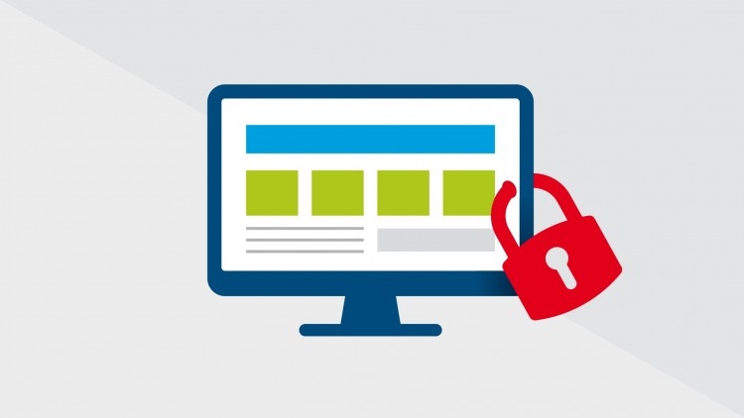

Data Security v/s Data Usage

## Amol Gote | Course Title | 04/04/2020**Position Paper Content**

Top of Form

Regardless of industry, business organizations struggle trying to balance the two seemingly opposing data related considerations: data security vs. data usage. Quite commonly, organizational infrastructure managers (such as chief technology officers, etc.) charged with data security strive to limit access to data as a way of mitigating the possibility data breaches, theft and related problems, while functional managers (such as chief marketing officers, brand managers, etc.) tend to favor broader and easier access to organizational data, as a way of encouraging more fact-based planning and decision making.

Is it possible for organizations to simultaneously accomplish both objectives, namely, making their data as secure as possible while also maximizing the usage and the utility of their data? Take a position, clearly describe and substantiate your reasoning; be specific.

You will be graded based on the attached Rubric.

ABottom of Form