ABC Pharmacy  
Business capability analysis and data model

12/15/2019

# Executive summary

## Overview

This document provides results on the data analysis performed on the historical data for ABC pharmacy, describes the data model associated, findings and business opportunities. It provides product performance across spectrum of product portfolio as well store performance across various states.

## Business Goals

* Identify investment opportunities on the products that are performing, so as to increase the quality of those products. Maintain appropriate inventory and adjust the supply and demand of the products.
* Identify the seasonality associated with any products so that appropriate stocks can be maintained.
* Sales revenue prediction and set appropriate sales targets.
* High and low performing stores
* Better business decisions based on historical data.

## Data Description

Data provides insights in the following for ABC Pharmacy

* Major product categories, product categories, products sub categories, product segments and finally product.
* Pharmacies across various states
* Sales transactions for various products and across pharmacies.

## Methodological summary

## Results

* Sales is restricted to only 6 states NJ,PA,NY,CT,MA,ME,DE.
  + NJ State has highest sales revenue of $6,413,468.42
  + DE has lowest sales revenue of $7,050.33
* Data Span across 6 months from Jan 2016 to June 2016, sales revenue maximum in March 2016 of $3,707,182
* Top 3 Products by Quantity

|  |  |
| --- | --- |
| Product | Quantity |
| DME SALES | 32583 |
| GENERICQS1ITEM | 21352 |
| VITAMINS/SUPPLEMENTS | 19201 |

* Top 3 Products By Sales Amount

|  |  |
| --- | --- |
| Products | Sales Value $ |
| MONEY ORDER | $ 1,662,010.26 |
| VITAMINS/SUPPLEMENTS | $ 756,299.96 |
| STRUTZ PRO | $ 745,804.90 |

* Top 3 Pharmacy stores by sales revenue

|  |  |
| --- | --- |
| Pharmacy Store | Pharmacy Sales Revenue $ |
| GNP PHARMACY #453 | $ 2,116,067.26 |
| GNP PHARMACY #200 | $ 1,743,900.83 |
| GNP PHARMACY #680 | $ 1,701,263.19 |

## Recommendations

# Core report

## Overview

This report provides the insights on the data analysis performed on the data of ABC pharmacy which includes their sales transactions from Jan to June 2016. It articulates business goals and questions associated with those goals as well as how data can help in achieving the business goals. Based on data analysis it provides recommendations for additional business opportunities and how the losses can be minimized. Based on the historical trends, patterns ABC pharmacy would be able to make appropriate predictions for future. It provides product and store performance which could critical for success of the business in future.

## Business goals

* Investments on type of products
  + Identify investment opportunities on the products that are performing exceptionally well, so as to increase the quality of those products.
* Adjust demand of supply of high volume products
  + Maintain appropriate inventory and adjust the supply and demand of the products.
  + Identify the seasonality associated with any products so that appropriate stocks can be maintained.
* Sales Revenue Targets
  + Sales revenue prediction and set appropriate sales targets for stores
* Store Performance
  + High and low performing stores
  + Identify geographically which states have higher sales revenue and which have lower.
* Total sales revenue for 6 months of transactions.

## Business questions

1. What’s total sales revenue for ABC Pharmacy?
2. What’s percentage gain/loss in sales revenue every month?
3. Which are the best-selling product?
4. Which product categories perform better?
5. What are the average number of products sold per transaction, per day, per month, per year?
6. Which store has maximum performance based on sales revenue?
7. What’s state wise sales revenue?
8. What’s average sale per store?
9. What are number of stores state wise?
10. For any particular store which product generates maximum revenue?
11. For any particular store which product does not generate any revenue or least revenue?
12. For any particular store which month has maximum sales?

## Data description

## Data quality

* Overall data seems to be appropriate with appropriate and consistent data types.
* Duplicate check
  + Performed duplicate check for following and did not find any duplicates
    - MAJOR_PROD_CAT
    - PROD_CAT
    - PROD_SUB_CAT
    - PROD_SEG
    - PROD_MASTER
    - PHRMCY_MASTER
  + In POS_TRANS checked duplicates based on BSKT_ID, PROD_NBR, PHRMCY_NBR, there are duplicates based on that so added SLS_DTE, EXT_SLS_AMT, SLS_QTY as part of unique identifier.
* Sales quantity is POS_TRANS is negative which seems to be legit as they could be returns in the store.
* CSV file related to MAJOR_PROD_CAT had an empty column so had to clean it.

## Data model

Below is the data model for ABC pharmacy data

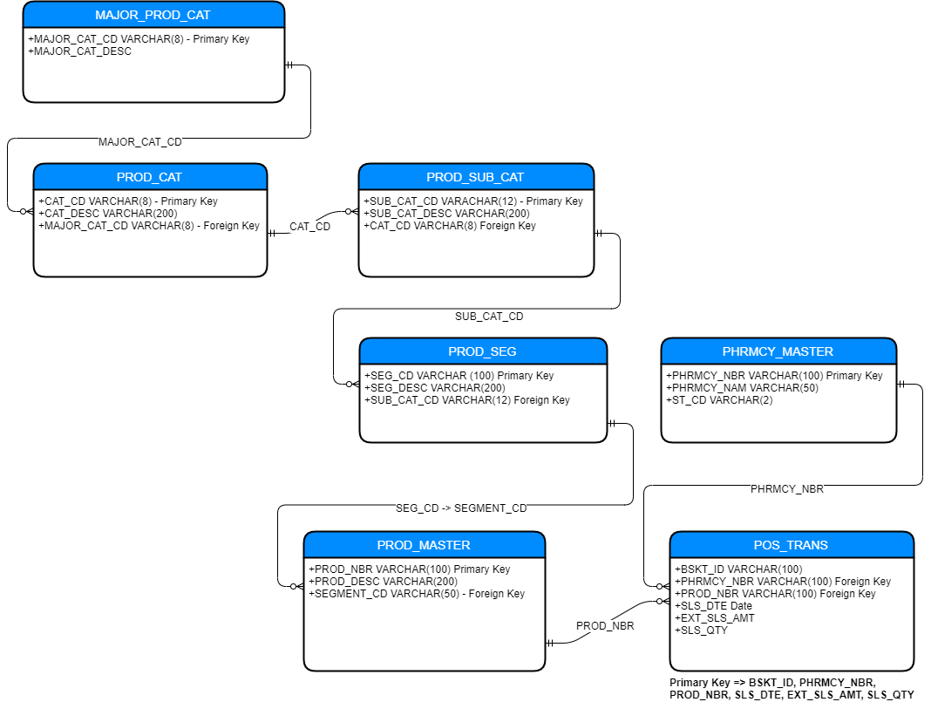

## Methodological summary

## Results

## Conclusions and recommendations