# Good Visualization

## Visualization description

* Many statistical measures show how productive the Unites States is, its economy is the largest in the world. What can be harder to decipher is how Americans use their land to create wealth. The 48 contiguous states alone are a 1.9 billion-acre jigsaw puzzle of cities, farms, forests and pastures that Americans use to feed themselves, power their economy and extract value for business and pleasure.
* Putting all those pieces together, this map gives you a rough sense of all the ways U.S. land is used. Much of U.S. land serve specific purposes, such as the 2 million acres devoted to golf courses or the 3 million acres for airports.

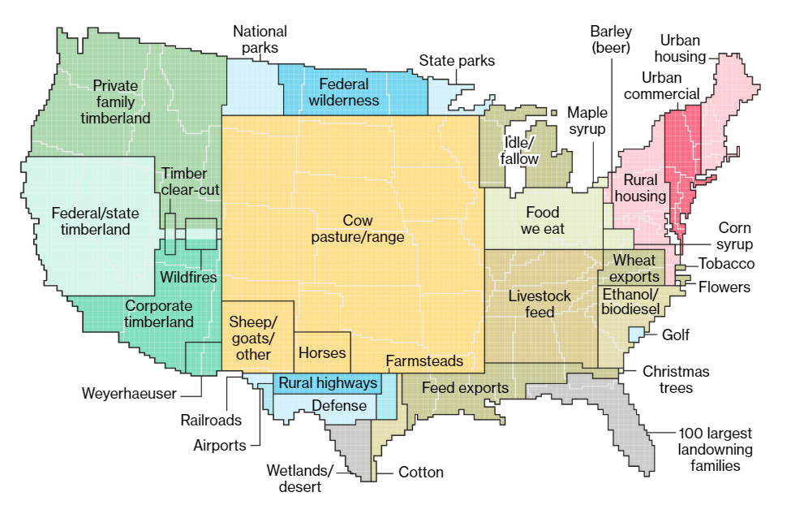

## Observations about the above good visualization

* Visualization is simple, makes the point very clear and conveys intended message
* Representation of the land distribution is very unique, typically this would have been represented in the pie chart, which would have been mundane and would not have caught the attention of the audience.
* Visualization is aesthetically pleasing and contains only the required information and contains no distractions. If the visualization had the numbers shown for each segment then that would have been a distraction.
* This visualization is the perfect blend of data and story.
* Some of the highlights from the visualization
  + More than one-third of U.S. land is used for pasture—by far the largest land-use type in the contiguous 48 states. And nearly 25 percent of that land is administered by the federal government, with most occurring in the West. That land is open to grazing for a fee.
  + The amount of land owned by the 100 largest private landowners has grown from 28 million acres to 40 million, an area larger than the state of Florida.
  + Data from Alaska and Hawaii are excluded from the analysis. Special-use land and forestland make up the biggest land types in those states.

# Bad Visualization

## Visualization description

The chart below shows the relation between the United States’ trade deficit in goods and the number of people employed in manufacturing

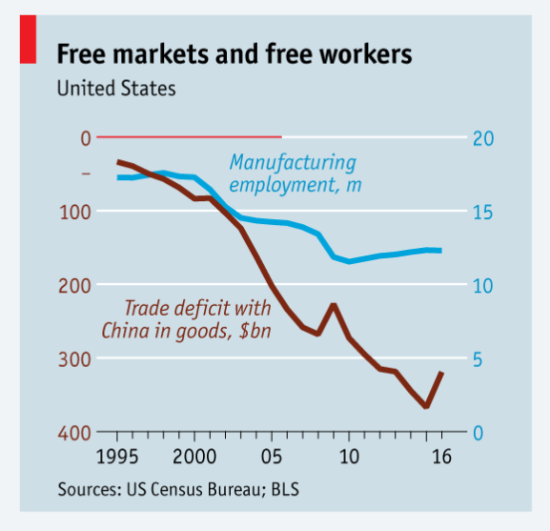

## Issues with the above bad visualization

* There are 2 data series that are getting plotted over here and one is negative (trade deficit) and the other is positive (Manufacturing Jobs), which does not seem to be readily visible to the user unless you deep dive into the chart and observe.
* The chart does not simplistically convey the intended message and it confuses the audience with 2 scales.
* The two data series don’t share a common baseline. The baseline of the trade deficit is at the top of the chart (highlighted by a red line drawn across half of the chart body). The baseline of the right scale is at the bottom. This can be misleading to the audience and confusing as well.
* The title mentions Free markets and Free Workers, which does not seem to be making sense, it could have just mentioned that Trade Deficit and decline in manufacturing jobs.
* There is nothing aesthetically pleasing in the chart or anything significantly different which catches audience attention.
* Instead of combining the 2 series they could have been shown separately in 2 charts side by side, this way it would had been simple easy to understand and would have had conveyed the intended message.

## Another bad example

It shows the average person age per state, the intended message to convey is very simple.

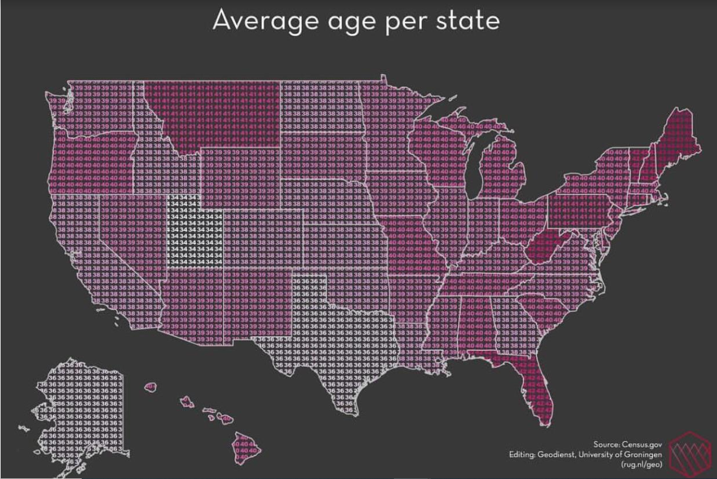

* It’s confusing to see the metric associated with each state.
* Comparing states with an equal average age is very troubling due to the closeness of colors which can mislead the user.
* Even though aesthetically pleasing but does not highlight the story behind the visualization precisely.
* The audience might get lost in the visualization, instead of showing repeated numbers within the state, only a single number with decent font size should be shown.