# Assignment 2: Visualization Critique

## Bad Visualization

From week 1 assignment, had chosen below visualization as bad visualization and had explained what the issues with the below visualization were.

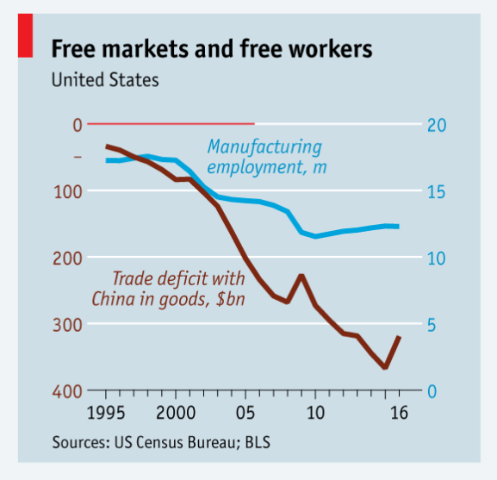

## Rebuilt Visualization

As part of the week-2 assignment have redrawn this visualization and have tried to resolve whatever issues that had been identified. Below is the modified version of the above visualization.

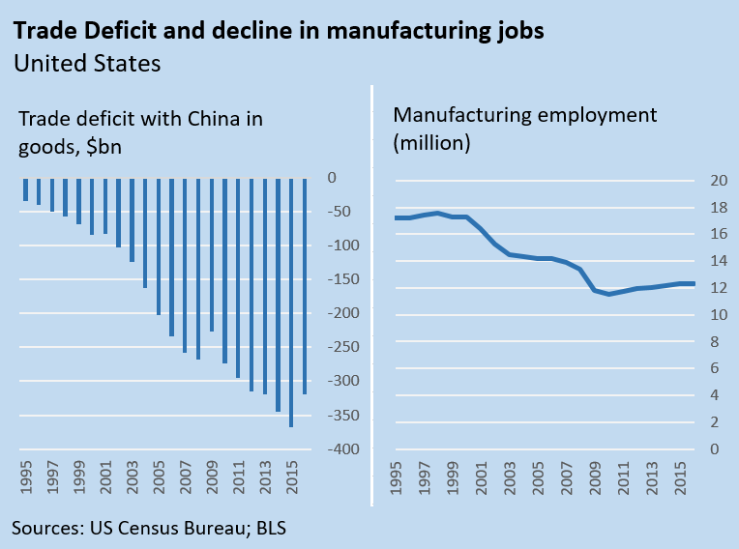

### What visualization represents

* The chart has two separate graphs
  + The trade deficit with China in goods - USD Billion
  + Manufacturing employment – Job number in Million.
* The chart represents
  + The relation between the United States’ trade deficit in goods and the number of people employed in manufacturing
  + The Chart indicates that, as the deficit in goods with China has increased, manufacturing jobs have declined steadily.
  + The trade deficit in 1995 was close to $35 billion and rose to greater than $350 billion in 2015, and during the same time, in 1995 manufacturing job count was close to 17 million and 2015 it was close to 12 million. So there are close to 5 million jobs lost in the USA.
  + The deficit grew 10 fold and resulted in 1/3rd of job losses or close 30% job losses in the manufacturing sector.

### Strengths of the visualization

* The chart is very simple and easy to understand, it follows the KISS (Keep it simple and straightforward) principle.
* When the audience looks at the chart it articulates the message directly and crisply.
* The amount of time required to understand the chart is very minimal compared to the previous one where there are multiple series with individual baselines.
* The relationship between the trade deficit and manufacturing employment remains clear and only takes a minimal amount of extra space.

### Weaknesses of the visualization

* The chart is intentionally kept simple, there is no fancy graphics or images to grab the attention of the audience. So some simple images or graphics could be added to make it more attractive and aesthetically pleasing.
* This visualization is a normal bar and line series, which can make it mundane.
* The chart does not provide any interactive experience to end users, like drill down on the bar chart or line series.

### Intended purpose of the visualization

* The visualization does convey the intended message.
* It conveys the message in a simple, elegant concise manner.
* Visualization is very easy to understand, due to which it explains the purpose behind plotting the data in this manner.

### Improvements in the redrawn visualization

* There is an issue in the x-axis scale, it shows years from 1995 to 2016, but all years are not visible due to space constraint, but having said that it should at least show scale like a marker for each year without the year label. Something like shown below.



* No graphics or images to attract the audience attention. Possibly adding national flag images of USA and China would draw the attention of the audience.
* Summarized text content or any unique fact about the data on the visualization would make the visualization more appealing.

### Why do you like or dislike this visualization?

#### Reasons for liking

* Visualization is straight forward to the point.
* There are no distractions in the visualization and it easily conveys the intended message.
* It shows the impact of the trade deficit on manufacturing jobs very clearly. Midwest USA (Detroit – Michigan) which was a hub of the manufacturing sector, especially the automobile sector has shown a steady decline in jobs, this graph clearly explains why this might have had happened.
* Trade deficit and jobs are a big politically contentious issue, this graph clearly explains why the issue is belligerent.

#### Reasons for disliking

* Since it is a regular bar and line chart without graphics and images, it can become unexciting from the end user’s perspective.
* It is a static chart with no interactivity for data drill-down.

### Chart Fixes

#### What’s been fixed in the chart

* The redesigned chart shows that there wasn’t any need to combine the two data series. Instead of showing combined the updated chart shows two data series separately.
* In the original chart, the title mentions “*Free markets and Free Workers*”, which does not seem to be making sense, so have changed it to “***Trade Deficit and decline in manufacturing jobs in the United States***”.
* In the original chart, there are 2 data series that are getting plotted one is negative (trade deficit) and the other is positive (Manufacturing Jobs), which does not seem to be readily visible to the user. But since in the updated chart these 2 series have been separated as separate, hence positive and negative y-axis numbers are very much evident.
* In the original chart, the two data series don’t share a common baseline and were confusing to users, but in the updated chart it has been separated into two charts so there is no question of common baseline.

#### What’s not been fixed

* The chart is a routine everyday graph with two data series, adding graphics or images would make it attractive, had attempted to do something on those lines but did not go that route, as it would cause an unnecessary distraction to the end users.
* X-axis scale shows from 1995 to 2016 but does not show all years due to space constraint had attempted to show markers like a scale for each year, but could not achieve that in excel.

### What principles of excellence best describe why it is good? (For Updated Visualization).

* The visualization does a fairly good job of minimizing distortions and accurately representing the data. Both Y-axis data start at 0.
* The two charts encourage comparisons effectively. Original visualization had 2 data series in a single plot which was doing the comparison but it was very difficult to understand due to different baselines.
* The visualization makes a data set easy to understand.
* It also encourages the eye to compare different pieces of data. The alignment and ordering of the deficit numbers and job numbers invites the user to follow the data points down the visualization.