Contents

Introduction of the dataset 2

Data Analysis objective 3

Visualizations 3

Link to dashboard 25

Executive Summary 25

Shiny Code 27

# Introduction of the dataset

Dataset belongs to company called Lending Club, it contains all the loans which have been issued by Lending Club from 2007 to 2018.

The [Lending Club](https://www.lendingclub.com/) is a peer-to-peer lending service (it lends money to customers by matching lenders to borrowers), based in the United States. This company enables borrowers to create loan listings on its website by supplying details about themselves and the loans that they would like to request. On the basis of the borrower’s credit score, credit history, desired loan amount and the borrower’s debt-to-income ratio, Lending Club determines whether the borrower is credit worthy and assigns to its approved loans a credit grade that determines payable interest rate and fees.

Dataset contains close to 2 million loan records, precise count of records = 2,260,668

Dataset contains various attributes based on which the credit lending decision takes place, this includes

1. Deb to income ratio
2. Annual Income
3. Home ownership type (Rented, Mortgage, Owned)
4. Employment details.

Dataset also contains geographical information like

1. State from which loan has originated.
2. Zip code.

It also has issued loan details like

1. Funded Loan Amount
2. Issued month and year.
3. Loan Term (36 or 60 months)
4. Interest rate.

Post loan has been issued, loan performance needs to be tracked, and this dataset also contains those details

1. Loan Status (Current, Paid Off, Charged Off, Delinquent)
2. Loan Grades.
3. Delinquency details.

# Data Analysis objective

* How lending club has performed in terms of number of loans and funded loan amount?
* Identify details around the loan term and funded loan amount, typically bigger loans are associated with longer term.
* Typically lenders favor applicants with lower DTIs, analyze the dataset to check if this holds good. Identify the sweet spot number, for DTI.
* Identify relationship between funded amount, annual income and interest rate.
* Identify geographically how loans are funded.

# Visualizations

**R Markdown with charts**

library(ggplot2)   
library(readr)   
library(gridExtra)  
library(tidyverse)  
library(sf)

library(maps)

lendingClubLoanData <- read.csv("data/lending_club_loan_data.csv")  
  
# Remove not required columns from the dataset, so as to minimize the dataset size.  
lendingClubLoanData <- lendingClubLoanData[, !(colnames(lendingClubLoanData)   
 %in% c("id","member_id", "url", "desc"))]  
  
lendingClubLoanData <- lendingClubLoanData[, !(colnames(lendingClubLoanData)   
 %in% c("open_acc_6m", "open_act_il", "open_il_12m",   
"open_il_24m", "mths_since_rcnt_il", "total_bal_il", "il_util", "open_rv_12m", "open_rv_24m", "max_bal_bc", "all_util",   
"total_rev_hi_lim", "inq_fi",   
"total_cu_tl", "acc_open_past_24mths", "bc_open_to_buy", "bc_util", "mo_sin_old_il_acct", "mo_sin_old_rev_tl_op",  
"mo_sin_rcnt_rev_tl_op",  
"mo_sin_rcnt_tl", "mths_since_recent_bc", "mths_since_recent_bc_dlq", "mths_since_recent_inq", "mths_since_recent_revol_delinq",  
"num_accts_ever_120_pd",  
"num_actv_bc_tl", "num_actv_rev_tl", "num_bc_sats", "num_bc_tl", "num_il_tl", "num_op_rev_tl", "num_rev_accts",  
"num_rev_tl_bal_gt_0", "num_sats",  
"pct_tl_nvr_dlq", "percent_bc_gt_75", "tot_hi_cred_lim", "total_bal_ex_mort", "total_bc_limit", "total_il_high_credit_limit",   
"revol_bal_joint",  
"sec_app_earliest_cr_line", "sec_app_inq_last_6mths", "sec_app_mort_acc", "sec_app_open_acc", "sec_app_revol_util",   
"sec_app_open_act_il",   
"sec_app_num_rev_accts", "sec_app_chargeoff_within_12_mths", "sec_app_collections_12_mths_ex_med",   
"sec_app_mths_since_last_major_derog",  
"hardship_reason", "hardship_status", "deferral_term", "hardship_amount", "hardship_start_date", "hardship_end_date",  
"payment_plan_start_date", "hardship_length", "hardship_dpd", "hardship_loan_status",   
"orig_projected_additional_accrued_interest",   
"hardship_payoff_balance_amount", "hardship_last_payment_amount", "disbursement_method",   
"debt_settlement_flag", "debt_settlement_flag_date",   
"settlement_status", "settlement_date", "settlement_amount", "settlement_percentage", "settlement_term"))]  
  
lendingClubLoanData <- lendingClubLoanData[, !(colnames(lendingClubLoanData) %in% c("earliest_cr_line",  
"inq_last_6mths","mths_since_last_delinq","mths_since_last_record","open_acc","pub_rec","revol_bal",  
"revol_util","total_acc","initial_list_status","out_prncp","out_prncp_inv","total_pymnt","total_pymnt_inv",  
"total_rec_prncp","total_rec_int","total_rec_late_fee","recoveries","collection_recovery_fee","last_pymnt_d",  
"last_pymnt_amnt","next_pymnt_d","last_credit_pull_d","collections_12_mths_ex_med","mths_since_last_major_derog",  
"policy_code","acc_now_delinq","tot_coll_amt","tot_cur_bal","inq_last_12m","avg_cur_bal","chargeoff_within_12_mths",  
"delinq_amnt","mort_acc","num_tl_120dpd_2m","num_tl_30dpd","num_tl_90g_dpd_24m","num_tl_op_past_12m"))]  
  
lendingClubLoanData$orig_year<-substr(lendingClubLoanData$issue_d,5,8)  
  
#Write the dataset to csv file for analysis  
write.csv(lendingClubLoanData, file = "data/lending_club_loan_data_final.csv", row.names=FALSE)  
  
lendingClubLoanData <- read.csv("data/lending_club_loan_data_final.csv")

1. Below visualization shows number of loans funded each year from 2007 till 2018.
2. From 2007 till 2012, it had gradual progress in number of loans issued.
3. 2012 to 2015 number of loans issued has grown exponentially.
4. 2015 to 2017 saw a marginal hike in number of loans, 2017 to 2018 saw a considerable hike.
5. Number of loans issued in 2018 by lending club is close to 500,000 which is highest

numberOfLoansByYear <- lendingClubLoanData %>%   
 group_by(orig_year)%>%  
 summarise(loanCountByYear=n())  
  
ggplot(data = numberOfLoansByYear)+  
 geom_line(color="steelblue", size=1.2, aes(x=orig_year,y=loanCountByYear))+  
 geom_point(color="steelblue", size=2.5, aes(x=orig_year,y=loanCountByYear))+  
 scale_x_continuous(breaks = numberOfLoansByYear$orig_year) +  
 scale_y_continuous(labels = scales::comma_format()) +  
 labs(x="Year",y="# Number of loans",title="Loans processed year on year (2007-2018)")+  
 theme_minimal()

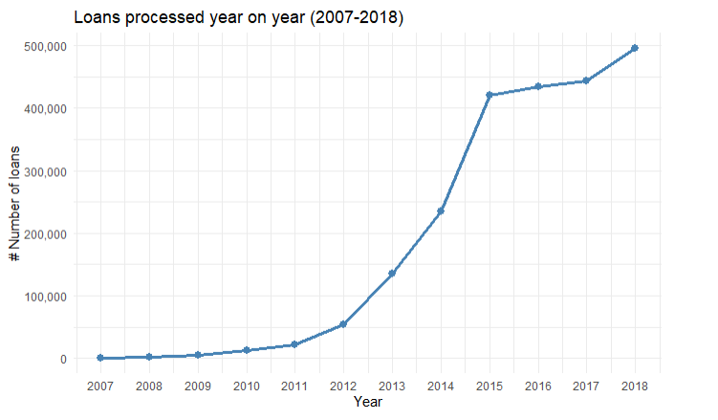

1. Below visualization shows total loan funded amount for each year from 2007 till 2018.
2. In general trend of total loan funded amount is in align to the number of loans issued as above visualization.
3. Lending club has funded loans maximum of $8 billion in 2018.
4. 2015 to 2017, total funded loan amount is flat.

totalFundedAMountPerYear <- lendingClubLoanData %>%   
 group_by(orig_year)%>%  
 summarise(totalFundedAmount= sum(as.numeric(funded_amnt)))  
  
ggplot(data = totalFundedAMountPerYear, aes(x=orig_year, y=totalFundedAmount)) +  
 geom_bar(stat="identity", width=0.5, fill = "steelblue") +  
 scale_x_continuous(breaks = numberOfLoansByYear$orig_year) +  
 scale_y_continuous(labels = scales::dollar) +  
 labs(x = "Year", y = "Total funded loan amount",  
 title="Total loan funded amount year on year (2007-2018)") +  
 theme_minimal()

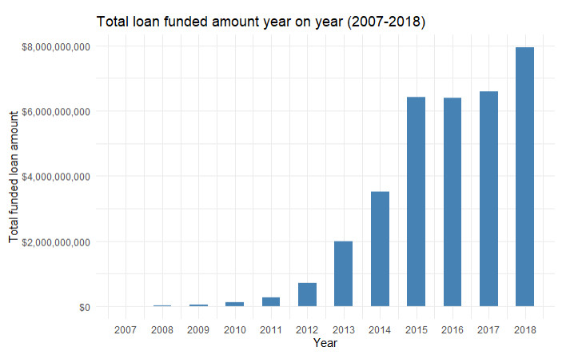

1. Below visualization shows relationship between loans funded amount and term.
2. Lending club offers only loans with 2 terms
   1. 36 Months
   2. 60 Months
3. For 36 months loan:
   1. Median loan funded amount is $10,000.
   2. Majority of the funded loan amount ranges from close $6000 to $16,000.
4. For 60 months loan:
   1. Median loan funded amount is $20000.
   2. Majority of the funded loan amount ranges from close $15,000 to $25,000.

lendingClubLoanData %>%  
ggplot() +  
 geom_boxplot(aes(x=term, y=funded_amnt, color=term)) +   
 scale_y_continuous(labels = scales::dollar) +  
 labs(x = "Term", y = "Loan funded amount", title="Loan funded amount and term relation") +  
 theme_minimal()

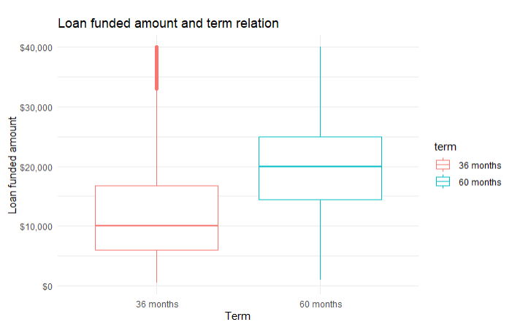

1. Below visualization shows relationship between funded loan amount, annual income and interest rate.
2. Visualization shows, that higher the annual income more is the funded loan amount.
3. As the annual income increase the interest rate drop by couple of percentage points.

filteredLendingClubData <- lendingClubLoanData %>%  
 drop_na(annual_inc)  
  
filteredLendingClubData <- filteredLendingClubData %>%  
 filter(annual_inc <= 300000)  
  
lbls <- c('0-20K','20-40K','40-60K','60-80K','80-100K','100-120K','120-140K','140-160K',  
 '160-180K','180-200K', '200-220K', '220-240K', '240-260K', '260-280K', '280-300K')  
groupedData <- filteredLendingClubData %>%   
 group_by(incomeGroup = cut(annual_inc, breaks= seq(0, 300000, by = 20000),   
 right = TRUE, include.lowest = TRUE, labels = lbls) ) %>%   
 summarise(averageInterest= mean(int_rate), averageLoanLoanFundedAmount = mean(funded_amnt))   
  
ggplot(data =groupedData, aes(x=incomeGroup, y=averageLoanLoanFundedAmount)) +  
 geom_point(colour="steelblue", shape=16, aes(size=averageInterest)) +  
 geom_smooth(aes(incomeGroup, averageLoanLoanFundedAmount, group = 1), method = "lm") +  
 scale_y_continuous(labels = scales::dollar) +  
 labs(x="Annual Income ($)",y="Average loan funded amount",  
 title="Relation between funded loan Amount, income and interest rate")+  
 guides(size=guide_legend("Average \ninterest rate (%)")) +  
 theme_minimal() +  
 theme(axis.text.x = element_text(angle =50, hjust=0.75))+  
 theme(legend.background = element_rect())

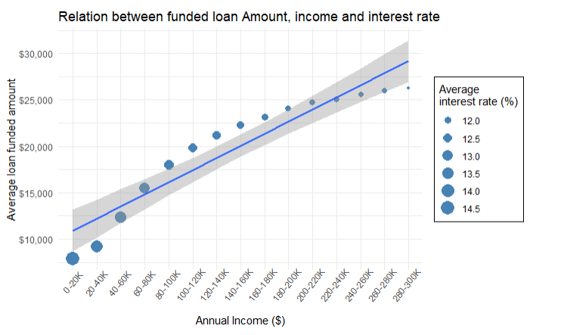

1. Below visualization shows the distribution of annual income of people getting loans.
2. Majority of people are having annual income less than $200K.
3. Median annual income seems to around $60K.
4. Have excluded loans taken by people having annual income > 300K, as they are few in number and are outliers.

filteredLendingClubData <- lendingClubLoanData %>%  
 drop_na(annual_inc)%>%  
 filter(annual_inc < 300000)  
  
ggplot(data = filteredLendingClubData, aes(x = annual_inc)) +  
 geom_density(fill="steelblue", color="steelblue", alpha=0.8) +  
 geom_vline(aes(xintercept=median(annual_inc)),color="green", linetype="dashed", size=1) +  
 scale_x_continuous(labels = scales::dollar) +  
 scale_y_continuous(labels = function(x) format(x, scientific = FALSE)) +  
 labs(x="Annual income",y="Density of loans",title="Annual income distribution") +  
 theme_minimal()

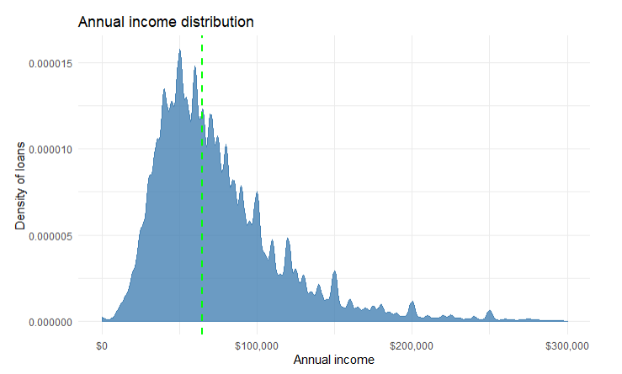

1. Below visualization shows geographical distribution of total loan funded amount across various US states.

2. California has the highest total funded loan amount, followed by Texas, New York and Florida.

fullStateNames <- read.csv("data/states.csv")  
states <- st_as_sf(map("state", plot = FALSE, fill = TRUE))  
  
fundedAmountByState <- lendingClubLoanData %>%   
 group_by(addr_state)%>%  
 summarise(totalFundedAmount= sum(as.numeric(funded_amnt)))  
  
fundedAmountByState <- fundedAmountByState %>%  
 inner_join(fullStateNames, by = c("addr_state" = "abbreviation"))  
  
  
states2 <- states %>% left_join(fundedAmountByState, by = c("ID" = "state" ))

ggplot(data = states2) +   
 geom_sf(aes(fill = totalFundedAmount)) +  
 scale_fill_viridis_c("Loan funded amount", labels = scales::dollar) +  
 labs(title = "Total loan funded amount by state") +  
 theme_minimal()

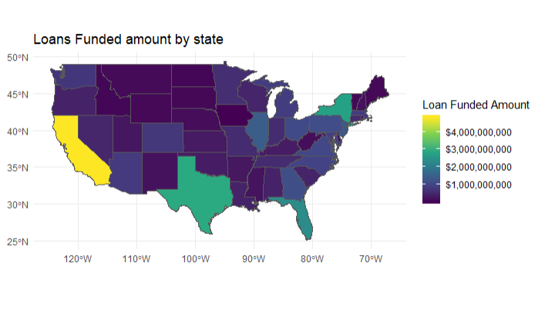

1. Below visualization shows the distribution of DTI (Debt to Income Ratio (%)) for the people getting loan.
2. Lower the DTI, higher the probability of getting the loan approved.

filteredLendingClubData <- lendingClubLoanData %>%  
 drop_na(dti)%>%  
 filter(dti < 100)  
  
ggplot(data = filteredLendingClubData, aes(x = dti)) +  
 geom_density(fill="steelblue", color="steelblue", alpha=0.8) +  
 geom_vline(aes(xintercept=median(dti)),color="green", linetype="dashed", size=1) +  
 labs(x="Debt to Income Ratio (DTI) %",y="Density of loans",title="Loan distribution across DTI") + theme_minimal()

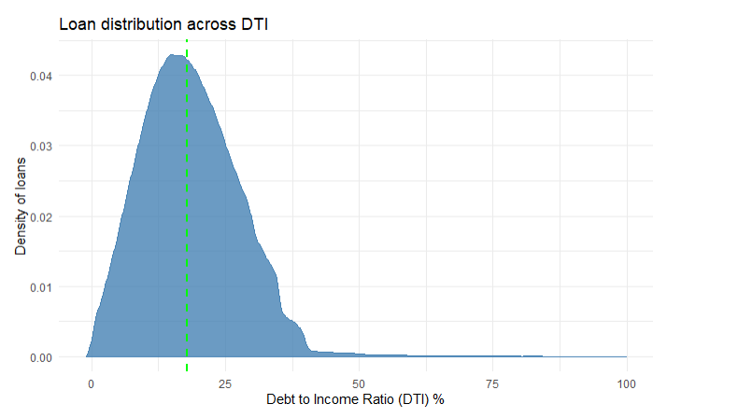

1. Below visualization shows loan distribution by the loan status.
2. Close to 900K loans are current and 1 Million loans are paid off.
3. Charged of loans are close to 2,61,655 out of total 2,260,668 loans. So the charge of percentage is close to 12% (exact 11.57 %).
4. Most current loans will be eventually paid off.

loan_statuses <- c("Current",  
 "Fully Paid",  
 "Late (31-120 days)",  
 "In Grace Period",  
 "Charged Off",  
 "Late (16-30 days)")  
  
numberOfLoansByLoanStatus <- lendingClubLoanData %>%   
 filter(loan_status %in% loan_statuses) %>%  
 group_by(loan_status)%>%  
 summarise(numberOfLoans = n())  
  
ggplot(data = numberOfLoansByLoanStatus, aes(x=loan_status, y=numberOfLoans)) +  
 geom_bar(stat="identity", width=0.5, fill = "steelblue") +  
 geom_text(aes(label=numberOfLoans), vjust=-0.3, size=3.5) +  
 scale_y_continuous(labels = scales::comma_format()) +  
 labs(x = "Loan Status", y = "Number of Loans (#)",title="# Loans by status") +  
 theme_minimal() +  
 theme(axis.text.x = element_text(angle =50, hjust=0.75))

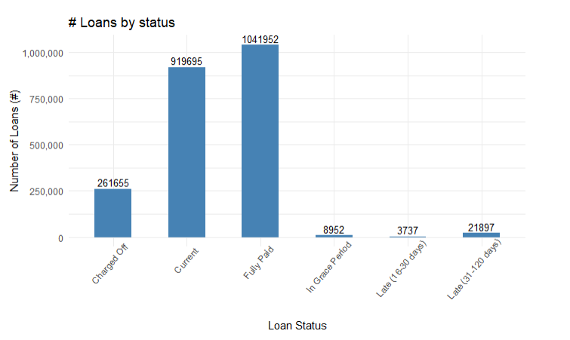

1. Below visualization shows the distribution of loans taken for various causes.
2. Debt consolidation is major primary purpose of taking loan from lending club.
3. Second major purpose of taking loan is for paying credit card bills.

numberOfLoansByPurpose <- lendingClubLoanData %>%   
 group_by(purpose)%>%  
 summarise(numberOfLoans = n())  
  
ggplot(data = numberOfLoansByPurpose, aes(x=purpose, y=numberOfLoans)) +  
 geom_bar(stat="identity", width=0.5, fill = "steelblue") +  
 scale_y_continuous(labels = scales::comma_format()) +  
 labs(x = "Loan Purpose", y = "Number of Loans (#)",title="# Loans by purpose") +  
 theme_minimal() +  
 theme(axis.text.x = element_text(angle =50, hjust=0.75))

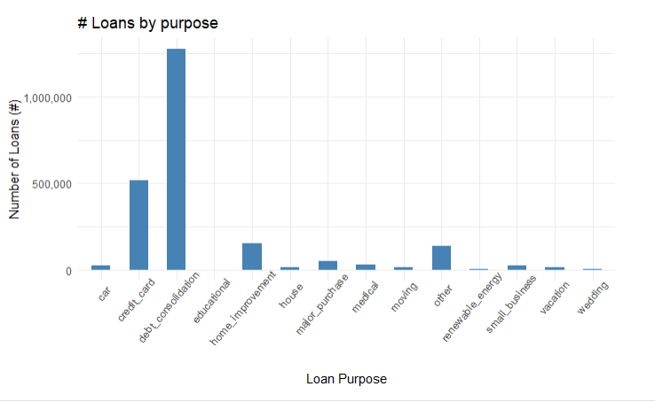

filteredLendingClubData <- lendingClubLoanData %>%  
 drop_na(loan_amnt) %>%  
 drop_na(funded_amnt)  
# Max loan amount  
as.numeric(max(filteredLendingClubData$loan_amnt))

## [1] 40000

# Minimum loan amount  
as.numeric(min(filteredLendingClubData$loan_amnt))

## [1] 500

# Unique loan statuses   
uniqueLoanStatus <- unique(filteredLendingClubData$loan_status)  
uniqueLoanStatus

## [1] Current   
## [2] Fully Paid   
## [3] Late (31-120 days)   
## [4] In Grace Period   
## [5] Charged Off   
## [6] Late (16-30 days)   
## [7] Default   
## [8] Does not meet the credit policy. Status:Fully Paid   
## [9] Does not meet the credit policy. Status:Charged Off  
## 9 Levels: Charged Off Current ... Late (31-120 days)

filteredLendingClubData <- lendingClubLoanData %>%  
 drop_na(dti)  
# Max DTI  
as.numeric(max(filteredLendingClubData$dti))

## [1] 999

#Minimum DTI  
as.numeric(min(filteredLendingClubData$dti))

## [1] -1

# Total loan funded amount  
as.numeric(sum(filteredLendingClubData$funded_amnt))

## [1] 33971525425

filteredLendingClubData <- lendingClubLoanData %>%  
 drop_na(annual_inc)%>%  
 filter(annual_inc < 300000)  
# Annual income median  
median(filteredLendingClubData$annual_inc)

## [1] 65000

filteredLendingClubData <- lendingClubLoanData %>%  
 drop_na(dti)%>%  
 filter(dti < 100)  
# Dti median  
median(filteredLendingClubData$dti)

## [1] 17.82

#Number of loans  
nrow(lendingClubLoanData)

## [1] 2260668

# Link to dashboard

<https://amol-gote.shinyapps.io/Week8/>

# Executive Summary

* 2.2 million Loans have been funded by lending club.
* Total funded loan amount is close to $ 33 billion
* Year on year there has been steady growth in number of loans funded and total funded loan amount.
  1. Year 2012 to 2015 saw the maximum growth.
  2. Highest number of loans issued was in 2018, close 500,000 loans
  3. Maximum total loan funded amount was in 2018 close to $8 billion.
* Loan distribution across term
  1. Lending club offers only loans with 2 terms 36 months and 60 months.
  2. For 36 months loan:
     1. Median loan funded amount is $10000.
     2. Majority of the funded loan amount ranges from close $6000 to $16000.
  3. For 60 months loan:
     1. Median loan funded amount is $20000.
     2. Majority of the funded loan amount ranges from close $15000 to $25000.
* Relationship between funded loan amount, annual income and interest rate
  1. Higher the annual income more is the funded loan amount.
  2. As the annual income increase the interest rate drop by couple of percentage points.
* Median annual income is $65,000. Majority of lenders are having annual income less than $200K.
* Lower the DTI higher the probability of getting the loan approved. Median DTI is close to 18% (17.82%). Above 38% DTI probability of loan getting funded is less.
* California has the highest total funded loan amount, followed by Texas, New York and Florida. Total Loan funded amount in California is greater than $4 billion.
* Loan performance
  1. Out of 2.2 million total loans, Close to 900K loans are current and 1 Million loans which are paid off.
  2. Charge of percentage is close to 12% (exact 11.57 %). So essentially 12% of loans are bad loans and remaining close 88% are good loans.
* Loan Purpose
  1. Debt consolidation is major primary purpose of taking loan from lending club.
  2. Second major purpose of taking loan is for paying credit card bills.

# Shiny Code

#server.R Code

#  
# This is the server logic of a Shiny web application. You can run the  
# application by clicking 'Run App' above.  
#  
# Find out more about building applications with Shiny here:  
#  
# http://shiny.rstudio.com/  
#  
  
library(shiny)  
library(tidyverse)  
library(maps)  
library(scales)  
library(sf)  
library(shinycssloaders)  
lendingClubLoanData <- read.csv("data/lending_club_loan_data_final.csv")  
fullStateNames <- read.csv("data/states.csv")  
states <- st_as_sf(map("state", plot = FALSE, fill = TRUE))  
incomeLabels <- c('0-20K','20-40K','40-60K','60-80K','80-100K','100-120K',  
 '120-140K','140-160K','160-180K','180-200K', '200-220K',   
 '220-240K', '240-260K', '260-280K', '280-300K')  
  
loan_statuses <- c("Current",  
 "Fully Paid",  
 "Late (31-120 days)",  
 "In Grace Period",  
 "Charged Off",  
 "Late (16-30 days)")  
  
filteredLendingClubData <- lendingClubLoanData %>%  
 drop_na(annual_inc)  
  
filtereDdtiData <- lendingClubLoanData %>%  
 drop_na(dti)%>%  
 drop_na(dti) %>%  
 filter(dti < 100)  
  
filteredAnnualIncomeData <- lendingClubLoanData %>%  
 drop_na(annual_inc)%>%  
 filter(annual_inc < 300000)  
  
  
# Define server logic required to draw a histogram  
shinyServer(function(input, output) {  
   
 loanStatusFilter <- function(loanStatusValue) {  
 toReturn <- c("Current",  
 "Fully Paid",  
 "Late (31-120 days)",  
 "In Grace Period",  
 "Charged Off",  
 "Late (16-30 days)",  
 "Default",  
 "Does not meet the credit policy. Status:Fully Paid",  
 "Does not meet the credit policy. Status:Charged Off")  
 if (loanStatusValue != "Any"){  
 toReturn <- c(loanStatusValue)  
 }  
 return(toReturn)  
 }  
   
 number_of_loans_each_year <- reactive({  
 numberOfLoansEachYear <- lendingClubLoanData %>%  
 filter (loan_amnt >= input$loanAmountRange[1] & loan_amnt <= input$loanAmountRange[2]) %>%  
 filter(grade %in% input$grades) %>%  
 filter(home_ownership %in% input$homeOwnerships) %>%  
 filter(loan_status %in% loanStatusFilter(loanStatusValue = input$loanStatus)) %>%  
 group_by(orig_year) %>%  
 summarise(loanCountByYear=n())  
 })  
   
 total_amount_funded_each_year <- reactive({  
 totalFundedAMountPerYear <- lendingClubLoanData %>%   
 filter (loan_amnt >= input$loanAmountRange[1] & loan_amnt <= input$loanAmountRange[2]) %>%  
 filter(grade %in% input$grades) %>%  
 filter(home_ownership %in% input$homeOwnerships) %>%  
 filter(loan_status %in% loanStatusFilter(loanStatusValue = input$loanStatus)) %>%  
 group_by(orig_year)%>%  
 summarise(totalFundedAmount= sum(as.numeric(funded_amnt)))  
 })  
   
 loan_amt_term_relation <- reactive({  
 lendingClubLoanData %>%  
 filter (loan_amnt >= input$loanAmountRange[1] & loan_amnt <= input$loanAmountRange[2]) %>%  
 filter(grade %in% input$grades) %>%  
 filter(home_ownership %in% input$homeOwnerships) %>%  
 filter(loan_status %in% loanStatusFilter(loanStatusValue = input$loanStatus))  
 })  
   
 dti_trend <- reactive({  
 filtereDdtiData %>%  
 filter(loan_amnt >= input$loanAmountRange[1] & loan_amnt <= input$loanAmountRange[2]) %>%  
 filter(grade %in% input$grades) %>%  
 filter(home_ownership %in% input$homeOwnerships) %>%  
 filter(loan_status %in% loanStatusFilter(loanStatusValue = input$loanStatus))  
 })  
   
 funded_amt_term_interest_relation <- reactive({  
 filteredLendingClubData <- filteredLendingClubData %>%  
 filter(annual_inc <= 300000) %>%  
 filter(loan_amnt >= input$loanAmountRange[1] & loan_amnt <= input$loanAmountRange[2]) %>%  
 filter(grade %in% input$grades) %>%  
 filter(home_ownership %in% input$homeOwnerships) %>%  
 filter(loan_status %in% loanStatusFilter(loanStatusValue = input$loanStatus))  
   
 groupedData <- filteredLendingClubData %>%   
 group_by(incomeGroup = cut(annual_inc, breaks= seq(0, 300000, by = 20000),   
 right = TRUE, include.lowest = TRUE, labels = incomeLabels) ) %>%   
 summarise(averageInterest= mean(int_rate), averageLoanLoanFundedAmount = mean(funded_amnt))   
   
 })  
   
 income_trend <- reactive({  
 filteredAnnualIncomeData %>%  
 filter (loan_amnt >= input$loanAmountRange[1] & loan_amnt <= input$loanAmountRange[2]) %>%  
 filter(grade %in% input$grades) %>%  
 filter(home_ownership %in% input$homeOwnerships) %>%  
 filter(loan_status %in% loanStatusFilter(loanStatusValue = input$loanStatus))  
 })  
   
 loan_funded_amt_by_state <- reactive({  
 fundedAmountByState <- lendingClubLoanData %>%   
 filter (loan_amnt >= input$loanAmountRange[1] & loan_amnt <= input$loanAmountRange[2]) %>%  
 filter(grade %in% input$grades) %>%  
 filter(home_ownership %in% input$homeOwnerships) %>%  
 filter(loan_status %in% loanStatusFilter(loanStatusValue = input$loanStatus)) %>%  
 group_by(addr_state)%>%  
 summarise(totalFundedAmount= sum(as.numeric(funded_amnt)))  
   
 fundedAmountByState <- fundedAmountByState %>%  
 inner_join(fullStateNames, by = c("addr_state" = "abbreviation"))  
   
 states2 <- states %>% left_join(fundedAmountByState, by = c("ID" = "state" ))  
 })  
   
 loans_by_status <- reactive({  
 numberOfLoansByLoanStatus <- lendingClubLoanData %>%   
 filter(loan_status %in% loan_statuses) %>%  
 filter(loan_amnt >= input$loanAmountRange[1] & loan_amnt <= input$loanAmountRange[2]) %>%  
 filter(grade %in% input$grades) %>%  
 filter(home_ownership %in% input$homeOwnerships) %>%  
 filter(loan_status %in% loanStatusFilter(loanStatusValue = input$loanStatus)) %>%  
 group_by(loan_status)%>%  
 summarise(numberOfLoans = n())  
 })  
   
 loans_by_purpose <- reactive({  
 numberOfLoansByPurpose <- lendingClubLoanData %>%   
 filter(loan_amnt >= input$loanAmountRange[1] & loan_amnt <= input$loanAmountRange[2]) %>%  
 filter(grade %in% input$grades) %>%  
 filter(home_ownership %in% input$homeOwnerships) %>%  
 filter(loan_status %in% loanStatusFilter(loanStatusValue = input$loanStatus)) %>%  
 group_by(purpose)%>%  
 summarise(numberOfLoans = n())  
 })  
   
   
   
 output$loanProcessesedEachYear <- renderPlot({  
 ggplot(data = number_of_loans_each_year())+  
 geom_line(color="steelblue", size=1.2, aes(x=orig_year,y=loanCountByYear))+  
 geom_point(color="steelblue", size=2.5, aes(x=orig_year,y=loanCountByYear))+  
 scale_x_continuous(breaks = number_of_loans_each_year()$orig_year) +  
 scale_y_continuous(labels = scales::comma_format()) +  
 labs(x="Year",y="# Number of loans",title="Loans processed year on year (2007-2018)")+  
 theme_minimal()   
 })  
   
 output$totalFundedLoanAmountEachYear <- renderPlot({  
 ggplot(data = total_amount_funded_each_year(), aes(x=orig_year, y=totalFundedAmount)) +  
 geom_bar(stat="identity", width=0.5, fill = "steelblue") +  
 scale_x_continuous(breaks = total_amount_funded_each_year()$orig_year) +  
 scale_y_continuous(labels = scales::dollar) +  
 labs(x = "Year", y = "Total funded loan amount",title="Total loan funded amount year on year (2007-2018)") +  
 theme_minimal()   
 })  
   
 output$loanAmtTermRelation <- renderPlot({  
 ggplot(data = loan_amt_term_relation()) +  
 geom_boxplot(aes(x=term, y=funded_amnt, color=term)) +   
 scale_y_continuous(labels = scales::dollar) +  
 labs(x = "Term", y = "Loan funded amount", title="Loan funded amount and term relation") +  
 theme_minimal()   
 })  
   
 output$fundedAmtIncomeAndInterestRelation <- renderPlot({  
 ggplot(data =funded_amt_term_interest_relation(), aes(x=incomeGroup, y=averageLoanLoanFundedAmount)) +  
 geom_point(colour="steelblue", shape=16, aes(size=averageInterest)) +  
 geom_smooth(aes(incomeGroup, averageLoanLoanFundedAmount, group = 1), method = "lm") +  
 scale_y_continuous(labels = scales::dollar) +  
 labs(x="Annual Income ($)",y="Average loan funded amount",  
 title="Relation between funded loan Amount, income and interest rate")+  
 guides(size=guide_legend("Average \ninterest rate (%)")) +  
 theme_minimal() +  
 theme(axis.text.x = element_text(angle =50, hjust=0.75))+  
 theme(legend.background = element_rect())  
 })  
  
 output$incomeTrend <- renderPlot({  
 ggplot(data = income_trend(), aes(x = annual_inc)) +  
 geom_density(fill="steelblue", color="steelblue", alpha=0.8) +  
 geom_vline(aes(xintercept=median(annual_inc)),color="green", linetype="dashed", size=1) +  
 scale_x_continuous(labels = scales::dollar) +  
 scale_y_continuous(labels = function(x) format(x, scientific = FALSE)) +  
 labs(x="Annual income",y="Density of loans",title="Annual income distribution") +  
 theme_minimal()  
 })  
   
 output$loanFundedAmtByState <- renderPlot({  
 ggplot(data = loan_funded_amt_by_state()) +   
 geom_sf(aes(fill = totalFundedAmount)) +  
 scale_fill_viridis_c("Loan funded amount", labels = scales::dollar) +  
 labs(title = "Total loan funded amount by state") +  
 theme_minimal()  
 })  
   
 output$dtiTrend <- renderPlot({  
 ggplot(data = dti_trend(), aes(x = dti)) +  
 geom_density(fill="steelblue", color="steelblue", alpha=0.8) +  
 geom_vline(aes(xintercept=median(dti)),color="green", linetype="dashed", size=1) +  
 labs(x="Debt to Income Ratio (DTI) %",y="Density of loans",  
 title="Loan distribution across DTI (Excluded > 100") +  
 theme_minimal()  
 })  
   
 output$loansByStatus <- renderPlot({  
 ggplot(loans_by_status(), aes(x=loan_status, y=numberOfLoans)) +  
 geom_bar(stat="identity", width=0.5, fill = "steelblue") +  
 geom_text(aes(label=numberOfLoans), vjust=-0.3, size=3.5) +  
 scale_y_continuous(labels = scales::comma_format()) +  
 labs(x = "Loan Status", y = "Number of Loans (#)",title="# Loans by status") +  
 theme_minimal() +  
 theme(axis.text.x = element_text(angle =50, hjust=0.75))  
 })  
   
 output$loansByPurpose <- renderPlot({  
 ggplot(loans_by_purpose(), aes(x=purpose, y=numberOfLoans)) +  
 geom_bar(stat="identity", width=0.5, fill = "steelblue") +  
 scale_y_continuous(labels = scales::comma_format()) +  
 labs(x = "Loan Purpose", y = "Number of Loans (#)",title="# Loans by purpose") +  
 theme_minimal() +  
 theme(axis.text.x = element_text(angle =50, hjust=0.75))  
 })  
   
})

#ui.R code

#  
# This is the user-interface definition of a Shiny web application. You can  
# run the application by clicking 'Run App' above.  
#  
# Find out more about building applications with Shiny here:  
#  
# http://shiny.rstudio.com/  
#  
  
library(shiny)  
library(shinythemes)  
library(shinycssloaders)  
# Define UI for application that draws a histogram  
shinyUI(fluidPage(  
 theme = shinytheme("slate"),  
 # Application title  
 titlePanel(""),  
 titlePanel(title=div(style="display:inline-block;width:100%;",  
 img(src="homelogo.png", style="height:100px;"), "Data analysis (2007-2018)"),   
 windowTitle = "Lending club data analysis"),  
   
 # Sidebar with a slider input for number of bins  
 sidebarLayout(  
 sidebarPanel(  
 # Price Range filter  
 sliderInput("loanAmountRange",  
 "Loan Amount:",  
 pre = "$",  
 min = 500,  
 max = 40000,  
 value = c(500, 40000)),  
 # Horizontal line ----  
 tags$hr(),  
   
 # House condition filter  
 checkboxGroupInput(inputId = "grades",  
 label ="Grade:",  
 choiceNames = c("A", "B", "C", "D", "E", "F", "G"),   
 choiceValues = c("A", "B", "C", "D", "E", "F", "G"),  
 selected = c("A", "B", "C", "D", "E", "F", "G"),  
 inline = TRUE),  
 # Horizontal line ----  
 tags$hr(),  
   
 # House condition filter  
 checkboxGroupInput(inputId = "homeOwnerships",  
 label ="Home Ownership:",  
 choiceNames = c("ANY", "RENT", "MORTGAGE", "OWN"),   
 choiceValues = c("ANY", "RENT", "MORTGAGE", "OWN"),  
 selected = c("ANY", "RENT", "MORTGAGE", "OWN"),  
 inline = TRUE),  
 # Horizontal line ----  
 tags$hr(),  
   
   
 # Number of bedrooms filter  
 selectInput("loanStatus", "Loan Status:",  
 c(  
 "Any" = "Any",  
 "Current" = "Current",  
 "Fully Paid" = "Fully Paid",  
 "Late (31-120 days)" = "Late (31-120 days)",  
 "In Grace Period" = "In Grace Period",  
 "Charged Off" = "Charged Off",  
 "Late (16-30 days)" = "Late (16-30 days)",  
 "Default" = "Default",  
 "Does not meet the credit policy. Status:Fully Paid" = "Does not meet the credit policy. Status:Fully Paid",  
 "Does not meet the credit policy. Status:Charged Off" = "Does not meet the credit policy. Status:Charged Off"  
 )),  
 # Horizontal line ----  
 tags$hr(),  
   
 # Price Range filter  
 sliderInput("dti",  
 "Debt to Income Ratio:",  
 pre = "%",  
 min = -1,  
 max = 999,  
 value = c(0, 100)),  
 # Horizontal line ----  
 tags$hr(),  
 tags$div(style="display:inline-block;width:100%;color:#e48806",   
 "** Due to large dataset size, visualizations and filters may run slow **"),  
 ),  
   
 # Show a plot of the generated distribution  
 mainPanel(  
 tabsetPanel(  
 tabPanel("Year wise loans trend", shinycssloaders::withSpinner(plotOutput("loanProcessesedEachYear")),   
 shinycssloaders::withSpinner(plotOutput("totalFundedLoanAmountEachYear"))),  
 tabPanel("Loan Amount, Term Relation",   
 shinycssloaders::withSpinner(plotOutput("loanAmtTermRelation", height="700px"))),  
 tabPanel("DTI Trend",   
 shinycssloaders::withSpinner(plotOutput("dtiTrend", height="700px"))),  
 tabPanel("Loan Amount, Income, Interest Relation",   
 shinycssloaders::withSpinner(plotOutput("fundedAmtIncomeAndInterestRelation")),  
 shinycssloaders::withSpinner(plotOutput("incomeTrend"))),  
 tabPanel("Loan Amount by state",   
 shinycssloaders::withSpinner(plotOutput("loanFundedAmtByState", height="700px"))),  
 tabPanel("Loans status and purpose",   
 shinycssloaders::withSpinner(plotOutput("loansByStatus")),  
 shinycssloaders::withSpinner(plotOutput("loansByPurpose")))  
 )  
 ),  
   
 )  
))