FinalAssignment

Amol Gote

3/7/2020

library(ggplot2)   
library(readr)   
library(gridExtra)  
library(tidyverse)  
library(sf)

## Warning: package 'sf' was built under R version 3.6.3

library(maps)

## Warning: package 'maps' was built under R version 3.6.3

## R Markdown

This is an R Markdown document. Markdown is a simple formatting syntax for authoring HTML, PDF, and MS Word documents. For more details on using R Markdown see <http://rmarkdown.rstudio.com>.

When you click the **Knit** button a document will be generated that includes both content as well as the output of any embedded R code chunks within the document. You can embed an R code chunk like this:

lendingClubLoanData <- read.csv("data/lending_club_loan_data.csv")  
lendingClubLoanData <- lendingClubLoanData[, !(colnames(lendingClubLoanData) %in% c("id","member_id", "url", "desc"))]  
lendingClubLoanData <- lendingClubLoanData[, !(colnames(lendingClubLoanData) %in% c("open_acc_6m", "open_act_il", "open_il_12m", "open_il_24m", "mths_since_rcnt_il", "total_bal_il", "il_util", "open_rv_12m", "open_rv_24m", "max_bal_bc", "all_util", "total_rev_hi_lim", "inq_fi", "total_cu_tl", "acc_open_past_24mths", "bc_open_to_buy", "bc_util", "mo_sin_old_il_acct", "mo_sin_old_rev_tl_op", "mo_sin_rcnt_rev_tl_op", "mo_sin_rcnt_tl", "mths_since_recent_bc", "mths_since_recent_bc_dlq", "mths_since_recent_inq", "mths_since_recent_revol_delinq", "num_accts_ever_120_pd", "num_actv_bc_tl", "num_actv_rev_tl", "num_bc_sats", "num_bc_tl", "num_il_tl", "num_op_rev_tl", "num_rev_accts", "num_rev_tl_bal_gt_0", "num_sats", "pct_tl_nvr_dlq", "percent_bc_gt_75", "tot_hi_cred_lim", "total_bal_ex_mort", "total_bc_limit", "total_il_high_credit_limit", "revol_bal_joint", "sec_app_earliest_cr_line", "sec_app_inq_last_6mths", "sec_app_mort_acc", "sec_app_open_acc", "sec_app_revol_util", "sec_app_open_act_il", "sec_app_num_rev_accts", "sec_app_chargeoff_within_12_mths", "sec_app_collections_12_mths_ex_med", "sec_app_mths_since_last_major_derog", "hardship_reason", "hardship_status", "deferral_term", "hardship_amount", "hardship_start_date", "hardship_end_date", "payment_plan_start_date", "hardship_length", "hardship_dpd", "hardship_loan_status", "orig_projected_additional_accrued_interest", "hardship_payoff_balance_amount", "hardship_last_payment_amount", "disbursement_method", "debt_settlement_flag", "debt_settlement_flag_date", "settlement_status", "settlement_date", "settlement_amount", "settlement_percentage", "settlement_term"))]  
lendingClubLoanData <- lendingClubLoanData[, !(colnames(lendingClubLoanData) %in% c("earliest_cr_line","inq_last_6mths","mths_since_last_delinq","mths_since_last_record","open_acc","pub_rec","revol_bal","revol_util","total_acc","initial_list_status","out_prncp","out_prncp_inv","total_pymnt","total_pymnt_inv","total_rec_prncp","total_rec_int","total_rec_late_fee","recoveries","collection_recovery_fee","last_pymnt_d","last_pymnt_amnt","next_pymnt_d","last_credit_pull_d","collections_12_mths_ex_med","mths_since_last_major_derog","policy_code","acc_now_delinq","tot_coll_amt","tot_cur_bal","inq_last_12m","avg_cur_bal","chargeoff_within_12_mths","delinq_amnt","mort_acc","num_tl_120dpd_2m","num_tl_30dpd","num_tl_90g_dpd_24m","num_tl_op_past_12m"))]  
lendingClubLoanData$orig_year<-substr(lendingClubLoanData$issue_d,5,8)  
write.csv(lendingClubLoanData, file = "data/lending_club_loan_data_final.csv", row.names=FALSE)  
lendingClubLoanData <- read.csv("data/lending_club_loan_data_final.csv")

numberOfLoansByYear <- lendingClubLoanData %>%   
 group_by(orig_year)%>%  
 summarise(loanCountByYear=n())  
  
ggplot(data = numberOfLoansByYear)+  
 geom_line(color="steelblue", size=1.2, aes(x=orig_year,y=loanCountByYear))+  
 geom_point(color="steelblue", size=2.5, aes(x=orig_year,y=loanCountByYear))+  
 scale_x_continuous(breaks = numberOfLoansByYear$orig_year) +  
 scale_y_continuous(labels = scales::comma_format()) +  
 labs(x="Year",y="# Number of loans",title="Loans processed in each Year")+  
 theme_minimal()

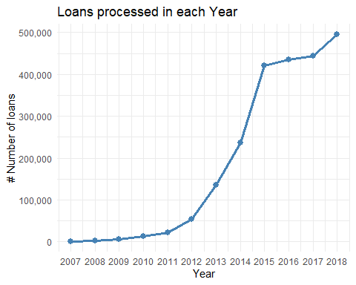

totalFundedAMountPerYear <- lendingClubLoanData %>%   
 group_by(orig_year)%>%  
 summarise(totalFundedAmount= sum(as.numeric(funded_amnt)))  
  
ggplot(data = totalFundedAMountPerYear, aes(x=orig_year, y=totalFundedAmount)) +  
 geom_bar(stat="identity", width=0.5, fill = "steelblue") +  
 scale_x_continuous(breaks = numberOfLoansByYear$orig_year) +  
 scale_y_continuous(labels = scales::dollar) +  
 labs(x = "Year", y = "$ Total funded loan",title="Total Funded Loan Amount each Year") +  
 theme_minimal()

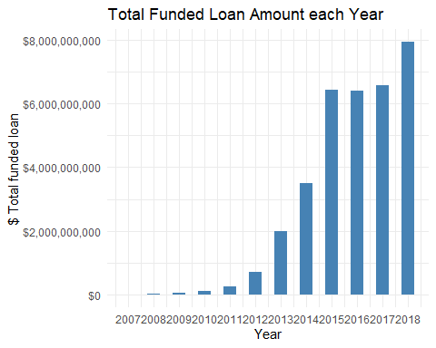

lendingClubLoanData %>%  
ggplot() +  
 geom_boxplot(aes(x=term, y=funded_amnt, color=term)) +   
 scale_y_continuous(labels = scales::dollar) +  
 labs(x = "Term", y = "Loan Funded Amount", title="Loan Amount and term relation") +  
 theme_minimal()

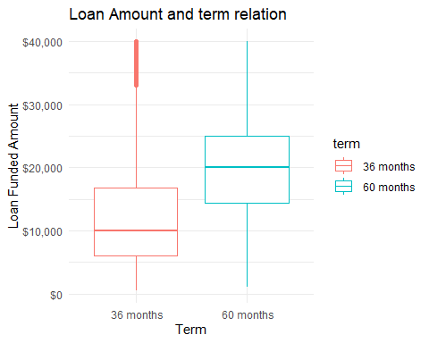

filteredLendingClubData <- lendingClubLoanData %>%  
 drop_na(annual_inc)  
  
filteredLendingClubData <- filteredLendingClubData %>%  
 filter(annual_inc <= 300000)  
  
lbls <- c('0-20K','20-40K','40-60K','60-80K','80-100K','100-120K','120-140K','140-160K','160-180K','180-200K', '200-220K', '220-240K', '240-260K', '260-280K', '280-300K')  
groupedData <- filteredLendingClubData %>%   
 group_by(incomeGroup = cut(annual_inc, breaks= seq(0, 300000, by = 20000), right = TRUE, include.lowest = TRUE, labels = lbls) ) %>%   
 summarise(averageInterest= mean(int_rate), averageLoanLoanFundedAmount = mean(funded_amnt))   
  
ggplot(data =groupedData, aes(x=incomeGroup, y=averageLoanLoanFundedAmount)) +  
 geom_point(colour="steelblue", shape=16, aes(size=averageInterest)) +  
 geom_smooth(aes(incomeGroup, averageLoanLoanFundedAmount, group = 1), method = "lm") +  
 scale_y_continuous(labels = scales::dollar) +  
 labs(x="Annual Income ($)",y="Average loan funded amount",title="Relation between Funded Amt, Income and Interest Rate")+  
 guides(size=guide_legend("Avg \nInterest Rate (%)")) +  
 theme_minimal() +  
 theme(axis.text.x = element_text(angle =50, hjust=0.75))+  
 theme(legend.background = element_rect())

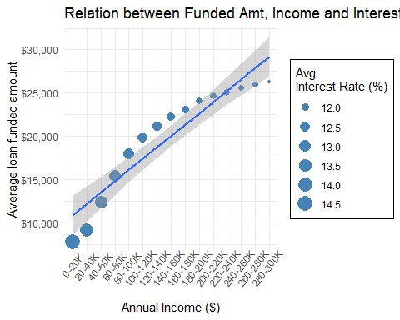

fullStateNames <- read.csv("data/states.csv")  
states <- st_as_sf(map("state", plot = FALSE, fill = TRUE))  
  
fundedAmountByState <- lendingClubLoanData %>%   
 group_by(addr_state)%>%  
 summarise(totalFundedAmount= sum(as.numeric(funded_amnt)))  
  
fundedAmountByState <- fundedAmountByState %>%  
 inner_join(fullStateNames, by = c("addr_state" = "abbreviation"))  
  
  
states2 <- states %>% left_join(fundedAmountByState, by = c("ID" = "state" ))

## Warning: Column `ID`/`state` joining factors with different levels,  
## coercing to character vector

ggplot(data = states2) +   
 geom_sf(aes(fill = totalFundedAmount)) +  
 scale_fill_viridis_c("Loan Funded Amount", labels = scales::dollar) +  
 labs(title = "Loans Funded amount by state") +  
 theme_minimal()

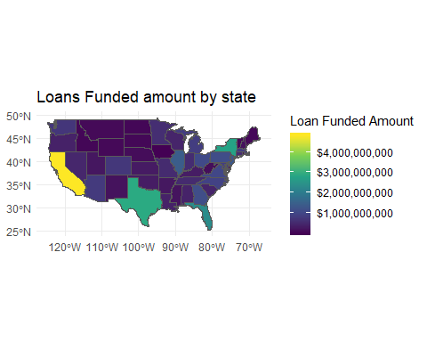

filteredLendingClubData <- lendingClubLoanData %>%  
 drop_na(dti)%>%  
 filter(dti < 100)  
  
ggplot(data = filteredLendingClubData, aes(x = dti)) +  
 geom_density(fill="steelblue", color="steelblue", alpha=0.8) +  
 labs(x="Debt to Income Ratio (DTI) %",y="Density of loans",title="Loan distribution across DTI") +  
 theme_minimal()

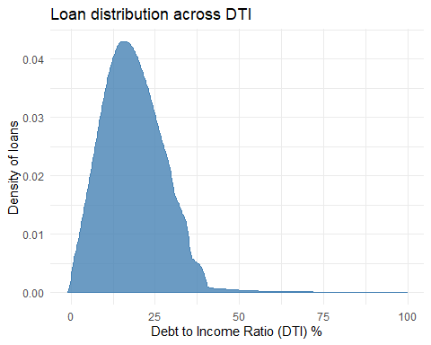

filteredLendingClubData <- lendingClubLoanData %>%  
 drop_na(annual_inc)%>%  
 filter(annual_inc < 300000)  
  
ggplot(data = filteredLendingClubData, aes(x = annual_inc)) +  
 geom_density(fill="steelblue", color="steelblue", alpha=0.8) +  
 scale_x_continuous(labels = scales::dollar) +  
 scale_y_continuous(labels = function(x) format(x, scientific = FALSE)) +  
 labs(x="Annual Income",y="Density of loans",title="Annual income distribution") +  
 theme_minimal()

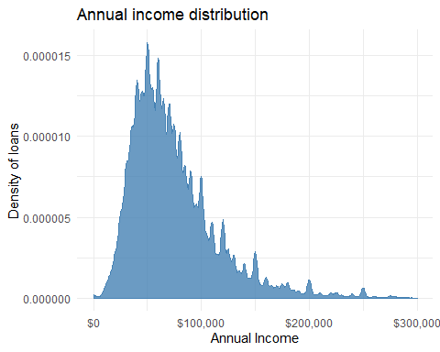

filteredLendingClubData <- lendingClubLoanData %>%  
 drop_na(loan_amnt)  
as.numeric(max(filteredLendingClubData$loan_amnt))

## [1] 40000

as.numeric(min(filteredLendingClubData$loan_amnt))

## [1] 500

loanGreaterThan100K <- filteredLendingClubData %>%  
 filter(loan_amnt > 100000)  
  
uniqueLoanStatus <- unique(filteredLendingClubData$loan_status)  
uniqueLoanStatus

## [1] Current   
## [2] Fully Paid   
## [3] Late (31-120 days)   
## [4] In Grace Period   
## [5] Charged Off   
## [6] Late (16-30 days)   
## [7] Default   
## [8] Does not meet the credit policy. Status:Fully Paid   
## [9] Does not meet the credit policy. Status:Charged Off  
## 9 Levels: Charged Off Current ... Late (31-120 days)

filteredLendingClubData <- lendingClubLoanData %>%  
 drop_na(dti)  
as.numeric(max(filteredLendingClubData$dti))

## [1] 999

as.numeric(min(filteredLendingClubData$dti))

## [1] -1