Final Project

Amol Gote

08/09/2020

lendingClubLoanData <- fread("data/Lending_club_dataset.csv", header = TRUE)

nrow(lendingClubLoanData)

## [1] 2260701

lendingClubLoanData$orig_year<-substr(lendingClubLoanData$issue_d,5,8)

lendingClubLoanData_2018 <- lendingClubLoanData %>%  
 filter(orig_year == 2018)

nrow(lendingClubLoanData_2018)

## [1] 495242

nrow(lendingClubLoanData_2018)

## [1] 495242

write.csv(lendingClubLoanData_2018, file = "data/lending_club_loan_data_2018_final.csv", row.names=FALSE)

final_dataset <- fread("data/lending_club_loan_data_2018_final.csv", header = TRUE)  
drops <- c("id","member_id", "url", "desc")  
final_dataset[ , !(names(final_dataset) %in% drops)]

## [1] FALSE FALSE TRUE TRUE TRUE TRUE TRUE TRUE TRUE TRUE TRUE TRUE  
## [13] TRUE TRUE TRUE TRUE TRUE TRUE FALSE FALSE TRUE TRUE TRUE TRUE  
## [25] TRUE TRUE TRUE TRUE TRUE TRUE TRUE TRUE TRUE TRUE TRUE TRUE  
## [37] TRUE TRUE TRUE TRUE TRUE TRUE TRUE TRUE TRUE TRUE TRUE TRUE  
## [49] TRUE TRUE TRUE TRUE TRUE TRUE TRUE TRUE TRUE TRUE TRUE TRUE  
## [61] TRUE TRUE TRUE TRUE TRUE TRUE TRUE TRUE TRUE TRUE TRUE TRUE  
## [73] TRUE TRUE TRUE TRUE TRUE TRUE TRUE TRUE TRUE TRUE TRUE TRUE  
## [85] TRUE TRUE TRUE TRUE TRUE TRUE TRUE TRUE TRUE TRUE TRUE TRUE  
## [97] TRUE TRUE TRUE TRUE TRUE TRUE TRUE TRUE TRUE TRUE TRUE TRUE  
## [109] TRUE TRUE TRUE TRUE TRUE TRUE TRUE TRUE TRUE TRUE TRUE TRUE  
## [121] TRUE TRUE TRUE TRUE TRUE TRUE TRUE TRUE TRUE TRUE TRUE TRUE  
## [133] TRUE TRUE TRUE TRUE TRUE TRUE TRUE TRUE TRUE TRUE TRUE TRUE  
## [145] TRUE TRUE TRUE TRUE TRUE TRUE TRUE TRUE

names(final_dataset)

## [1] "id"   
## [2] "member_id"   
## [3] "loan_amnt"   
## [4] "funded_amnt"   
## [5] "funded_amnt_inv"   
## [6] "term"   
## [7] "int_rate"   
## [8] "installment"   
## [9] "grade"   
## [10] "sub_grade"   
## [11] "emp_title"   
## [12] "emp_length"   
## [13] "home_ownership"   
## [14] "annual_inc"   
## [15] "verification_status"   
## [16] "issue_d"   
## [17] "loan_status"   
## [18] "pymnt_plan"   
## [19] "url"   
## [20] "desc"   
## [21] "purpose"   
## [22] "title"   
## [23] "zip_code"   
## [24] "addr_state"   
## [25] "dti"   
## [26] "delinq_2yrs"   
## [27] "earliest_cr_line"   
## [28] "fico_range_low"   
## [29] "fico_range_high"   
## [30] "inq_last_6mths"   
## [31] "mths_since_last_delinq"   
## [32] "mths_since_last_record"   
## [33] "open_acc"   
## [34] "pub_rec"   
## [35] "revol_bal"   
## [36] "revol_util"   
## [37] "total_acc"   
## [38] "initial_list_status"   
## [39] "out_prncp"   
## [40] "out_prncp_inv"   
## [41] "total_pymnt"   
## [42] "total_pymnt_inv"   
## [43] "total_rec_prncp"   
## [44] "total_rec_int"   
## [45] "total_rec_late_fee"   
## [46] "recoveries"   
## [47] "collection_recovery_fee"   
## [48] "last_pymnt_d"   
## [49] "last_pymnt_amnt"   
## [50] "next_pymnt_d"   
## [51] "last_credit_pull_d"   
## [52] "last_fico_range_high"   
## [53] "last_fico_range_low"   
## [54] "collections_12_mths_ex_med"   
## [55] "mths_since_last_major_derog"   
## [56] "policy_code"   
## [57] "application_type"   
## [58] "annual_inc_joint"   
## [59] "dti_joint"   
## [60] "verification_status_joint"   
## [61] "acc_now_delinq"   
## [62] "tot_coll_amt"   
## [63] "tot_cur_bal"   
## [64] "open_acc_6m"   
## [65] "open_act_il"   
## [66] "open_il_12m"   
## [67] "open_il_24m"   
## [68] "mths_since_rcnt_il"   
## [69] "total_bal_il"   
## [70] "il_util"   
## [71] "open_rv_12m"   
## [72] "open_rv_24m"   
## [73] "max_bal_bc"   
## [74] "all_util"   
## [75] "total_rev_hi_lim"   
## [76] "inq_fi"   
## [77] "total_cu_tl"   
## [78] "inq_last_12m"   
## [79] "acc_open_past_24mths"   
## [80] "avg_cur_bal"   
## [81] "bc_open_to_buy"   
## [82] "bc_util"   
## [83] "chargeoff_within_12_mths"   
## [84] "delinq_amnt"   
## [85] "mo_sin_old_il_acct"   
## [86] "mo_sin_old_rev_tl_op"   
## [87] "mo_sin_rcnt_rev_tl_op"   
## [88] "mo_sin_rcnt_tl"   
## [89] "mort_acc"   
## [90] "mths_since_recent_bc"   
## [91] "mths_since_recent_bc_dlq"   
## [92] "mths_since_recent_inq"   
## [93] "mths_since_recent_revol_delinq"   
## [94] "num_accts_ever_120_pd"   
## [95] "num_actv_bc_tl"   
## [96] "num_actv_rev_tl"   
## [97] "num_bc_sats"   
## [98] "num_bc_tl"   
## [99] "num_il_tl"   
## [100] "num_op_rev_tl"   
## [101] "num_rev_accts"   
## [102] "num_rev_tl_bal_gt_0"   
## [103] "num_sats"   
## [104] "num_tl_120dpd_2m"   
## [105] "num_tl_30dpd"   
## [106] "num_tl_90g_dpd_24m"   
## [107] "num_tl_op_past_12m"   
## [108] "pct_tl_nvr_dlq"   
## [109] "percent_bc_gt_75"   
## [110] "pub_rec_bankruptcies"   
## [111] "tax_liens"   
## [112] "tot_hi_cred_lim"   
## [113] "total_bal_ex_mort"   
## [114] "total_bc_limit"   
## [115] "total_il_high_credit_limit"   
## [116] "revol_bal_joint"   
## [117] "sec_app_fico_range_low"   
## [118] "sec_app_fico_range_high"   
## [119] "sec_app_earliest_cr_line"   
## [120] "sec_app_inq_last_6mths"   
## [121] "sec_app_mort_acc"   
## [122] "sec_app_open_acc"   
## [123] "sec_app_revol_util"   
## [124] "sec_app_open_act_il"   
## [125] "sec_app_num_rev_accts"   
## [126] "sec_app_chargeoff_within_12_mths"   
## [127] "sec_app_collections_12_mths_ex_med"   
## [128] "sec_app_mths_since_last_major_derog"   
## [129] "hardship_flag"   
## [130] "hardship_type"   
## [131] "hardship_reason"   
## [132] "hardship_status"   
## [133] "deferral_term"   
## [134] "hardship_amount"   
## [135] "hardship_start_date"   
## [136] "hardship_end_date"   
## [137] "payment_plan_start_date"   
## [138] "hardship_length"   
## [139] "hardship_dpd"   
## [140] "hardship_loan_status"   
## [141] "orig_projected_additional_accrued_interest"  
## [142] "hardship_payoff_balance_amount"   
## [143] "hardship_last_payment_amount"   
## [144] "disbursement_method"   
## [145] "debt_settlement_flag"   
## [146] "debt_settlement_flag_date"   
## [147] "settlement_status"   
## [148] "settlement_date"   
## [149] "settlement_amount"   
## [150] "settlement_percentage"   
## [151] "settlement_term"   
## [152] "orig_year"

ds_lc <- final_dataset[,c("loan_amnt",  
 "funded_amnt",  
 "funded_amnt_inv",  
 "term",  
 "int_rate",  
 "installment",  
 "grade",  
 "sub_grade",  
 "home_ownership",  
 "annual_inc",  
 "loan_status",  
 "dti",  
 "delinq_2yrs",  
 "fico_range_low",  
 "fico_range_high",  
 "inq_last_6mths",  
 "mths_since_last_delinq",  
 "mths_since_last_record",  
 "open_acc",  
 "pub_rec",  
 "revol_bal",  
 "revol_util",  
 "total_acc",  
 "out_prncp",  
 "out_prncp_inv",  
 "total_pymnt",  
 "total_pymnt_inv",  
 "total_rec_prncp",  
 "total_rec_int",  
 "total_rec_late_fee",  
 "recoveries",  
 "collection_recovery_fee",  
 "last_fico_range_high",  
 "last_fico_range_low",  
 "mths_since_last_major_derog",  
 "acc_now_delinq",  
 "avg_cur_bal"  
 )]  
  
  
  
ds_lc <- final_dataset[,c(  
 "loan_amnt",  
 "term",  
 "int_rate",  
 "installment",  
 "grade",  
 "sub_grade",  
 "home_ownership",  
 "annual_inc",  
 "loan_status",  
 "dti",  
 "delinq_2yrs",  
 "fico_range_low",  
 "fico_range_high",  
 "inq_last_6mths",  
 "open_acc",  
 "pub_rec"  
 )]

nrow(ds_lc)

## [1] 495242

ds_lc <- na.omit(ds_lc, cols = c("dti", "int_rate"))  
nrow(ds_lc)

## [1] 494110

levels(factor(ds_lc$loan_status))

## [1] "Charged Off" "Current" "Default"   
## [4] "Fully Paid" "In Grace Period" "Late (16-30 days)"   
## [7] "Late (31-120 days)"

levels(factor(ds_lc$grade))

## [1] "A" "B" "C" "D" "E" "F" "G"

levels(factor(ds_lc$sub_grade))

## [1] "A1" "A2" "A3" "A4" "A5" "B1" "B2" "B3" "B4" "B5" "C1" "C2" "C3" "C4" "C5"  
## [16] "D1" "D2" "D3" "D4" "D5" "E1" "E2" "E3" "E4" "E5" "F1" "F2" "F3" "F4" "F5"  
## [31] "G1" "G2" "G3" "G4" "G5"

levels(factor(ds_lc$home_ownership))

## [1] "ANY" "MORTGAGE" "OWN" "RENT"

ds_lc$term <- as.integer(as.factor(ds_lc$term))   
ds_lc$grade <- as.integer(as.factor(ds_lc$grade))  
ds_lc$sub_grade <- as.integer(as.factor(ds_lc$sub_grade))  
ds_lc$home_ownership <- as.integer(as.factor(ds_lc$home_ownership))  
ds_lc$int_rate <- as.numeric(ds_lc$int_rate)  
#ds_lc$mths_since_last_record[is.na(ds_lc$mths_since_last_record)] <- 0  
#ds_lc$mths_since_last_major_derog[is.na(ds_lc$mths_since_last_major_derog)] <- 0  
#ds_lc$revol_util[is.na(ds_lc$revol_util)] <- mean(ds_lc$revol_util, na.rm = T)  
ds_lc$loan_status <- as.integer(as.factor(ds_lc$loan_status))  
ds_lc$is_acct_delinquent[ds_lc$loan_status == 1] <- 1  
ds_lc$is_acct_delinquent[ds_lc$loan_status == 2] <- 0  
ds_lc$is_acct_delinquent[ds_lc$loan_status == 3] <- 1  
ds_lc$is_acct_delinquent[ds_lc$loan_status == 4] <- 0  
ds_lc$is_acct_delinquent[ds_lc$loan_status == 5] <- 1  
ds_lc$is_acct_delinquent[ds_lc$loan_status == 6] <- 0  
ds_lc$is_acct_delinquent[ds_lc$loan_status == 7] <- 1  
ds_lc$is_acct_delinquent <- factor(ds_lc$is_acct_delinquent)  
levels(factor(ds_lc$is_acct_delinquent))

## [1] "0" "1"

ds_lc = subset(ds_lc, select = -c(loan_status))  
#ds_lc = subset(ds_lc, select = -c(loan_status,  
 #mths_since_last_delinq,  
 #mths_since_last_record,  
 #open_acc,  
 #pub_rec,  
 #revol_bal,  
 #revol_util,  
 #total_acc,  
 #out_prncp,  
 #out_prncp_inv,  
 #total_pymnt,  
 #total_pymnt_inv,  
 #total_rec_prncp,  
 #total_rec_int,  
 #total_rec_late_fee,  
 #recoveries  
 #collection_recovery_fee,  
 #last_fico_range_high,  
 #last_fico_range_low,  
 #mths_since_last_major_derog,  
 #acc_now_delinq  
 #avg_cur_bal  
 #))  
#ds_lc$is_acct_delinquent  
  
  
#ds_lc$is_acct_chargedoff[ds_lc$loan_status == 1] <- 1  
#ds_lc$is_acct_chargedoff[ds_lc$loan_status == 2] <- 0  
#ds_lc$is_acct_chargedoff[ds_lc$loan_status == 3] <- 0  
#ds_lc$is_acct_chargedoff[ds_lc$loan_status == 4] <- 0  
#ds_lc$is_acct_chargedoff[ds_lc$loan_status == 5] <- 0  
#ds_lc$is_acct_chargedoff[ds_lc$loan_status == 6] <- 0  
#ds_lc$is_acct_chargedoff[ds_lc$loan_status == 7] <- 0  
#ds_lc$is_acct_chargedoff <- factor(ds_lc$is_acct_chargedoff)  
#levels(factor(ds_lc$is_acct_chargedoff))  
#ds_lc$is_acct_chargedoff  
#ds_lc$int_rate

str(ds_lc)

## Classes 'data.table' and 'data.frame': 494110 obs. of 16 variables:  
## $ loan_amnt : int 5000 15000 11200 25000 3000 17000 20000 19200 6500 10000 ...  
## $ term : int 1 1 2 2 1 2 1 2 1 2 ...  
## $ int_rate : num 20.39 9.92 30.79 21.85 7.34 ...  
## $ installment : num 186.8 483.4 367.8 688.4 93.1 ...  
## $ grade : int 4 2 7 4 1 4 2 4 1 3 ...  
## $ sub_grade : int 19 7 31 20 4 19 8 16 2 11 ...  
## $ home_ownership : int 4 3 4 2 4 4 2 4 2 2 ...  
## $ annual_inc : num 50000 196000 44000 65000 52000 52000 19000 36500 50000 80000 ...  
## $ dti : num 21.8 18.29 43.97 12.89 0.58 ...  
## $ delinq_2yrs : int 1 0 1 1 0 0 0 3 0 0 ...  
## $ fico_range_low : int 665 700 665 665 760 670 795 675 705 660 ...  
## $ fico_range_high : int 669 704 669 669 764 674 799 679 709 664 ...  
## $ inq_last_6mths : int 0 0 2 1 0 0 1 0 0 1 ...  
## $ open_acc : int 5 19 8 7 7 9 6 14 7 17 ...  
## $ pub_rec : int 0 0 0 0 0 0 0 0 0 0 ...  
## $ is_acct_delinquent: Factor w/ 2 levels "0","1": 1 1 1 1 1 1 1 1 1 1 ...  
## - attr(*, ".internal.selfref")=<externalptr>

summary(ds_lc)

## loan_amnt term int_rate installment   
## Min. : 1000 Min. :1.000 Min. : 5.31 Min. : 29.76   
## 1st Qu.: 8000 1st Qu.:1.000 1st Qu.: 8.46 1st Qu.: 254.50   
## Median :14000 Median :1.000 Median :11.80 Median : 386.76   
## Mean :16017 Mean :1.304 Mean :12.73 Mean : 466.38   
## 3rd Qu.:22000 3rd Qu.:2.000 3rd Qu.:16.01 3rd Qu.: 628.67   
## Max. :40000 Max. :2.000 Max. :30.99 Max. :1670.15   
## grade sub_grade home_ownership annual_inc dti   
## Min. :1.000 Min. : 1 Min. :1.00 Min. : 0 Min. : 0.00   
## 1st Qu.:1.000 1st Qu.: 5 1st Qu.:2.00 1st Qu.: 46000 1st Qu.: 11.43   
## Median :2.000 Median : 9 Median :3.00 Median : 66000 Median : 17.71   
## Mean :2.409 Mean :10 Mean :2.91 Mean : 80277 Mean : 19.67   
## 3rd Qu.:3.000 3rd Qu.:14 3rd Qu.:4.00 3rd Qu.: 96000 3rd Qu.: 25.03   
## Max. :7.000 Max. :35 Max. :4.00 Max. :9930475 Max. :999.00   
## delinq_2yrs fico_range_low fico_range_high inq_last_6mths   
## Min. : 0.0000 Min. :660.0 Min. :664.0 Min. :0.0000   
## 1st Qu.: 0.0000 1st Qu.:680.0 1st Qu.:684.0 1st Qu.:0.0000   
## Median : 0.0000 Median :700.0 Median :704.0 Median :0.0000   
## Mean : 0.2295 Mean :706.4 Mean :710.4 Mean :0.4426   
## 3rd Qu.: 0.0000 3rd Qu.:725.0 3rd Qu.:729.0 3rd Qu.:1.0000   
## Max. :58.0000 Max. :845.0 Max. :850.0 Max. :5.0000   
## open_acc pub_rec is_acct_delinquent  
## Min. : 0.0 Min. : 0.0000 0:475138   
## 1st Qu.: 7.0 1st Qu.: 0.0000 1: 18972   
## Median : 10.0 Median : 0.0000   
## Mean : 11.5 Mean : 0.1346   
## 3rd Qu.: 14.0 3rd Qu.: 0.0000   
## Max. :101.0 Max. :52.0000

corr_ds_subset <- sample(nrow(ds_lc), 100)  
corr_ds = ds_lc[corr_ds_subset, ]  
pairs(~   
 loan_amnt +   
 term +   
 int_rate +   
 installment +   
 grade +   
 sub_grade +   
 home_ownership  
 , corr_ds)

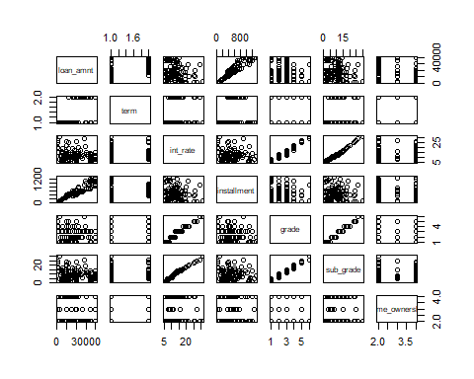

head(ds_lc)

## loan_amnt term int_rate installment grade sub_grade home_ownership  
## 1: 5000 1 20.39 186.82 4 19 4  
## 2: 15000 1 9.92 483.45 2 7 3  
## 3: 11200 2 30.79 367.82 7 31 4  
## 4: 25000 2 21.85 688.35 4 20 2  
## 5: 3000 1 7.34 93.10 1 4 4  
## 6: 17000 2 20.39 454.10 4 19 4  
## annual_inc dti delinq_2yrs fico_range_low fico_range_high inq_last_6mths  
## 1: 50000 21.80 1 665 669 0  
## 2: 196000 18.29 0 700 704 0  
## 3: 44000 43.97 1 665 669 2  
## 4: 65000 12.89 1 665 669 1  
## 5: 52000 0.58 0 760 764 0  
## 6: 52000 15.65 0 670 674 0  
## open_acc pub_rec is_acct_delinquent  
## 1: 5 0 0  
## 2: 19 0 0  
## 3: 8 0 0  
## 4: 7 0 0  
## 5: 7 0 0  
## 6: 9 0 0

sample_set<-sample(nrow(ds_lc),nrow(ds_lc)*0.6)  
training_dataset <- ds_lc[sample_set,]  
test_dataset <- ds_lc[-sample_set,]  
regression_model <- glm(is_acct_delinquent ~   
 loan_amnt +   
 term +   
 int_rate +   
 installment +   
 grade +   
 sub_grade +   
 home_ownership +   
 annual_inc +   
 dti +   
 delinq_2yrs +   
 fico_range_low +   
 fico_range_high +   
 inq_last_6mths +   
 open_acc +   
 pub_rec,  
 data = training_dataset, family = "binomial")  
probablity<-predict(regression_model,test_dataset,type="response")  
prediction<-ifelse(probablity > 0.5, 1, 0)  
validation_error_rate1 <- mean(prediction != test_dataset$is_acct_delinquent)  
validation_error_rate1

## [1] 0.03885268

sample_set<-sample(nrow(ds_lc),nrow(ds_lc)*0.7)  
training_dataset <- ds_lc[sample_set,]  
test_dataset <- ds_lc[-sample_set,]  
regression_model <- glm(is_acct_delinquent ~   
 loan_amnt +   
 term +   
 int_rate +   
 installment +   
 grade +   
 sub_grade +   
 home_ownership +   
 annual_inc +   
 dti +   
 delinq_2yrs +   
 fico_range_low +   
 fico_range_high +   
 inq_last_6mths +   
 open_acc +   
 pub_rec,  
 data = training_dataset, family = "binomial")  
probablity<-predict(regression_model,test_dataset,type="response")  
prediction<-ifelse(probablity > 0.5, 1, 0)  
validation_error_rate2 <- mean(prediction != test_dataset$is_acct_delinquent)  
validation_error_rate2

## [1] 0.0395391

sample_set<-sample(nrow(ds_lc),nrow(ds_lc)*0.75)  
training_dataset <- ds_lc[sample_set,]  
test_dataset <- ds_lc[-sample_set,]  
regression_model <- glm(is_acct_delinquent ~   
 loan_amnt +   
 term +   
 int_rate +   
 installment +   
 grade +   
 sub_grade +   
 home_ownership +   
 annual_inc +   
 dti +   
 delinq_2yrs +   
 fico_range_low +   
 fico_range_high +   
 inq_last_6mths +   
 open_acc +   
 pub_rec,  
 data = training_dataset, family = "binomial")  
probablity<-predict(regression_model,test_dataset,type="response")  
prediction<-ifelse(probablity > 0.5, 1, 0)  
validation_error_rate3 <- mean(prediction != test_dataset$is_acct_delinquent)  
validation_error_rate3

## [1] 0.03870378

sample_set<-sample(nrow(ds_lc),nrow(ds_lc)*0.8)  
training_dataset <- ds_lc[sample_set,]  
test_dataset <- ds_lc[-sample_set,]  
regression_model <- glm(is_acct_delinquent ~   
 loan_amnt +   
 term +   
 int_rate +   
 installment +   
 grade +   
 sub_grade +   
 home_ownership +   
 annual_inc +   
 dti +   
 delinq_2yrs +   
 fico_range_low +   
 fico_range_high +   
 inq_last_6mths +   
 open_acc +   
 pub_rec,  
 data = training_dataset, family = "binomial")  
probablity<-predict(regression_model,test_dataset,type="response")  
prediction<-ifelse(probablity > 0.5, 1, 0)  
validation_error_rate4 <- mean(prediction != test_dataset$is_acct_delinquent)  
validation_error_rate4

## [1] 0.03870596

Following is the data split in training and test data ration along with validation error rate/misclassification

1. Tranining : Test -> 60 : 40, validation error rate 0.0388527. or 3.8852685%   
2. Tranining : Test -> 70 : 30, validation error rate 0.0395391. or 3.9539104%   
3. Tranining : Test -> 75 : 25, validation error rate 0.0387038. or 3.8703776%   
3. Tranining : Test -> 80 : 20, validation error rate 0.0387038. or 3.8705956%

Validation error rate is different for different sample splits of taining and test dataset. This indicates that validation error rate varies by which observations are in the training/validation sets.

data_partition <- createDataPartition(y = ds_lc$is_acct_delinquent, p = 0.75, list = FALSE)  
train_dataset <- ds_lc[data_partition,]  
test_dataset <- ds_lc[-data_partition,]

nrow(train_dataset)

## [1] 370583

nrow(test_dataset)

## [1] 123527

logistic_regression <- glm(is_acct_delinquent ~   
 loan_amnt +   
 term +   
 int_rate +   
 installment +   
 grade +   
 sub_grade +   
 home_ownership +   
 annual_inc +   
 dti +   
 delinq_2yrs +   
 fico_range_low +   
 fico_range_high +   
 inq_last_6mths +   
 open_acc +   
 pub_rec  
 ,data = train_dataset, family = binomial)  
  
predictions <- predict(logistic_regression, test_dataset, type="response")  
predicted_direction <- ifelse(predictions > 0.5, 1, 0)  
error_rate_lr <- mean(predicted_direction != test_dataset$is_acct_delinquent)  
error_rate_lr

## [1] 0.03863123

lda_model <- lda(is_acct_delinquent ~   
 loan_amnt +   
 term +   
 int_rate +   
 installment +   
 grade +   
 sub_grade +   
 home_ownership +   
 annual_inc +   
 dti +   
 delinq_2yrs +   
 fico_range_low +   
 fico_range_high +   
 inq_last_6mths +   
 open_acc +   
 pub_rec  
 ,data = train_dataset)  
predictions <- predict(lda_model, test_dataset, type="response")  
confusion_matrix <- table(predictions$class,   
 test_dataset$is_acct_delinquent,   
 dnn = c("Predicted Status", "Observed Status"))  
confusion_matrix

## Observed Status  
## Predicted Status 0 1  
## 0 118755 4738  
## 1 29 5

error_rate_lda <- mean(predictions$class != test_dataset$is_acct_delinquent)  
error_rate_lda

## [1] 0.03859075

tree_lc <- tree(is_acct_delinquent ~ .,train_dataset)  
summary(tree_lc)

##   
## Classification tree:  
## tree(formula = is_acct_delinquent ~ ., data = train_dataset)  
## Variables actually used in tree construction:  
## [1] "sub_grade"  
## Number of terminal nodes: 2   
## Residual mean deviance: 0.3135 = 116200 / 370600   
## Misclassification error rate: 0.0384 = 14229 / 370583

tree_lc

## node), split, n, deviance, yval, (yprob)  
## * denotes terminal node  
##   
## 1) root 370583 120700 0 ( 0.96160 0.03840 )   
## 2) sub_grade < 9.5 185587 33140 0 ( 0.98221 0.01779 ) *  
## 3) sub_grade > 9.5 184996 83030 0 ( 0.94093 0.05907 ) *

plot(tree_lc)  
text(tree_lc, pretty=0)

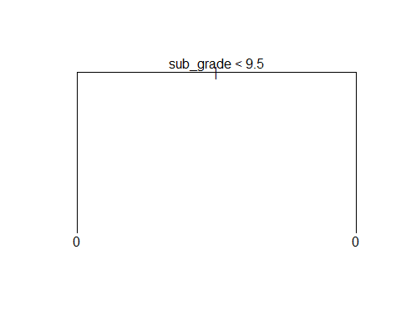

prediction <- predict(tree_lc, test_dataset, type="class")  
error_rate_tree <- mean(prediction != test_dataset$is_acct_delinquent)  
error_rate_tree

## [1] 0.03839646

optimal_tree <- cv.tree(tree_lc, FUN = prune.tree)  
optimal_tree

## $size  
## [1] 2 1  
##   
## $dev  
## [1] 116257.6 120674.5  
##   
## $k  
## [1] -Inf 4499.304  
##   
## $method  
## [1] "deviance"  
##   
## attr(,"class")  
## [1] "prune" "tree.sequence"

tree_plot <- data.frame(x=optimal_tree$size, y=optimal_tree$dev)  
ggplot(tree_plot, aes(x=x,y=y)) +   
 geom_point() +   
 geom_line() +   
 xlab("Tree Size") +   
 ylab("Deviance")

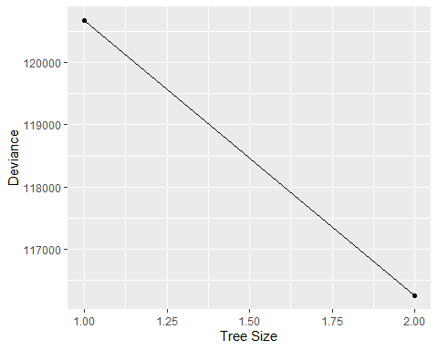

pruned_tree <- prune.tree(tree_lc, best = 2)

summary(pruned_tree)

##   
## Classification tree:  
## tree(formula = is_acct_delinquent ~ ., data = train_dataset)  
## Variables actually used in tree construction:  
## [1] "sub_grade"  
## Number of terminal nodes: 2   
## Residual mean deviance: 0.3135 = 116200 / 370600   
## Misclassification error rate: 0.0384 = 14229 / 370583

summary(tree_lc)

##   
## Classification tree:  
## tree(formula = is_acct_delinquent ~ ., data = train_dataset)  
## Variables actually used in tree construction:  
## [1] "sub_grade"  
## Number of terminal nodes: 2   
## Residual mean deviance: 0.3135 = 116200 / 370600   
## Misclassification error rate: 0.0384 = 14229 / 370583

test_error_rate_pruned <- mean(predict(pruned_tree, test_dataset, type = "class") != test_dataset$is_acct_delinquent)  
test_error_rate_pruned

## [1] 0.03839646

# Predicting the Interest Rate

test_interest_mean <- mean(test_dataset$int_rate)  
test_interest_mse <- mean((test_dataset$int_rate - test_interest_mean)^2)  
test_interest_mean

## [1] 12.73598

test_interest_mse

## [1] 26.48413

# 9b Fit a linear model using least squares on the training set, and report the test error obtained.

lm_fit <- lm(int_rate ~ . , data = train_dataset)  
lm_predictions <- predict(lm_fit, test_dataset)  
lm_mse <- mean((lm_predictions - test_dataset$int_rate)^2)  
lm_mse

## [1] 0.375435

train_ds_matrix <- model.matrix(int_rate ~ ., data = train_dataset)  
test_ds_matrix <- model.matrix(int_rate ~ ., data = test_dataset)  
  
grid <- 10 ^ seq(4, -2, length = 100)  
  
ridge_reg_model <- cv.glmnet(train_ds_matrix, train_dataset$int_rate, alpha = 0, lambda = grid, thresh = 1e-12)  
ridge_reg_predictions <- predict(ridge_reg_model, test_ds_matrix, s = ridge_reg_model$lambda.min)  
ridge_mse <- mean((test_dataset$int_rate - ridge_reg_predictions)^2)  
ridge_mse

## [1] 0.3765767

lasso_model <- cv.glmnet(train_ds_matrix, train_dataset$int_rate, alpha = 1, lambda = grid, thresh = 1e-12)  
lasso_predictions <- predict(lasso_model, test_ds_matrix, s = lasso_model$lambda.min)  
lasso_mse <- mean((test_dataset$int_rate - lasso_predictions)^2)  
lasso_rmse <- sqrt(mean((test_dataset$int_rate - lasso_predictions)^2))  
lasso_mse

## [1] 0.3873661

pcr_model <- pcr(int_rate ~ . , data = train_dataset, scale=T, validation="CV")  
validationplot(pcr_model, val.type = "MSEP")

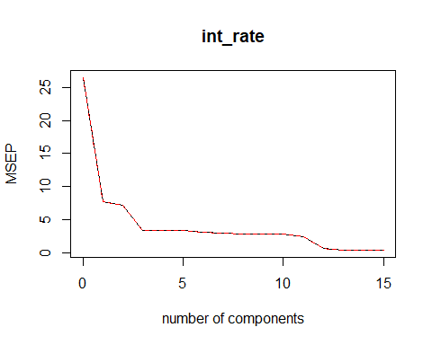

pcr_predictions <- predict(pcr_model, test_dataset, ncomp = 10)  
pcr_mse <- mean((test_dataset$int_rate - pcr_predictions)^2)  
pcr_rmse <- sqrt(mean((test_dataset$int_rate - pcr_predictions)^2))

pls_model <- plsr(int_rate ~ . , data = train_dataset, scale=T, validation="CV")  
validationplot(pls_model, val.type = "MSEP")

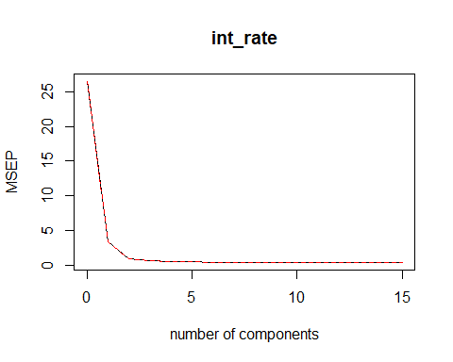

pls_predictions <- predict(pls_model, test_dataset, ncomp = 10)  
pls_mse <- mean((test_dataset$int_rate - pls_predictions)^2)  
pls_rmse <- sqrt(mean((test_dataset$int_rate - pls_predictions)^2))  
pls_mse

## [1] 0.3759499

lm_test_r2 <- (1 - (lm_mse/test_interest_mse))  
ridge_test_r2 <- (1 - (ridge_mse/test_interest_mse))  
lasso_test_r2 <- (1 - (lasso_mse/test_interest_mse))  
pcr_test_r2 <- (1 - (pcr_mse/test_interest_mse))  
pls_test_r2 <- (1 - (pls_mse/test_interest_mse))  
  
cat("R square with linear model : ", lm_test_r2, "\n")

## R square with linear model : 0.9858242

cat("R square with ridge model : ", ridge_test_r2, "\n")

## R square with ridge model : 0.985781

cat("R square with lasso model : ", lasso_test_r2, "\n")

## R square with lasso model : 0.9853737

cat("R square with pcr : ", pcr_test_r2, "\n")

## R square with pcr : 0.8955828

cat("R square with pls : ", pls_test_r2, "\n")

## R square with pls : 0.9858047

barplot(c(lm_test_r2, ridge_test_r2, lasso_test_r2, pcr_test_r2, pls_test_r2),  
 names.arg = c("LM", "Ridge", "Lasso", "PCR", "PLS"))

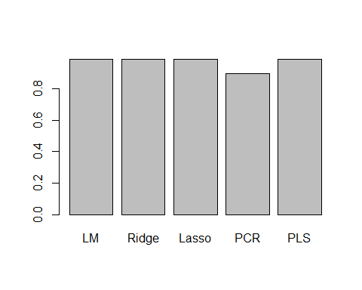

train_dataset_mini <- train_dataset[1:5000,]  
test_dataset_mini <- test_dataset[(1:5000),]  
  
pows <- seq(-10, -0.2, by = 0.1)  
lambdas <- 10^pows  
training_errors <- rep(NA, length(lambdas))  
  
  
for (i in 1:length(lambdas)) {  
 boosting_model <- gbm(int_rate ~ . , data = train_dataset_mini, distribution = "gaussian",   
 n.trees = 1000, shrinkage = lambdas[i])  
   
 training_predictions <- predict(boosting_model, train_dataset_mini, n.trees = 1000)  
 training_errors[i] <- mean((training_predictions - train_dataset_mini$int_rate)^2)  
}  
  
plot(lambdas, training_errors, xlab = "Shrinkage Values", ylab = "Training set MSE", type = "b", pch = 20)

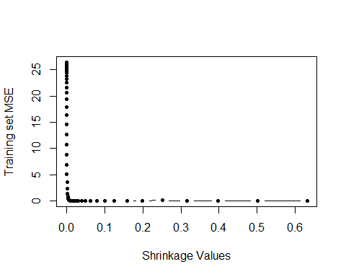

test_errors <- rep(NA, length(lambdas))  
  
  
for (i in 1:length(lambdas)) {  
 boosting_model <- gbm(int_rate ~ . , data = train_dataset_mini, distribution = "gaussian",   
 n.trees = 1000, shrinkage = lambdas[i])  
   
 test_predictions <- predict(boosting_model, test_dataset_mini, n.trees = 1000)  
 test_errors[i] <- mean((test_predictions - test_dataset_mini$int_rate)^2)  
}  
  
plot(lambdas, test_errors, xlab = "Shrinkage Values", ylab = "Training set MSE", type = "b", pch = 20)

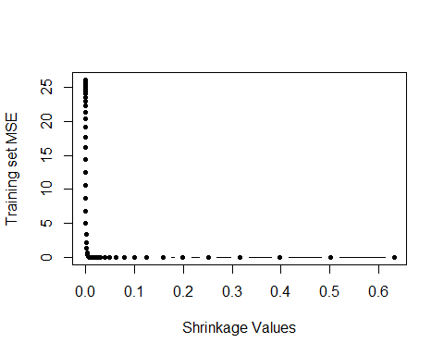

min(test_errors)

## [1] 0.001951323

min_test_err <- min(test_errors)  
min_test_err_at <- lambdas[which.min(test_errors)]

Both regression approaches lm and lasso have higher MSE compared to that of boosting.

boosting_model <- gbm(int_rate ~ . , data = train_dataset_mini, distribution = "gaussian",   
 n.trees = 1000, shrinkage = min_test_err)  
summary(boosting_model)

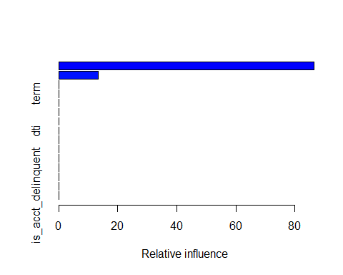

## var rel.inf  
## sub_grade sub_grade 86.56652  
## grade grade 13.43348  
## loan_amnt loan_amnt 0.00000  
## term term 0.00000  
## installment installment 0.00000  
## home_ownership home_ownership 0.00000  
## annual_inc annual_inc 0.00000  
## dti dti 0.00000  
## delinq_2yrs delinq_2yrs 0.00000  
## fico_range_low fico_range_low 0.00000  
## fico_range_high fico_range_high 0.00000  
## inq_last_6mths inq_last_6mths 0.00000  
## open_acc open_acc 0.00000  
## pub_rec pub_rec 0.00000  
## is_acct_delinquent is_acct_delinquent 0.00000

random_forest_model <- randomForest(int_rate ~ . , data = train_dataset_mini, ntree = 500, mtry = ncol(train_dataset_mini)-1)  
random_forest_predictions <- predict(random_forest_model, test_dataset_mini)  
  
random_forest_test_mse <- mean((random_forest_predictions - test_dataset_mini$int_rate)^2)  
random_forest_test_mse

## [1] 0.03471787

Test MSE for bagging is 0.0347179 which is better than 0.0019513 which is best MSE from boosting

# Unspervised Learning - PCA

ds_lc_pca <- ds_lc[,c(  
 "loan_amnt",  
 "term",  
 "int_rate",  
 "installment",  
 "grade",  
 "sub_grade",  
 "home_ownership",  
 "annual_inc",  
 "dti",  
 "delinq_2yrs",  
 "fico_range_low",  
 "fico_range_high",  
 "inq_last_6mths",  
 "open_acc",  
 "pub_rec"  
 )]  
ds_lc_pca_subset <- sample(nrow(ds_lc), 1000)  
ds_lc_pca = ds_lc_pca[ds_lc_pca_subset, ]  
  
str(ds_lc_pca)

## Classes 'data.table' and 'data.frame': 1000 obs. of 15 variables:  
## $ loan_amnt : int 15000 6000 1000 25000 25000 14000 9000 20000 36000 18000 ...  
## $ term : int 1 1 1 2 1 2 1 2 1 2 ...  
## $ int_rate : num 10.9 16.14 18.94 7.21 14.47 ...  
## $ installment : num 490.4 211.4 36.6 497.5 860.2 ...  
## $ grade : int 2 3 4 1 3 2 1 4 1 3 ...  
## $ sub_grade : int 9 14 17 3 12 6 4 17 1 14 ...  
## $ home_ownership : int 2 4 2 2 2 3 2 3 2 4 ...  
## $ annual_inc : num 44232 25920 90000 85000 120000 ...  
## $ dti : num 3.18 25.69 17.67 30.37 29.85 ...  
## $ delinq_2yrs : int 1 0 0 0 0 2 0 0 0 0 ...  
## $ fico_range_low : int 710 670 680 730 685 700 775 685 730 710 ...  
## $ fico_range_high: int 714 674 684 734 689 704 779 689 734 714 ...  
## $ inq_last_6mths : int 3 0 0 0 1 0 0 0 0 0 ...  
## $ open_acc : int 6 7 7 15 18 9 9 10 16 9 ...  
## $ pub_rec : int 0 0 0 0 0 0 0 0 0 0 ...  
## - attr(*, ".internal.selfref")=<externalptr>

pr.out <- prcomp (ds_lc_pca, scale =TRUE)  
names(pr.out)

## [1] "sdev" "rotation" "center" "scale" "x"

pr.out$center

## loan_amnt term int_rate installment grade   
## 15317.27500 1.28000 12.81135 448.54785 2.42500   
## sub_grade home_ownership annual_inc dti delinq_2yrs   
## 10.11300 2.93000 75935.35083 18.90746 0.22900   
## fico_range_low fico_range_high inq_last_6mths open_acc pub_rec   
## 706.13000 710.13000 0.42200 11.46400 0.12600

pr.out$scale

## loan_amnt term int_rate installment grade   
## 1.028473e+04 4.492236e-01 5.299601e+00 2.912727e+02 1.222239e+00   
## sub_grade home_ownership annual_inc dti delinq_2yrs   
## 6.148661e+00 9.380725e-01 4.491856e+04 1.113957e+01 6.595407e-01   
## fico_range_low fico_range_high inq_last_6mths open_acc pub_rec   
## 3.572253e+01 3.572253e+01 6.843861e-01 6.006395e+00 3.553171e-01

pr.out$rotation

## PC1 PC2 PC3 PC4 PC5  
## loan_amnt 0.006605629 0.58003110 -0.0545297304 0.19285218 -0.17585157  
## term -0.155732755 0.28974736 -0.2799346661 -0.09668434 0.08062965  
## int_rate -0.475999649 0.01935206 -0.2332918130 -0.05129638 0.08532478  
## installment -0.007636083 0.54179639 -0.0009614438 0.23145002 -0.21746121  
## grade -0.473040209 0.01853215 -0.2293123788 -0.04570269 0.10073042  
## sub_grade -0.480611622 0.01490580 -0.2202432839 -0.04987475 0.07827835  
## home_ownership -0.013758165 -0.22918545 -0.2056042435 0.29086456 -0.27620951  
## annual_inc 0.074692455 0.39291474 0.1863401313 0.18437788 0.31447475  
## dti -0.121580547 0.08220175 0.0711923377 -0.54214809 -0.56065336  
## delinq_2yrs -0.096167167 0.01056164 0.2171211547 0.05118269 0.34488031  
## fico_range_low 0.358588475 0.07902587 -0.4480652494 -0.26701115 0.14604703  
## fico_range_high 0.358588475 0.07902587 -0.4480652494 -0.26701115 0.14604703  
## inq_last_6mths -0.072326118 0.06089252 0.2110780589 -0.30660043 0.47624057  
## open_acc -0.025148507 0.22578832 0.3247671860 -0.48889421 -0.05120646  
## pub_rec -0.038497021 -0.06458991 0.2870322696 -0.04393885 -0.10575414  
## PC6 PC7 PC8 PC9 PC10  
## loan_amnt -0.02681484 0.04910305 -0.13782456 -0.16600454 -0.054920334  
## term -0.12512666 -0.28299552 0.36043680 -0.23129187 -0.679649223  
## int_rate -0.02335245 0.02877098 -0.07533751 0.15515159 0.121206140  
## installment 0.01047814 0.14762192 -0.28210635 -0.09640162 0.161646206  
## grade -0.03177112 0.01757674 -0.07646625 0.14673702 0.120994084  
## sub_grade -0.02729377 0.03061077 -0.07711553 0.13243359 0.116339940  
## home_ownership 0.09887902 0.66261640 -0.09859539 0.19149113 -0.466589440  
## annual_inc -0.04221689 0.07621762 0.21908281 0.46378985 0.128893259  
## dti 0.17503734 -0.01961296 -0.11787268 -0.15206793 0.100116146  
## delinq_2yrs 0.61988540 -0.21970311 -0.53213982 -0.01891549 -0.313764734  
## fico_range_low -0.01769485 0.01502545 -0.22120987 0.14720230 0.022387567  
## fico_range_high -0.01769485 0.01502545 -0.22120987 0.14720230 0.022387567  
## inq_last_6mths -0.24724173 0.55611776 -0.10469986 -0.48847374 -0.006536942  
## open_acc 0.17649080 0.21304469 0.21441021 0.46838104 -0.215062739  
## pub_rec -0.67959974 -0.21214663 -0.49441843 0.26445059 -0.275640831  
## PC11 PC12 PC13 PC14  
## loan_amnt 0.123752471 0.0917245308 0.654332720 -0.2963986742  
## term -0.114604821 -0.0285033906 -0.188783628 0.0831779240  
## int_rate 0.021643040 -0.4221955610 -0.208776069 -0.6637743399  
## installment 0.197742079 -0.0784016937 -0.594647488 0.2641510613  
## grade 0.026584534 0.8131419932 -0.075505731 0.0112023465  
## sub_grade 0.029656772 -0.3804724298 0.364857832 0.6278580626  
## home_ownership -0.176255642 0.0108109927 0.001209976 0.0004513594  
## annual_inc -0.620190555 -0.0079710725 -0.009481488 0.0182728933  
## dti -0.535634769 0.0123576590 -0.003686119 -0.0006688116  
## delinq_2yrs -0.086122246 -0.0027414897 0.002166760 -0.0010575670  
## fico_range_low -0.006813201 -0.0039521047 0.003261541 0.0081845348  
## fico_range_high -0.006813201 -0.0039521047 0.003261541 0.0081845348  
## inq_last_6mths -0.074969889 -0.0004538554 -0.004631504 -0.0070156304  
## open_acc 0.461577477 0.0061156644 0.006402930 -0.0002815421  
## pub_rec -0.040041654 -0.0030967974 0.000792840 -0.0026310452  
## PC15  
## loan_amnt 8.513487e-16  
## term 1.468208e-16  
## int_rate 2.744999e-15  
## installment -6.922222e-16  
## grade 3.038121e-16  
## sub_grade -4.094823e-15  
## home_ownership -7.462468e-17  
## annual_inc -2.392466e-16  
## dti -9.443205e-17  
## delinq_2yrs -3.759133e-16  
## fico_range_low 7.071068e-01  
## fico_range_high -7.071068e-01  
## inq_last_6mths -5.728263e-19  
## open_acc -1.061237e-16  
## pub_rec -1.493534e-16

biplot(pr.out)

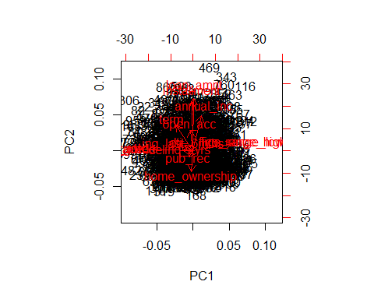

pr.out$rotation=-pr.out$rotation  
pr.out$x=-pr.out$x  
biplot (pr.out , scale =0)

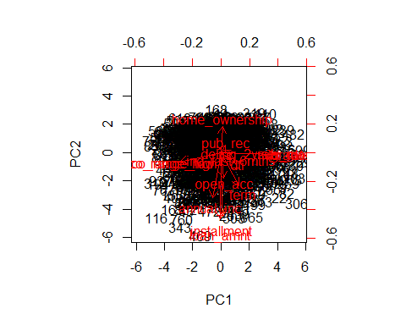

#pr.out$sdev  
pr.var =pr.out$sdev ^2  
pve=pr.var/sum(pr.var )  
pve

## [1] 2.518557e-01 1.708062e-01 1.096674e-01 8.472282e-02 7.482386e-02  
## [6] 7.283161e-02 6.035401e-02 5.103440e-02 4.632298e-02 4.514161e-02  
## [11] 2.901450e-02 2.229948e-03 7.383321e-04 4.564958e-04 3.026850e-31

plot(pve , xlab="Principal Component ", ylab="Proportion of Variance Explained ", ylim=c(0,1) ,type="b")

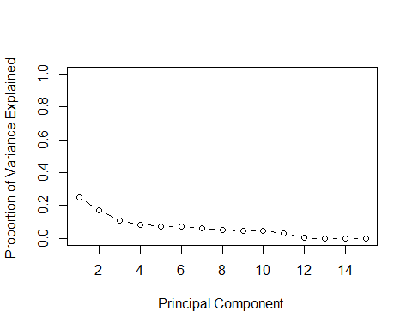

plot(cumsum (pve ), xlab="Principal Component ", ylab ="Cumulative Proportion of Variance Explained ", ylim=c(0,1) , type="b")

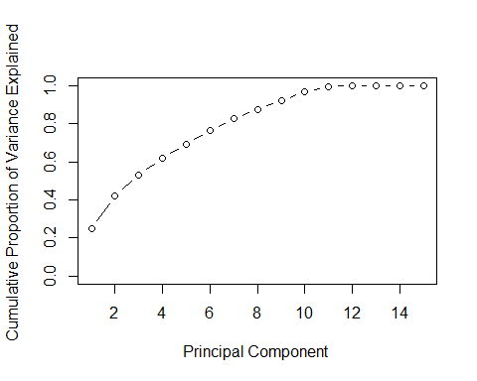

#autoplot(pr.out)  
biplot (pr.out , scale =0)



fviz_eig(pr.out, addlabels = TRUE, ylim = c(0, 50))

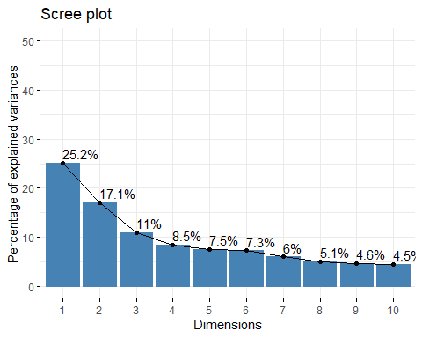

PCA does not bring in much value. Very dimension were identified with PCA.

ds_lc_kmean <- ds_lc[,c(  
 "loan_amnt",  
 "term",  
 "int_rate",  
 "installment",  
 "grade",  
 "sub_grade",  
 "home_ownership",  
 "annual_inc",  
 "dti",  
 "delinq_2yrs",  
 "fico_range_low",  
 "fico_range_high",  
 "inq_last_6mths",  
 "open_acc",  
 "pub_rec"  
 )]  
ds_lc_kmean_subset <- sample(nrow(ds_lc_kmean), 1000)  
ds_lc_kmean = ds_lc_kmean[ds_lc_kmean_subset, ]  
ds_lc_kmean_scaled <- as.data.frame(scale(ds_lc_kmean))

k2 <- kmeans(ds_lc_kmean_scaled, centers = 2, nstart = 25)  
k3 <- kmeans(ds_lc_kmean_scaled, centers = 3, nstart = 25)  
k4 <- kmeans(ds_lc_kmean_scaled, centers = 4, nstart = 25)  
k5 <- kmeans(ds_lc_kmean_scaled, centers = 5, nstart = 25)  
k6 <- kmeans(ds_lc_kmean_scaled, centers = 6, nstart = 25)  
k7 <- kmeans(ds_lc_kmean_scaled, centers = 7, nstart = 25)  
k8 <- kmeans(ds_lc_kmean_scaled, centers = 8, nstart = 25)  
k9 <- kmeans(ds_lc_kmean_scaled, centers = 9, nstart = 25)  
  
  
# plots to compare  
p2 <- fviz_cluster(k2, geom = "point", data = ds_lc_kmean_scaled, ggtheme = theme_minimal()) + ggtitle("k = 2")  
p3 <- fviz_cluster(k3, geom = "point", data = ds_lc_kmean_scaled, ggtheme = theme_minimal()) + ggtitle("k = 3")  
p4 <- fviz_cluster(k4, geom = "point", data = ds_lc_kmean_scaled, ggtheme = theme_minimal()) + ggtitle("k = 4")  
p5 <- fviz_cluster(k5, geom = "point", data = ds_lc_kmean_scaled, ggtheme = theme_minimal()) + ggtitle("k = 5")  
p6 <- fviz_cluster(k6, geom = "point", data = ds_lc_kmean_scaled, ggtheme = theme_minimal()) + ggtitle("k = 6")  
p7 <- fviz_cluster(k7, geom = "point", data = ds_lc_kmean_scaled, ggtheme = theme_minimal()) + ggtitle("k = 7")  
p8 <- fviz_cluster(k8, geom = "point", data = ds_lc_kmean_scaled, ggtheme = theme_minimal()) + ggtitle("k = 8")  
p9 <- fviz_cluster(k9, geom = "point", data = ds_lc_kmean_scaled, ggtheme = theme_minimal()) + ggtitle("k = 9")  
p10 <- fviz_cluster(k9, geom = "point", data = ds_lc_kmean_scaled, ggtheme = theme_minimal()) + ggtitle("k = 10")  
  
  
grid.arrange(p2, p3, p4, p5, nrow = 2)

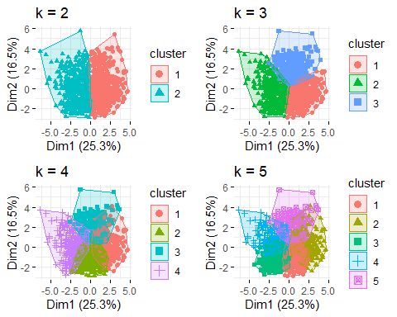

grid.arrange(p6, p7, p8, p9, nrow = 2)

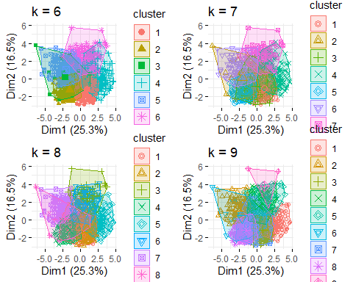

grid.arrange(p10, nrow = 2)

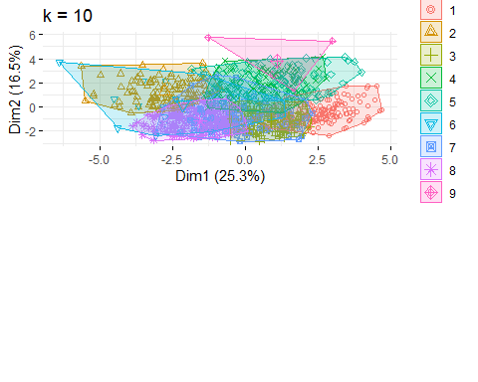

set.seed(1234)  
#Function to compute total within cluster sum of squares   
wss <- function(k) {  
 kmeans(ds_lc_kmean_scaled, k, nstart = 25, iter.max = 10)$tot.withinss  
}  
  
#Compute and plot the within sum of squares (wss) for k = 1 to k = 10  
k.values <- 1:15  
  
#Extract wss for 2 - 10 clusters  
wss_values <- map_dbl(k.values, wss)

## Warning: did not converge in 10 iterations  
  
## Warning: did not converge in 10 iterations  
  
## Warning: did not converge in 10 iterations

plot(k.values, wss_values,  
 type = "b", pch = 19, frame = FALSE,  
 xlab = "Number of clusters K",  
 ylab = "Total within clusters sum of squares")

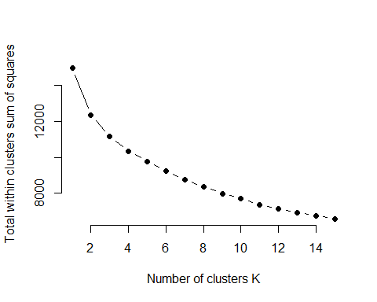

set.seed(1234)  
fviz_nbclust(ds_lc_kmean_scaled, kmeans, method = "wss")

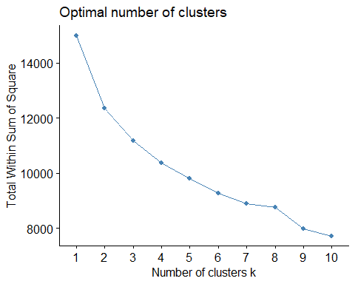

Based on the visualization 3 or 4 clusters seems to be better classification. 3 clusters have very less overlap compared to that of the 4 clusters.

ds_lc_kmean$cluster <- k3$cluster

ds_lc_kmean$category <- ""  
for(i in 1:nrow(ds_lc_kmean)){  
   
 if (ds_lc_kmean$cluster[i] == 1){  
 ds_lc_kmean$category[i] <- "Low"  
 }  
 else if (ds_lc_kmean$cluster[i] == 2){  
 ds_lc_kmean$category[i] <- "Medium"  
 }  
 else if (ds_lc_kmean$cluster[i] == 3){  
 ds_lc_kmean$category[i] <- "High"  
 }  
}  
  
low_risk_loans <- ds_lc_kmean %>%  
 filter(category == "Low")  
  
medium_risk_loans <- ds_lc_kmean %>%  
 filter(category == "Medium")  
  
high_risk_loans <- ds_lc_kmean %>%  
 filter(category == "High")

mean(low_risk_loans$int_rate)

## [1] 8.76289

mean(medium_risk_loans$int_rate)

## [1] 17.97925

mean(high_risk_loans$int_rate)

## [1] 11.51484

mean(low_risk_loans$annual_inc)

## [1] 67194.69

mean(medium_risk_loans$annual_inc)

## [1] 66523.53

mean(high_risk_loans$annual_inc)

## [1] 128719.9

mean(low_risk_loans$dti)

## [1] 16.79985

mean(medium_risk_loans$dti)

## [1] 20.90247

mean(high_risk_loans$dti)

## [1] 19.32208

mean(low_risk_loans$fico_range_low)

## [1] 719.5908

mean(medium_risk_loans$fico_range_low)

## [1] 683.2732

mean(high_risk_loans$fico_range_low)

## [1] 716.6063

mean(low_risk_loans$fico_range_high)

## [1] 723.5934

mean(medium_risk_loans$fico_range_high)

## [1] 687.2732

mean(high_risk_loans$fico_range_high)

## [1] 720.6063

mean(low_risk_loans$inq_last_6mths)

## [1] 0.3554987

mean(medium_risk_loans$inq_last_6mths)

## [1] 0.5386598

mean(high_risk_loans$inq_last_6mths)

## [1] 0.4660633

mean(low_risk_loans$delinq_2yrs)

## [1] 0.1227621

mean(medium_risk_loans$delinq_2yrs)

## [1] 0.435567

mean(high_risk_loans$delinq_2yrs)

## [1] 0.1809955

mean(low_risk_loans$grade)

## [1] 1.478261

mean(medium_risk_loans$grade)

## [1] 3.618557

mean(high_risk_loans$grade)

## [1] 2.167421

mean(low_risk_loans$sub_grade)

## [1] 5.199488

mean(medium_risk_loans$sub_grade)

## [1] 16.15206

mean(high_risk_loans$sub_grade)

## [1] 8.769231