Predictive_Modeling_Week_1_Excercise_1

Amol Gote

7/11/2020

# Problem 10

# 8a Read File

college <- read.csv("data/College.csv")  
#college

# 8b Fix College name column

rownames(college) = college[,1]  
college_orig <- college  
college =college [,-1]  
fix(college)  
#college

# 8c_i Summary

summary(college)

## Private Apps Accept Enroll Top10perc   
## No :212 Min. : 81 Min. : 72 Min. : 35 Min. : 1.00   
## Yes:565 1st Qu.: 776 1st Qu.: 604 1st Qu.: 242 1st Qu.:15.00   
## Median : 1558 Median : 1110 Median : 434 Median :23.00   
## Mean : 3002 Mean : 2019 Mean : 780 Mean :27.56   
## 3rd Qu.: 3624 3rd Qu.: 2424 3rd Qu.: 902 3rd Qu.:35.00   
## Max. :48094 Max. :26330 Max. :6392 Max. :96.00   
## Top25perc F.Undergrad P.Undergrad Outstate   
## Min. : 9.0 Min. : 139 Min. : 1.0 Min. : 2340   
## 1st Qu.: 41.0 1st Qu.: 992 1st Qu.: 95.0 1st Qu.: 7320   
## Median : 54.0 Median : 1707 Median : 353.0 Median : 9990   
## Mean : 55.8 Mean : 3700 Mean : 855.3 Mean :10441   
## 3rd Qu.: 69.0 3rd Qu.: 4005 3rd Qu.: 967.0 3rd Qu.:12925   
## Max. :100.0 Max. :31643 Max. :21836.0 Max. :21700   
## Room.Board Books Personal PhD   
## Min. :1780 Min. : 96.0 Min. : 250 Min. : 8.00   
## 1st Qu.:3597 1st Qu.: 470.0 1st Qu.: 850 1st Qu.: 62.00   
## Median :4200 Median : 500.0 Median :1200 Median : 75.00   
## Mean :4358 Mean : 549.4 Mean :1341 Mean : 72.66   
## 3rd Qu.:5050 3rd Qu.: 600.0 3rd Qu.:1700 3rd Qu.: 85.00   
## Max. :8124 Max. :2340.0 Max. :6800 Max. :103.00   
## Terminal S.F.Ratio perc.alumni Expend   
## Min. : 24.0 Min. : 2.50 Min. : 0.00 Min. : 3186   
## 1st Qu.: 71.0 1st Qu.:11.50 1st Qu.:13.00 1st Qu.: 6751   
## Median : 82.0 Median :13.60 Median :21.00 Median : 8377   
## Mean : 79.7 Mean :14.09 Mean :22.74 Mean : 9660   
## 3rd Qu.: 92.0 3rd Qu.:16.50 3rd Qu.:31.00 3rd Qu.:10830   
## Max. :100.0 Max. :39.80 Max. :64.00 Max. :56233   
## Grad.Rate   
## Min. : 10.00   
## 1st Qu.: 53.00   
## Median : 65.00   
## Mean : 65.46   
## 3rd Qu.: 78.00   
## Max. :118.00

# 8c_ii pairs() function - produce a scatterplot matrix of the first ten columns or variables of the data

pairs(college[,1:10])

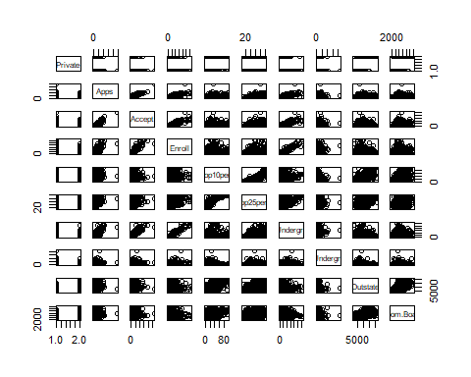

pairs(∼ Apps + Accept + Enroll + Top10perc + Top25perc + F.Undergrad +   
 P.Undergrad + Outstate + Room.Board + Books, college)

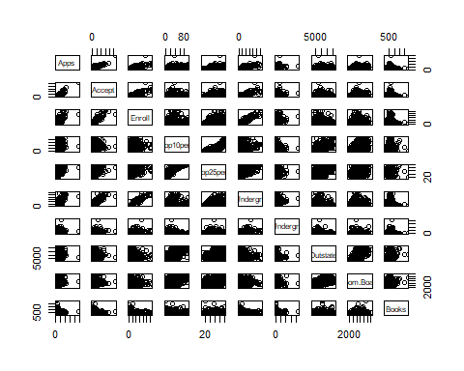

pairs(college[,1:10])



pairs(∼ Apps + Accept + Enroll + Top10perc + Top25perc + F.Undergrad +   
 P.Undergrad + Outstate + Room.Board + Books, college)



# 8c_iii plot function - produce side-by-side boxplots of Outstate versus Private.

plot(college$Private, college$Outstate,   
 xlab = "Private University", ylab ="Out of State", main = "Outstate versus Private")

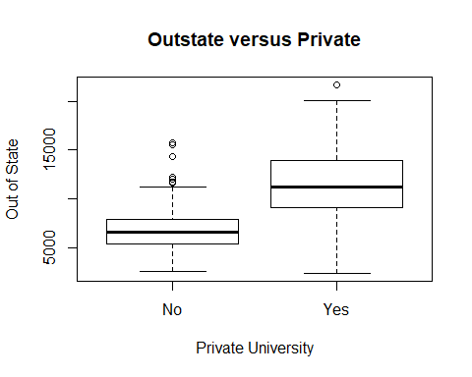

# 8c_iv Elite - binning the Top10perc variable - side-by-side boxplots of Outstate versus Elite

Elite = rep("No",nrow(college))  
Elite[college$Top10perc > 50]= "Yes"  
Elite = as.factor (Elite)  
college = data.frame(college, Elite)  
summary(college)

## Private Apps Accept Enroll Top10perc   
## No :212 Min. : 81 Min. : 72 Min. : 35 Min. : 1.00   
## Yes:565 1st Qu.: 776 1st Qu.: 604 1st Qu.: 242 1st Qu.:15.00   
## Median : 1558 Median : 1110 Median : 434 Median :23.00   
## Mean : 3002 Mean : 2019 Mean : 780 Mean :27.56   
## 3rd Qu.: 3624 3rd Qu.: 2424 3rd Qu.: 902 3rd Qu.:35.00   
## Max. :48094 Max. :26330 Max. :6392 Max. :96.00   
## Top25perc F.Undergrad P.Undergrad Outstate   
## Min. : 9.0 Min. : 139 Min. : 1.0 Min. : 2340   
## 1st Qu.: 41.0 1st Qu.: 992 1st Qu.: 95.0 1st Qu.: 7320   
## Median : 54.0 Median : 1707 Median : 353.0 Median : 9990   
## Mean : 55.8 Mean : 3700 Mean : 855.3 Mean :10441   
## 3rd Qu.: 69.0 3rd Qu.: 4005 3rd Qu.: 967.0 3rd Qu.:12925   
## Max. :100.0 Max. :31643 Max. :21836.0 Max. :21700   
## Room.Board Books Personal PhD   
## Min. :1780 Min. : 96.0 Min. : 250 Min. : 8.00   
## 1st Qu.:3597 1st Qu.: 470.0 1st Qu.: 850 1st Qu.: 62.00   
## Median :4200 Median : 500.0 Median :1200 Median : 75.00   
## Mean :4358 Mean : 549.4 Mean :1341 Mean : 72.66   
## 3rd Qu.:5050 3rd Qu.: 600.0 3rd Qu.:1700 3rd Qu.: 85.00   
## Max. :8124 Max. :2340.0 Max. :6800 Max. :103.00   
## Terminal S.F.Ratio perc.alumni Expend   
## Min. : 24.0 Min. : 2.50 Min. : 0.00 Min. : 3186   
## 1st Qu.: 71.0 1st Qu.:11.50 1st Qu.:13.00 1st Qu.: 6751   
## Median : 82.0 Median :13.60 Median :21.00 Median : 8377   
## Mean : 79.7 Mean :14.09 Mean :22.74 Mean : 9660   
## 3rd Qu.: 92.0 3rd Qu.:16.50 3rd Qu.:31.00 3rd Qu.:10830   
## Max. :100.0 Max. :39.80 Max. :64.00 Max. :56233   
## Grad.Rate Elite   
## Min. : 10.00 No :699   
## 1st Qu.: 53.00 Yes: 78   
## Median : 65.00   
## Mean : 65.46   
## 3rd Qu.: 78.00   
## Max. :118.00

summary(college$Elite)

## No Yes   
## 699 78

plot(college$Elite, college$Outstate,   
 xlab = "Elite University", ylab ="Out of State", main = "Outstate versus Elite")

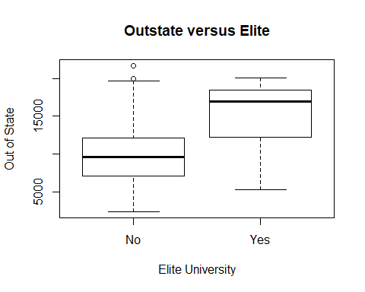

# 8c_v Histograms

par(mfrow=c(2,2))  
hist(college$Apps, col = 2, xlab = "# applications", ylab = "Frequency", main = "Applications")  
hist(college$Accept, col = 4, xlab = "# Accepted applicatons", ylab = "Frequency", main = "College acceptance")  
hist(college$Enroll, col = 4, xlab = "# Enrollments", ylab = "Frequency", main = "College enrollment")  
hist(college$Grad.Rate, col = 5, breaks=10, xlab = "Graduation Rate", ylab = "Frequency", main = "Graduation rates")

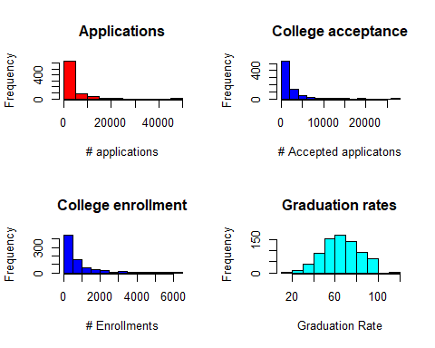

hist(college$PhD, col = 6, breaks=10, xlab = "PhD", ylab = "Frequency", main = "Phd's")  
hist(college$Books, col = 7, xlab = "Books", ylab = "Frequency", main = "Books cost")  
hist(college$S.F.Ratio, col=3, breaks=10, xlab = "Student faculty ratio", ylab = "Frequency", main = "SF Ratio")  
hist(college$Expend, col=4, breaks=100, xlab = "Expenditure per student", ylab = "Frequency", main = "Expenditure")

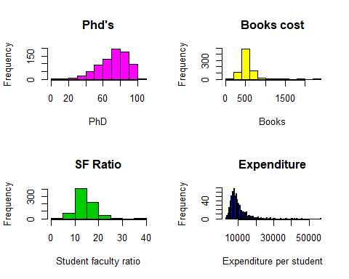

# 8c_vi Continue exploring the data, and provide a brief summary of what you discover.

college$rejected <- college$Apps - college$Accept  
par(mfrow=c(3,2))  
hist(college$rejected, col = 2, xlab = "Number of rejected", ylab = "Count", main = "Distribution of rejection")  
hist(college$Outstate, col = 3, xlab = "Out-of-state tuition", ylab = "Count", main = "Distribution of Out-of-state tuition cost")  
summary(college$rejected)

## Min. 1st Qu. Median Mean 3rd Qu. Max.   
## 0.0 131.0 326.0 982.8 1066.0 21764.0

summary(college$Outstate)

## Min. 1st Qu. Median Mean 3rd Qu. Max.   
## 2340 7320 9990 10441 12925 21700

summary(college$Grad.Rate)

## Min. 1st Qu. Median Mean 3rd Qu. Max.   
## 10.00 53.00 65.00 65.46 78.00 118.00

colleges_rejected_5000 <- college %>%  
 filter(college$rejected > 5000)  
nrow(colleges_rejected_5000)

## [1] 24

colleges_rejected_20000 <- college %>%  
 filter(college$rejected > 20000)  
colleges_rejected_20000

## Private Apps Accept Enroll Top10perc Top25perc  
## Rutgers at New Brunswick No 48094 26330 4520 36 79  
## F.Undergrad P.Undergrad Outstate Room.Board Books  
## Rutgers at New Brunswick 21401 3712 7410 4748 690  
## Personal PhD Terminal S.F.Ratio perc.alumni Expend  
## Rutgers at New Brunswick 2009 90 95 19.5 19 10474  
## Grad.Rate Elite rejected  
## Rutgers at New Brunswick 77 No 21764

colleges_with_high_reject <- college_orig %>%  
 filter(Apps == 48094)  
colleges_with_high_reject

## X Private Apps Accept Enroll  
## Rutgers at New Brunswick Rutgers at New Brunswick No 48094 26330 4520  
## Top10perc Top25perc F.Undergrad P.Undergrad Outstate  
## Rutgers at New Brunswick 36 79 21401 3712 7410  
## Room.Board Books Personal PhD Terminal S.F.Ratio  
## Rutgers at New Brunswick 4748 690 2009 90 95 19.5  
## perc.alumni Expend Grad.Rate  
## Rutgers at New Brunswick 19 10474 77

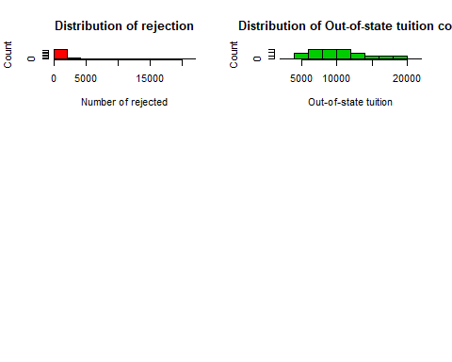

1. Difference between number of applications and accepted indicates how many applications have been rejected.
2. Average rejected applications is 928 and median is 326.
3. There are 24 colleges with number of applications rejected > 5000.
4. “Rutgers at New Brunswick” college has the highest rejected applications as well as highest number of applications which is 48090.
5. College out state tuition follows normal distribution with mean and median around 10000
6. Graduation rate follows normal distribution with median and mean around 65.
7. Distribution of college acceptance, enrollment rejection all are right skewed and unimodal.
8. Distribution of Phd are left skewed and unimodal

# Problem 10

# 10a Boston dataset info

#?Boston  
#Boston  
nrow(Boston)

## [1] 506

ncol(Boston)

## [1] 14

1. Dataset has 506 rows
2. Dataset has 14 columns.
3. Each column represents variable for which an observation was made in 506 neighborhoods of Boston.These variables include
   1. crim - per capita crime rate by town.
   2. zn - proportion of residential land zoned for lots over 25,000 sq.ft.
   3. indus - proportion of non-retail business acres per town.
   4. chas - Charles River dummy variable (= 1 if tract bounds river; 0 otherwise).
   5. nox - nitrogen oxides concentration (parts per 10 million).
   6. rm - average number of rooms per dwelling.
   7. age - proportion of owner-occupied units built prior to 1940.
   8. dis - weighted mean of distances to five Boston employment centres.
   9. rad - index of accessibility to radial highways.
   10. tax - full-value property-tax rate per $10,000.
   11. ptratio - pupil-teacher ratio by town.
   12. black - 1000(Bk - 0.63)^2 where Bk is the proportion of blacks by town.
   13. lstat - lower status of the population (percent).
   14. medv - median value of owner-occupied homes in $1000s.

# 10b Pairwise scatterplots of the predictors

pairs(∼ crim + zn +   
 + rm  
 + age   
 + dis   
 + tax   
 + ptratio  
 + black  
 + lstat  
 + medv, Boston  
 )

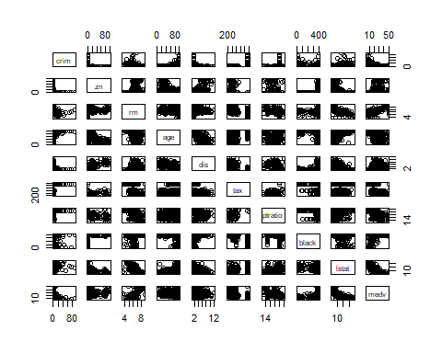

pairs(crim ~ age + tax + black + medv + rad, Boston)

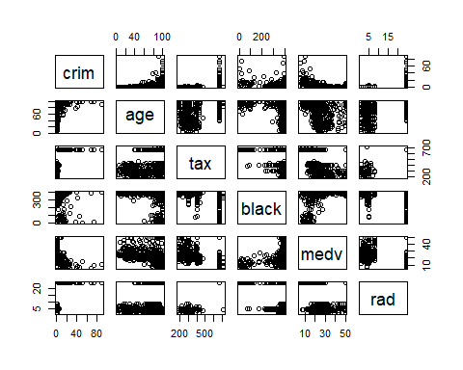

pairs(nox ~ zn, Boston)

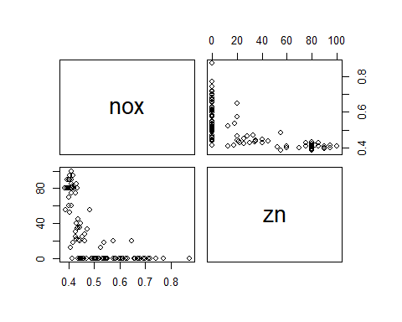

pairs(medv ~ tax + lstat + nox + rm, Boston)

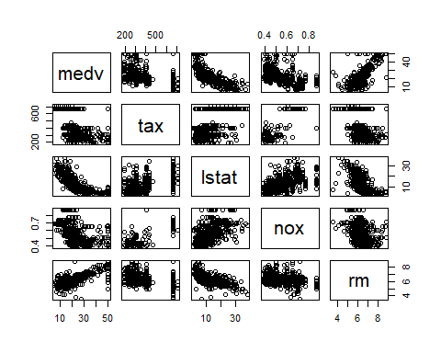

1. Where Proportion of residential land zoned is less the nox levels have increased.
2. As lsat (lower status of the population) increases then medv(median value of owner-occupied homes) decreases.
3. As nox (lower status of the population) increases then medv(median value of owner-occupied homes) decreases.
4. As rm (average number of rooms per dwelling) increases then medv(median value of owner-occupied homes) increases.

# 10c predictors associated with per capita crime rate?

pairs(crim ~ rad, Boston)

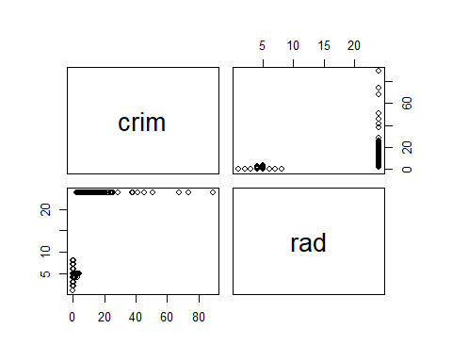

pairs(crim ~ age, Boston)

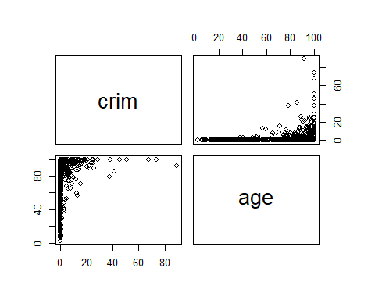

pairs(crim ~ medv, Boston)

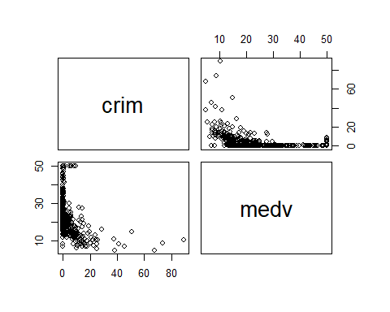

pairs(crim ~ tax, Boston)

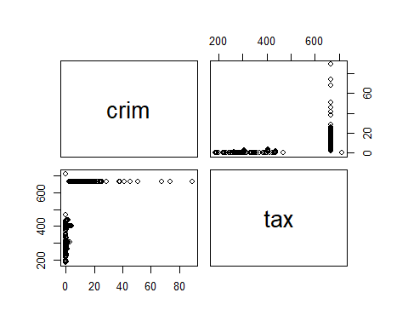

1. A higher values of rad (index of accessibility to radial highways) contain the highest level of crime rate.
2. As the age (proportion of owner-occupied units built prior to 1940) has increased the crime rate has increased.
3. crime rate is higher in the lower median value of owner-occupied homes.
4. As tax rate increase, crime rate increases.

# 10d_1 suburbs of Boston that have particularly high crime rates

summary(Boston$crim)

## Min. 1st Qu. Median Mean 3rd Qu. Max.   
## 0.00632 0.08204 0.25651 3.61352 3.67708 88.97620

crimeGreateThan20 <- Boston$crim[Boston$crim>20]  
crimeGreateThan30 <- Boston$crim[Boston$crim>30]  
length(crimeGreateThan20)

## [1] 18

length(crimeGreateThan30)

## [1] 8

par(mfrow=c(3,2))  
hist(Boston$crim, col = 3, xlab = "Crime rate", ylab = "Suburbs", main = "Crime rate")  
highCrime <- Boston$crim[Boston$crim>20]  
hist(highCrime, col = 3, xlab = "Crime rate", ylab = "Suburbs", main = "Crime rate > 20")  
highCrime <- Boston$crim[Boston$crim>30]  
hist(highCrime, col = 3, xlab = "Crime rate", ylab = "Suburbs", main = "Crime rate > 30")

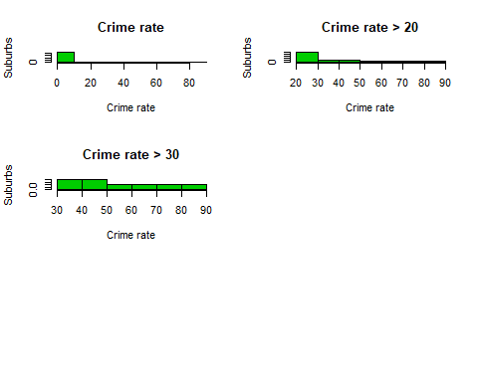 # 10d_2 suburbs of Boston appear that have particularly Tax rates, Pupil-teacher ratios

par(mfrow=c(1,2))  
hist(Boston$tax, col = 3, xlab = "Tax", ylab = "# Suburbs", main = "Distribution of tax")  
hist(Boston$ptratio, col = 8, xlab = "Pupil teacher ratios", ylab = "# Suburbs", main = "Distribution of Pupil-teacher ratios")

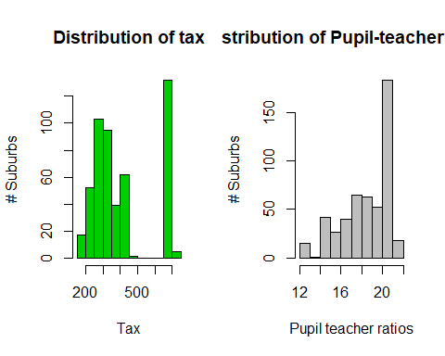

summary(Boston$tax)

## Min. 1st Qu. Median Mean 3rd Qu. Max.   
## 187.0 279.0 330.0 408.2 666.0 711.0

summary(Boston$ptratio)

## Min. 1st Qu. Median Mean 3rd Qu. Max.   
## 12.60 17.40 19.05 18.46 20.20 22.00

length(Boston$crim[Boston$tax>600])

## [1] 137

length(Boston$crim[Boston$ptratio>20])

## [1] 201

1. Most cities have less crime rate with average crime rate = 3.6.
2. There are 18 suburbs with crime rate greater than 20 and 8 suburbs with crime rate greater than 30.
3. Some suburbs have the highest tax with value greater than 600, there are 137 suburbs like these. These suburbs are beyond the 3rd quartile values.
4. Some suburbs have the highest Pupil-teacher ratios with value greater than 20, there are 201 suburbs like these. These suburbs are beyond the 3rd quartile values.

# 10e Suburbs in this data set bound the Charles river

suburbs_bound_to_river <- Boston %>%  
 filter(chas == 1)  
nrow(suburbs_bound_to_river)

## [1] 35

1. Number of Suburbs bound to the Charles river is 35.

# 10f What is the median pupil-teacher ratio among the towns in this data set?

median(Boston$ptratio)

## [1] 19.05

1. Median pupil-teacher ratio is 19.05.

# 10g_1 Which suburb of Boston has lowest median value of owneroccupied homes?

lowestMedianValue <- Boston %>%  
 filter(medv == min(Boston$medv))  
lowestMedianValue

## crim zn indus chas nox rm age dis rad tax ptratio black lstat  
## 1 38.3518 0 18.1 0 0.693 5.453 100 1.4896 24 666 20.2 396.90 30.59  
## 2 67.9208 0 18.1 0 0.693 5.683 100 1.4254 24 666 20.2 384.97 22.98  
## medv  
## 1 5  
## 2 5

1. There are 2 suburbs with with lowest median value of 5.

compare_summary_dataset <- function(dataset_orig,dataset_target) {  
 sum1 <- apply(dataset_orig,2,summary) %>% data.frame()   
 sum2 <- apply(dataset_target,2,summary) %>% data.frame()   
  
 names(sum1) <- paste0(names(sum1),"1")  
 names(sum2) <- paste0(names(sum2),"2")  
  
 final <- cbind(sum1,sum2)  
  
 final1 <- t(final)   
  
 final2 <- final1[order(row.names(final1)), ]  
  
 final_1 <- t(final2) %>% data.frame()  
 final_1  
}

# 10g_2 Values of the other predictors for that suburb, and how do those values compare to the overall ranges for those predictors and Comments on findings.

t(compare_summary_dataset(Boston,lowestMedianValue))

## Min. 1st Qu. Median Mean 3rd Qu. Max.  
## age1 2.90000 45.025000 77.50000 68.57490119 94.075000 100.0000  
## age2 100.00000 100.000000 100.00000 100.00000000 100.000000 100.0000  
## black1 0.32000 375.377500 391.44000 356.67403162 396.225000 396.9000  
## black2 384.97000 387.952500 390.93500 390.93500000 393.917500 396.9000  
## chas1 0.00000 0.000000 0.00000 0.06916996 0.000000 1.0000  
## chas2 0.00000 0.000000 0.00000 0.00000000 0.000000 0.0000  
## crim1 0.00632 0.082045 0.25651 3.61352356 3.677083 88.9762  
## crim2 38.35180 45.744050 53.13630 53.13630000 60.528550 67.9208  
## dis1 1.12960 2.100175 3.20745 3.79504269 5.188425 12.1265  
## dis2 1.42540 1.441450 1.45750 1.45750000 1.473550 1.4896  
## indus1 0.46000 5.190000 9.69000 11.13677866 18.100000 27.7400  
## indus2 18.10000 18.100000 18.10000 18.10000000 18.100000 18.1000  
## lstat1 1.73000 6.950000 11.36000 12.65306324 16.955000 37.9700  
## lstat2 22.98000 24.882500 26.78500 26.78500000 28.687500 30.5900  
## medv1 5.00000 17.025000 21.20000 22.53280632 25.000000 50.0000  
## medv2 5.00000 5.000000 5.00000 5.00000000 5.000000 5.0000  
## nox1 0.38500 0.449000 0.53800 0.55469506 0.624000 0.8710  
## nox2 0.69300 0.693000 0.69300 0.69300000 0.693000 0.6930  
## ptratio1 12.60000 17.400000 19.05000 18.45553360 20.200000 22.0000  
## ptratio2 20.20000 20.200000 20.20000 20.20000000 20.200000 20.2000  
## rad1 1.00000 4.000000 5.00000 9.54940711 24.000000 24.0000  
## rad2 24.00000 24.000000 24.00000 24.00000000 24.000000 24.0000  
## rm1 3.56100 5.885500 6.20850 6.28463439 6.623500 8.7800  
## rm2 5.45300 5.510500 5.56800 5.56800000 5.625500 5.6830  
## tax1 187.00000 279.000000 330.00000 408.23715415 666.000000 711.0000  
## tax2 666.00000 666.000000 666.00000 666.00000000 666.000000 666.0000  
## zn1 0.00000 0.000000 0.00000 11.36363636 12.500000 100.0000  
## zn2 0.00000 0.000000 0.00000 0.00000000 0.000000 0.0000

1. Age of lowest median value of owner-occupied homes is higher compared to overall dataset.
2. Proportion of blacks is same as that of median of overall dataset, mean of these 2 suburbs is on higher side.
3. Crime rate is on the higher side; 2 suburbs have crime rate of 38 and 67 with average of 53 which is considerably higher than the overall dataset.
4. Lower status of the population (percent) is greater than mean and median of overall dataset.
5. nox (nitrogen oxides concentration (parts per 10 million)) is on higher side.
6. ptratio (pupil-teacher ratio) falls in that tower of > 20 in the above histogram.
7. Tax is on the higher side compared to overall dataset and it falls in the tower > 600 histogram.

# 10h_1 Suburbs average more than seven rooms per dwelling

dwelling_7 <- Boston %>%  
 filter(rm > 7)  
nrow(dwelling_7)

## [1] 64

# 10h_2 Suburbs average more than eight rooms per dwelling

dwelling_8 <- Boston %>%  
 filter(rm > 8)  
nrow(dwelling_8)

## [1] 13

summary(dwelling_8)

## crim zn indus chas   
## Min. :0.02009 Min. : 0.00 Min. : 2.680 Min. :0.0000   
## 1st Qu.:0.33147 1st Qu.: 0.00 1st Qu.: 3.970 1st Qu.:0.0000   
## Median :0.52014 Median : 0.00 Median : 6.200 Median :0.0000   
## Mean :0.71879 Mean :13.62 Mean : 7.078 Mean :0.1538   
## 3rd Qu.:0.57834 3rd Qu.:20.00 3rd Qu.: 6.200 3rd Qu.:0.0000   
## Max. :3.47428 Max. :95.00 Max. :19.580 Max. :1.0000   
## nox rm age dis   
## Min. :0.4161 Min. :8.034 Min. : 8.40 Min. :1.801   
## 1st Qu.:0.5040 1st Qu.:8.247 1st Qu.:70.40 1st Qu.:2.288   
## Median :0.5070 Median :8.297 Median :78.30 Median :2.894   
## Mean :0.5392 Mean :8.349 Mean :71.54 Mean :3.430   
## 3rd Qu.:0.6050 3rd Qu.:8.398 3rd Qu.:86.50 3rd Qu.:3.652   
## Max. :0.7180 Max. :8.780 Max. :93.90 Max. :8.907   
## rad tax ptratio black   
## Min. : 2.000 Min. :224.0 Min. :13.00 Min. :354.6   
## 1st Qu.: 5.000 1st Qu.:264.0 1st Qu.:14.70 1st Qu.:384.5   
## Median : 7.000 Median :307.0 Median :17.40 Median :386.9   
## Mean : 7.462 Mean :325.1 Mean :16.36 Mean :385.2   
## 3rd Qu.: 8.000 3rd Qu.:307.0 3rd Qu.:17.40 3rd Qu.:389.7   
## Max. :24.000 Max. :666.0 Max. :20.20 Max. :396.9   
## lstat medv   
## Min. :2.47 Min. :21.9   
## 1st Qu.:3.32 1st Qu.:41.7   
## Median :4.14 Median :48.3   
## Mean :4.31 Mean :44.2   
## 3rd Qu.:5.12 3rd Qu.:50.0   
## Max. :7.44 Max. :50.0

1. Number of suburbs with more than seven rooms per dwelling is 64.
2. Number of suburbs with more than eight rooms per dwelling is 13.

# 10h_3 Suburbs that average more than eight rooms per dwelling compared to overall dataset.

t(compare_summary_dataset(Boston,dwelling_8))

## Min. 1st Qu. Median Mean 3rd Qu. Max.  
## age1 2.90000 45.025000 77.50000 68.57490119 94.075000 100.00000  
## age2 8.40000 70.400000 78.30000 71.53846154 86.500000 93.90000  
## black1 0.32000 375.377500 391.44000 356.67403162 396.225000 396.90000  
## black2 354.55000 384.540000 386.86000 385.21076923 389.700000 396.90000  
## chas1 0.00000 0.000000 0.00000 0.06916996 0.000000 1.00000  
## chas2 0.00000 0.000000 0.00000 0.15384615 0.000000 1.00000  
## crim1 0.00632 0.082045 0.25651 3.61352356 3.677083 88.97620  
## crim2 0.02009 0.331470 0.52014 0.71879538 0.578340 3.47428  
## dis1 1.12960 2.100175 3.20745 3.79504269 5.188425 12.12650  
## dis2 1.80100 2.288500 2.89440 3.43019231 3.651900 8.90670  
## indus1 0.46000 5.190000 9.69000 11.13677866 18.100000 27.74000  
## indus2 2.68000 3.970000 6.20000 7.07846154 6.200000 19.58000  
## lstat1 1.73000 6.950000 11.36000 12.65306324 16.955000 37.97000  
## lstat2 2.47000 3.320000 4.14000 4.31000000 5.120000 7.44000  
## medv1 5.00000 17.025000 21.20000 22.53280632 25.000000 50.00000  
## medv2 21.90000 41.700000 48.30000 44.20000000 50.000000 50.00000  
## nox1 0.38500 0.449000 0.53800 0.55469506 0.624000 0.87100  
## nox2 0.41610 0.504000 0.50700 0.53923846 0.605000 0.71800  
## ptratio1 12.60000 17.400000 19.05000 18.45553360 20.200000 22.00000  
## ptratio2 13.00000 14.700000 17.40000 16.36153846 17.400000 20.20000  
## rad1 1.00000 4.000000 5.00000 9.54940711 24.000000 24.00000  
## rad2 2.00000 5.000000 7.00000 7.46153846 8.000000 24.00000  
## rm1 3.56100 5.885500 6.20850 6.28463439 6.623500 8.78000  
## rm2 8.03400 8.247000 8.29700 8.34853846 8.398000 8.78000  
## tax1 187.00000 279.000000 330.00000 408.23715415 666.000000 711.00000  
## tax2 224.00000 264.000000 307.00000 325.07692308 307.000000 666.00000  
## zn1 0.00000 0.000000 0.00000 11.36363636 12.500000 100.00000  
## zn2 0.00000 0.000000 0.00000 13.61538462 20.000000 95.00000

1. Crime rate for suburbs with more than eight rooms per dwelling is on lower side compared to overall dataset.
2. lstat (lower status of the population (percent)) is lower than the overall population.
3. medv (median value of owner-occupied homes) is on higher side than overall dataset.
4. tax (full-value property-tax rate per $10,000) mean is lower than that of the overall dataset.