Assignment: Chapter 8 Exercises (Week 7)

Amol Gote

08/23/2020

# Problem 9 This problem involves the OJ data set which is part of the ISLR package.

training_oj_subset <- sample(nrow(OJ), 800)  
training_oj_ds = OJ[training_oj_subset, ]  
test_oj_ds = OJ[-training_oj_subset, ]  
nrow(training_oj_ds)

## [1] 800

nrow(test_oj_ds)

## [1] 270

tree_oj <- tree(Purchase∼., OJ ,subset = training_oj_subset )

prediction <- predict(tree_oj, test_oj_ds, type="class")  
table(prediction, test_oj_ds$Purchase)

##   
## prediction CH MM  
## CH 137 32  
## MM 20 81

test_error_rate <- mean(prediction != test_oj_ds$Purchase)  
test_error_rate_percentage <- test_error_rate * 100  
test_error_rate_percentage

## [1] 19.25926

test_accuracy_rate <- mean(prediction == test_oj_ds$Purchase)  
test_accuracy_rate_percentage <- test_accuracy_rate * 100  
test_accuracy_rate_percentage

## [1] 80.74074

optimal_tree <- cv.tree(tree_oj, FUN = prune.tree)

# 9g Produce a plot with tree size on the x-axis and cross-validated classification error rate on the y-axis.

tree_plot <- data.frame(x=optimal_tree$size, y=optimal_tree$dev)  
ggplot(tree_plot, aes(x=x,y=y)) +   
 geom_point() +   
 geom_line() +   
 xlab("Tree Size") +   
 ylab("Deviance")

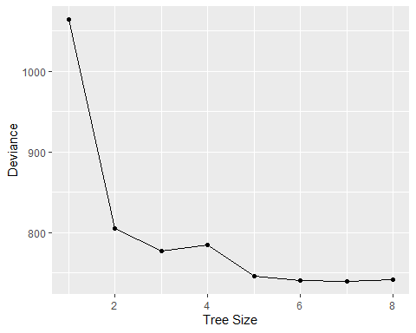

# 9h Which tree size corresponds to the lowest cross-validated classification error rate?

Tree size which corresponds to the lowest cross-validated classification error rate is: 7

# 9i Produce a pruned tree corresponding to the optimal tree size obtained using cross-validation. If cross-validation does not lead to selection of a pruned tree, then create a pruned tree with five terminal nodes.

pruned_tree <- prune.tree(tree_oj, best = 7)

# 9j Compare the training error rates between the pruned and unpruned trees. Which is higher?

summary(pruned_tree)

##   
## Classification tree:  
## snip.tree(tree = tree_oj, nodes = 5L)  
## Variables actually used in tree construction:  
## [1] "LoyalCH" "PriceDiff"  
## Number of terminal nodes: 7   
## Residual mean deviance: 0.7583 = 601.3 / 793   
## Misclassification error rate: 0.1662 = 133 / 800

summary(tree_oj)

##   
## Classification tree:  
## tree(formula = Purchase ~ ., data = OJ, subset = training_oj_subset)  
## Variables actually used in tree construction:  
## [1] "LoyalCH" "PriceDiff"  
## Number of terminal nodes: 8   
## Residual mean deviance: 0.7402 = 586.3 / 792   
## Misclassification error rate: 0.16 = 128 / 800

Misclassification rate on pruned tree is is higher

# 9k Compare the test error rates between the pruned and unpruned trees. Which is higher?

test_error_rate_pruned <- mean(predict(pruned_tree, test_oj_ds, type = "class") != test_oj_ds$Purchase)  
test_error_rate_pruned

## [1] 0.1814815

test_error_rate_unpruned <- mean(prediction != test_oj_ds$Purchase)  
test_error_rate_unpruned

## [1] 0.1925926

Test error rate of pruned tree is 0.1814815 and unpruned tree is 0.1925926. Pruned tree error rate is lower.

# Problem 10 - We now use boosting to predict Salary in the Hitters data set.

# 10a Remove the observations for whom the salary information is unknown, and then log-transform the salaries.

hitters_ds <- Hitters   
no_salary <- hitters_ds %>%  
 filter(is.na(Salary))  
no_salary_row_count <- nrow(no_salary)  
  
  
filtered_hitters_ds <- hitters_ds %>%  
 filter(!is.na(Salary))  
filtered_hitters_ds$Salary <- log(filtered_hitters_ds$Salary)

# 10b Create a training set consisting of the first 200 observations, and a test set consisting of the remaining observations.

hitters_ds_training <- filtered_hitters_ds[1:200,]  
hitters_ds_testing <- filtered_hitters_ds[-(1:200),]

# 10c Perform boosting on the training set with 1,000 trees for a range of values of the shrinkage parameter λ. Produce a plot with different shrinkage values on the x-axis and the corresponding training set MSE on the y-axis.

pows <- seq(-10, -0.2, by = 0.1)  
lambdas <- 10^pows  
training_errors <- rep(NA, length(lambdas))  
  
  
for (i in 1:length(lambdas)) {  
 boosting_model <- gbm(Salary ~ . , data = hitters_ds_training, distribution = "gaussian",   
 n.trees = 1000, shrinkage = lambdas[i])  
   
 training_predictions <- predict(boosting_model, hitters_ds_training, n.trees = 1000)  
 training_errors[i] <- mean((training_predictions - hitters_ds_training$Salary)^2)  
}  
  
plot(lambdas, training_errors, xlab = "Shrinkage Values", ylab = "Training set MSE", type = "b", pch = 20)

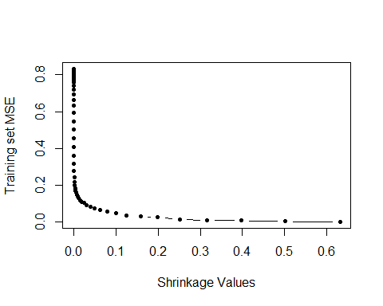

# 10d Produce a plot with different shrinkage values on the x-axis and the corresponding test set MSE on the y-axis.

test_errors <- rep(NA, length(lambdas))  
  
  
for (i in 1:length(lambdas)) {  
 boosting_model <- gbm(Salary ~ . , data = hitters_ds_training, distribution = "gaussian",   
 n.trees = 1000, shrinkage = lambdas[i])  
   
 test_predictions <- predict(boosting_model, hitters_ds_testing, n.trees = 1000)  
 test_errors[i] <- mean((test_predictions - hitters_ds_testing$Salary)^2)  
}  
  
plot(lambdas, test_errors, xlab = "Shrinkage Values", ylab = "Training set MSE", type = "b", pch = 20)

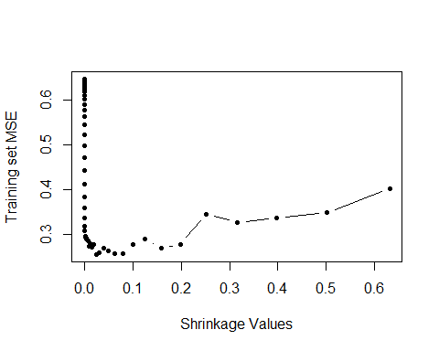

min(test_errors)

## [1] 0.2557404

min_test_err <- min(test_errors)  
min_test_err_at <- lambdas[which.min(test_errors)]

Minimum test error is obtained at λ = 0.0251189

# 10e Compare the test MSE of boosting to the test MSE that results from applying two of the regression approaches seen in Chapters 3 and 6

lm_model <- lm(Salary ~ . , data = hitters_ds_training)  
lm_model_predictions <- predict(lm_model, hitters_ds_testing)  
lm_model_test_mse <- mean((lm_model_predictions - hitters_ds_testing$Salary)^2)  
lm_model_test_mse

## [1] 0.4917959

lasso_model <- lm(Salary ~ . , data = hitters_ds_training)  
  
hitters_ds_training_matrix <- model.matrix(Salary ~ . , data = hitters_ds_training)  
hitters_ds_testing_matrix <- model.matrix(Salary ~ . , data = hitters_ds_testing)  
  
lasso_model <- glmnet(hitters_ds_training_matrix, hitters_ds_training$Salary, alpha = 1)  
lasso_model_predictions <- predict(lasso_model, s=0.01, newx=hitters_ds_testing_matrix)  
  
  
lasso_model_test_mse <- mean((lasso_model_predictions - hitters_ds_testing$Salary)^2)  
lasso_model_test_mse

## [1] 0.4700537

Both regression approaches lm and lasso have higher MSE compared to that of boosting.

# 10f Which variables appear to be the most important predictors in the boosted model?

boosting_model <- gbm(Salary ~ . , data = hitters_ds_training, distribution = "gaussian",   
 n.trees = 1000, shrinkage = min_test_err)  
summary(boosting_model)

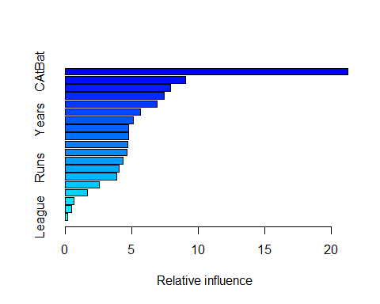

## var rel.inf  
## CAtBat CAtBat 21.2484603  
## PutOuts PutOuts 9.0208616  
## CRuns CRuns 7.9273379  
## Walks Walks 7.4314427  
## CRBI CRBI 6.8794741  
## Assists Assists 5.6582958  
## Years Years 5.1497895  
## CWalks CWalks 4.7599174  
## AtBat AtBat 4.7433505  
## RBI RBI 4.7339007  
## CHmRun CHmRun 4.6621621  
## Hits Hits 4.3321089  
## Runs Runs 4.0771840  
## HmRun HmRun 3.8735363  
## Errors Errors 2.5592030  
## CHits CHits 1.6622569  
## NewLeague NewLeague 0.6368087  
## Division Division 0.4746364  
## League League 0.1692733

Variables that appear to be most important predictors are

1. CAtBat

2. PutOuts

3. CRuns

4. CRBI

# 10g Now apply bagging to the training set. What is the test set MSE for this approach?

random_forest_model <- randomForest(Salary ~ . , data = hitters_ds_training, ntree = 500, mtry = ncol(hitters_ds_training)-1)  
random_forest_predictions <- predict(random_forest_model, hitters_ds_testing)  
  
random_forest_test_mse <- mean((random_forest_predictions - hitters_ds_testing$Salary)^2)  
random_forest_test_mse

## [1] 0.2328366

Test MSE for bagging is 0.2328366 which is better than 0.2557404 which is best MSE from boosting