**4.2** **Identify the parameter, Part II.**

For each of the following situations, state whether the parameter of interest is a mean or a proportion.

1. A poll shows that 64% of Americans personally worry a great deal about federal spending and the budget deficit.

🡺 **Proportion**

It shows how much % are worried and remaining 36% percentage could be not worried or neither. So it’s categorical (Worried/Not Worried)

1. A survey reports that local TV news has shown a 17% increase in revenue between 2009 and 2011 while newspaper revenues decreased by 6.4% during this time period

🡺 **Mean**

Its flat numerical revenue increase/ decrease in revenue.

1. In a survey, high school and college students are asked whether or not they use geo-location services on their smart phones.

🡺 **Proportion**

Categorical – It is binary choice between geo-location service been used or not.

1. In a survey, smart phone users are asked whether or not they use a web-based taxi service.

🡺 **Proportion**

Categorical – 2 Categories over here whether smart phone users use web-based taxi service or not.

1. In a survey, smart phone users are asked how many times they used a web-based taxi service over the last year.

🡺 **Mean**

Numerical – How many time smart phone users have used web-based taxi service in last one year.

**4.10 Twitter users and news, Part II.**

A poll conducted in 2013 found that 52% of U.S. adult Twitter users get at least some news on Twitter, and the standard error for this estimate was 2.4%. Identify each of the following statements as true or false. Provide an explanation to justify each of your answers.

1. The data provide statistically significant evidence that more than half of U.S. adult Twitter User’s get some news through Twitter. Use a significance level of α = 0.01.

**True**

For α = 0.01 confidence interval is 99%, so based on this

Point estimate= 52%

SE = 2.4

Z* = 2.58 🡺 for 99% confidence level

52+- 2.58 * 2.4

Point estimate upper bound = 52 + (2.58*2.4) = 45.81%

Point estimate lower bound = 52 - (2.58*2.4) = 58.19%

So we conclude that “99% confident that proportion of US adult twitter users get at least some news from twitter lies in the range of 45.81% to 58.19%”.

This give sufficient evidence that more than half of U.S. adult Twitter User’s get some news through Twitter

1. Since the standard error is 2.4%, we can conclude that 97.6% of all U.S. adult Twitter users were included in the study.

**False.**

Standard error is typically overall error in randomness. It describes the typical error or uncertainty associated with the estimate and not the actual numbers.

1. If we want to reduce the standard error of the estimate, we should collect less data.

**False**

**SE = σ/√n**

where

σ is standard deviation

n is sample size.

So based on the above equation it is pretty clearly evident that the larger the sample size lesser the SE (Standard error).

For e.g. for SD = 10 and sample size 100 and 400

SE (100) = 1

SE (400) = 0.5

The larger sample has a smaller standard error. The standard error of the sample with 400 observations is lower than that of the sample with 100 observations. The standard error describes the typical error, and since it is lower for the larger sample, this mathematically shows the estimate from the larger sample tends to be better though it does not guarantee that every large sample will provide a better estimate than a particular small sample.

1. If we construct a 90% confidence interval for the percentage of U.S. adults Twitter users who get some news through Twitter, this confidence interval will be wider than a corresponding 99% confidence interval.

**False**

* 90% confidence interval will be **not be wider** than the 99% confidence interval.
* 99% confidence interval ranges from -2.58 to +2.58
* 90% confidence interval it ranges from -1.65 to +1.65

**4.22 Thanksgiving spending Part II.**

Exercise 4.14 provides a 95% confidence interval for the average spending by American adults during the six-day period after Thanksgiving 2009: ($80.31, $89.11).

1. A local news anchor claims that the average spending during this period in 2009 was $100. What do you think of her claim?

Local news anchor Claim is **incorrect**

Confidence interval is the plausible range of plausible values, $100 does not fall in the plausible range of $80.31 and $89.11

Point estimate for 95% confidence interval

80.31 + (1.96 * SE) = 89.11 - (1.96 * SE)

Solving this equation gives

SE: 2.25

Point Estimate = $84.71

If even if we go with 99% confidence interval the then range is

84.71 – 2.58 * 2.25 = 78.92

84.71 + 2.58 * 2.25 = 90.50

$100 does not fall in this range of 99%confident interval as.

1. Would the news anchor's claim be considered reasonable based on a 90% confidence interval? Why or why not? (Do not actually calculate the interval.)

For 90% confidence level the **range would be even narrower than** that of 95%, so the lower point estimate would be greater than $80.31 and upper point estimate would be lesser than $89.11. Going by this analysis $100 will not in range of 90% confidence level factor. So in summary claim by news anchor is unreasonable.

**4.30 Testing for food safety.**

A food safety inspector is called upon to investigate a restaurant with a few customer reports of poor sanitation practices. The food safety inspector uses a hypothesis testing framework to evaluate whether regulations are not being met. If he decides the restaurant is in gross violation, its license to serve food will be revoked.

|  |  |  |  |
| --- | --- | --- | --- |
|  |  | **Test Conclusion** | |
|  |  | **Do not reject Ho in favor of HA** | **Reject Ho in favor of HA** |
| **Truth** | **Regulations are met** | OK | **Type 1 Error**: Regulations are met but license to serve food will be revoked |
| **Regulations are not met** | Type 2 Error: Regulations are not met but license to serve food is retained (Not Revoked) | OK |

1. Write the hypotheses in words.

Null Hypothesis 🡺 Regulations are met

Alternative Hypothesis 🡺 Regulations are **not met**.

1. What is a Type 1 Error in this context?

Regulations are met but license to serve food will be revoked.

1. What is a Type 2 Error in this context?

Regulations are not met but license to serve food is retained (Not revoked).

1. Which error is more problematic for the restaurant owner? Why?

From restaurant owner perspective **Type 1 error** is more harmful/problematic to him. Reason been all the regulations have been followed, but still owner’s license to serve food is cancelled which means the owner cannot do any further business.

1. Which error is more problematic for the diners? Why?

From the perspective of the people who are dinning over there **Type 2 Error** is problematic as restaurant owner is not following the regulations, yet his license is retained and not revoked. In case of type 2 errors, there are indeed some poor sanitation practices followed in the restaurant which could impact the health of the people dining over there.

1. As a diner, would you prefer that the food safety inspector requires strong evidence or very strong evidence of health concerns before revoking a restaurant's license? Explain your reasoning.

* Strong evidence rather than very strong evidence.
* It impacts their health and well-being of diners. It’s better to minimize the Type 2 errors.
* Diners can be rest assured that appropriate sanitation practices are getting incorporated.
* This will more likely cause the restaurant to fail the inspection. But it will set the precedence to this restaurant and other restaurants as well to increase the sanitation standards.
* Choosing the stronger evidence on contrary to very stronger evidence lowers the threshold of evaluating evidence which may cause level 1 errors so delicate balance has to be incorporated, so for first couple of samples very strong evidence could be considered which will certify majority of restaurants, but with more tests (more samples) for failed restaurants strong evidence could be considered.

**4.38 Identify distributions, Part II.**

Four plots are presented below. The plot at the top is a distribution for a population. The mean is 60 and the standard deviation is 18. Also shown below is a distribution of

1. A single random sample of 500 values from this population,
2. A distribution of 500 sample means from random samples of each size 18

1. A distribution of 500 sample means from random samples of each size 81.

Determine which plot (A, B, or C) is which and explain your reasoning.

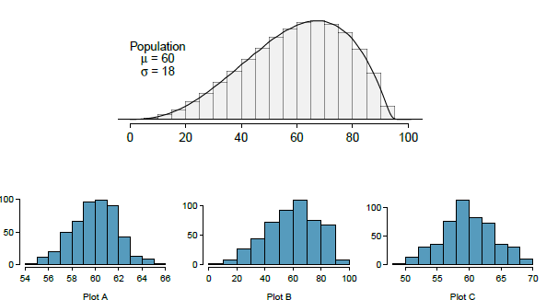

1. 1 🡺 B

Has wide variety of range and is more variable than A and C.

1. 2 🡺 A

Moderately variable compared to B, but more variable than C

1. 3🡺 C

Less variable compared to other 2 (B and A)

**4.40 CFLBs.**

A manufacturer of compact fluorescent light bulbs advertises that the distribution of the lifespans of these light bulbs is nearly normal with a mean of 9,000 hours and a standard deviation of 1,000 hours.

X`x`

σ = 1000

µ = 9000

1. What is the probability that a randomly chosen light bulb lasts more than 10,500 hours?

Z score = (x - µ)/ σ

Probability of < 10,500 = (10500 – 9000)/1000

= 1.5

Probability value of 1.5 = 0.9332

**So probability for lasting more than 10,500 hours** = 1 – 0.9332

= 0.0668

= **6.68%**

1. Describe the distribution of the mean lifespan of 15 light bulbs.

Here the sample size is small, hence the mean distribution could be skewed, which is evident from the fact that the SE is going to be high as well. Larger sample has smaller standard error. In this case distribution can be anything as outliers will have significant impact.

Sample size n increases SE decreases. As the sample size increases we would expect samples to yield more consistent sample means, hence the variability among the sample means would be lower.

Sample Size n = 15

**SE = σ/√n**

where

σ is standard deviation

n is sample size.

SE = 1000/√15 = 258.20

1. What is the probability that the mean lifespan of 15 randomly chosen light bulbs is more than 10,500 hours?

**0.00%**

Sample Size n = 15

Z = (10500 – 9000) / (1000/√15) = 5.81

For Z > 3.50 assuming the last probability value of 0.9998

So Probability value us going to = 1 – 0.9998

Which is = 0.0002, which is practically 0%

1. Sketch the two distributions (population and sampling) on the same scale.

**Blue line is Sampling**

**Red line is Population**

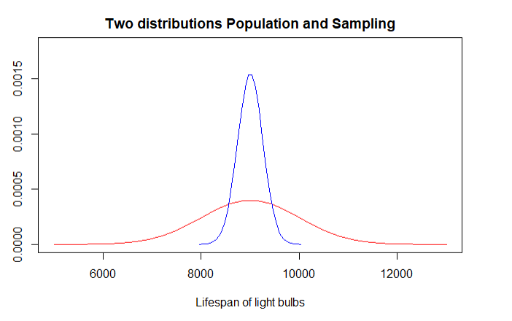

1. Could you estimate the probabilities from parts (a) and (c) if the lifespans of light bulbs had a skewed distribution?
2. In case of skewed distribution we cannot calculate probability using the normal distribution.
3. For sampling there is possibility that the means follow the normal distribution even though the actual data is skewed but we cannot use Central limit theorem as the sample size = 15 which is less than 30.

**4.46. Unemployment and relationship problems.**

A USA Today/Gallup poll conducted between 2010 and 2011 asked a group of unemployed and underemployed Americans if they have had major problems in their relationships with their spouse or another close family member as a result of not having a job (if unemployed) or not having a full-time job (if underemployed). 27% of the 1,145 unemployed respondents and 25% of the 675 underemployed respondents said they had major problems in relationships as a result of their employment status.

1. What are the hypotheses for evaluating if the proportions of unemployed and underemployed people who had relationship problems were different?

Null Hypothesis 🡺 P(unemployed) **=** P(underemployed)

Proportion of unemployed having problem with in their relationships with their spouse or another close family member is **equal** to the proportion of the underemployed.

Alternative hypothesis 🡺 P(unemployed) **!=** P(underemployed)

Proportion of unemployed having problem with in their relationships with their spouse or another close family member is **not equal** to the proportion of the underemployed.

1. The p-value for this hypothesis test is approximately 0.35. Explain what this means in context of the hypothesis test and the data.

P-Value = 0.35 which is way greater than significance level (α = 0.05) we cannot reject the null hypothesis theory (Fail to reject the null hypothesis). Data does not provide any conclusive evidence to prove the alternative hypothesis that proportion of unemployed and underemployed having problem with spouse/family members are different.