# 7.4 Identify relationships, Part II.

For each of the six plots, identify the strength of the relationship (e.g. weak, moderate, or strong) in the data and whether fitting a linear model would be reasonable.

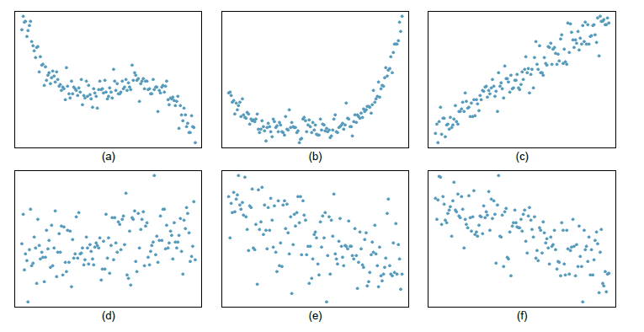

1. a 🡺 Strong relationship, but straight line would not fit the data. Not fitting linear model.
2. b 🡺Strong relationship, but straight line would not fit the data. Not fitting linear model.
3. c 🡺 Strong relationship and linear fit would be reasonable.
4. d 🡺Weak relationship and trying a linear fit would be reasonable.
5. e 🡺Weak relationship and trying linear fit would be reasonable.
6. f 🡺Moderate relationship. Linear fit would be reasonable.

# 7.6 Husbands and wives, Part I.

The Great Britain Office of Population Census and Surveys once collected data on a random sample of 170 married couples in Britain, recording the age (in years) and heights (converted here to inches) of the husbands and wives.16 The scatterplot on the left shows the wife's age plotted against her husband's age, and the plot on the right shows wife's height plotted against husband's height.

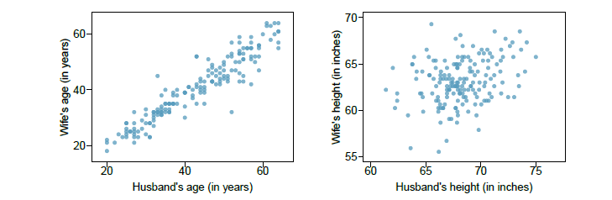

(a) Describe the relationship between husbands' and wives' ages.

* Relationship between husbands and wives ages is strong positively linearly correlated.
* By the clear linear positive correlation it is evident that younger men tend to marry younger women and old men tend to marry older women.

(b) Describe the relationship between husbands' and wives' heights.

* Strength of relationship between husband’s and wife’s height is weak.
* Correlation is weak if any.
* Points are scattered across and does not fit the linear model.

(c) Which plot shows a stronger correlation? Explain your reasoning.

* Plot between Husband’s wand wife’s age is showing strong correlation
* Reason
  + All the points are close to each other.
  + If we draw the straight line, then the residuals for most of the points is small, barring few exceptions.
  + Relationship is positively linearly correlated, as x (Husband’s age) increases y (wife’s age) increases as well.

(d) Data on heights were originally collected in centimeters, and then converted to inches. Does this conversion affect the correlation between husbands' and wives' heights?

* No conversion should not affect the correlation between husbands' and wives' heights, as when the data was originally collected it was collected in same units across 2.

# 7.8 Match the correlation, Part II.

Match the calculated correlations to the corresponding scatterplot.

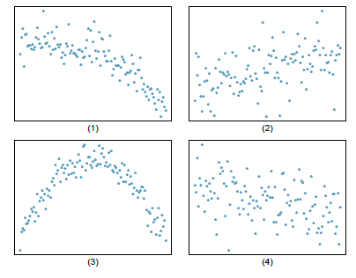

(a) r = 0.49 🡺 2

(b) r = -0.48 🡺 4

(c) r = -0.03 🡺 3

(d) r = - 0.85🡺1

# 7.10 Guess the correlation.

Eduardo and Rosie are both collecting data on number of rainy days in a year and the total rainfall for the year. Eduardo records rainfall in inches and Rosie in centimeters. How will their correlation coefficients compare?

Formula for correlation coefficient is



* Since it’s a standard formula change in units across datasets will not impact correlation coefficient.
* Changes in scale or units of measurement will not affect correlation coefficient.

# 7.14 Crawling babies, Part I.

A study conducted at the University of Denver investigated whether babies take longer to learn to crawl in cold months, when they are often bundled in clothes that restrict their movement, than in warmer months.18 Infants born during the study year were split into twelve groups, one for each birth month. We consider the average crawling age of babies in each group against the average temperature when the babies are six months old (that's when babies often begin trying to crawl). Temperature is measured in degrees Fahrenheit (F) and age is measured in weeks.

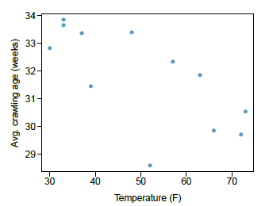

(a) Describe the relationship between temperature and crawling age.

* There is a weak negative relationship between average crawling age (weeks) and Temperature (F). Linear fit is reasonable.

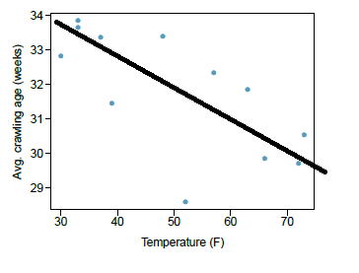

(b) How would the relationship change if temperature was measured in degrees Celsius (C) and age was measured in months?

* Changing the units will not change the form, direction or strength of the relationship between the two variables.
* If larger temperature measured in Fahrenheit is associated with larger age measured in weeks, larger temperature measured is Celsius will be associated with larger age measured in months.

(c) The correlation between temperature in F and age in weeks was r =-0:70. If we converted the temperature to C and age to months, what would the correlation be?

* Changing units doesn't affect correlation: r = -0.70.

# 7.18 Correlation, Part II.

What would be the correlation between the annual salaries of males and females at a company if for a certain type of position men always made?

Annual salary for men represented by = aSM

Annual salary for men represented by = aSW

(a) $5,000 more than women?

* aSM = aSW + 5000
* Linear model with positive association (Positive linear relationship). There will be an upward sloping line shown in the scatter plot.
* Slope is positive and is 1 and intercept is 5000.

(b) 25% more than women?

* aSM = aSW + (0.25*aSW)

aSM = 1.25*aSW

* Linear model with positive association (Positive linear relationship). There will be an upward sloping line shown in the scatter plot.
* Slope is positive and is 1.25 and intercept is 0.

(c) 15% less than women?

* aSM = aSW - (0.15*aSW)

aSM = 0.85*aSW

* Linear model with positive association (Positive linear relationship). There will be an upward sloping line shown in the scatter plot.
* Slope is positive and is 0.85 and intercept is 0.