# 2.16 PB & J.

Suppose 80% of people like peanut butter, 89% like jelly, and 78% like both. Given that a randomly sampled person likes peanut butter, what's the probability that he also likes jelly?

P(Peanut butter) = 0.80

P(Jelly) = 89%

P(Peanut butter and Jelly) = 0.78

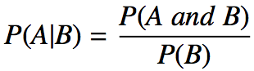

P(Jelly | Peanut Butter) = P(Peanut butter and Jelly) / P(Peanut butter)

P(Jelly | Peanut Butter) = 0.78 / 0.80 = 0.975

For randomly sample person who likes peanut butter, probability of liking jelly as well is **97.5%**

# 2.22 Predisposition for thrombosis.

A genetic test is used to determine if people have a predisposition for thrombosis, which is the formation of a blood clot inside a blood vessel that obstructs the flow of blood through the circulatory system. It is believed that 3% of people actually have this predisposition. The genetic test is 99% accurate if a person actually has the predisposition, meaning that the probability of a positive test result when a person actually has the predisposition is 0.99. The test is 98% accurate if a person does not have the predisposition. What is the probability that a randomly selected person who tests positive for the predisposition by the test actually has the predisposition?

Tree diagram

|  |  |  |  |  |  |  |
| --- | --- | --- | --- | --- | --- | --- |
|  |  |  |  |  | **Probability** |  |
|  |  |  | 0.99 | 0.99*0.03 | **0.0297** |  |
|  |  | |  | | --- | |  | | **Positive** |  |  |  |
|  | 0.03 |  |  |  |  |  |
|  | **Predisposition for Thrombosis** |  |  |  |  |  |
|  |  |  | 0.01 | 0.01*.0.3 | **0.0003** |  |
|  |  |  | **Negative** |  |  |  |
|  |  |  |  |  |  |  |
|  |  |  |  |  |  |  |
|  | |  | | --- | |  | |  | **Positivie** | 0.02*0.97 | **0.0194** |  |
|  |  |  | 0.02 |  |  |  |
|  | 0.97 |  |  |  |  |  |
|  | **No Predisposition for Thrombosis** |  |  |  |  |  |
|  |  |  | 0.98 | 0.98*0.97 | **0.9506** |  |
|  |  |  | **Negative** |  |  |  |
|  |  |  |  |  |  |  |
|  |  |  |  |  |  |  |

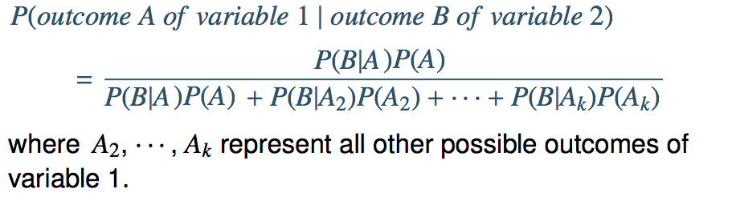

P(predispos | +ve) = P(+ve | predispos) * P(predispos)

P(+ve | predispos) * P(predispos) + P(+ve | No predispos) * P( No predisposition)

P(predispos | +ve) = 0.0297 /(0.0297 + 0.0194) = **0.604887984**

Probability that a randomly selected person who tests positive for the predisposition by the test actually has the predisposition is **60.49%**

# 2.24 Exit poll.

Edison Research gathered exit poll results from several sources for the Wisconsin recall election of Scott Walker. They found that 53% of the respondents voted in favor of Scott Walker. Additionally, they estimated that of those who did vote in favor for Scott Walker, 37% had a college degree, while 44% of those who voted against Scott Walker had a college degree. Suppose we randomly sampled a person who participated in the exit poll and found that he had a college degree. What is the probability that he voted in favor of Scott Walker?

Tree Diagram

|  |  |  |  |  |  |  |
| --- | --- | --- | --- | --- | --- | --- |
|  |  |  |  |  | **Probability** | |
|  |  |  | 0.37 | 0.53*0.37 | **0.1961** |  |
|  |  | |  | | --- | |  | | **College Degree** |  |  |  |
|  | 0.53 |  |  |  |  |  |
|  | **Voted Scott** |  |  |  |  |  |
|  |  |  | 0.63 | 0.53*0.63 | **0.3339** |  |
|  |  |  | **No College Degree** |  |  |  |
|  |  |  |  |  |  |  |
|  |  |  |  |  |  |  |
|  |  | |  | | --- | |  | | **College Degree** | 0.47*0.44 | **0.2068** |  |
|  |  |  | 0.44 |  |  |  |
|  | 0.47 |  |  |  |  |  |
|  | **Not Voted Scott** | |  | | --- | |  | |  |  |  |  |
|  |  |  | 0.56 | 0.47*0.56 | **0.2632** |  |
|  |  |  | **No College Degree** |  |  |  |
|  |  |  |  |  |  |  |
|  |  |  |  |  |  |  |

P(voted|degree) = P(degree | voted) * P(voted)

P(degree |voted) * P(degree) + P(degree | Not Voted) * P( Not Voted)

P(voted|degree) = 0.1961/(0.1962+0.2068) = **0.486600496**

There is about **48.67%** chance that a randomly sampled person with a college degree voted for Scott Walker.

# 2.26 Twins.

About 30% of human twins are identical, and the rest are fraternal. Identical twins are necessarily the same sex - half are males and the other half are females. One-quarter of fraternal twins are both male, one-quarter both female, and one-half are mixes: one male, one female. You have just become a parent of twins and are told they are both girls. Given this information, what is the probability that they are identical?

Tree diagram

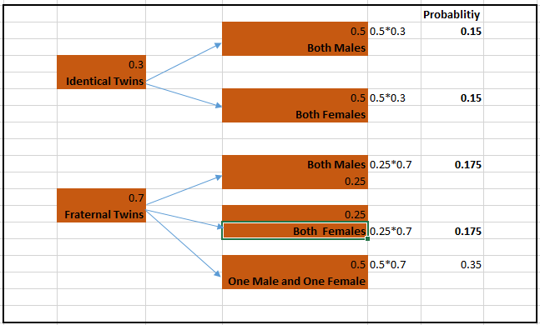

P(Identical|F) = P(F | Identical) * P(Identical)

P(F | Identical) * P(Identical) + P(F | Fraternal) * P(Fraternal)

P(Identical|F) = 0.15/(0.15 + 0.175) = **0.461538462**

Probability of both girls been female is **46.15%**