1. Course Basic info page should not contain basic info static part. [TPD – 001]

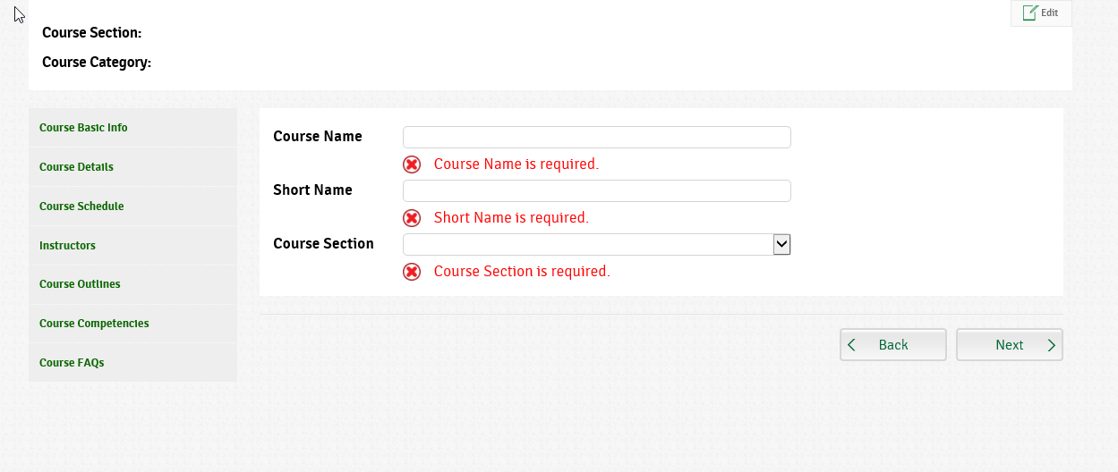

1. Course short Name to be removed (As agreed with Amira before). [TPD – 001]



1. Validation messages are fired once page is opened. [TPD – 001]



1. In course details, Course brief name is displayed without spaces. [TPD – 002]

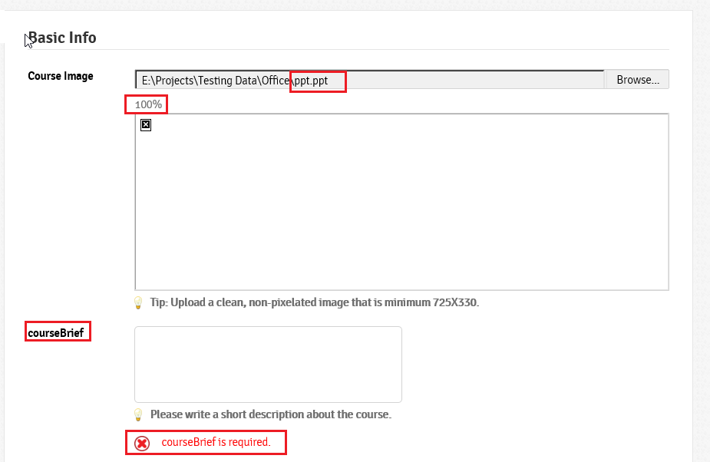

1. In course image upload, user can upload any type of file even if not an image. [TPD – 002]



1. After uploading any file (course image or session materials), there’s a label “100%” under browse control that should be removed. [TPD – 002]



1. Wrong validation message text for About the course field. [TPD - 003]

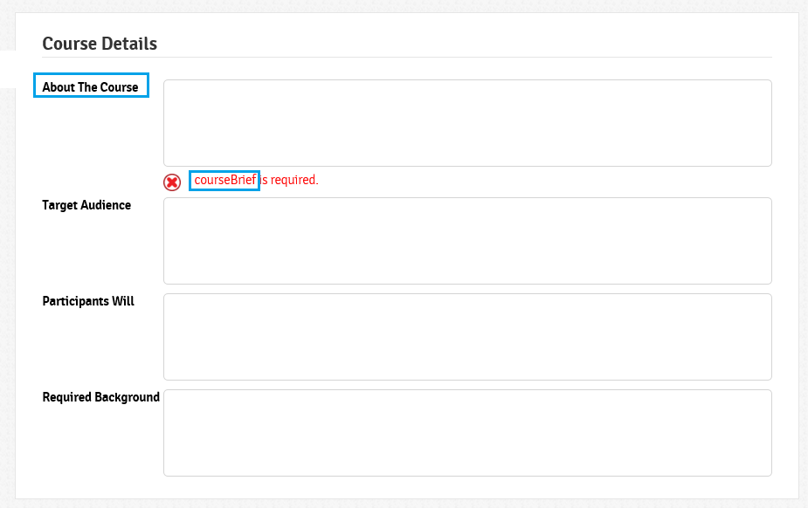

1. Date formats in textboxes are not user friendly. And there should be a calendar control for user. [TPD - 004]

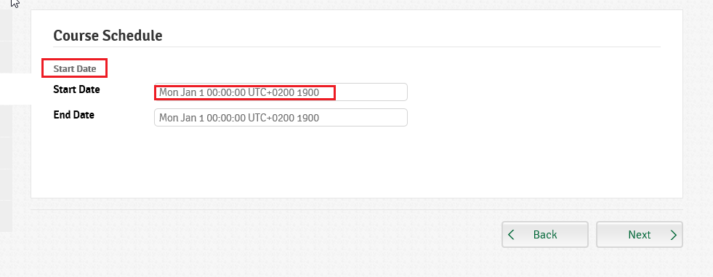

1. In Course schedule page, Start date is displayed on top of date. [TPD - 004]



1. In sessions, Material title should not be mandatory. [TPD - 005]

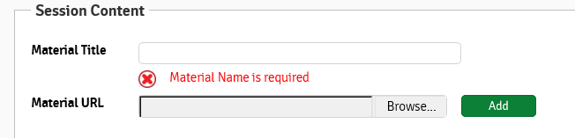

1. In Sessions, Delete material icon is not working.
2. In Sessions, “At least one session should be added” message is not displayed.
3. Edit/Delete in sessions and FAQ are not working
4. Published date is bold and Published date title label is not. [TPD - 006]
5. Files type in sessions materials are not displayed next to files [TPD - 006]
6. Session content Text should have spaces [TPD - 006]
7. In Sessions, File uploaded in material is not cleared from control after clicking on Add.
8. When clicking on portal tabs (Course catalog or dashboard) not exactly on text, clicked tab is highlighted but user is not directed to the selected page. [TPD - 007]
9. When opening a course details page/create course from dashboard or course catalogue, tab remain highlighted. No tab should be highlighted when course details is opened [TPD - 008]
10. While page is loading, only 1 loading wheel should be displayed for the whole page [TPD - 009]
11. There’s a large space between description & Title and sometimes a small space between description & enroll button [TPD - 010]
12. No login module provided
13. “Welcome User” text should have spaces.
14. Edit Basic info part is not working
15. No maximum length validation applied to instructors, course title and course in brief
16. In dashboard, clicking on Pie chart sections doesn’t always display the correct courses.
17. Sometimes it doesn’t click.
18. Language switcher is not working.
19. Dashboard: Default Drill Down List
20. Dashboard: Remove 0 items list from Dashboard “ex: completed  List = 0”
21. Dashboard: Show Empty Chart Div when there is no Enrolled Courses
22. Dashboard: Drill Down Scroll “UI”
23. Dashboard: Dashboard Header
24. Profile UI
25. Instructor profile
26. Course Catalogue Paging
27. Course Catalogue Search
28. Course Catalogue Filter By Competency
29. Course Catalogue , All  “Done but need some UI”
30. Membership Forms
31. Windows Authentication
32. Course Details : Instructor name redirect to instructor profile
33. Course Details : Instructor data
34. Course Details : Competencies fix for multi-level
35. Course Details : Course Schedule Date Format
36. Course Details : Empty Data msg
37. Create course: Remove head section
38. Create course: Add first step to wizard
39. Create course: Date pickers
40. Create course: required validation in all steps
41. Create course: Date validation in all steps
42. Create course: Remove next button from last step and remove first step from first step
43. Create course: Inactive next button when data invalid “just UI”
44. Create course: Left tab navigation
45. Create course: File progress bar
46. Create course: File upload style
47. Create course: Rich text for all textboxes
48. Create course: Max length validation
49. Create course: Instructors as tags
50. Create course: Instructors auto complete
51. Create course: Session div should be displayed by default without clicking on Add new Session
52. Create Session: User can Add session without adding any materials
53. Create Session: If User added material validate the title and URL both are required
54. Session Publishing Date Validation within Course Start and End Date
55. Competences Tab
56. FAQ list style
57. Pages Footer
58. Using Angular Animation