UNIVERSITY OF CALIFORNIA, LOS ANGELES
CS M117

Homework #3

Students Name ___Jonathan Nguy___
HW Due 01/30/13
Section A:
1. (2) Wireless nets:
(a) What is the main similarity between a Wireless LAN and an Ad Hoc network
(b) What is the main difference?
(a) They both use polling and they have dynamic topology
(b) Ad Hoc network is P2P, and it requires no base and has no infrastructure. Wireless LAN has peers talk through some access point.

2. (3) Why is multihopping used in Ad-Hoc nets?

In Ad Hoc nets, many devices can be trying to communicate with each other. Multihopping is required to ensure there are no collisions between peers.
Section B:
Bluetooth Communications
(T. Ch. 4. 310-317)

1). (2) From Figure 1 shown bellow; we see that a Bluetooth device can be in two piconets at the same time.

M
M
Bridge slave

Figure 1
Is there any reason why one device cannot be the master in both of them
at the same time?
One reason is that if two masters have a 7-node piconet, one node between them cannot be a master for both piconets at the same time to cover 13 nodes. The most a master can have is 7.

2). (2) Figure 2 shows several physical layer protocols. Which of these is closest to the Bluetooth physical layer protocol?

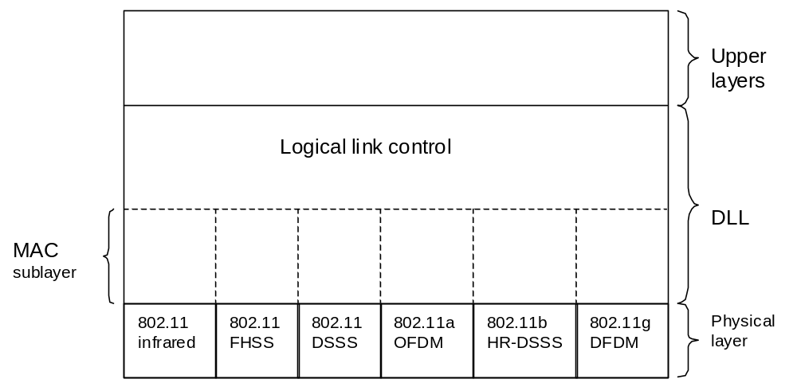
Figure 2

What is the biggest difference between the two?
Both Bluetooth and WLAN use FHSS, so 802.11 FHSS is the closest to the Bluetooth protocol. The difference is that Bluetooth hops a lot faster than WLAN (around 1600 hops per second)

3). (3) Beacon frame in the frequency hopping spread spectrum variant of 802.11 contain the dwell time, Do you think the analogous beacon frame in Bluetooth also contain the dwell time? Discuss your answer.

No. For Bluetooth, the dwell time is 625ms, which is hardwired onto all Bluetooth devices. For 802.11, the dwell time is dynamic, so it is different for every new device.

4) (3) (a) List the three different modes of signal propagation (besides direct signal) and the cause for each of these modes.
(b) What kind of signal reception problems these different modes cause?
- reflection, diffraction, scattering

  - reflection – delays signal
  - diffraction – weakens signal
  - scattering – weakens signal more than diffraction

5) (4) (a) How do multipath signals effect signal reception? This effect limits
the transmission rate of wireless channel.
(b) Give relation between transmission rate and this “effect“ in part (a).
- Depending from the shifted phases of different signals, the reception can be weak or strong.

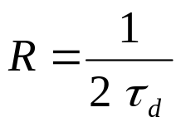

6) (1) What is frequency range of Bluetooth Channel?
2,400 MHZ to 2,480 MHz

