**Assessment 2:**

**Smart Parking Management System**

**(Group Project)**

**MSE806–Intelligent Transport Systems**

Arnold Aristotle Tayag, 270559700

Wen Liang, 270428923

Hengpan He, 270558515

Master of Software Engineering

**A. Project Objectives**

1. To optimize parking space utilization – this is to ensure that the city’s parking capacity is used more efficiently by directing drivers to available spaces and distributing demand across each facility. For example, a guidance system can help drivers quickly identify open parking spots, thus greatly enhancing overall parking efficiency.
2. To reduce congestion and improve traffic flow – this will minimize the time vehicles spend roaming the streets looking for a parking space. By guiding drivers directly to open spots, the system streamlines traffic flow and cuts down congestion on Auckland’s roads. This also improves safety and reduces frustration for motorists.
3. To provide real–time information on parking availability – this will enable drivers to have access to real–time updates on availability of parking spaces & occupancy levels at locations within a certain distance from them.
4. To recommend the best parking spaces – based on location of the driver & parking congestion, the system will use location data and congestion levels to suggest the optimal parking area for a user. The system will consider the driver’s destination (within a certain distance) and guide them to nearby parking with available capacity, avoiding full or heavily congested spaces. This dynamic recommendation reduces unnecessary circling and saves them time.
5. To predict future parking availability – using the historical parking data collected, the system will employ predictive analytics and machine learning to forecast parking occupancy in the future. By analyzing historical usage patterns and current trends, the system will predict demand hours in advance. This will allow users to check expected parking availability for a given time period, i.e. later in the day like two hours from now, and can help city planners anticipate and manage peak periods.

**B. System Functionalities**

The proposed system is intended to have the following features:

1. The system will collect data on different parking areas (within Auckland), i.e. the number of cars coming in and out of the parking
2. The system will give real–time status of parking congestion for the different parking areas
3. The system can recommend which is the best parking area to park the car based on location and parking congestion
4. The system will provide prediction of parking congestion (full or not full) based on available parking data within the 24-hour period. User can do fine-grained query on an hourly basis, i.e. 1 hr from current time, 2 hrs from current time, etc.

**C. Conceptual Architecture Diagram**

Below is a proposed conceptual architecture diagram that integrates the three key components into a cohesive smart parking management system. This architecture ensures that raw parking data is effectively captured, processed for trends and predictions, and ultimately translated into actionable recommendations for parking users in real time.

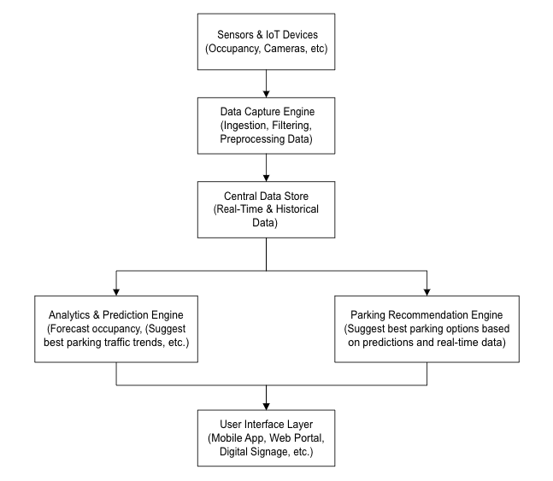

**Description of Components**

1. Data Capture engine

* The primary role is to continuously ingest raw data from sensors and IoT devices placed in parking facilities.
* Will function as data filtering, preprocessing, and forwarding the cleansed data to the central data store.

1. Central Data Store

* The primary role is to serve as the central repository for both real-time and historical parking data.
* This provides a unified source of data for further processing by downstream engines.

1. Analytics & Prediction engine

* The primary role is to process the collected data to analyze current occupancy, detect trends, and forecast future parking availability using machine learning or statistical models.

1. Parking Recommendation engine

* The primary role is to combine real-time data and predictive analytics to offer personalized parking suggestions.
* This engine considers factors like predicted occupancy, user location, and current availability to recommend the best parking spots.

1. User Interface layer

* The primary role is to deliver actionable insights to end users (drivers, parking administrators) through mobile apps, web portals, or digital signage.
* The main feature includes real-time parking availability maps, navigation to recommended spots, and other interactive elements.

**D. Implementation Strategy**

1. Data collection
2. System development (UI, DB, App)
3. AI/ML model training for prediction
4. API integration and testing
5. Pilot testing and evaluation
6. Deployment

**User Interfaces**:

**Database Schema Design**:

Below are the primary tables that we will use for this application. We are using a lightweight database management system called SQLite for this purpose.

# This table records individual parking sessions for users, including entry and exit times along with fee and payment status information

CREATE TABLE ParkingTransactions (

transaction_id INT PRIMARY KEY AUTO_INCREMENT,

user_id INT NOT NULL, parking_lot_id INT NOT NULL,

vehicle_plate VARCHAR(20), entry_time DATETIME NOT NULL,

exit_time DATETIME,

parking_fee DECIMAL(8,2), payment_status ENUM('Pending','Paid','Cancelled') DEFAULT 'Pending',

created_at DATETIME DEFAULT CURRENT_TIMESTAMP,

updated_at DATETIME DEFAULT CURRENT_TIMESTAMP ON UPDATE CURRENT_TIMESTAMP,

FOREIGN KEY (user_id) REFERENCES Users(user_id),

FOREIGN KEY (parking_lot_id) REFERENCES ParkingLots(lot_id)

);

# This table stores details about each parking facility, including location, capacity, and current availability

CREATE TABLE ParkingLots (

lot_id INT PRIMARY KEY AUTO_INCREMENT,

name VARCHAR(100) NOT NULL,

address VARCHAR(255),

latitude DECIMAL(9,6),

longitude DECIMAL(9,6),

total_spaces INT NOT NULL,

available_spaces INT,

created_at DATETIME DEFAULT CURRENT_TIMESTAMP,

updated_at DATETIME DEFAULT CURRENT_TIMESTAMP ON UPDATE CURRENT_TIMESTAMP

);

# This table holds AI-generated predictions about parking occupancy and availability. It can be used for forecasting future parking conditions

CREATE TABLE AI_Predictions (

prediction_id INT PRIMARY KEY AUTO_INCREMENT,

lot_id INT NOT NULL,

prediction_time DATETIME NOT NULL,

predicted_occupied_spaces INT,

predicted_available_spaces INT,

predicted_occupancy_rate DECIMAL(5,2),

confidence_score DECIMAL(4,2),

model_version VARCHAR(50),

created_at DATETIME DEFAULT CURRENT_TIMESTAMP,

FOREIGN KEY (lot_id) REFERENCES ParkingLots(lot_id)

);

# This table manages user information for both customers and system administrators

CREATE TABLE Users (

user_id INT PRIMARY KEY AUTO_INCREMENT,

username VARCHAR(50) NOT NULL UNIQUE,

email VARCHAR(100) NOT NULL UNIQUE,

password_hash VARCHAR(255) NOT NULL,

phone VARCHAR(20),

user_type ENUM('Customer', 'Admin') DEFAULT 'Customer',

created_at DATETIME DEFAULT CURRENT_TIMESTAMP,

updated_at DATETIME DEFAULT CURRENT_TIMESTAMP ON UPDATE CURRENT_TIMESTAMP

);

# This table logs payment details linked to parking transactions, including the method, amount, and status of each payment

CREATE TABLE Payments (

payment_id INT PRIMARY KEY AUTO_INCREMENT,

transaction_id INT NOT NULL,

amount DECIMAL(8,2) NOT NULL,

payment_method ENUM('Credit Card', 'Debit Card', 'Mobile Wallet', 'Cash') NOT NULL, payment_date DATETIME DEFAULT CURRENT_TIMESTAMP,

payment_status ENUM('Pending', 'Completed', 'Failed') DEFAULT 'Pending',

created_at DATETIME DEFAULT CURRENT_TIMESTAMP,

updated_at DATETIME DEFAULT CURRENT_TIMESTAMP ON UPDATE CURRENT_TIMESTAMP,

FOREIGN KEY (transaction_id) REFERENCES ParkingTransactions(transaction_id)

);

**AI/ML Models Used**

In our projects, based on the datasets and features chosen, two types of neural network models are established which are LSTM and DNN respectively. The following are details of the each models. Obviously the datasets patterns in weekdays and weekends are different, the datasets are split into two groups aiming for weekdays and weekends.

1. LSTM

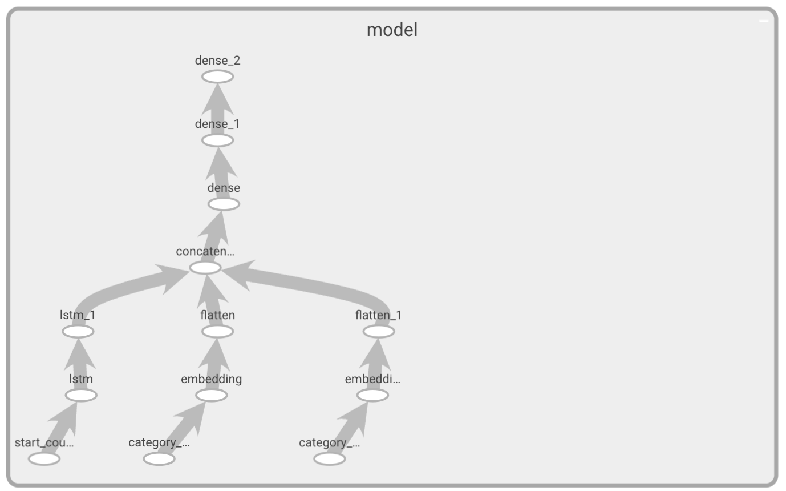

Fig: LSTM Neural Network Structure

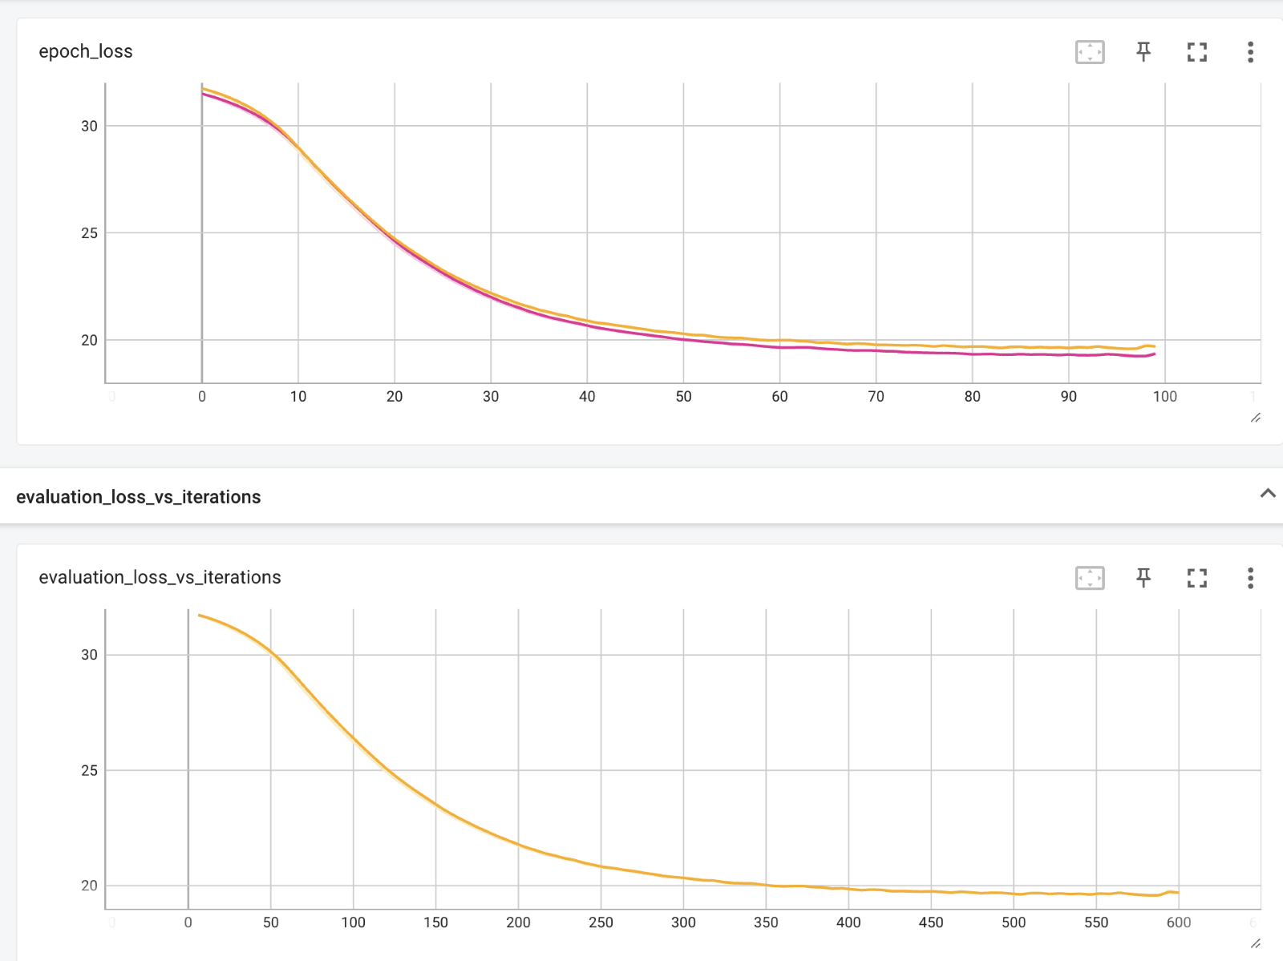

Fig: Loss Information of LSTM for Weekdays Training Process

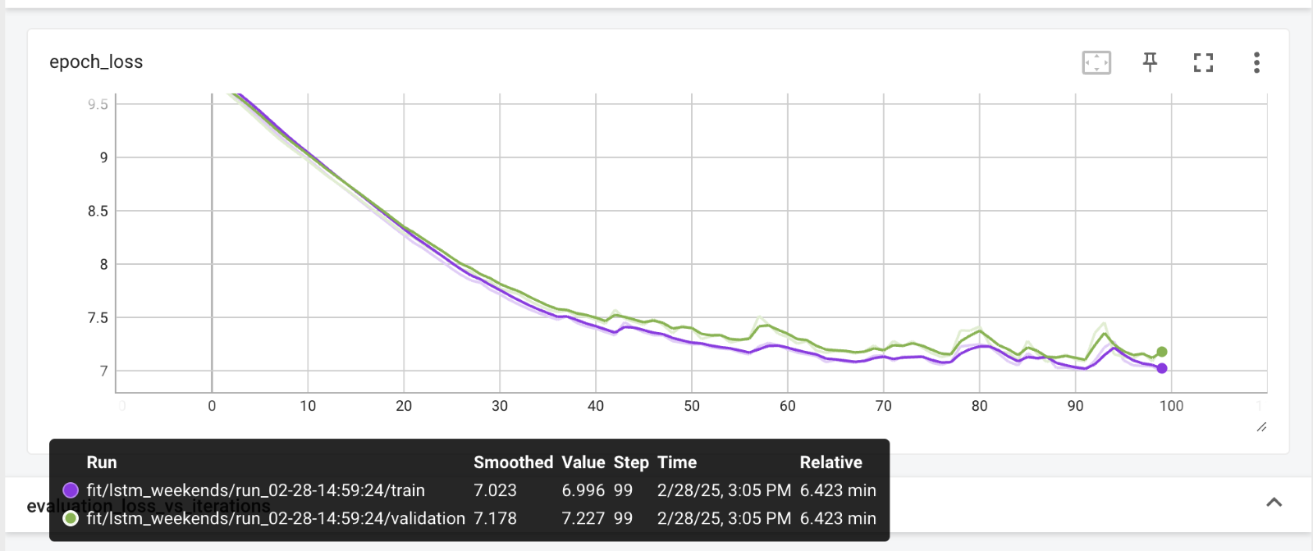

Fig: Loss Information of LSTM for Weekends Training Process

Mean Absolute Error: 4.6543187935305355

R2 Score: 0.7820992993833515

1. DNN

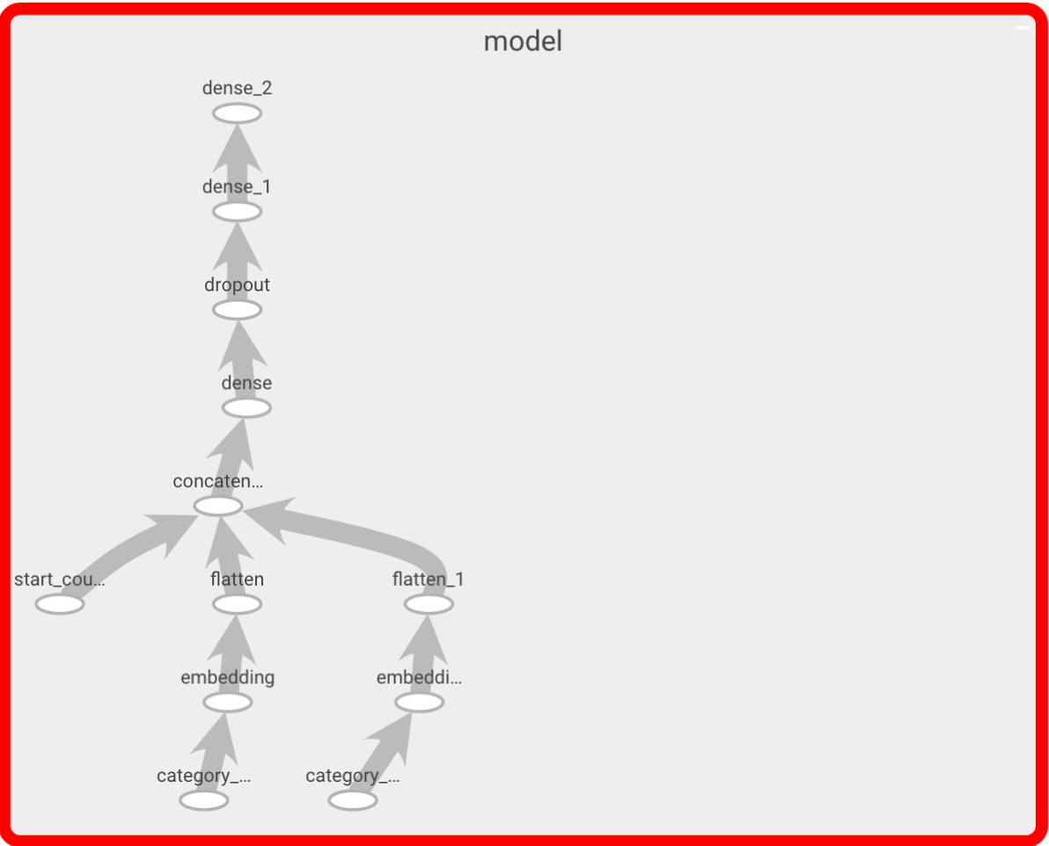

Fig: DNN Neural Network Structure

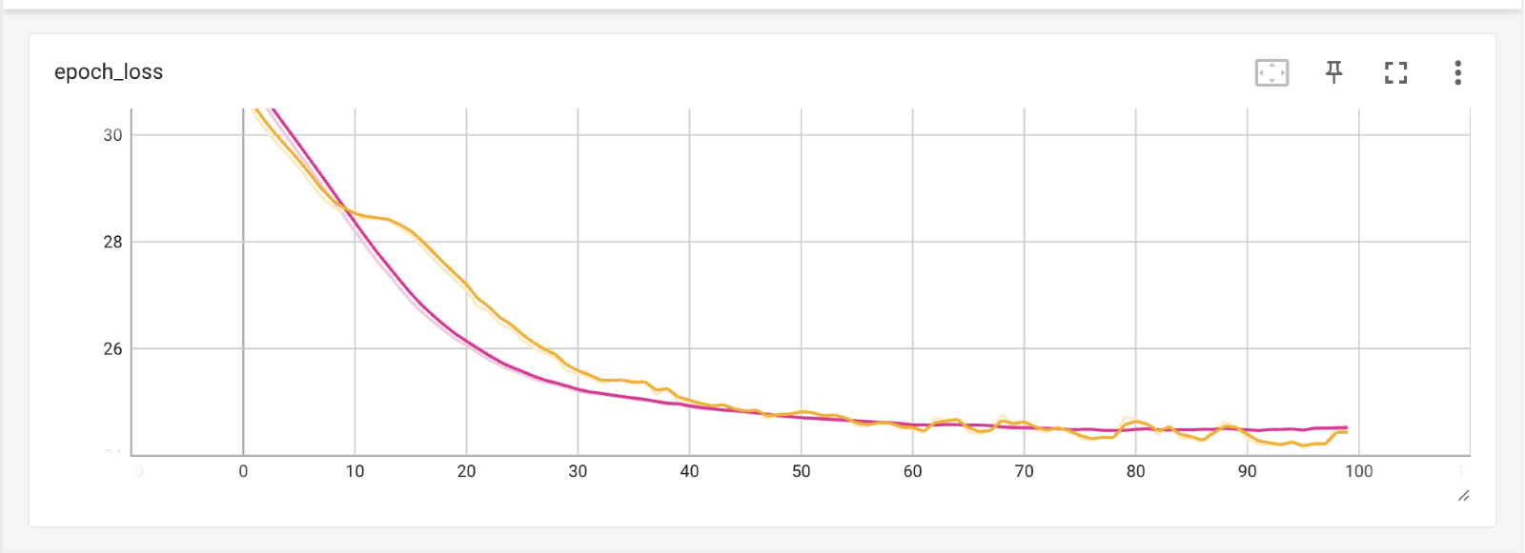

Fig: Loss Information of DNN for Weekdays Training Process

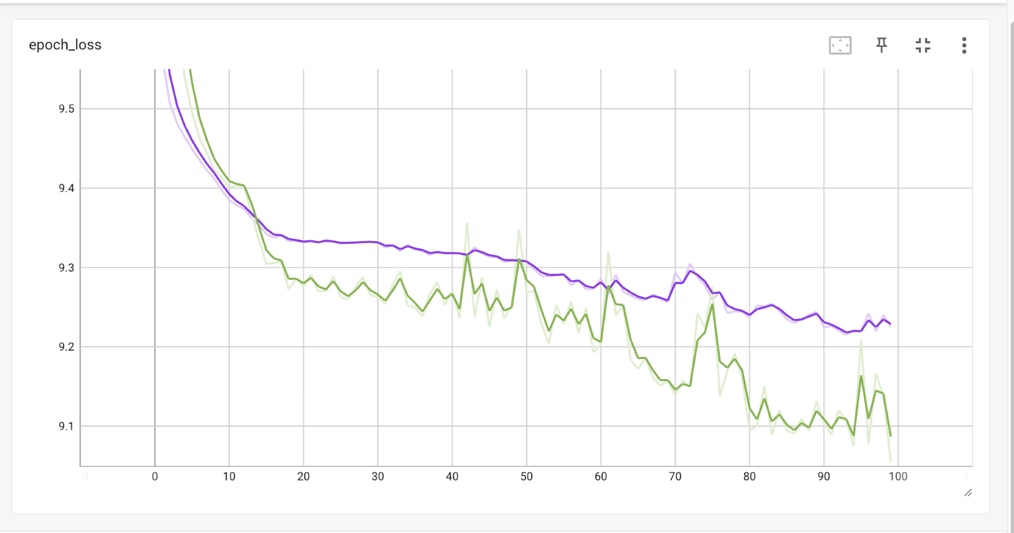

Fig: Loss Information of DNN for Weekends Training Process

**E. Ethical and Security Considerations**

When developing a smart parking management system, it's important to consider several security and ethical concerns:

1. Privacy and Data Protection:

* Data collection and usage – the system may collect sensitive information such as vehicle movements, license plate data, or personal location data. It’s essential to anonymize data and obtain user consent to ensure privacy
* Data security – implement strong cybersecurity plan to secure data from unauthorized access, which could undermine user privacy

1. Surveillance and Tracking:

* Monitoring concerns – continuous tracking of vehicles and drivers could raise concerns about surveillance. Transparency in what data is collected and how it is used is critical

1. Fairness and Accessibility:

* Equitable access – the system should be designed so that it serves all user groups, including those with limited access to technology or those living in less urbanized areas
* Avoiding bias – ensure that algorithms for recommendations and congestion predictions do not inadvertently favor certain areas or demographics, which could lead to inequitable resource distribution

1. Environmental and Social Impact:

* Urban planning impact – consider the broader impact on traffic patterns and local communities. The system should contribute positively to reducing congestion and emissions without adversely affecting local neighborhoods

1. Regulatory Compliance:

* Legal Standards: Adhere to local and international data protection laws, such as GDPR or local privacy regulations and industry standards to avoid legal and ethical problems.

**F. Expected Benefits of the System**

1. Enhanced user experience and convenience – through this system, the general public will enjoy a smoother, stress–free experience when it comes to parking. Instead of uncertainty and frustration, drivers can confidently set out knowing they have information on where they can park. The convenience of finding a spot quickly, paying through a unified app, makes the entire journey more pleasant. By alleviating the frustration associated with hunting for parking in busy areas, the system boosts customer satisfaction. Businesses in Auckland may also see indirect benefits – when parking is easier, people are more likely to visit shopping areas or events, knowing that the hassle is reduced. Overall, the smart parking service becomes an appreciated amenity for residents and visitors, reflecting positively on the city’s image as a modern, smart city.
2. Reduction in search time & congestion – thru this system, drivers will spend far less time circling blocks or parking structures looking for an open spot. By guiding vehicles directly to available parking, the system cuts down the average search time dramatically. This smart guidance can significantly decrease traffic congestion in busy areas since fewer cars are clogging the roads looking for parking. In Auckland, this means smoother traffic flow downtown and in popular districts, even during peak hours.
3. Lower fuel consumption and emissions – when cars find parking faster, they burn less fuel. This reduction in looking for parking leads to lower gasoline/diesel consumption and, consequently, fewer carbon emissions. For a growing city concerned with sustainability, this is a crucial benefit. Auckland can expect improved air quality and progress toward climate goals with a widespread smart parking solution.
4. Improved urban traffic management – the real–time data on parking availability gives city traffic managers a powerful new tool to monitor parking saturation across different neighborhoods and intervene when needed. Over the long term, the data trends allow for informed urban planning – identifying where more parking or transit alternatives are needed. With this smart parking system, Auckland Transport can more dynamically manage parking as part of the overall transportation network, leading to more efficient use of road space.
5. Data–driven decision making – the data collected, and insights generated by the system will create ongoing value for decision–makers. The Auckland Council and transport planners will have access to detailed analytics on parking utilization, i.e. which areas are under or over–used, peak demand times, effects of pricing changes, and many more. This information can guide policies such as setting appropriate parking fees, determining where to invest in new parking structures or public transport options, and measuring the impact of initiatives, like a new bus line reducing parking demand in an area. Private parking operators also benefit from data–driven optimization – they can adjust their operations (staffing, rates) based on predicted demand.

In summary, the smart parking management system not only provides immediate relief to drivers but also serves as a long–term planning tool to continually optimize urban mobility in Auckland.

**G. Technical considerations for future improvement**:

When developing a smart parking management system, several technical considerations come into play to ensure the solution is efficient, reliable, and scalable. It is important to note that due to time constraints, we are not able to implement some of these in the final solution but below are some key points to consider. These can be added to the solution as an improvement to the system.

1. Data management and processing

* Real–time data analysis – use robust analytics to process real-time sensor data for monitoring parking occupancy and usage patterns.
* Cloud integration – consider cloud-based storage and processing solutions for scalability, data redundancy, and advanced analytics.

1. System Scalability and Flexibility

* Modular architecture – design the system with a modular approach to easily add new features or integrate additional parking zones.
* API integration – develop standardized APIs for integrating with third-party applications such as mobile apps or city management systems.

1. User interface and experience

* Mobile and web applications – ensure the user-facing applications are intuitive, responsive, and provide real-time updates on parking availability.
* Navigation and payment integration – include features for navigation to available spots and support for digital payment processing.

1. Sensor and hardware integration

* Type and placement of sensors – selecting appropriate sensors, like ultrasonic, infrared, camera–based, or magnetic, is critical for detecting vehicle presence and occupancy.
* Reliability and maintenance – ensure sensors are durable under varying weather conditions and have low maintenance requirements.

1. Connectivity and IoT communication:

* Network protocols – choose reliable communication protocols to support real-time data transmission.
* Edge computing – implement edge devices for local data processing to reduce latency and bandwidth usage.

1. Security and privacy

* Data encryption – implement strong encryption for data in transit and at rest to protect sensitive information.
* Access control and authentication – use robust authentication mechanisms to ensure that only authorized users can access system controls and data.

1. Reliability and fault tolerance

* Redundancy – design for redundancy in both hardware and software components to minimize downtime.
* Error handling and recovery – develop mechanisms for automatic error detection and recovery to maintain system stability.

1. Regulatory compliance and standards

* Local regulations – ensure the system complies with local laws and standards regarding data privacy, IoT devices, and urban infrastructure.
* Interoperability standards – follow industry standards to facilitate integration with other smart city systems.

**Thank You!!!**