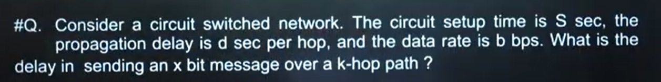


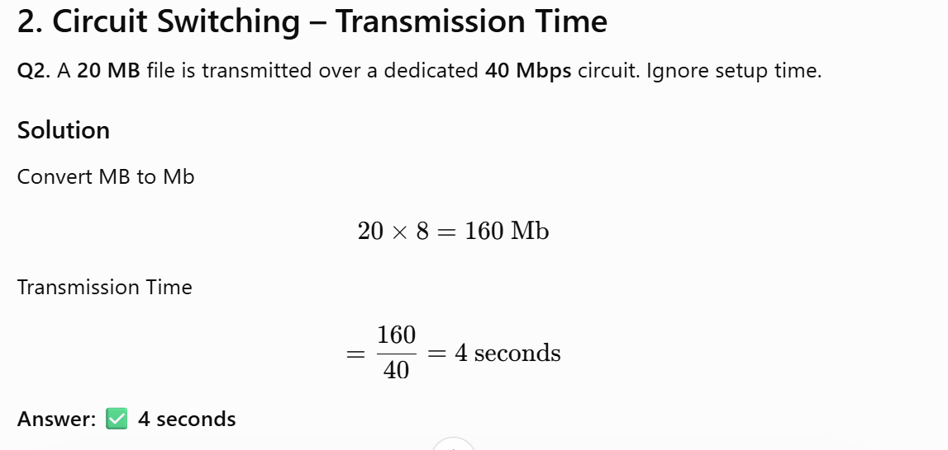
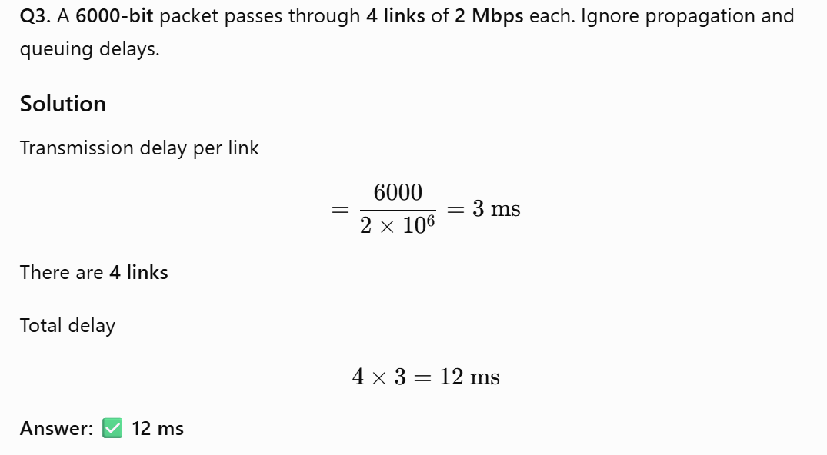
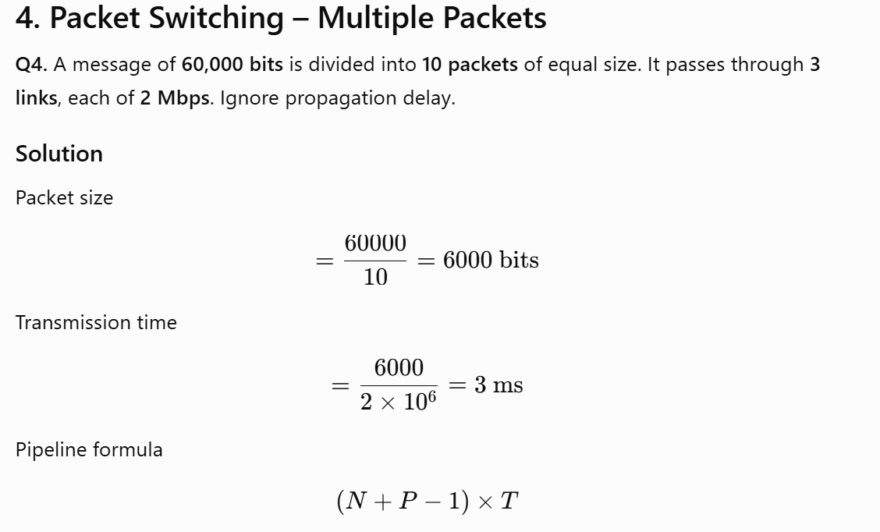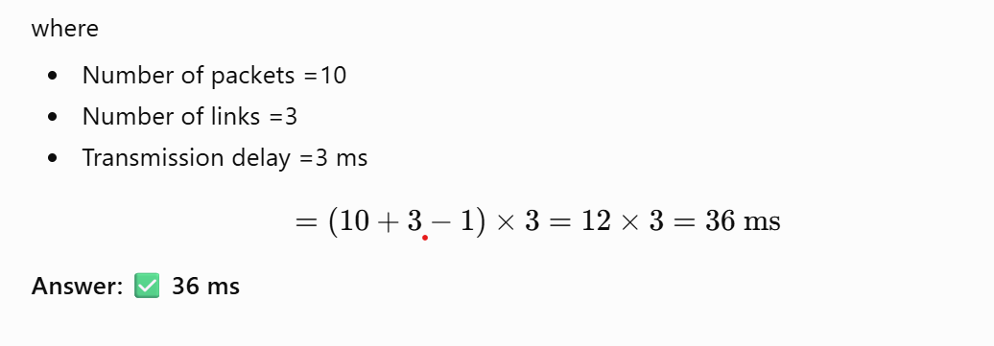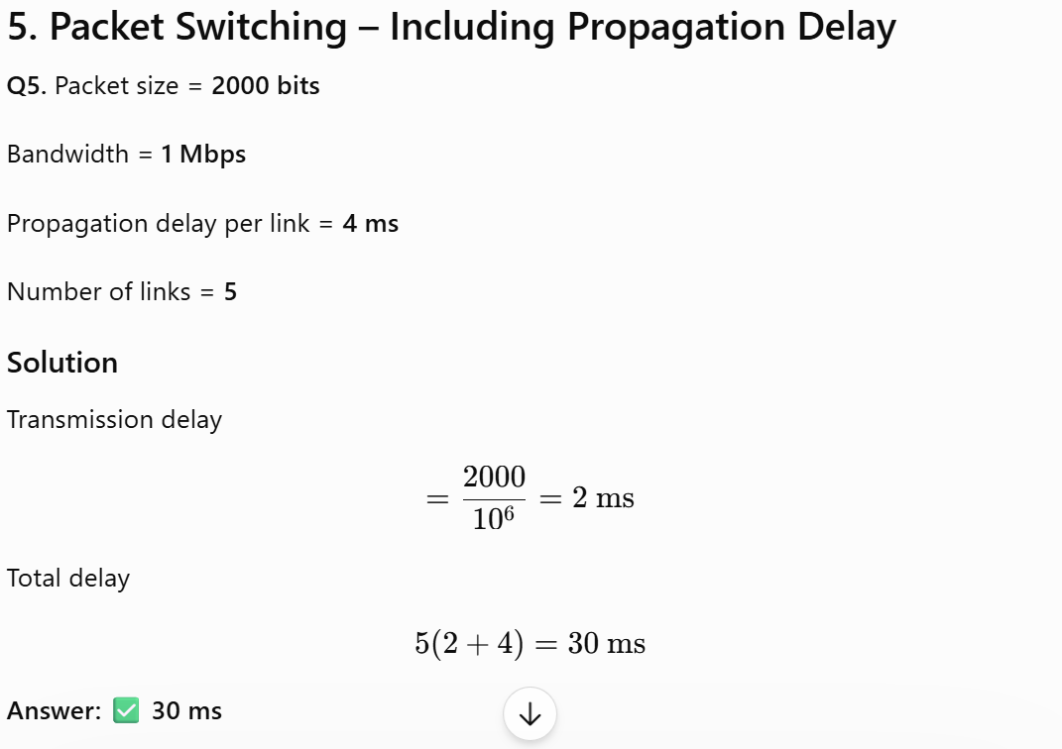

GATE 2015:
Since it is a network that uses switch, every packet goes through two links, one from source to switch and other from switch to destination.
Since there are 10000 bits and packet size is 5000, two packets are sent. Transmission time for each packet is 5000 / 10⁷ microseconds.
Two hosts are connected via a packet switch with 10⁷ bits per second links. Each link has a propagation delay of 20 microseconds. The switch begins forwarding a packet 35 microseconds after it receives the same. If 10000 bits of data are to be transmitted between the two hosts using a packet size of 5000 bits, the time elapsed between the transmission of the first bit of data and the reception of the last bit of the data in microseconds is _________

Explanation :
Sender host transmits first packet to switch, the transmission time is 5000/10⁷ which is 500 microseconds. After 500 microseconds, the second packet is transmitted. The first packet reaches destination in 500 + 35 + 20 + 20 + 500 = 1075 microseconds. While the first packet is traveling to destination, the second packet starts its journey after 500 microseconds and rest of the time taken by second packet overlaps with first packet. So overall time is 1075 + 500 = 1575.

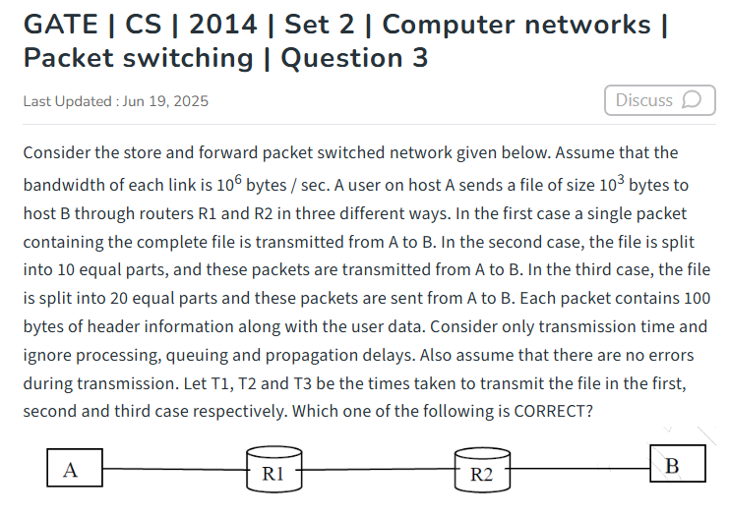

- T1 < T2 < T3

- T1 > T2 > T3
- T2 = T3, T3 < T1
- T1 = T3, T3 > T2

Explanation :
The important thing to note here is in first case, the whole packet is being transmitted, so no pipelining of packet happens. In second and third case, we have advantage of pipelining (While packet 'i' is being transmitted from R1 to R2, packet 'i-1' is being transmitted from A to R1 at the same time). Following are complete calculations.

- The message 11001001 is to be transmitted using the CRC polynomial x³ + 1 to protect it from errors. The message that should be transmitted is:
11001001000
11001001011
11001010
110010010011
- 2. Consider the transmission of data bits 110001011 over a link that uses Cyclic Redundancy Check (CRC) code for error detection. If the generator bit pattern is given to be 1001, which one of the following options shows the remainder bit pattern appended to the data bits before transmission?
A | 011
B | 101
C | 000
D | 100

Example 2 - If the data transmitted along with checksum is 10101001 00111001 00011101. But the data received at destination is 00101001 10111001 00011101.

Example 1 - If the data unit to be transmitted is 10101001 00111001, the following procedure is used at Sender site and Receiver site.

Parity Check Questions

Q1.
A sender uses even parity to transmit the 8-bit data 10110101. What parity bit should be added?
A. 0
B. 1
C. Depends on receiver
D. Cannot be determined
Answer: B
Explanation:
Number of 1's
10110101
= 5 (odd)
Even parity requires an even number of 1's.
Add parity bit = 1
Total 1's = 6 (even)

Q2.
Which one of the following errors cannot be detected by a single parity bit?
A. Single-bit error
B. Three-bit error
C. Two-bit error
D. Five-bit error
Answer: C
Explanation
Parity detects only odd number of bit errors.
Two-bit error is even.
Hence parity remains unchanged.

Q3. (GATE Style)
A communication channel uses odd parity. The transmitted codeword is
10101100
The receiver gets
11101100
The receiver concludes
A. No error
B. One-bit error detected
C. Two-bit error detected
D. Cannot determine
Answer: B

Checksum Questions

Q4.
A sender transmits two 8-bit words
10101010
01010101
using 1's complement checksum.
The checksum is
A. 00000000
B. 11111111
C. 10101010
D. 01010101
Answer: A

Solution
10101010
01010101
---------
11111111
1's complement
00000000

Q5.
Internet checksum is mainly used in
A. Data Link Layer
B. Network Layer
C. Physical Layer
D. Application Layer
Answer: B
(Also used by TCP and UDP at the Transport Layer.)

Q6. (GATE)
Which statement is TRUE regarding checksum?
A. Detects all burst errors
B. Better than CRC
C. Simpler but less reliable than CRC
D. Detects all multiple-bit errors
Answer: C

Q7.
Suppose the receiver receives all data words along with checksum.
If the final sum after addition becomes
11111111
the receiver
A. Rejects packet
B. Accepts packet
C. Requests retransmission
D. Performs CRC
Answer: B

CRC Questions

Q8.
The generator polynomial is
G(x)=x^3+x+1
Its binary representation is
A. 1011
B. 1101
C. 1110
D. 1001
Answer: A

Q9.
If generator polynomial degree is 4, CRC bits added are
A. 3
B. 4
C. 5
D. Depends on data
Answer: B

Q10.
CRC detects
A. Only single-bit errors
B. Only burst errors
C. Most burst errors and many random errors
D. No multiple-bit errors
Answer: C

Q11.
For CRC, if the remainder after division at receiver is
0000
then
A. Error definitely exists
B. No detectable error
C. Retransmission required
D. Checksum error
Answer: B

Q12.
The divisor used in CRC is
A. Decimal number
B. Binary polynomial
C. Hexadecimal checksum
D. ASCII value
Answer: B

Q13. (Very Common GATE)
The generator polynomial is
1101
The number of CRC bits added equals
A. 2
B. 3
C. 4
D. 5
Answer: B
Degree = 3
CRC bits = 3

Q14.
Which technique provides the highest error detection capability?
A. Vertical parity
B. Checksum
C. CRC
D. VRC
Answer: C

Q15.
CRC uses which arithmetic?
A. Decimal division
B. Binary subtraction with borrow
C. Modulo-2 division (XOR)
D. Floating-point division
Answer: C

Numerical CRC Questions

Q16.
If the generator polynomial has degree 8, the CRC field contains
A. 7 bits
B. 8 bits
C. 9 bits
D. 16 bits
Answer: B

Q17.
Data length = 100 bits
Generator polynomial degree = 5
Total transmitted bits =
A. 100
B. 104
C. 105
D. 95
Answer: C
CRC bits = 5
Total
100+5
=105

Q18.
A CRC generator polynomial of degree r guarantees detection of
A. All burst errors of length ≤ r
B. All burst errors of length < r
C. All burst errors of length ≤ r + 1
D. No burst errors
Answer: A

Concept-Based GATE Questions

Q19.
Which one of the following is NOT an error detection technique?
A. CRC
B. Checksum
C. Parity
D. Hamming Code
Answer: D
(Hamming Code performs both error detection and error correction.)

Q20.
Which technique is used in Ethernet frames for error detection?
A. Checksum
B. CRC-32
C. Parity
D. Hamming Code
Answer: B

Previous GATE-Type Concept Question

Q21.
Arrange the following techniques in increasing order of error detection capability.
- Parity
- Checksum
- CRC
Choose the correct order.
A. 1 → 2 → 3
B. 2 → 1 → 3
C. 3 → 2 → 1
D. 2 → 3 → 1
Answer: A

2. UGC-NET Computer Science — October 2022

The representation of the 4-bit data 1101 into a 7-bit, even-parity Hamming code is:

1010101

1111001

1011101

1110000

Answer:

1010101​

6. UGC-NET Computer Science — October 2020

A code has four valid codewords:

0000000000 0000011111 1111100000 1111111111

The minimum Hamming distance is 5. If the received codeword is:

0000000111

the original codeword is:

0000011111

0000000000

1111100000

1111111111

Answer:

0000011111​

Previous GATE Numerical Style

Q22.
A CRC uses a generator polynomial of degree 16. The transmitted frame has 256 bits of data.
The total frame length is
A. 256
B. 272
C. 273
D. 240
Answer: B
Since CRC adds 16 bits:
Total = 256 + 16 = 272 bits.