**The Sparks Foundation** 

**Digital Marketing Internship**

**About Sparks Foundation:**

* It is a not-for-profit Organization, registered in India and Singapore.
* Main Aim of TSF is to collaborate with organizations with the same aim, to help the students through programs to **Inspire**, **Integrate** using **Innovative** ways, and bring some commendable changes to the education they are providing to the upcoming generation.

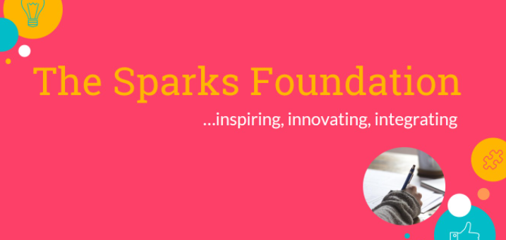

**Some of the programs they conduct are:**

* Student Scholarship Program
* Student Mentorship Program
* Student SOS Program
* Workshops
* Corporate Programs

**GRIP (Graduate Rotational Internship Program)**

* It is a unique offer for the students or the recent graduates to join the TSF network.
* GRIP is basically an internship program, based online as a part-time Internship that aims students to build a professionally capable experience to work, to update their resume with unordinary projects.

**Task-1:**

**Social Media Marketing Plan for The Sparks Foundation(TSF).**

**Following are the most basic questions:**

* Why online platforms?
* Who are we?
* What kind of audience do we need to attract?
* From where?
* How to engage them?
* How will the customers be able to find us?

**Starting from the very basic one, why is online medium important?**

* The traditional way to attract the customers was to attract their attention through billboards, newspaper ads,Television ads, magazines articles.
* Earlier this way used to work to attract the customers, as these were the major medium of connecting to people, but now these ways can be only used to build brand awareness.
* In order to reach the customers, we have to reach to their fingertips!
* And to reach their fingertips, online medium is crucially important, otherwise unless you have monopoly, no one would reconsider your service.

**Getting online, requires the company to provide correct information to the user ( who we are?) :**



* Be as loyal as a dog to your customers.
* Acknowledging customers, about your company, aim, location, leads is of crucial importance.
  + An example of such to generate leads by posting on various social media platforms:
    - **The Sparks Foundation**
    - The goal of TSF is to help the school and college graduates to upskill their abilities towards the professional world.
    - TSF aims at providing their leads their best way to educate students, provides best possible mentorship and an amazingly helpful community where all students can grow together.
    - Under this students can learn through workshops, talks, live interactive sessions.
    - So hurry up and sign up for the program as it is free of charge and gives you a great opportunity to learn, engage, and to grow your skills.

Likewise, uploading ads, posters, videos on media depending on the type of content like instagram focuses more on pictures, youtube on videos, Medium on Blogs etc...

The very next step after generating leads is to filter the leads as the audience that they have approached are not always the “aimed” once.

Dividing the audience is of prime importance as per their choice of content.

One of the ways to do that is to provide the forms to the customers to give their choice of priority or through A/B testing.

Because **What Audience needs is the main aim of marketing.**

**Community Engagement:**



To engage the audience, without physical interaction is really a task.

To make them stick to us requires a constant way to provide them with the things they want.

This means experimenting with messaging, emailing, providing them articles to read, reviews of your loyal customers(v.imp), live sessions, to post blogs or posts,reels,clips consistently, to provide them with some exciting offers.

Using the above steps helps to make the audience keep their interest intact in the product plus the engagement of new leads through any reference or through social media posts that we are consistent on.

**How to locate us online?**

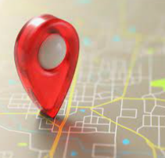

* Organically, getting the traffic to our website can be done by providing correct keywords, phrases, here, thinking like a customer plays a very important role( think like a customer and provide those words/phrases ).
* We need to optimize the keywords, to get higher rank in the searches.
* Relevance of the website to the query(page titles and description).
* There should not be any technical robustness of the website(coding errors, page loading speed)
* Mobile Friendly
* Security and privacy
* Ease of navigation through the website.
* Provide correct **Name, Address, Phone number.**
* Content of the page:
  + Fresh
  + Rich
  + Keyword Density
* Eg. The Sparks Foundation focuses on students, to motivate them to learn in the community, to innovate, inspire other students around them…
* **Their keywords can be**:
  + Students, College Graduates,Innovate, Inspire, Integrate, Community Driven, Non-for-profit Community, Online learning, Free Internship Program etc...

**Metrics that helps us analyse our audience:**

**(Some Google Analytics parameters)**



**Users**: The number of users visited our site.

**Sessions**: Number of times the website is visited.

**Page View**: Number of pages viewed on a website.

**Unique Page View**: Number of sessions in which a page was visited once or more.

**Bounce Rate**: High bounce rate reflects the lack of engagement.

**Real Time Reports**: How many people are currently present on our website.

**Audience Reports**: Who are visiting our website, i.e characteristics:

Age, Gender, Location, Technology etc…

**Acquisition Reports:** Tells top channels sending visitors to your website.

**Behaviour Reports:** Provides the behaviour of the customer, i.e their activities.

**Conversion Reports:** Any action that has happened on the website.

Above mentioned are some basic and crucial methods which can be followed for the social media engagement of **The Sparks Foundation** and social media strategies through which some amazing results can be achieved.

