**PAYROLL MANAGEMENT SYSTEM**

*A Project Report*

*Submitted By*

**Anusha Anand – 2114120004**

**Gaurav Bajaj -2114110006**

**Harshita Jain -2114110061**

**Raghav kwatra -2214110584**

*In partial fulfilment of the requirement For*

*Project Based Learning of*

**BACHELOR OF TECHNOLOGY**

*In*

**COMPUTER SCIENCE AND ENGINEERING** *For*

*Skill lab -1*

*Under the guidance of*

***Priyanka Suryawanshi Ma’am***



**DEPARTMENT OF COMPUTER SCIENCE AND ENGINEERING**

**BHARATI VIDYAPEETH (DEEMED TO BE UNIVERSITY) COLLEGE OF ENGINEERING, PUNE- 43**

2022-23

**BHARATI VIDYAPEETH (DEEMED TO BE UNIVERSITY) COLLEGE OF ENGINEERING, PUNE- 43**



**CERTIFICATE**

This is to certify that the Project Based Learning report titled **Employee payroll system**, submitted by **Anusha Anand (2114110004), Gaurav Bajaj (2114110006) , Harshita Jain ( 2114110061) , Raghav kwatra (2214110584)** to the Bharati Vidyapeeth (Deemed to be University),

College of Engineering, Pune - 43 for the award of the degree of **BACHELOR OF TECHNOLOGY** in Computer Science and Engineering is a bonafide record of the PBL work done by him/them under my supervision.

Place: Pune Name of Subject Teacher Date: 24/04/23.                                                                   Priyanka Suryawanshi Ma’am

**Index**

|  |  |  |
| --- | --- | --- |
| **Sr.No.** | **Title** | **Page No.** |
| 1 | Introduction of Topic | 3 |
| 2 | Methodology Used in the Project | 4 |
| 3 | Snapshots of  Implementation | 5-7 |
| 4 | Limitations/ Future Scope | 8 |
| 5 | Conclusion | 9 |

**Introduction of topic**

Employee Database And Payroll Management System” is designed to make the existing manual system automatic with the help of computerised equipment and full-edged computer software, fulfilling their requirements, so that their valuable data and information can be stored for a longer period with easy access and manipulation of the same. The required software is easily available and easy to work with. This web application can maintain and view computerised records without getting redundant entries. The project describes how to manage user data for good performance and provide better services for the client.

The proposed project “Employee Database and Payroll Management System” has been developed to overcome the problems faced in the practicing of manual system. This software is built to eliminate and in some cases reduce the hardships faced by the existing system. Moreover this system is designed for particular need of the company to carry out its operations in a smooth and effective manner. This web application is reduced as much as possible to avoid errors while entering data. It also provides error message while entering invalid data. It is user-friendly as no formal knowledge is required to use the system. Human resource challenges are faced by every organization which has to be overcome by the organization. Every organization has different employee and payroll management needs. Therefore I have design exclusive Employee and payroll Management System that are adapted to the organization’s Managerial Requirements

**Methodology used in project**

**Modules:**

**Admin**

The Admin gets logged in by valid username and password. Admin can add new Employee, add

new Department, add new Pay Grade for the employees. Admin can set the ‘from’ and ‘to’ date

worked by an employee in a department with specific pay grade. The Admin can generate an

automated monthly salary of an employee. The admin can view all the past records of any

recorded employee.

**Project Category: Web-Based Application**

**Available Technologies:**

Languages: HTML, PHP, JavaScript

RDBMS: Online MySQL

Web Server: WAMP server

Development Platform: Adobe Dreamweaver

**Tools Used:**

Editor Used: Dreamweaver for PHP, WAMP server for MySQL

Operating System: Windows 10

**Hardware Used:**

Processor: Intel core i3

RAM: 2GB

Hard Disk: 1T

**Codes**

<html>

<body>

<h1>Payroll System</h1>

<form action="" method="post">

Enter Payroll_id : <br>

<input type="text" name="e1"><br>

Enter Name : <br>

<input type="text" name="n1"><br>

Enter Role : <br>

<input type="text" name="a1"><br>

Enter Address : <br>

<input type="text" name="d1"><br>

Enter Salary : <br>

<input type="text" name="s1"><br>

Enter Loan : <br>

<input type="text" name="l1"><br>

Enter Tax : <br>

<input type="text" name="t1"><br>

Enter Phone_No : <br>

<input type="text" name="p1"><br>

Enter Email : <br>

<input type="text" name="m1"><br>

<input type="submit" name="submit" value="submit">

</form>

<?php

$connection=mysqli_connect("localhost","root","","subtraction");

if (isset($_POST['submit']))

{

$Payroll_id=$_POST['e1'];

$Name=$_POST['n1'];

$Role=$_POST['a1'];

$Address=$_POST['d1'];

$Salary=$_POST['s1'];

$Loan=$_POST['l1'];

$Tax=$_POST['t1'];

$Phone_No=$_POST['p1'];

$Email=$_POST['m1'];

$sql="insert into information (Payroll_id,Name,Role,Address,Salary,Loan,Tax,Phone_No,Email) values ('$Payroll_id','$Name','$Role','$Address','$Salary','$Loan','$Tax','$Phone_No','$Email')";

$result=mysqli_query($connection,$sql);

if ($result)

{

echo "data inserted";

}

else

{

echo "not inserted";

}

}

?>

</body>

</html>

**Outputs**

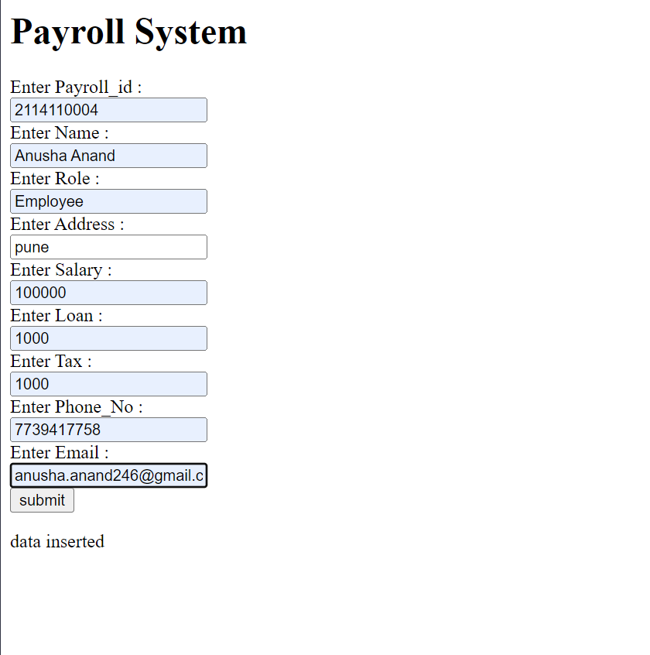

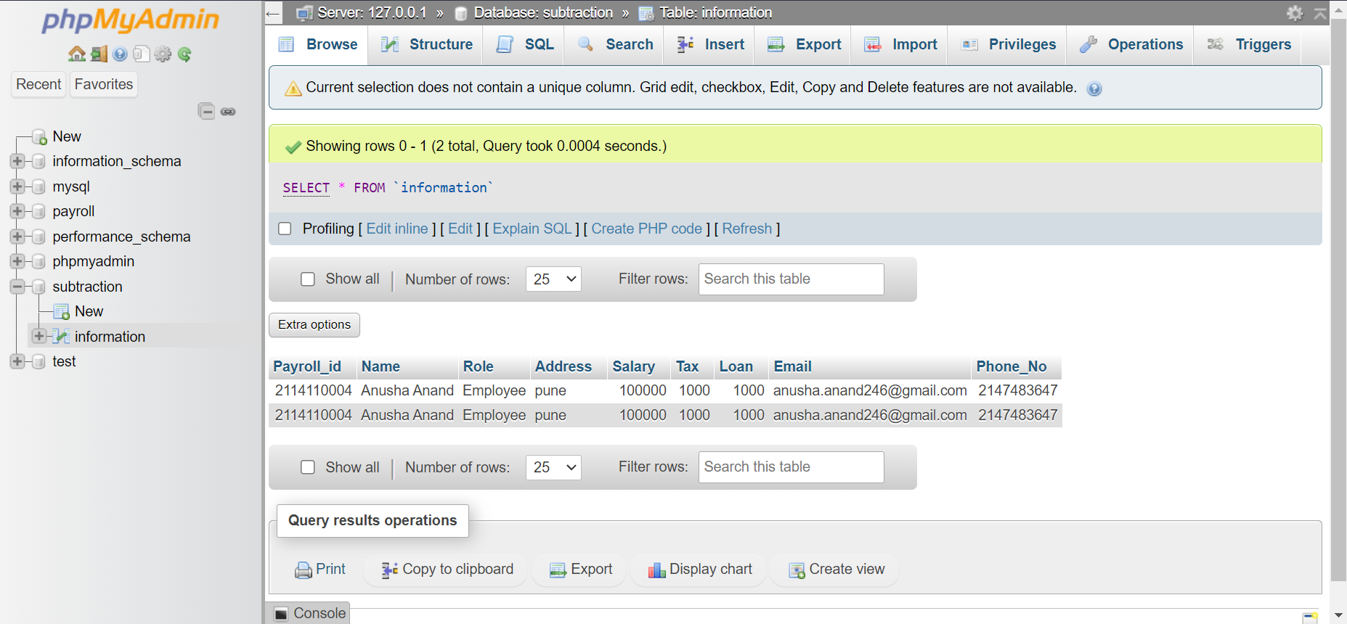

**Limitations and Future scope**

**Limitations:**

* It requires an internet connection.
* It requires large database.

**Advantages:**

* It is cost effective as the user control the web application himself and does not go for

 professional service.

* It saves time as it speeds up every aspect of the employee database management and
* payroll process with a range of automated features.
* It is secure as the employee database and the payroll process is managed by the admin
* in house rather than sending private information to a third party.
* Validating procedures and checks restrict user from making mistakes.
* The software is easy to use and is user friendly so no expertise is required.
* The calculations are automated so no chance of error.

**Features of Employee database and payroll**

**management system:**

• Easy to use.

• It is completely secure.

• It is completely controlled by admin.

• This system is easily compatible with most of the web browsers.

• It is very interactive and saves time.

• Reduces paper works.

• Calculations are automated so it is highly accurate.

• Admin can view all the records whenever necessary with ease.

**Future scope of the work:**

* The option to print the records In future.
* I intend to add a leave structure in the future.
* I would like to implement a regular backup mechanism to back up the

              employee database to avoid disastfutur

* The system can be developed in such a way that its existing features can

               be modified to better versions.

**Conclusion**

This project is built keeping in mind that it is to be used by only one user that is the

admin. It is built for use in small scale organization where the number of employees is

limited. According to the requested requirement the admin can add, manipulate, update

and delete all employee data in his organization. The admin can add new departments

and delete them. The Admin can also add predefined pay grades for the employees.

The required records can be easily viewed by the admin anytime time he wants in an

instant. The payment of the employee is based on monthly basis. Numerous validations

implemented would enable the admin to enter accurate data. The main objective of this

framework is to save time, make the system cost effective and management records

efficiently