**SpamGuard**

***A Machine Learning Approach to Spam Detection***

*A Project Report*

*Submitted By*

**Anusha Anand – 2114110004**

**Gaurav Bajaj – 2114110006**

**Harshita Jain – 2114110061**

**Raghav Kwatra - 2214110584**

*In partial fulfilment of the requirement*

*For the course of*

**BACHELOR OF TECHNOLOGY**

*In*

**COMPUTER SCIENCE AND ENGINEERING**

*Under the guidance of*

***Dr. Manisha Kasar Ma’am***



**DEPARTMENT OF**

**COMPUTER SCIENCE AND ENGINEERING**

**BHARATI VIDYAPEETH (DEEMED TO BE UNIVERSITY)**

**COLLEGE OF ENGINEERING, PUNE- 43**

2023-24

**BHARATI VIDYAPEETH (DEEMED TO BE UNIVERSITY)**

**COLLEGE OF ENGINEERING, PUNE- 43**



**CERTIFICATE**

This is to certify that the Project Based Learning report titled **SpamGuard : A Machine Learning Approach to Spam Detection**, submitted by **Anusha Anand(2114110004), Gaurav Bajaj(211411006), Harshita Jain(2114110061), Raghav Kwatra(2214110584)**, to the Bharati Vidyapeeth (Deemed to be University), College of Engineering, Pune - 43 for the award of the degree of **BACHELOR OF TECHNOLOGY** in Computer Science and Engineering is a bonafide record of the PBL work done by him/them under my supervision.

Place: Pune Name of Subject Teacher:

Date: 08-04-2024 Dr. Manisha Kasar Ma’am

ABSTRACT

This project focuses on the development of a machine learning-based system for spam detection in email messages. The proliferation of spam emails poses a significant challenge for email users and organizations, leading to wasted time and resources. Therefore, the ability to automatically identify and filter out spam emails is of utmost importance.  
  
The dataset utilized in this project consists of email messages labeled as either spam or ham (not spam). These messages are preprocessed to handle missing values and convert categorical labels into numerical format for further analysis. The dataset is then split into training and testing sets to facilitate model development and evaluation.  
  
For feature extraction, TF-IDF (Term Frequency-Inverse Document Frequency) vectorization is employed. TF-IDF assigns weights to words based on their frequency in a document relative to the entire corpus, capturing the importance of words in distinguishing between spam and ham emails.  
  
The machine learning algorithm chosen for this task is Logistic Regression. Logistic Regression is a widely used algorithm for binary classification tasks due to its simplicity and effectiveness. It models the probability that a given input belongs to a particular class, making it suitable for discriminating between spam and ham emails based on their TF-IDF features.  
  
The trained model is evaluated using accuracy scores on both training and testing data to assess its performance in classifying emails. Additionally, an example prediction is provided, demonstrating how the model can be used to classify a new email message as spam or ham.  
  
Overall, this project aims to provide an effective solution for spam detection in email messages, leveraging machine learning techniques and natural language processing to enhance email security and user experience. Further improvements and optimizations can be explored to enhance the model's performance and scalability in real-world applications.

INTRODUCTION

In today's digital age, email communication has become an integral part of both personal and professional interactions. However, alongside legitimate messages, inboxes are often inundated with unsolicited and potentially harmful spam emails. These spam messages not only clutter inboxes but also pose serious threats such as phishing scams, malware distribution, and identity theft. Therefore, the development of robust spam detection systems is imperative to safeguard users' privacy, security, and productivity.

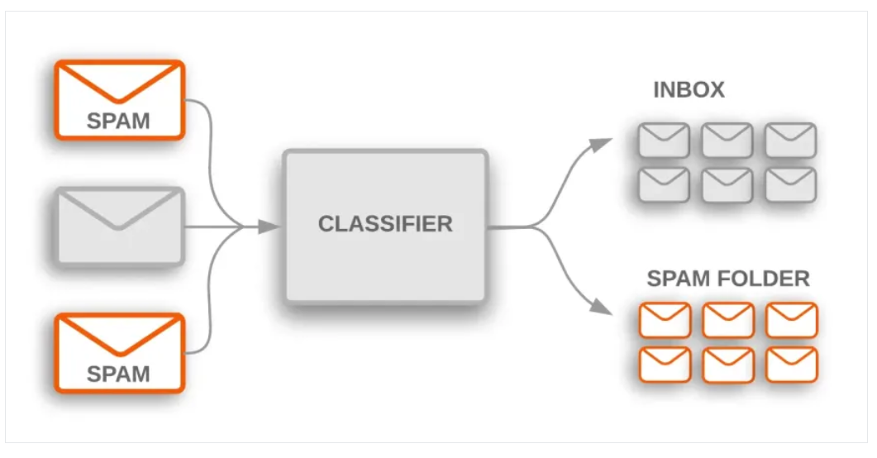

Fig. Spam detection algorithm process

The significance of spam detection extends beyond individual users to encompass businesses, organizations, and internet service providers (ISPs). For businesses, spam emails can disrupt operations, decrease employee productivity, and compromise sensitive data. Organizations face similar challenges, with spam posing risks to network security and integrity. ISPs must contend with the burden of filtering vast quantities of spam emails to maintain service quality and protect users' email accounts.  
  
The motivation behind this project stems from the pressing need to mitigate the adverse effects of spam emails through intelligent and automated detection mechanisms. By leveraging machine learning algorithms and natural language processing techniques, we aim to develop a sophisticated spam detection system capable of accurately identifying and filtering out spam emails while preserving legitimate communication.  
  
This project contributes to the broader efforts in cybersecurity and data privacy by addressing a prevalent and persistent issue in the digital landscape. Through the implementation of advanced algorithms and data-driven methodologies, we seek to enhance email security, streamline communication processes, and empower users to navigate their inboxes with confidence.  
  
In the subsequent sections of this report, we delve into the methodology employed, the dataset utilized, the machine learning algorithms applied, and the evaluation of model performance. Furthermore, we provide insights into the practical implications and future directions of spam detection research, emphasizing its relevance in safeguarding online communication channels.

LITERATURE

Spam detection has been a subject of extensive research within the fields of machine learning, natural language processing (NLP), and cybersecurity. Various approaches and techniques have been proposed and studied to address the challenges posed by spam emails.

* **Machine Learning Approaches**  
   Machine learning algorithms, particularly supervised learning methods, have been widely employed for spam detection. Logistic Regression, Naive Bayes, Support Vector Machines (SVM), and Decision Trees are among the popular algorithms used for classifying emails as spam or ham. These algorithms utilize features extracted from email content, such as word frequencies, TF-IDF scores, and n-grams, to learn patterns indicative of spam behavior.
* **Natural Language Processing Techniques** Natural language processing techniques play a crucial role in preprocessing and feature extraction for spam detection. Tokenization, stemming, and stop word removal are common preprocessing steps applied to email text data. Feature extraction methods like TF-IDF and word embeddings capture semantic information and enable the representation of text data in numerical format suitable for machine learning algorithms.
* **Ensemble and Deep Learning Models** Ensemble learning techniques, such as Random Forests and Gradient Boosting Machines (GBM), have been explored to improve the robustness and performance of spam detection models by combining multiple base learners. Additionally, deep learning models, including Convolutional Neural Networks (CNNs) and Recurrent Neural Networks (RNNs), have shown promise in capturing complex patterns in textual data, leading to enhanced spam detection accuracy.
* **Evaluation Metrics** Evaluation metrics such as accuracy, precision, recall, F1-score, and receiver operating characteristic (ROC) curve analysis are commonly used to assess the performance of spam detection models. These metrics provide insights into the model's ability to correctly classify spam and ham emails while minimizing false positives and false negatives.
* **Challenges and Future Directions**  
   Despite significant advancements, spam detection continues to face challenges such as evolving spamming techniques, class imbalance, and adversarial attacks. Future research directions include exploring semi-supervised and unsupervised learning approaches, leveraging deep learning for feature extraction, and integrating domain-specific knowledge to enhance model performance and adaptability.  
    
  In conclusion, the literature on spam detection encompasses a wide range of methodologies and techniques aimed at combating the persistent threat of spam emails. By leveraging insights from existing research, this project seeks to contribute to the development of effective and scalable spam detection solutions.

METHODOLOGY USED

1. **DATA COLLECTION AND PREPROCESSING**

* **Data Source**: The dataset containing email messages labeled as spam or ham is obtained from a reliable source or repository.
* **Preprocessing**: Missing values are handled, and categorical labels are converted into numerical format. Text preprocessing techniques such as tokenization, stop word removal, and stemming may be applied to clean the text data.

1. **FEATURE EXTRACTION**

* **TF-IDF Vectorization**: The TF-IDF (Term Frequency-Inverse Document Frequency) technique is used to convert text data into numerical features. TF-IDF assigns weights to words based on their frequency in a document relative to the entire corpus, capturing the importance of words in distinguishing between spam and ham emails.

1. MODEL SELECTION AND TRAINING

* **Algorithm:** Logistic Regression is chosen as the machine learning algorithm for its simplicity and effectiveness in binary classification tasks.  
  Training: The Logistic Regression model is trained on the training dataset, which consists of TF-IDF features extracted from email messages.

1. MODEL EVALUATION

* **Accuracy Score**: The accuracy of the trained model is evaluated using accuracy scores on both the training and testing datasets. Accuracy measures the proportion of correctly classified emails.
* **Confusion Matrix**: A confusion matrix is generated to analyze the performance of the model in terms of true positives, true negatives, false positives, and false negatives.  
  Precision, Recall, and F1-Score: Additional evaluation metrics such as precision, recall, and F1-score provide insights into the model's ability to minimize false positives and false negatives.

1. HYPERPARAMETER TUNING

* **Grid Search**: Hyperparameter tuning techniques such as grid search may be employed to optimize the performance of the Logistic Regression model by searching for the best combination of hyperparameters.

1. MODEL DEPLOYMENT AND PREDICTION

* **Deployment**: Once the model is trained and evaluated, it can be deployed into production environments to classify new email messages as spam or ham.  
  Prediction: To classify a new email message, the TF-IDF vectorization technique is applied to extract features, and the trained Logistic Regression model is used to predict the class label.

1. PERFORMANCE ANALYSIS AND INTERPRETATION

* **Analysis of Results**: The performance of the trained model is analyzed based on evaluation metrics and visualization techniques.  
  Interpretation: Insights are drawn from the results to understand the strengths and limitations of the spam detection system and identify areas for improvement.  
  By following this methodology, the project aims to develop an accurate and efficient spam detection system capable of effectively classifying email messages and mitigating the risks associated with spam emails.

SNAPSHOT OF IMPLEMENTATION RESULT

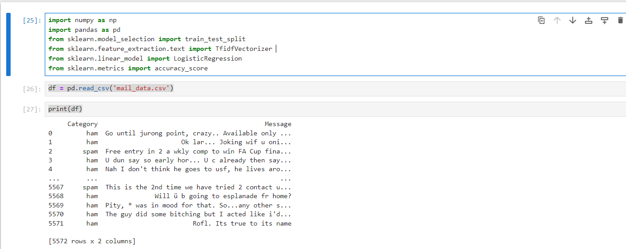

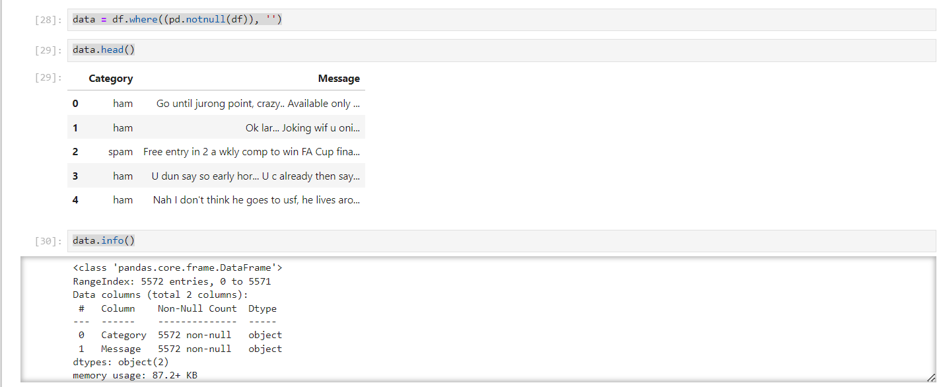 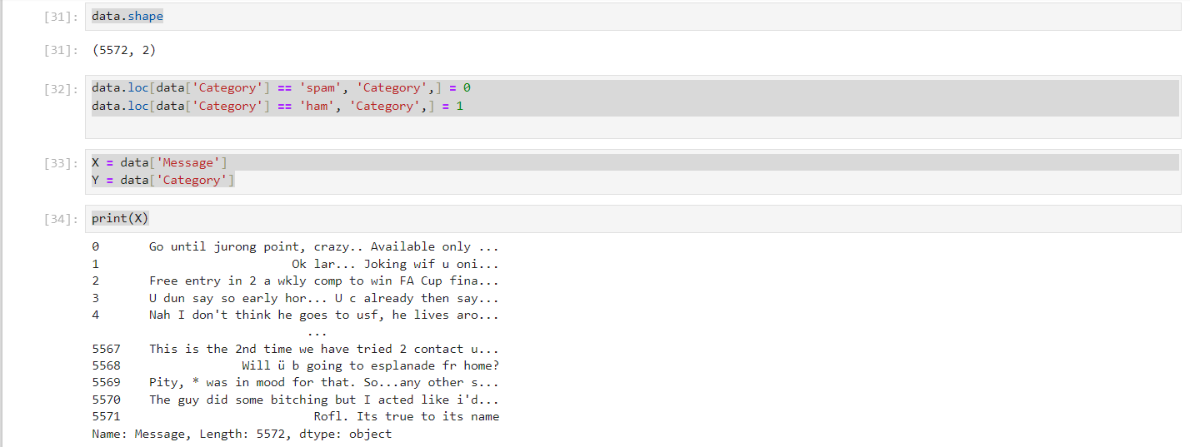

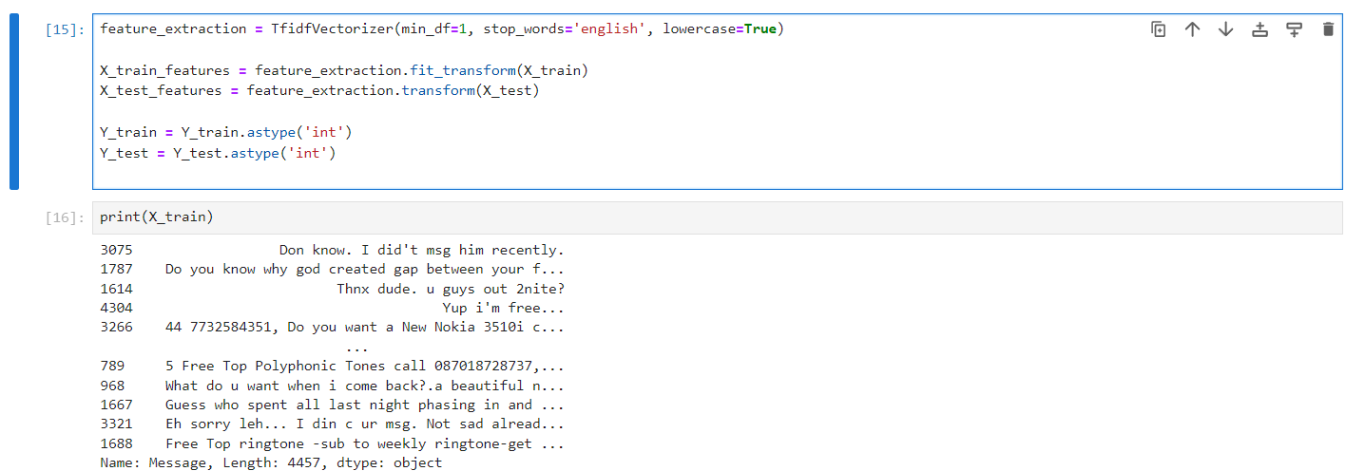

ADVANTAGE AND DISAVANTAGES

**ADVANTAGES**

1. Effective Spam Detection: Machine learning-based spam detection systems can accurately identify and filter out spam emails, reducing the burden on users and organizations.
2. Automation: Automated spam detection processes streamline email management tasks and reduce manual effort in sorting through large volumes of emails.
3. Customization: Machine learning models can be customized and fine-tuned to adapt to evolving spamming techniques and patterns, improving detection accuracy over time.  
   Scalability: Spam detection systems based on machine learning algorithms can scale to handle large datasets and accommodate increasing email traffic.
4. Real-time Detection: With efficient algorithms and processing capabilities, machine learning models can provide real-time detection of spam emails, enhancing email security.
5. Reduced False Positives: By leveraging advanced features and algorithms, machine learning models can minimize false positives, ensuring that legitimate emails are not incorrectly flagged as spam.

**DISADVANTAGES**

1. Data Quality: The performance of machine learning models heavily relies on the quality and representativeness of the training data. Poorly labeled or biased datasets can lead to suboptimal performance.
2. Overfitting: Machine learning models may overfit to the training data, capturing noise or irrelevant patterns that do not generalize well to unseen data, leading to decreased performance on test data.
3. Feature Engineering: Extracting informative features from raw email text data can be challenging and require domain expertise. Inadequate feature selection or representation may impact the model's effectiveness.
4. Computational Resources: Training and deploying machine learning models for spam detection may require significant computational resources, especially for large-scale deployments or real-time processing.
5. Adversarial Attacks: Spammers may employ sophisticated techniques to evade spam detection systems, such as obfuscating email content or injecting benign-looking text. Machine learning models may be susceptible to adversarial attacks if not robustly designed and trained.
6. Privacy Concerns: Spam detection systems may involve processing and analyzing users' email content, raising privacy concerns regarding the collection and use of personal data.

APPLICATION

1. Email Filtering Systems

* **Commercial Email Services**: Companies offering email services implement spam detection algorithms to filter out unwanted emails from users' inboxes, ensuring a better user experience.
* **Corporate Email Servers**: Organizations deploy spam filters on their email servers to protect employees from malicious emails and maintain productivity.

1. Cybersecurity

* **Phishing Detection**: Spam detection techniques are instrumental in identifying phishing emails that attempt to deceive users into revealing sensitive information or downloading malware.
* **Malware Detection**: Spam filters play a crucial role in detecting emails containing malware attachments or links to malicious websites, thereby preventing cyber attacks.

1. Fraud Prevention

* **Financial Institutions**: Banks and financial institutions use spam detection systems to identify fraudulent emails that aim to trick users into disclosing financial information or transferring funds illegitimately.
* **E-commerce Platforms**: Online marketplaces implement spam filters to detect and block fraudulent product listings, reviews, and messages aimed at defrauding customers.

1. **Regulatory Compliance**

* **GDPR Compliance**: Organizations subject to data protection regulations such as GDPR (General Data Protection Regulation) use spam filters to ensure compliance with email communication guidelines and protect user privacy.
* **CAN-SPAM Compliance**: Companies adhere to CAN-SPAM Act regulations by implementing spam detection mechanisms to prevent the dissemination of unsolicited commercial emails.

1. **Social Media Platforms**

* **Message Filtering**: Social media platforms employ spam detection algorithms to identify and remove spammy messages, comments, and accounts, enhancing user engagement and platform integrity.
* **Advertisement Filtering**: Spam detection systems help social media platforms detect and block spammy advertisements that violate advertising policies or target users with misleading content.

1. **Mobile Applications**

* **Messaging Apps**: Mobile messaging applications integrate spam detection features to identify and filter spam messages, ensuring a secure and seamless communication experience for users.
* **Personalization and Recommendations**: Mobile apps leverage spam detection techniques to personalize content recommendations and filter out irrelevant or spammy notifications.

1. **Future Directions**

* **AI-driven Solutions**: Advancements in artificial intelligence (AI) and machine learning enable the development of more sophisticated spam detection systems capable of adapting to evolving spamming techniques and patterns.
* **Cross-Platform Integration**: Spam detection solutions may extend beyond email to encompass other communication channels such as instant messaging, social media, and voice calls.
* **User Empowerment**: Empowering users with tools and controls to customize spam filters and report suspicious content can enhance the effectiveness of spam detection efforts and foster a safer online environment.

By applying spam detection techniques across various domains and platforms, organizations and individuals can mitigate the risks associated with spam emails and protect against cyber threats, fraud, and privacy violations. Continued innovation and collaboration in the field of spam detection are essential to stay ahead of evolving spamming tactics and safeguard digital communication channels.

CONCLUSION

In conclusion, spam detection systems represent a critical defense mechanism against the proliferation of unsolicited and potentially harmful emails. Through the deployment of machine learning algorithms and advanced natural language processing techniques, these systems play a pivotal role in safeguarding users, organizations, and digital communication channels.  
  
Machine learning algorithms like Logistic Regression, coupled with TF-IDF vectorization for feature extraction, enable accurate classification of emails as spam or ham based on their content characteristics. Despite challenges such as data quality issues and adversarial attacks, ongoing research and innovation continue to drive improvements in spam detection technology.  
  
The practical implications of spam detection span various industries, including email services, cybersecurity, finance, and regulatory compliance. By implementing spam detection solutions, organizations can mitigate the risks associated with phishing scams, malware distribution, and fraudulent activities, thereby preserving trust and integrity.  
  
Looking ahead, collaboration among researchers, industry stakeholders, and regulatory bodies will be essential in addressing emerging threats and enhancing the effectiveness of spam detection systems. Continued innovation, knowledge sharing, and user education efforts will contribute to creating a safer and more secure digital environment for all. In conclusion, spam detection remains a vital component of cybersecurity strategies, and ongoing advancements will shape the future of spam detection technology.

REFRENCES

1. <http://localhost:8888/tree/Desktop/projects-nlp>
2. <https://www.youtube.com/watch?v=FkF2jhaRJIs>
3. <https://www.youtube.com/watch?v=xsfq0WFbOk0>
4. <https://chat.openai.com/c/2ef6a0b9-2d91-4931-8e46-306e0eba7fc6>
5. <https://onlinenotepad.org/notepad>