***Project name – Flipkart***

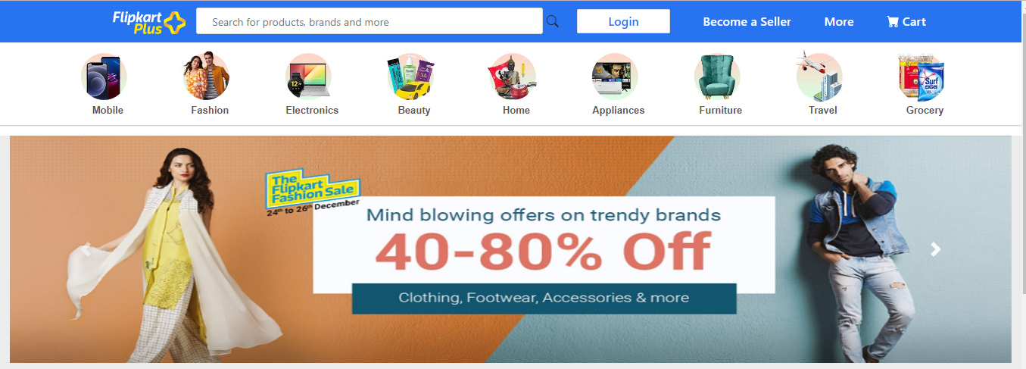

Flipkart is an Indian e-commerce company. The company focused on consumer electronics, fashion, home essentials, groceries, and lifestyle products.

**Goal**

Login/Signup

Add to cart

Payment page

**Technologies used**-

**Front-End:**

1. HTML

2. CSS

3. Bootstrap

4. React

**Back-End:**

1. JS (Java script)

**Database:**

1. Mongo Db

**Code compilers:**

1. Visual studio code

2. Git bash

3. Git hub

**Home Page:**

1. Header
2. Logo
3. Icons
4. Search Bar
5. Slider
6. Footer

**Signup Form:**

* + - 1. E-MAIL ADDRESS

1. Mobile Number

**Payment Page:**

* + - 1. Address
      2. Payment method- (Phonepe, Google pay, BHIM UPI, COD, Credit/Debit Card, Net Banking , EMI , PAYTM)

URL - <https://github.com/aanandsudeep/Flipkartdoc>