Sajjad Arshad
Finance
Management (Manager/Director)
Personal Info: | sajjad arshad  DOB: Mar 20,1976  Gender: Male  House#25-A/1,Street#16 Mian Bilal Park Drogha wala Lahore  Lahore - 54931  Pakistan  821068723022  sajjad_817@yahoo.com | 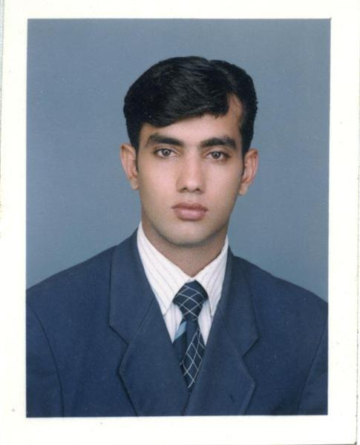

Objective: | To utilize my talent and skills for better performance of my duties and responsibilities to meet overall goals for enhancement of organization / institutionâ€™s interest where I can grow professionally and be rewarded financially For last two years I am waorking as a Project Manager in south korea.Responsibilites are included to mangage the international meeting with buyers.Making assignments.Create international links with the buyers. and to deliver the short lectures about the project.
Experience:  1 Entry(s)
  Organisation | Ays Trading company
  Organisation Type | import and export firm
  Designation | Handeling international dealing accounts
  Location | 35-G shabnam center shalimar link road lahore , Pakistan
  Type of Experience
  Tenure | Feb-2004 To Date
  Description | Responsibilties including to deal on international level,and managing all kinds of books of accounts.
Project:  1 Entry(s)
  Company | Kast Engineering Company Ltd. south korea
  Title | sajjad Arshad
  Role | overseas Marketing
  Tenure | Jan-2007 To Date
  Description | Working as overseas marketing manager.
Skill:  1 Entry(s)
  Skill Name | Level | Last Used
  MS WORD,EXCELL | Excellent | Currently Working
Education:  2 Entry(s)
  Degree Name | M.com
  Level Attained | Masters Degree
  CGPA | 4.00
  Institute | Al-Khair University
  Address | lahore, Pakistan
  Session | 2000 - 2002
  Majors | Finance.
  Degree Name | Master Degree
  Level Attained | Masters Degree
  CGPA | 4.00
  Institute | Al-khair University
  Address | Lahore, Pakistan
  Session | 2000 - 2002
  Majors
Language:  6 Entry(s)
  Read | Write | Speak | Understand | Typing | Shorthand
  korean
  Not Easily | Not Easily | Easily | Easily | (WPM) | (WPM)
  chinese
  Not Easily | Not Easily | Not Easily | Not Easily | (WPM) | (WPM)
  punjabi,
  Easily | Easily | Easily | Easily | (WPM) | (WPM)
  English
  Easily | Easily | Easily | Easily | (WPM) | (WPM)
  urdu
  Easily | Easily | Easily | Easily | (WPM) | (WPM)
  chinese
  Not Easily | Not Easily | Not Easily | Not Easily | (WPM) | (WPM)
Affiliation:  1 Entry(s)
  Organization | aanchal foundation
  Role | project manager
  Session | Jan-2005 To Date
Reference:  1 Entry(s)
  Name | Title | Company | Phone/Email | Aquaintence | Type
  M.fiaz | Managing director | AYS TRADER CO. | 0300-4440988 | 3 Years | Personal
Additional Info: | I am looking for a challenging position in an organization that provides me the opportunity to employee my management skills fully. I've got an aptitude for finance and accounting. I regularly study the finacial statistics of the reputed organizations.I am proficient in speaking english which is considered the mode of communication in major countries on the globe. I hope you will consider me the right candidate of the solicated post.

