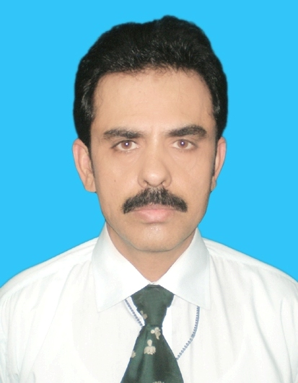

PERSONAL INFORMATIONS

Name : Muhammad Latif Mehr
Date of Birth : 20.03.1964
Nationality : Pakistani (District Okara)
Contact # : Off: 042-99214194
Cell: 0333-4286783

Address (Res.) : 11/2-D, Lane # 21 Wafaqi Colony, DSW

Lahore # 20

(Office) : A.G.P.R. Sub-Office (8th Floor, A.G
Office Building) Lahore

ACADEMIC RECORD

- S.A.S (Subordinate Accounts Auditor General of Pakistan
Services)
- B.A (Stat. & Economics) Bahauddin Zakaria University, Multan
- F.A Multan Board
- Matric Multan Board (Scholarship)

MEMBERSHIP IN PROFESSIONAL SOCIETIES

- Associate of Pakistan Institute of Public Finance Accountants

EMPLOYMENT RECORD

S # | Job Description | From | To
1 | Resource Person Financial Reporting, Accounts Officer Accounts, Book and Accounts Sections & System Administrator (SAP) | February 07,2007 | To Date
 | Assistant Accounts Officer Book & Computer Sections & FI(SAP) -AGPR Sub-Office Lahore | September, 2001 | February 06, 2007
2 | Assistant accounts Officer  Pension / Pay roll Sections Pak. Ranger Cell (AGPR SO Lahore) | December 11, 1999 | September, 2001
3 | Assistant Accounts Officer Administration & Faculty member | October 1, 1991 | December 10, 1999
4 | Assistant Accounts Officer  Pension/ GP Fund Sections (AGPR SO Lahore) | July 16, 1990 | September 30, 1991
5 | Senior Auditor  Cheque and Administrations Sections | March 4, 1985 | July 15, 1990

PROFESSIONAL EXPERIENCE

- Have 26 years experience ( 20 years as Gezetted Officer) in the fields of Govt. Accounts, Budget, Pension, pay Rolls and all other rules / procedures pertaining to Service & Financial matters
- Have specialized knowledge & skill in fields of Government Accounts, Budget, Service & Financial Rules and SAP-FI
- Have been compiling reading material for various long & short professional training programmes for about 14 years
- 18 years teaching experience in fields of Government Accounts, Service & Financial Rules and Budget
- Handling all kind of accounts of Punjab circle of Federal Account for a period over ten years and Accounts & Financial Reports in SAP system, as Assistant Accounts Officer / Accounts Officer Computer Accounts since 2004.
- Performed as regular Faculity Member (Govt. Accounting, Budget, Service & Financial Rules for more than eight years in the office of the DG AATI , Lahore Department of the Auditor General of Pakistan
- Have been engaged as subject specialist to impart training in the area of Service & Financial Rules (regular trainer for full subject of 200/100 marks to the Probationers of Accounts Group / PA & AS (25th to 28th , 30th to 37th Specialized Training Programme)
- Have been engaged as guest speaker by the DMG Campus Lahore to impart training on the subject of “Financial Rules” to the Probationers of District Management Group since 2004
- Have regularly been invited as guest speaker to deliver lectures on various topics (Govt. Accounts, Budget and Service & Financial Rules) by the Population Welfare Institute Lahore since last 10 years, Federal Bureau of Statistics, Pakistan Institute of Public Finance Accountants etc.
- Have also been engaged as Master Trainer to impart training in the areas of NAM (New Accounting Module)/SAP-FI under PIFRA
- Have been engaged by PIPFA (Pakistan Institute of Public Finance Accountants) for their Final classes
- Have been invited by DOT (Directorate of Income Tax Training) Lahore to impart training to their employees
- Have been appointed as a member of various Task Forces of the offices of the Auditor General of Pakistan and Controller General of Accounts
- Have been engaged as consultant to prepare a “Guide Books” for the Drawing & Disbursing Officers of the District Governments of the Governments of Punjab and Sind by the Urban Institute (USAID PAKISTAN) under “Districts That Work Project”

PROFESSIONAL TRAINING RECEIVED
- Inter Personal Skills Management workshop
- Commercial Accounting with Computer
- Typing Made Easy (on Computer)
- Foundation Training of Trainers
- Computer Budget Preparation
- Public Financial Management
- Use of PCs in Government Organizations
- NAM (New Accounting Module)
- Financials Module in Systems Applications and Products in Data Processing (SAP R/3) conducted by the SIEMENS-Pakistan
- SAP Academy ( FI- Consultant) from 13th November to 15th December 2006

COMPUTER SKILLS
- MS Word, Excel & Power Point
- SAP-R3 (FI)

