IT Manager
Computer and Information Technology
Management (Manager/Director)
Personal Info: | Shahid Aziz  DOB: Nov 21,1964  Gender: Male  552/A, Peoples Colony No.2  Faisalabad - 0  Pakistan  (041-5510490) (0332-8654925)  sazizm@yahoo.com | 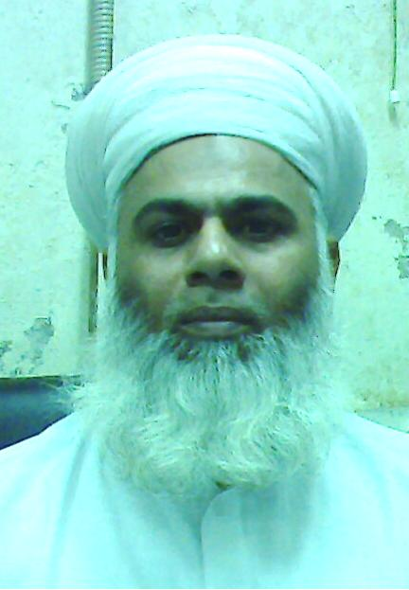

Objective: | A management position in I.T. Department. To interact at corporate level in making decisions using MIS Applications according to the latest trends in IT by leading the team of IT professionals in a progressive and target oriented environment.
Experience:  7 Entry(s)
  Organisation | J.K. Group of Comnpanies.
  Organisation Type | Textile
  Designation | IT Manager
  Location | Faisalabad , Pakistan
  Type of Experience | Full Time
  Tenure | Oct-2005 To Date
  Description | MIS Management: Sering as IT/MIS Manager at corporate level, established decision support system at management level, identified data and its acquisition mechanism, developed IT based solutions, impart training to all users and implemented system successfully. Acquired feedback from users, identified gray areas at management level and at data processing level as well. Solutions provided at all levels through improvement of data acquisition methods, users training and managersâ€™ requirement analysis.
  Organisation | Hameed Processing Factory
  Organisation Type | Textiles
  Designation | IT Manager
  Location | Faisalabad , Pakistan
  Type of Experience | Full Time
  Tenure | Apr-2002 To Aug-2005
  Description | Head of IT Department. Looked after companies Software and Harware infrastructure. Full fil management requirements regarding IT and MIS.
  Reason for Leaving | Got Better Salary
  Organisation | Sitara Group of Industries
  Organisation Type | Textiles
  Designation | IT Manager
  Location | Faisalabad , Pakistan
  Type of Experience | Full Time
  Tenure | Sep-1999 To Apr-2002
  Description | as Group Head of IT coordinatred amoung all group related IT activities and the top managemnt. Upgraded groups current Softwares from Foxpro To Oracle 8. Established a team of professionals and developed total system (Accounts, Finance, Inventory/Store, Production, Exprt Doccumentation, Costing, Samples, Grey Procurement, Payroll) in Developer 2000.
  Reason for Leaving | Got a better Salary
  Organisation | Madian Group of Companies
  Organisation Type | Sugar Industry
  Designation | IT Manager
  Location | Faisalabad , Pakistan
  Type of Experience | Full Time
  Tenure | Oct-1997 To Aug-1999
  Description
  Organisation | Academy of Computer Sciences
  Organisation Type | Education
  Designation | Principal/Director
  Location | Faisalabad , Pakistan
  Type of Experience | Full Time
  Tenure | Oct-1989 To Jul-1997
  Description
  Reason for Leaving | Got a chance to join the industry
  Organisation | J.K. Brothers (Pvt) Ltd.
  Organisation Type | Textiles
  Designation | Programmer
  Location | Faisalabad , Pakistan
  Type of Experience | Full Time
  Tenure | Jan-1986 To Aug-1989
  Description
  Organisation | Pasrur Sugar Mills Ltd
  Organisation Type | Sugar Industry
  Designation | Lab. Analyst
  Location | Pasrur , Pakistan
  Type of Experience | Full Time
  Tenure | Nov-1984 To Dec-1985
  Description
Project:  2 Entry(s)
  Company | Sitara Textile Industries Ltd.
  Title | Integrated Software System
  Role | Project Manager
  Tenure | Jan-2000 To Jun-2000
  Description | Developed and replaced old software Foxpro based with a new in house build integrated software using Oracle 8 Database and Developer 2000/6i for Accounts, Store, Export Costing, Documentation, Marketing and Production.
  Company | Sitara Textile Industries
  Title | IT Infrastructure
  Role | Project Manager
  Tenure | Sep-1999 To Dec-1999
  Description | Build a LAN of more than 100 PCs with Multiple Servers split accross the group. Successfully established the Windws 2000 Server to connect users. Build Oracle Database Server and Email Proxy Server for companies emails and internat activitis.
Skill:  5 Entry(s)
  Skill Name | Level | Last Used
  MS Project | Average | Currently Working
  Visio | Average | Currently Working
  Toad | Good | Currently Working
  Developer 2000/6i | Good | Currently Working
  Oracle | Good | Currently Working
Education:  4 Entry(s)
  Degree Name | MCS
  Level Attained | Masters Degree
  Institute | Al-Khair University
  Address | Faisalabad, Pakistan
  Session | 1998 - 2000
  Majors
  Degree Name | B.Sc.
  Level Attained | Bachelors Degree (2-3 Years)
  Aggreagte % | 55.00
  Institute | University of the Punjab Lahore
  Address | Faisalabad, Pakistan
  Session | 1983 - 1988
  Majors | Double Math, Stat
  Degree Name | F.Sc.
  Level Attained | High School / A Levels (12 Years)
  Aggreagte % | 48.00
  Institute | Govt. Murray College
  Address | Sialkot, Pakistan
  Session | 1980 - 1982
  Majors
  Degree Name | Matric
  Level Attained | Matriculation / O levels
  Aggreagte % | 60.00
  Institute | Govt. High School No.1 Pasrur
  Address | Parur, Pakistan
  Session | 1978 - 1980
  Majors
Language:  3 Entry(s)
  Read | Write | Speak | Understand | Typing | Shorthand
  English
  Easily | Easily | Easily | Easily | (WPM) | (WPM)
  Urdu
  Easily | Easily | Easily | Easily | (WPM) | (WPM)
  Punjabi
  Easily | Easily | Easily | Easily | (WPM) | (WPM)

