RESUME

FAZLI HALEEM
OBJECTIVE:
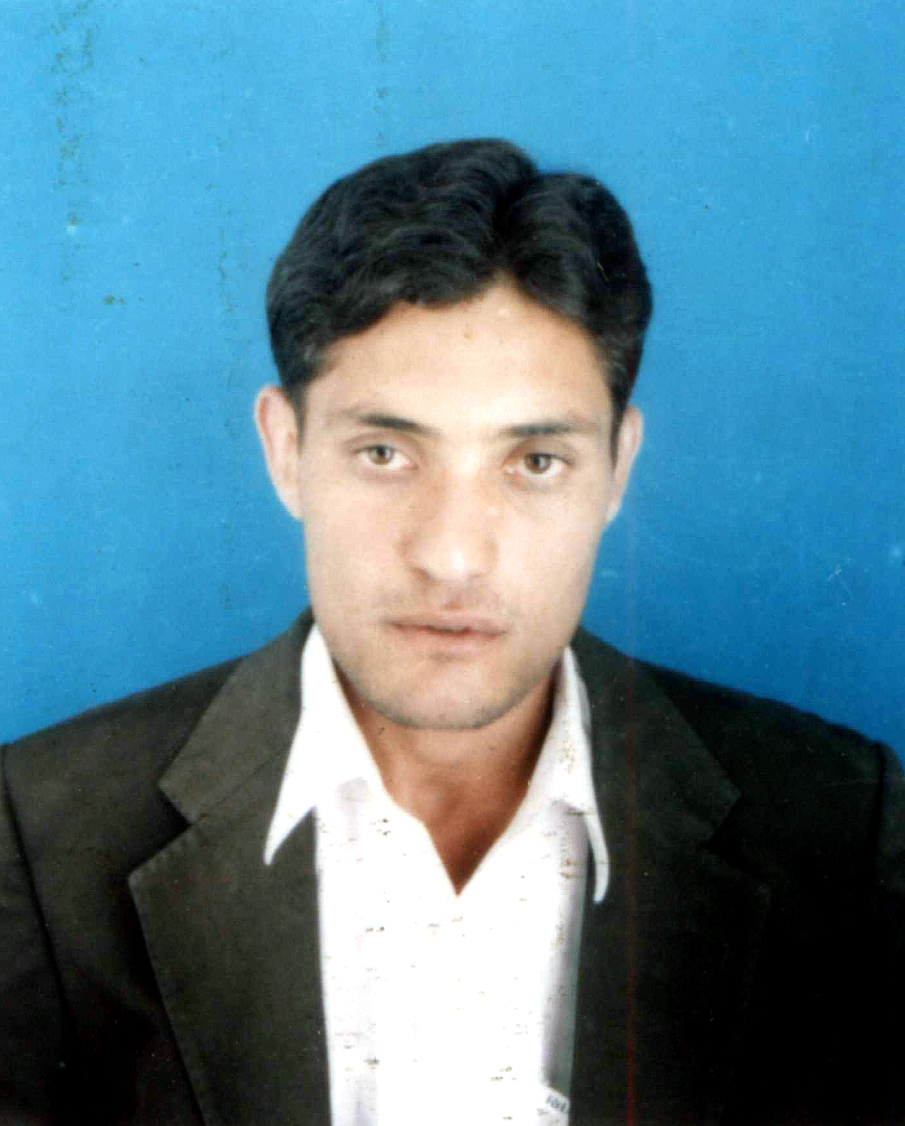
To seek a challenging job in an organization where
I can learn, and utilize my skills in the interests
Of the organization and to grow professionally with
Increasing responsibilities.

BBA (Hons) 4 years
Halem20062003@yahoo.com

PERSONAL DETAILS ADDRESS
Father Name | : | FAZLI KARIM Village Amlook Dara P/O Ziarat Talash
Date of Birth | : | 02-02-1985 Teh: Temergara District Dir (lower)
CNIC | : | 15302-0703754-9
Religion | : | Islam
Nationality | : | Pakistani
Domicile | : | Malakand (N-W.F.P)
Sex | : | Male
Marital Status | : | Single
Cell No | : | +92 3429636354

Education Profile
S.No. | Name of Examination | Year of Passing | Marks in % | Division | Board/University
1 | MS (MS) | Last semister |  |  | SZABIST
2 | BBA (hons)  4years | 2003-07 | 83.98% | 1st | University of Malakand, N.W.F.P
3 | F.A. (humanities) | 2003 | 69% | 1st | Peshawar Board
4 | SSC  (10 YEAR) | 2001 | 77% | 1st | BISE, Swat
Web Links: www.bisess.edu.pk (BISE, Swat)
www.uom.edu.pk (University Of Malakand)

LANGUAGES
- English (Medium of Instruction)
- Urdu (National Language)
- Pashto (Mother Language)

MAJOR SUBJECTS
Corporate Finance Islamic Banking and Finance
Business Finance Financial Management
Seminar in Finance Financial Accounting
Financial Accounting Money, Banking &Finance
Financial Statements Analysis International Business

COMPUTER SKILLS HOBBIES
Microsoft Office Reading interesting books
Microsoft Windows Adventurous, traveling
Use Internet regularly. Protection of environment
Social Development

CERTIFICATES, ACHIEVEMENTS& SEMINAR
- Member of SWIFT (Society for Welfare Interaction Functions & Tours) welfare body in University of Malakand from Dec 2005 Up to Dec 2006, and responsible for the management of this Welfare Society.
- Two months practical experience (Internship) in National Bank of Pakistan Batkhela (1534).
- Arrange and attended a seminar on “Understanding towards the Stock Exchange”
- Member of Organizing Committee to arrange a National level Seminar on “Project Management” being jointly organized by Department of Management Studies & HEC Islamabad
- Member of organizing committee to organize a national level seminar on “E. Business” being jointly organized by Department of Management Studies & Higher Education Commission “HEC” Islamabad.
- Organize a seminar on “Fight against Thalisemia” in the collaboration with Al-fajar Foundation Swat.
- Arranged different parties, functions & trips in university of Malakand.
- Served MIHO (Mobile immunization health organization) as finance assistant for one year.
- Served WHO as Complain Support Person for 3 months
- Currently teaching at Shaheed Benazir Bhutto University Sheringal Upper Dir

PROJECTS
- Telenor: In this project I conducted financial analysis for the two consecutive years2005-2006.
- Pepsi Cola International: In this project I pointed out various products and marketing strategies.
- Interest in the Light of Quran: In this project I made an analysis of interest in the light of Quran.
- Logical Fallacies: The project aimed to point out logical fallacies from print, electronic media and daily life.
- Islamic Modes of Financing: In this project various Islamic modes of financing were pointed out.

INTERNSHIP
From September 26 2007 to Sep November26 2007.
At National Bank of Pakistan, Batkhela branch (1534).

REFERENCES
Mr.Fazal Rashad
Field Operation Officer
Mobile Immunization And Health Care Organization
(MIHO)
Cell# 0345918008

