Technical Manager
Technical
Mid Career (2+ years of experience)
Personal Info: | Akram Malik  DOB: Jun 05,1975  Gender: Male  H.NO NE-274 GHOSIA STREET,DHOKE FARMAN ALI,CHAKLALA,RAWALPINDI - H.NO P-30,ST,NO 3 MOHALLAH RASUL PURA GOJRA ROAD JHANG SADAR  Jhang - 051  Pakistan  (051-5878104) (0321-5106376)  doctor_malik2007@yahoo.com | 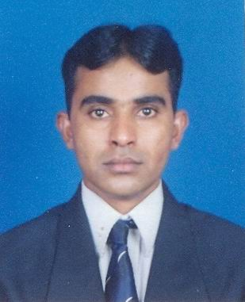

Experience:  1 Entry(s)
  Organisation | Pakistan Air Force
  Organisation Type | Aviation and Aerospace
  Employer Contact Number | 051-9527413
  Designation | Chief Technician
  Location | Rawalpindi , Pakistan
  Type of Experience | Full Time
  Tenure | Feb-1991 To Date
  Description | Having 16 years Human Resourse management, Office management and technical management experience.
Project:  1 Entry(s)
  Company | Pakistan Air Force
  Title | Technical Manager
  Role | Technical Manager
  Tenure | Aug-2003 To Date
  Description | Hold Seminars at air headquarters levels. Hold international meeting at air headquarters level. Technical manager for overhauling of cargo aircrafts.
Skill:  1 Entry(s)
  Skill Name | Level | Last Used
  Technical Management | Excellent | Currently Working
  human Resourse Management,Office management and Technical Management.
Education:  6 Entry(s)
  Degree Name | DCHS
  Level Attained | Diploma
  Aggreagte % | 50.00
  Institute | National institute of Science and Technical Education, H-8, Islamabad
  Address | Islamabad, Pakistan
  Session | 2006 - 2007
  Majors
  Degree Name | MBA(Marketing)
  Level Attained | Masters Degree
  CGPA | 2.90
  Institute | Preston University
  Address | Kohat, Pakistan
  Session | 2003 - 2005
  Majors | Marketing
  Degree Name | Bachelor of Electronics Technology
  Level Attained | Bachelors Degree (2-3 Years)
  CGPA | 2.30
  Institute | Preston Institute of Management Sciences and Technology Karachi
  Address | Karachi, Pakistan
  Session | 2001 - 2003
  Majors
  Degree Name | Bachelor of Arts
  Level Attained | Bachelors Degree (2-3 Years)
  Aggreagte % | 45.00
  Institute | University of the Punjab Lahore
  Address | Lahore, Pakistan
  Session | 1995 - 1997
  Majors
  Degree Name | Intermediate (DAE in Instruments Technology)
  Level Attained | Diploma of Associate Engineering (DAE 3 Years)
  Aggreagte % | 71.00
  Institute | School of Aeronautics Pakistan Air force Korangi Creek Karachi
  Address | Karachi, Pakistan
  Session | 1991 - 1993
  Majors
  Degree Name | Matric
  Level Attained | Matriculation / O levels
  Aggreagte % | 67.00
  Institute | Board of Intermediate and Secondary Education, Faisalabad
  Address | Jhang, Pakistan
  Session | 1988 - 1990
  Majors
Language:  3 Entry(s)
  Read | Write | Speak | Understand | Typing | Shorthand
  English
  Easily | Easily | Easily | Easily | (WPM) | (WPM)
  Urdu
  Easily | Easily | Easily | Easily | (WPM) | (WPM)
  Punjabi
  Easily | Easily | Easily | Easily | (WPM) | (WPM)
Reference:  1 Entry(s)
  Name | Title | Company | Phone/Email | Aquaintence | Type
  shafiq ahmed | Civil Engineer | NESPAK | 03009411959 / sqahmadpk@yahoo.com | 2 Years | Personal
Additional Info: | With my technical,Human resourse management background I have strong desire to utilize my knowledge, skills and capabilities in the fields of engineering,management and marketing.

