NASIR IQBAL MALIK
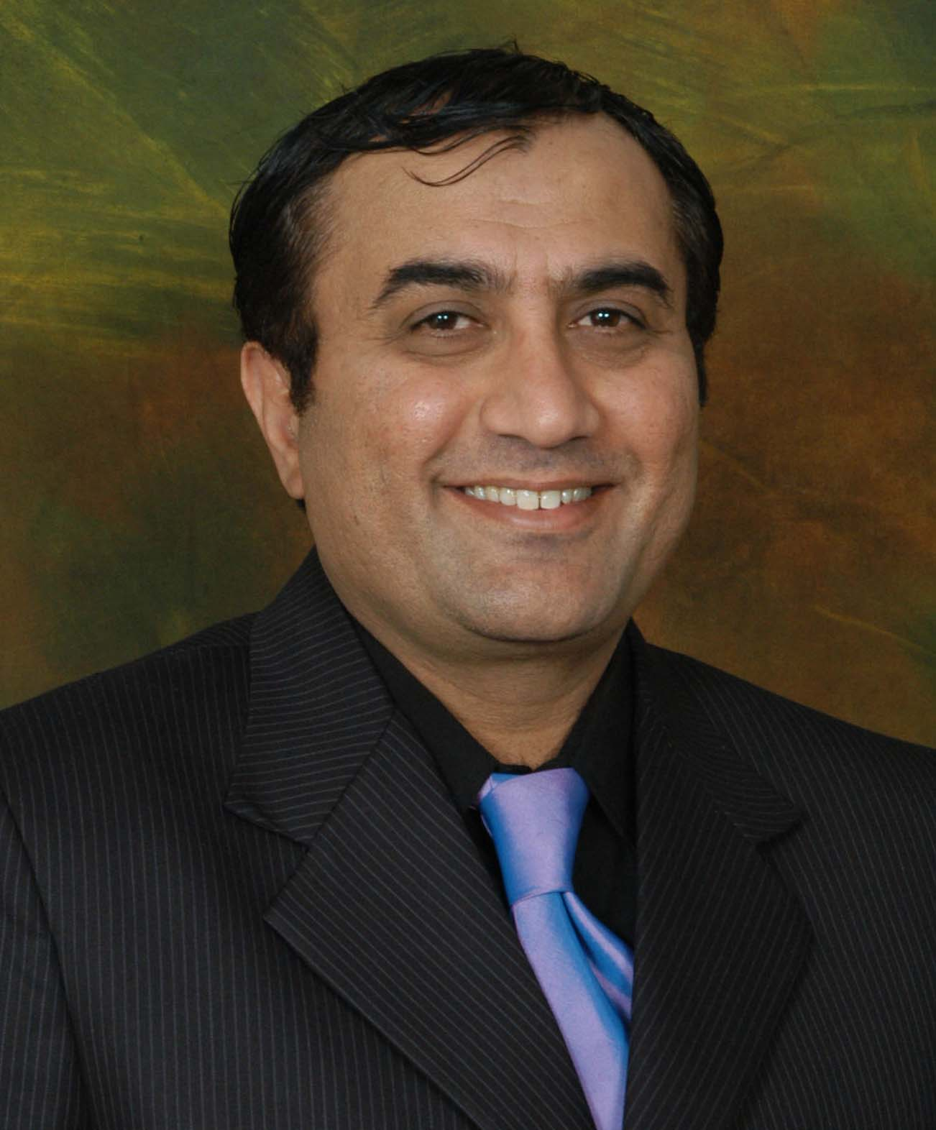
H/No 4 Lane 4 Defense Road
Newlalazar Rawalpindi
nasirmalikx@gmail.com
0301-5536468

Objective

To work my best, investing, enriching my skills and all my energy for my company. To work for a reputable organization where I can learn and develop professional skills that will help utilize my potential to the maximum, enabling me to work efficiently and effectively. I am a poet, songwriter and writer, using this talent to highlight issues, sufferings, human interest stories for media moreover creating awareness.

Education

2004 MA Media and Communication, Strayer University, Washington DC, USA
2013 MSc. Mass Communication, AIOU, Islamabad

Work Experience
2012-present Chief Campaigner (Institute of Advocacy for Social Development) Message Trust®, Islamabad, Pakistan
Developing Media and Communications Strategy, Programs development, Training, producing documentaries on children, Planning & coordination, Public Relations, arranging media interviews, Producing & assisting media programs, Puppet show, media campaigns, teaching & training, Print & Electronic media coverage, Press releases, Press conferences, publications.
2009-2012 Coordinator, Awareness-raising and Communication
Pakistan Wetlands Programme WWF (UNDP Project), Islamabad, Pakistan
Developing strategies Advocacy and Campaign, Awareness raising on water and wetlands and its associated biodiversity, Organized massive schools WWF campaigns since three years, partnership & networking, coordinating with Ramsar Int, GEF, EKN and UN agencies, liaison with Ministry of Environment, Communication, Education, Public Awareness CEPA strategies, Capacity building, environmental development, organizing school campaigns and art competitions, tree plantations, Media campaigns, Media relations, talkshows, Print & Electronic media coverage, Press releases, Press conferences, publications, Reports, Newsletter, E-Newsletter, Brochures, producing documentaries, field staff training, photo guidelines, website updating, developing stories, posters cartoons on endangered species, Community theater, Puppet shows, Social media (Facebook, Linkedin, Twitter, Reliefweb) Environmental policy analysis and strategic planning to building the productivity and understanding, Plantation Campaigns, Behavior change communication, Safeguarding water and environment, CSR.
Website: www.pakistanwetlands.org

2008-2009 Communication Officer, Research & Training Center for Social Development.

Islamabad, Pakistan
Developing Media and Communications Strategy, Developing strategies Advocacy and Campaign, media campaigns, Print & Electronic media coverage, Press releases, Press conferences, publications, Newsletter, Brochures, flyers, Designing, E-Newsletter, Emergency response media coverage, partnership & networking, Making Annual plans, photo guidelines, Media relations, provide human interest stories, Community theater, Puppet shows, Social media (Facebook, Linkedin, Twitter, Reliefweb).
2005-2008 Media and Communication Officer.
Muslim Aid UK Pakistan Field Office, Islamabad, Pakistan
Developing Media and Communications Strategy, Advocacy, media campaigns, Print & Electronic media coverage, Press releases, Press conferences, publications, Newsletter, Brochures, flyers, Designing, E-Newsletter, Making Annual plans & beyond, Media relations, Emergency response media coverage, digital photography, videography, Event Management, liaison with editors & journalists, Requesting Columnists to write for organizational profile/projects developing publications of thematic areas in bilingual, banners, flex, updating website, collaborate with Resource mobilization, fundraising, arranging & organizing events(Ramadan events,iftar dinners, seminars, meetings, National/International days, talkshows, roadshows, exhibitions ), liaison with (universities, ministries, institutions, diplomats, donors/agencies), clippings record, write ups for(Success stories, case studies, publications, articles), making documentaries, arranging media interviews, photo guidelines, Community theater, Puppet shows, meeting deadlines, Child Support program, Education & Youth Programs, Field activities, Therapy Programs for Earthquake Victims, Relief work, Livelihood, hospital, school & houses building in earthquake areas, Logistics management, partnership & networking, PR, Performance evaluation, Appraisal, Recommendations & Proposals.
2002-2005 Media and Communication Officer
Water & Sanitation Program, Washington DC, USA
Developing Media and Communications Strategy, Advocacy, Print & Electronic media coverage, Media relations, Press releases, Press conferences, designing, publications, Newsletter, Brochures, flyers, E-Newsletter, Emergency response media coverage, Media campaigns, digital photography, videography, marketing, Event Management, liaison with editors & journalists, Requesting Columnists to write for organizational profile/projects developing publications of thematic areas in bilingual, banners, flex, updating website, collaborate with Resource mobilization, fundraising, arranging & organizing events(events, dinners, seminars, meetings, National/International days, talkshows, roadshows, exhibitions), liaison with (universities, ministries, institutions, diplomats, donors/agencies), clippings record, write ups for(Success stories, case studies, publications, articles), making documentaries, arranging media interviews, meeting deadlines, Education & Youth Programs, Field visits,Logistics management, PR, Social & Group Therapies, partnership & networking, Conflict Analysis & Resolution, Recommendations & Proposals, and Logistics.
1994-2002 Communication Officer, Inter Action
Washington DC, USA
Media and Communications Strategy, Advocacy, Print & Electronic media coverage, media campaigns, Make Annual plans, Media relations, Press releases, Press conferences, publications, Newsletter, Brochures, flyers, E-Newsletter, Emergency response media coverage, digital photography, videography, Event Management, liaison with editors & journalists, Requesting Columnists to write for organizational profile/projects developing publications of thematic areas in bilingual, banners, flex, updating website, collaborate with Resource mobilization, fundraising, arranging & organizing events(events, dinners, seminars, meetings, National/International days, talkshows, roadshows, exhibitions ), liaison with (universities, ministries, institutions, diplomats, donors/agencies), clippings record, write ups for(Success stories, case studies, publications, articles), making documentaries, arranging media interviews, partnership & networking, Life saving programs, Conflict Analysis & Resolution, and Logistics.

Professional Education
UNEP Certificate of Appreciation for conducting Campaign World Environment Day in Pakistan
“Leadership with Communication Skills” NCRD Akhtar Hameed Khan
OIC & WWF “Green Technologies”, Workshop on Multilateral Environmental Agreements & GIS
Communications Workshop UNDP for its projects
Workshop on TNA for Capacity building, Workshop on Success in Presentation
International Conference on Girl’s Education Oxfam, PCE & UNESICO
Certificate Coordination Training (Scenario Workshop) RedR UK
Gender Mainstreaming Rural Development Academy Baluchistan
Peace & Conflict Management Pakistan Wetlands Programme WWF
Sustainable use of wetlands, Monitoring & Evaluation, Training needs assessment
Community Empowerment for Sustainable Wetlands Management
Executive member of Columnists & Writers Association Pak Intl (Regd)

Workshop on Integrated Management Sciences QMS Australia/IIUI
Workshop on Strategic planning and Program Development
Seminar of Google on Ad sense IIUI
Workshop on Journey towards Integrated Development
Workshop on Developing publications and Effective Press Release
Workshop on “How to conduct a High-quality Press Conference”
Seminar Media in Social & Development Sector
Workshop on Community development, capacity building & women empowerment
Media & Communication Conference & Workshop in Colombo, Sri Lanka (Muslim Aid)
Media consultation Workshop on Child rights by SPARC
Certificate in Computer Skills National Institute of Computer Sciences, Sadar, Rawalpindi
Advocacy Training Workshop, InterAction, USA, Workshop on HIV AIDS Awareness VA, USA
Workshop on Effectiveness of Community Development in Public Health, VA, USA
Certificate in Counseling Techniques, Certificate in Human resources,
Certificate in Childcare Fundamentals Brainbench
Certificate in Web Language (HTML) Adult & Community Education, Virginia, USA
Conflict Resolution & Management George Mason University, Fairfax, Virginia, USA
International English Language Testing System (IELTS) Listening Band 7 Score 6.5

Courses
Event Management, Project Development
Manchester College of Arts and Technology, School of Music, Manchester, UK

Awards & Achievements
Strengthening Women Parliamentarians for Effective Government in Pakistan organized
Media for Peace, Peacebuilding Training for Radio Pakistan Presenters & Producers organized
TOT for Districts dialogue forums organized
Organized massive schools WWF campaigns since three years
Organized a massive event Guinness World Record in Tree Planting
Certificate of Excellence on conducting World Wetlands Day 2010 Campaign
Certificate of Appreciation on conducting World Wetlands Day 2010 Media Campaign
Certificate of Excellence on conducting World Wetlands Day 2011 Campaign
Certificate of Appreciation on Maximum Press Releases Published World Wetlands Day 2011 Campaign
Certificate of Excellence on conducting World Environment Day 2012 schools Campaign
Honorary member Standing Committee of CSR Health and Education Federation of Chambers of Commerce
Certificate of Appreciation Muslim Aid
Earthquake 2005 Relief work - Sind Flood 2007 Relief work – Peshawar Flood 2008
Fundraising for Indian (Gujrat) earthquake, Fundraising for Tsunami disaster
Fundraising for different International disasters
Delivered media strategies to different institutions.
Lok Virsa first prize for documentary.
Articles published in Newspapers by Nasir Malik
Urdu Poetry Book “Aadhay Khawab ki Azeeiat” by Nasir Malik
Various famous columnists wrote articles about Muslim Aid (Media Interaction)
Organized various rallies, roadshows, forums and media campaigns
Team Challenge Workshop
Entertainment & Sponsor Coordinator ARY Digital Eid Mela 2005, 2003
Arranged & Organized Chand Raat Mela 2001 Nova College, Annandale, Virginia, USA
Certificate of Completion Volunteer Tutor, Literacy Council of Northern Virginia, Inc.USA
Performance Certificate Radio Presenter, Music & Talk Show Host, Awaz Radio, USA
Radio Presenter, Asian Sound Radio, Manchester, UK
Volunteer Course for Deaf Blind, UK

Softwares - ProTools- Photo Shop-Corel draw –Adobe Family -Windows -MS Office Family –HTML

Personal Information
Father's Name: Malik Nawab Khan
Hobbies: Computer Music, Poetry, Composing Music, Traveling, Movies, Gym, Basketball, and Football Languages: Urdu, Punjabi, Saraiki, Hindko, Spanish, German, English & little bit Russian & understanding of Arabic.
Website: www.pakistanwetlands.org

