Project Management
Project Management
Mid Career (2+ years of experience)
Personal Info: | Syed Shahrukh Hussain  DOB: Oct 19,1980  Gender: Male  6 - B, Tech Society, Canal Bank, Lahore.  Lahore - 0 - Punjab  Pakistan  345-4063314  resumelhr@yahoo.com | 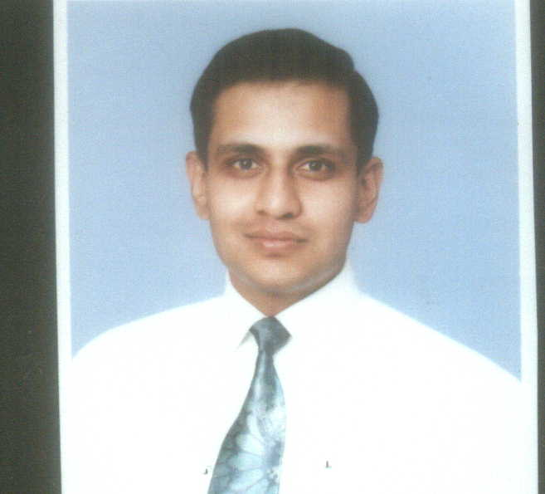

Objective: | To obtain a managerial position that will allow me to utilize my knowledge and experience to increase profit margins, productivity and quality.
Experience:  4 Entry(s)
  Organisation | University of Management & Technology Lahore, Pakistan
  Organisation Type
  Designation | Software Engineer
  Location | Lahore , Pakistan
  Type of Experience | Full Time
  Tenure | May-2005 To Jan-2006
  Description | â€¢ Collect and document user's requirements. â€¢ Training development team. â€¢ Research, evaluate and synthesize technical information. â€¢ Improved admission system by 30% in throughput thereby reducing administration cost. I have managed and trained development team of online admission system project for University of Management and Technology.
  Organisation | Universal Telecom Services (BVBA)
  Organisation Type
  Designation | Network/ Switch Manager
  Location | Lahore , Pakistan
  Type of Experience
  Tenure | Jan-2004 To Date
  Description | My duties include:
  Organisation | MPS Call Center
  Organisation Type | Call Center
  Designation | Assistant Network Admin/CSR
  Location | Lahore , Pakistan
  Type of Experience
  Tenure | Jan-2004 To Apr-2004
  Description | Administer and configure networks with routers supporting VoIP.
  Organisation | APIIT Lahore
  Organisation Type
  Designation | Lab Assistant
  Location | Lahore , Pakistan
  Type of Experience
  Tenure | Jan-2003 To Aug-2003
  Description | • Performed routine lab service and maintenance as directed by supervisor
Project:  3 Entry(s)
  Company | Adelaide Graduate School of Business, SA, Australia
  Title | Six Sigma Green Belt
  Role | Research
  Tenure | Jan-2006 To May-2007
  Description | Certified six sigma green belt from the Adelaide Graduate School of Management.
  Company | APIIT Lahore
  Title | Workflow Management System
  Role | Team Leader
  Tenure | Oct-2003 To Jan-2004
  Description | Workflow Management System The workflow process is traditionally defined in office terms moving the paper, processing the order, issuing the invoice. But the same principles and tools apply to filling the order from the warehouse, assembling documents, parts, tools, and people to repair a complex system, or manufacturing the complex device.
  Company | K.F.C (Kentucky Fried Chicken) Pakistan
  Title | web based business solution
  Role | Web Consultant
  Tenure | Jan-2003 To Apr-2003
  Description | I provided a configurable web based business solution. Currently the solution is being implemented at K.F.C (Kentucky Fried Chicken) Pakistan and APIIT Lahore.
Skill:  8 Entry(s)
  Skill Name | Level | Last Used
  Six Sigma green belt | Excellent | Currently Working
  I am a certified Six Sigma green belt from Adelaide Graduate School of Management.
  Web Development | Excellent | Currently Working
  • ASP.NET • PHP
  DBMS Administration | Good | Currently Working
  • Oracle • Microsoft SQL Server • DB2 • Sybase Adaptive Server
  Software Development | Good | Currently Working
  • Visual Basic 6.0 • VB.NET • Java-JDBC • Java-CORBA • Java-RMI • Java-Sockets • Visual C++ MFC • Visual C++ WIN32 API • C/C++
  Database Programming | Good | Currently Working
  • PL/SQL on Oracle • TSQL on SQL Server & Sybase Adaptive Server • SQLJ with DB2 & Oracle • Embedded SQL with Oracle Pro C_C++ • Java Stored Procedures on Oracle & DB2
  NOS (Network Operating Systems) | Good | Currently Working
  Linux, Open BSD • Network Management • Configuring Samba Server • Configuring Squid proxy Server • Configuring Apache http Server • Configuring Databases Servers
  DBMS Replication | Good | Jan 2003
  • Oracle Primary Site Asynchronous Replication • SQL Server Primary Site Asynchronous Replication
  Shell Programming | Good | Jan 2003
  • Shell( sh, ksh, bash) • Perl
Education:  4 Entry(s)
  Degree Name | Master of Business Administration
  Level Attained | Masters Degree
  Aggreagte % | 80.00
  Institute | The University of Adelaide, SA, Australia
  Address | SA, Australia, Australia
  Session | 2005 - 2007
  Majors | Six Sigma Green Belt Certified six sigma green belt from the Adelaide Graduate School of Management. Operations Proven ability to design and implement effective strategies, develop new products, and manage resources to produce profit. Proven ability to streamline processes and increase productivity. Business Performance Improvement Develop strategies for business process re-engineering. Map business processes for the workflow management system. Entrepreneurial Skills Strategic positioning of business and selecting target market for the product. Ensuring business operations are efficient and effective.
  Degree Name | Bachelor of Science (Computing) Honors Degree
  Level Attained | Bachelors Degree (2-3 Years)
  Aggreagte % | 84.00
  Institute | Staffordshire University UK
  Address | Lahore, UK
  Session | 2000 - 2004
  Majors | During three years with Staffordshire University UK, I had completed the APIIT BCS Honors Program with Distinction in computing and information technology which include computer programming, networking and multimedia technology. Skill Set: NOS (Network Operating Systems) Linux, Open BSD Window 200 Server ï¿½ Windows Networking (Domain Management) ï¿½ IIS Server DBMS Administration DBMS Replication Oracle Primary Site Asynchronous Replication SQL Server Primary Site Asynchronous Replication Software Development Web Development Shell Programming Database Programmin
  Degree Name | Certified Oracle 8.0 DBA, 2000
  Level Attained | Certification
  Institute | Oracle University
  Address | Lahore, Pakistan
  Session | 1999 - 2000
  Majors | I have been recognized by the Oracle Certified Professional program as an Oracle 8 Certified Database Administrator.
  Degree Name | Bachelor of Science Degree
  Level Attained | Bachelors Degree (2-3 Years)
  Institute | Forman Christian College, Lahore
  Address | Lahore, Pakistan
  Session | 1996 - 1998
  Majors | Mathematics & space science
Language:  3 Entry(s)
  Read | Write | Speak | Understand | Typing | Shorthand
  English
  Easily | Easily | Easily | Easily | (WPM) | (WPM)
  Urdu
  Easily | Easily | Easily | Easily | (WPM) | (WPM)
  Punjabi
  Not Easily | Not Easily | Easily | Easily | (WPM) | (WPM)
Reference:  1 Entry(s)
  Name | Title | Company | Phone/Email | Aquaintence | Type
  Saad Salaiman | Relationship Manager | Citi Bank, Islamabad | 0300-4291547 | 8 Years | Professional
Additional Info: | PROFESSIONAL SKILLS Operations Proven ability to design and implement effective operational strategies, develop new products, and manage resources to produce profit. Proven ability to streamline processes and increase productivity. Maintain a positive attitude that promotes team work within the organization and a favorable image of the organization. Project Management Developing work break down structure, Gantt chart, PERT chart,resource allocation and budget using MS Project and MS Excel. Project documentation and presentation using MS Word and MS Power Point. Successfully completed implementation of news agency Internet portal. Business Performance Improvement Develop strategies for business process re-engineering. Map business processes for the workflow management system. Collect and document client's requirements. Research, evaluate and synthesize technical information. Training improvement project team. Improved University admission system by 30% in throughput thereby reducing administration cost. Entrepreneurial Strategic positioning of business and selecting target market for the product. Ensuring business operations are efficient and effective. Participation in staff recruitment, hiring and scheduling. I would appreciate a call for an interview so that I could tell you more about myself. Yours sincerely, Syed Shahrukh Hussain.

