operations
Business Operations
Mid Career (2+ years of experience)
Personal Info: | Shahrukh Hussain  DOB: Oct 19,1980  Gender: Male  6-B TECH SOCIETY CANAL BANK  Lahore - 0  Pakistan  +923454063314  shahrokh.hossein@gmail.com | 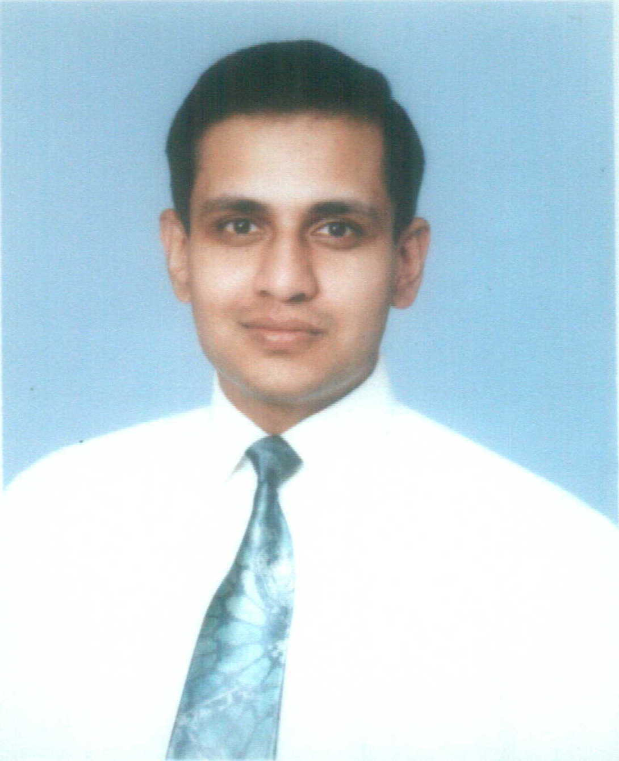

Objective: | To obtain a managerial position that will allow me to utilize my knowledge and experience to increase profit margins, productivity and quality.
Experience:  3 Entry(s)
  Organisation | University of Management and Technology
  Organisation Type | Education
  Employer Contact Number | +92425884172
  Designation | Software Engineer
  Location | Lahore , Pakistan
  Type of Experience | Full Time
  Tenure | May-2005 To Dec-2005
  Description | â€¢ Collect and document user's requirements. â€¢ Research, evaluate and synthesize technical information. â€¢ Improved admission system by 30% in throughput thereby reducing administration cost.
  Reason for Leaving | Further education
  Organisation | Oxter Solutions
  Organisation Type | Information Technology and Services
  Employer Contact Number | +923454063314
  Designation | Business Partner
  Location | Lahore , Pakistan
  Type of Experience | Part Time
  Tenure | Dec-2004 To Jan-2006
  Description | â€¢ Development and implementation of software. â€¢ Acquire leadership and strategic skills
  Reason for Leaving | Further study
  Organisation | Universal Telecom Services
  Organisation Type | Telecommunications
  Designation | Network Engineer
  Location | Lahore , Pakistan
  Type of Experience | Full Time
  Tenure | Mar-2004 To Apr-2005
  Description | â€¢ Configuring WTL (World Telecom) soft switch based in Belgium. â€¢ Applying efficient LCR (Least Cost Routes). â€¢ Managing SQL server 2000. â€¢ General Software development specific to the WTL Switch. â€¢ Calculation of Day to Day Revenue Generation. â€¢ Strategic planning of technology.
  Reason for Leaving | Company stopped operations
Project:  1 Entry(s)
  Company | University of Management and Technology
  Title | Online Admission System
  Role | Team Leader
  Tenure | Jun-2005 To Dec-2005
  Description | During my period of work at the university, I got my self involved in the business process engineering of the admission and enrolment of students. Being the team leader I developed plans for deliverables and measured project progress. Within six months the system was placed on testing. By employing online enrol the university enrolling system improved by 30% in throughput thereby reducing administration cost.
Skill:  4 Entry(s)
  Skill Name | Level | Last Used
  Technical skills | Excellent | Dec 2005
  Proficient with Word, Excel, Power Point and MS Project. Programming in Java J2EE, PHP, C/C++ and Visual Basic. Windows NT and UNIX system administration. Oracle and SQL server database administration.
  Operations | Excellent | Dec 2005
  Proven ability to design and implement effective strategies, develop new products, and manage resources to produce profit. Proven ability to streamline processes and increase productivity.
  Entrepreneurial Skills | Good | Dec 2005
  Strategic positioning of business and selecting target market for the product. Ensuring business operations are efficient and effective.
  Business Performance Improvement | Good | Dec 2005
  Develop strategies for business process re-engineering. Map business processes for the workflow management system.
Education:  3 Entry(s)
  Degree Name | Master of Business Administration
  Level Attained | Masters Degree
  Aggreagte % | 64.00
  Institute | Adelaide Graduate School of Management - The University of Adelaide
  Address | Adelaide, Australia
  Session | 2006 - 2007
  Majors
  Degree Name | Bachelor of Computing and IT
  Level Attained | Bachelors Degree (2-3 Years)
  Aggreagte % | 75.00
  Institute | Staffordshire University
  Address | Stoke-on-Trent, UK
  Session | 2001 - 2004
  Majors
  Degree Name | Bachelor of Sciences
  Level Attained | Bachelors Degree (2-3 Years)
  Aggreagte % | 69.00
  Institute | Forman Christian College Lahore
  Address | Lahore, Pakistan
  Session | 1996 - 1998
  Majors
Language:  2 Entry(s)
  Read | Write | Speak | Understand | Typing | Shorthand
  English
  Easily | Easily | Easily | Easily | (WPM) | (WPM)
  Urdu
  Easily | Easily | Easily | Easily | (WPM) | (WPM)
Reference:  1 Entry(s)
  Name | Title | Company | Phone/Email | Aquaintence | Type
  Saad Sulaiman | Relationship Manager | Citi Bank | saad.suliaman@citi.com | 5 Years | Professional
Additional Info: | CERTIFICATIONS: a)Six Sigma Green Belt b)Oracle Certified Database Administrator

