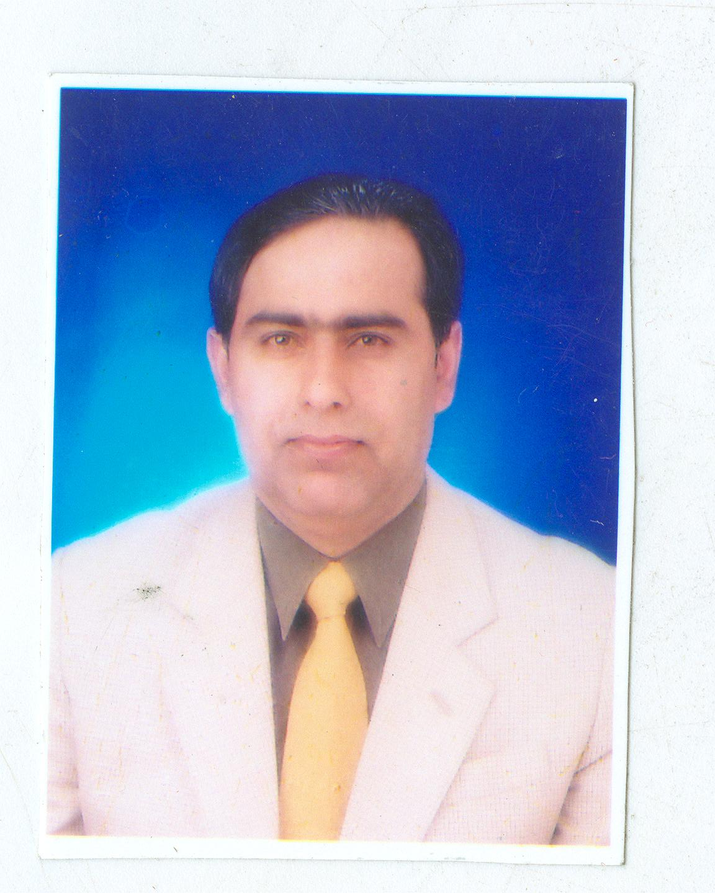
Resume
Asif Rasool
Master Trainer,
Cell: +92-334-3188899
Email: asifrasool2006@yahoo.com
Present postal address; ZAF cloth house & garments shop main bazaar new pind Sukkur

Summary

A competent professional educationist having over 15 years experience working as a Master Trainer with national and international agencies to enhance the capacity of teachers, promote health and hygiene & mobilize the community to deliver better education. Also a social activist dedicated to achieving landmark progress and demonstrating a flexible attitude adjusted to any challenging environment.

Job History
Working as a executive Director in ZAF public elementary School Sukkur
giving support to school in all five areas, learning environment Teaching learning ,school administration, Nature club &students welfare & enhance community participation.
November & December 2014 worked as field coordinator and done a research work on education and send report to FAFEN of those NGOs who were working on education at grass root level , the purpose of that activity to promote the qualitative work through advocacy at local & national level to for the betterment of education.

June 2012 to June 2013 Worked as a Lead Trainer with FAFEN & TRAINING FOR Pakistan & FAFEN in election project.
Received three TOTs and worked on manual development then conducted A series of trainings of local observers for last general election 2013 and trained thousands local short term and long term observers of FAFEN partner organizations all over the Pakistan.
The main Theme of training YOUNG VOTERS & PEACE FUL ELECTION and following topics were covered during the trainings Democracy, Election process ( Pre election, election day & post election) ,importance of vote ,procedure of vote casting, importance of Observation ,observation skills, parliament, Judiciary, Governance, form of states, election laws ,ICCPR, use of RTI, & ECP code of conduct.etc.
March 2009 to Coordinator and Master Trainer
To Dec-2010 (www.irc-pk.net) Indus Resource Centre Karachi
Project of Water Sanitation, Health & Hygiene (UN HABITAT)

Responsibilities:
- Liaise with Government authorities.
- Train teaching staff of government schools.
- Conducted focus group meetings with college students, religious personals and house hold women

June 2007 to may- 2010 Master Trainer & Observer District Coordinator (FAFEN)
(www.fafen.org.com)
Responsibilities:

- Conduct meetings with departments that collect information on Democratic Governance Program.
- Arrange Seminars on different community issues related to development.
- Conducted focus group meetings with formers, students, trade unions, labours, Teachers, political workers & women to identify their issues.
- Monitor field activities randomly.
- Monitor the General Election Process 2008.
- Trained local observers / constituency coordinators &constituency relation group volunteers in 2007 to up to date and trained thousands local observers , I have conducted the number of trainings or the part of those trainings as a master trainer and trained number of persons of different NGOs in various Districts of Pakistan as like Islam Abad, Lahore, Karachi, Hyderabad,Multan,Quetta, Khair pur, Sukkur, Shikar pur,Larkana,etc

Jan 2007 to May 2007 District Coordinator
(www.irc-pk.net),

(A joint project of IRC and Devolution Trust for Community Empowerment (DTCE)

Responsibilities:

- Liaise with District Government authorities.
- Train Local Government Setup i.e. UC Nazim, and their Executive Bodies.
- Organize progressive community group CCBs and register them with the District Government for the purpose of establishing development programs at community level.
- Work towards the main objective to improve living standards of rural communities.

March 2009 to Coordinator and Master Trainer
To Dec-2010 (www.irc-pk.net) Indus Resource Centre Karachi
Project of Water Sanitation, Health & Hygiene (UN HABITAT)

Responsibilities:
- Liaise with Government authorities.
- Train teaching staff of government schools.

June 2003 & March 2012- UP TO FEB 2011 As a Master Trainer school management committee (SMC) IRC & REFORM SUPPORT PROJECT (RSU)

Responsibilities:

- Conduct meetings with SMC & community to collect information on school management committee.

- Developed SMC vision regarding the model school, enhance the skills for the school improvement plan (SIP), action plan, SMC record keeping , ownership of schools and utilization of resources.

- I have conducted the number of trainings or the part of those trainings as a master trainer and trained number of persons of different at least 300 SMCs in various Districts of Sindh province as like Karachi, , Khair pur, Sukkur, Shikar pur,Larkana,Ghotki, Jacobabad, etc

May 2004 to November 2005 Worked As a Master Trainer with AKU (IED) in ESRA
Conducted 48 teachers training one day workshops in all subjects related to the primary education
Responsibilities:

- Coordinate with primary school teachers to identify their academic issues.
- Monitor field activities randomly.

- I have conducted 48 training workshops on different subjects especially English,Science, Math,Social Studies and focussed on learning out comes through activity based learning process..

Aug-1998 to July-1999 Master Trainer in (DFID) Project
Government of SINDH Education Department

Responsibilities:
- Conduct meetings in departments for improvement of Primary education.
- Train teachers and community leaders for quality education.
- Strengthen the capacity of teachers and develop model schools.

Education/ Training

- Masters in International Relation in 2000 from Shah Abdul Latif University.
- Postgraduate Certificate of Professional Development in Education from Hull University United Kingdom in 1999-2000
- Certificate in education from Harvard University USA (on line course) in 2003
- Certificate in education from Aga Khan University in 2004
- Training of Trainer received from Nepal on water, sanitation Health & hygiene education in April 2009 in UN habitat Project.

Languages (Read, Write, Speak)
English, Urdu, Sindhi, Balochi and understanding of Punjabi and Srieki.

Personal Information
Date of Birth : September-29th -1967
Domicile : Sukkur
Nationality : Pakistani

References:
- Dr Harriet Marland
EX Head of Department of Professional Development in Education
Bishop Grosseteste University College Lincoln, LN1 3DY, England
Phone: 0044- 1522 583674 email: harriet.marland@bishopg.ac.uk
- Ms Mossarat Qadeem
Executive body Member of FAFEN ISLAMABAD
Contact: +92-300-8566439 email: mossarat_coco@yahoo.com

- Ms Ashley Bar.
Training expert election & governance related topics
FAFEN Islam abad.

