A PERFECT CANDIDATE
Telecommunication
Management (Manager/Director)
Personal Info: | ayub khan umraj  DOB: Apr 05,1957  Gender: Male  H NO: 148, SOHNY ROAD I-10/4 ISLAM ABAD - H NO: 148, SOHNY ROAD I-10/4 ISLAM ABAD  ISLAM ABAD - 44000  Pakistan  (+923335127070) (+92514843100)  umraj111@yahoo.com | 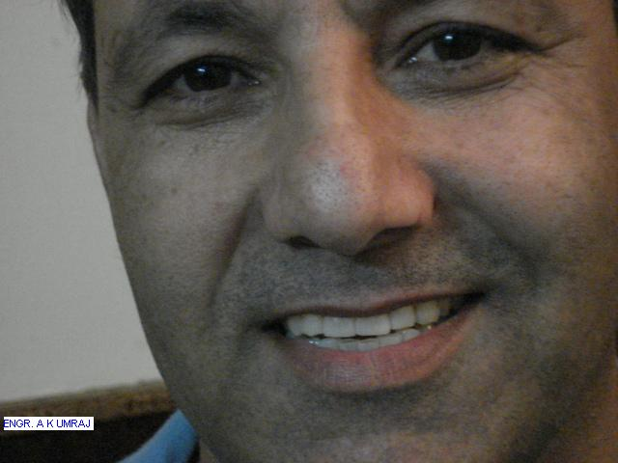

Objective: | Worked & gained experiance during last 22 years in: -CUSTOMERS/PUBLIC DEALING -TELECOM OSP MANAGMENT -TELECOM TECHNICAL MANAGMENT -HRM
Education:  1 Entry(s)
  Degree Name | MSc ENGG, MBA, BE ELECT, BSc
  Level Attained | Masters Degree
  CGPA | 3.80
  Institute | NED University of Engineering and Technology Karachi
  Address | ISLAM ABAD, Pakistan
  Session | 2003 - 2004
  Majors | -Simple BSc in 1978 from Peshawar Univ. -Graduated in Electronics Engg from NED Univ Karachi in 1985. -Got MBA degree in Marketing from ICMC Nazimuddin r'd Islam abad in 1996. -Completed MSc Engg (T) from Institute of Advance Studies (IAT/IMT-ILM Lahore) from IAT (campus) in F-8 Islam abad with first position & a medal. -Have attended/completed numerious short courses in managment, IT & special/other courses during service in Pakistan Air Force & DPD/POFs. -Serving in PTCL (Etissalat now)since 1988 in different positions as HR manager, senior manager and technical manager etc. Presently serving in PTCL as a Director Operations Rawalpindi.

