Sultan Abbas Date of Birth : April 02, 1974
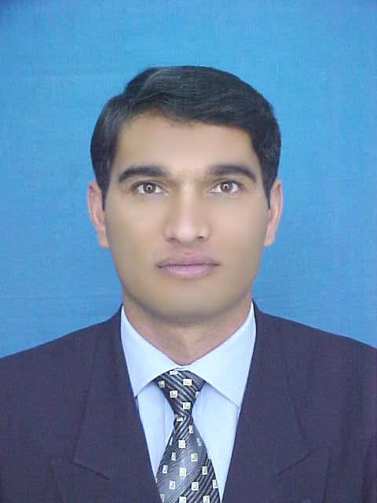
House 808, Street 19, G-10/1 Islamabad Domicile : Chitral
Cell: +92 302 5518494 Nationality : Pakistani
Email: yam_sultan74@hotmail.com Marital Status : Married

Experience | Jan 2013 to….. date Mountain Institute for Educational Development (MIED) - Islamabad  Programme Manager Education  Major responsibilities:  Work closely with ministry of education for successful implementation of education programmes; contribute in developing strategy for education programmes; lead in conducting teachers’ professional development programmes, guide in conducting training need assessments; lead in designing and implementing Inclusive Education Programmes for Afghan Refugees; support partner schools in developing and implementing school improvement plans; develop monitoring framework in coordination with the field offices; support partners schools in introducing school self evaluation; develop follow up mechanism for training courses; provide technical guidance and support to field education team in all aspect of their work; monitor and review project implementation to assess delivery, identify challenges and suggest practical solutions; provide guidance in developing work plans and ensure accountability to achieve targets; contribute in proposal writing; improve network with donors, civil society, government agencies, communities and local level authorities.  Jul 2012 to Dec 2013 Adam Smith International – DFID’s KP Education Support Programme  Education Advisor  Major responsibilities:  Provide technical support to the Government of Khyber Pakhtunkhwa (GoKP) in developing and implementing partnerships with the low cost private schools; provide guidance and support for developing and implementing comprehensive plans and programmes for public private partnerships in education; support the development of a strategic plan for the Elementary Education Foundation (EEF); through government education department develop outreach programmes for out of school children and provide adult literacy and skills programmes for women and youth; support the development of systems that measure and monitor performance including learning outcomes in private schools; provide technical support to government in developing accreditation system for private schools; provide technical support to government in developing policies and strategies for regulating private schools; support the development of monitoring and evaluation framework; support the development of communication strategy; contribute to overall programme reporting for DFID and other donors.  Nov 2011 to Jun 2012 Norwegian Refugee Council (NRC) – Peshawar  Team Leader, Education  Major responsibilities:  Work closely with the ministry of education for the successful implementation of education projects of NRC in Khyber Pakhtunkhwa (KP); develop proposals for new education projects; participate in education coordination meetings, forums, and conferences; participate in education cluster meetings; coordinate closely with Provincial Institute of Teacher Education (PITE) in conducting training courses for government teachers; coordinate with National Institute of Research and Education in developing tailor made curriculum for Accelerated Learning Programme (ALP); coordinate with Elementary Education Foundation (EEF for joint monitoring of education projects; establish committees (PTCs, PTAs, SMCs); conduct workshops for field staff and provide them with direction and support; provide guidance to filed education team in implementation of project activities; capacity building of field education team; lead the planning and distribution of teaching and learning materials for government schools; guide new project team in planning and implementation; develop emergency education plan and ensure its implementation.  Jan 2009 to Oct 2011 The Citizens Foundation (TCF) – Karachi  Manager Monitoring and Evaluation  Major responsibilities:  Develop mechanism for effective monitoring and evaluation of education programmes; Guide units in developing work plans and ensure implementation; develop mechanisms and tools for collecting qualitative and quantitative data; visit programme areas to monitor inputs;; lead professionals in conducting baselines, impact assessment and research studies and share lesson learnt with relevant stakeholders; lead in planning and conducting teacher and student assessments; monitor the academic standard of TCF and partner schools; lead in conducting outcome evaluation, coordinate with other educational providers; plan and arrange workshops to share learning experiences; write reports for different stakeholders; manage department’s budget.  Dec 2003 to Dec 2008 Aga Khan Education Service, Pakistan – Chitral  Assistant Manager, School Development  Major responsibilities:  Design and conduct teachers’ training courses; conduct workshops for teachers, educational leaders, government officials, social worker and SMCs; conduct TOT for teacher educators, education officers and field staff; develop follow up and monitoring mechanisms for training courses; provide support to field education officers on interactive teaching and learning processes; guide field education team in developing and implementing school development plans; design and run advocacy campaigns for promotion of girls education and retention of girls in schools; identify gender discrimination in curriculum to address them during training courses; build the capacity of government education department; assist community development manager in arranging capacity building programmes for PTAs, SMCs and VECs; support HR is teachers’ performance appraisal.  Dec 2002 to Nov 2003 Army Public School (Chitral)  Principal  Aug 1997 to Jul 1998 Government High School Booni, Chitral  Teacher  Oct 1994 to Apr1995 Pamir Public School Booni, Chitral  Teacher
Education  Workshops  Computer Skills  Languages  References | 2006 - 2007 University of London, Institute of Education  MA Education and International Development  First division  1999 - 2000 Preston University Islamabad  Masters of Business Administration (MBA)  Distinction  2002 - 2003 Allama Iqbal Open University Islamabad  Bachelors of Education (B.Ed)  First division  - Participated in IAEP (International Adolescent Education Programme).  - Participated in a number of workshops/trainings. Few of them are disaster management, disaster risk reduction, security, field travel safety, wash essentials, shelter essentials,  water, sanitation and hygiene, participatory monitoring, project designing, proposal writing, project management.  - Participated in a three days’ workshop on ‘ Understanding diverse learners’ organized  by Teacher Resource Center Karachi  - Participated in a 10 days TOT (Training of Trainers) course organized by  Aga Khan Education Service, Northern Areas from 20 – 30 June 2004.  - Participated in an International Conference on ‘Leadership in challenging time’  organized by the Aga Khan University – Institute for Educational Development  (AKU-IED) from 19 - 23 February 2005 in Karachi.  - Participated in a three days’ workshop on ‘Qualitative Data Analysis’ organized by Professional Development Center (PDC) Chitral.  - Participated in a two days workshop on ‘LFA reviewing and revising’ conducted  by European Community (EC) Mid-term Monitoring Mission.  MS Office, Stata, Internet Explorer, In Page, Outlook Express  English, Urdu, Pashto (basic), Khowar (Chitrali)  Arshad Nafees Khan Qurat-ul- Ain Sadozai  Ex-Team Leader Country Director  Adam Smith International Norwegian Refugee Council, Pakistan  Cell: +92-302-8110019 Cell: +92-345-0556555  Email: arshad.nafees@gmail.com Email: qurat.sadozai@nrc.no  Abdul Jahan  Executive Director  Mountain Institute for Educational Development (MIED)  Cell: +92-300-9882462  Email: abdul.jahan@mied.org

